Name:

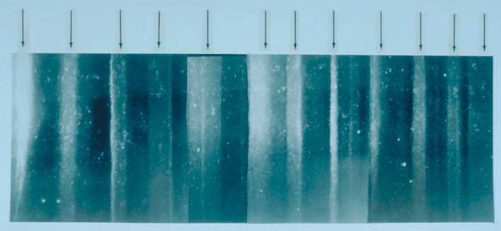
(Above) 19 cm-long section of a GISP2 ice core from 1855 m depth showing annual layers. Summer layers (arrowed) are sandwiched between darker winter layers.
Photo credit: Anthony Gow/USACE/NOAA 2001
Interpretations: Reading the Book of Earth
To geologists, this planet of ours isn't just a place where wondrous things happen every day. The Earth we study is a dynamic system, constantly producing the environments we all experience while simultaneously writing its autobiography.
The layers in sand dunes, glaciers, and lake bottoms are pages of this book.

Geologists and climate scientists translate these tomes, so that everyone can learn Earth's story. Just as we read of the world

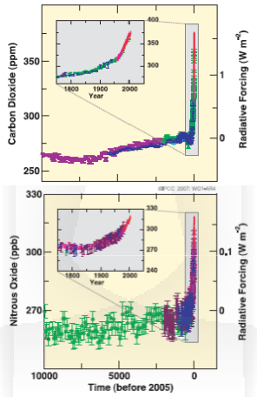of dinosaurs, the life of the ancient seas, and lush jungles that have turned to deserts, so too do we read of changes in the skies above them. The temperature ranges and precipitation patterns that govern life today were no less important in the past. Glacial ice is a vast repository containing snow that once fell, dust that flew through the air, and bubbles ̶ tiny samples of the ancient atmosphere. The ice core pictured above is just one excerpt from the book, with each layer of ice preserving one year of Earth's story.

Through the course of this activity you will interpret a portion of the book of Earth by
҉ Graphing and analyzing ice core methane data,
҉ Calculating the rate of change in modern atmospheric concentration,
҉ Comparing the radiative forcing of CO2 and CH4 quantitatively, and
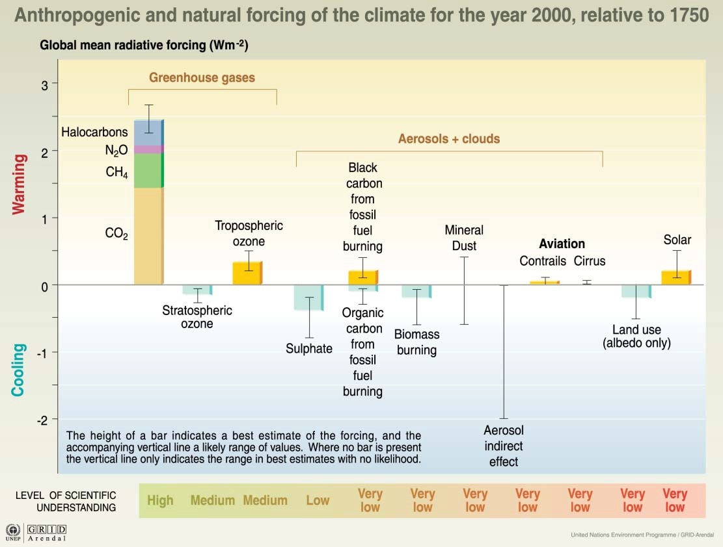҉ Predicting the next chapter in this story and the place of humanity in it.

(Above) Atmospheric concentrations of carbon dioxide and nitrous oxide over the last 10,000 kBP and since 1750 (inset panels). Measurements are shown from ice cores (different colours for different studies) and atmospheric samples (red lines). Corresponding radiative forcings are shown on the right axes.
©IPCC 2007 Summary for Policymakers
(Left) Relative forcing mechanisms of modern climate change.
©UNEP/GRID-Arendal 2005 Vital Climate Change Graphics

- Open the case study 5.2 student dataset using your spreadsheet program.
- Create a scatterplot (the kind connected with a line) of your data with methane concentration on the y‐axis and age on the x‐axis. Reverse your x‐axis so that 0 years kBP (the present) is on the right.
- Attach an image or copy of your graph to this assignment.
- Characterize your graph. What trends do you notice? How does the present differ from the past in terms of atmospheric methane concentration? Be specific.

- According to your ice core data, when does the most drastic change in atmospheric methane concentration occur? From that date to the present, what is the rate of increase in methane concentration in ppb per year?

- How does your atmospheric concentration graph for methane compare to those of other greenhouse gases (shown on the first page of the activity)?

- Radiative forcing is a measure of the power that radiation has per unit area of Earth's surface. The greater the radiative power of the atmosphere, the more heat energy it maintains, and the greater the impact (or force) it has on the climate. If CO2 has a radiative forcing of 1 W/m2 at 340 ppm and CH4 has a radiative forcing of 0.1 W/m2 at 850 ppb, which gas is more powerful?

- How many times greater is the radiative forcing of the more powerful gas?

- Based on experimental data*, doubling of the current amount of methane in the atmosphere would result in at least a 0.5°C increase in global average temperature. At the current rate of change, when would the atmosphere reach a doubled concentration? How much hotter would Earth be on average at that time due solely to the doubling of methane in degrees C and F? (1°C = 0.56°F)

- Given that the current primary sources of atmospheric methane are livestock activity and extraction from natural gas fields and coal seams, do you foresee an increase, decrease, or stability in the rate of change in atmospheric methane? Explain in detail. How will future climate differ according to your prediction?

- Is it possible to change the future you just predicted? If so, how? If not, how will we have to change to live in this future climate?

* Wuebbles, D.J., and Hayhoe, K. (2000). Atmospheric methane: Trends and impacts. In: Non‐CO Greenhouse Gases: Scientific Understanding, Control and Implementation, J. van Ham et al. (eds.), pp. 425‐432. Kluwer Academic Publishers, Netherlands. Available at http://www.atmosresearch.com/NCGG2a%202002.pdf, last accessed 12 Aug 2012.
2

