
Hawaiian Islands: Erosion and Giant Landslides

Annotated Teacher Edition
http://serc.carleton.edu/geomapapp

Why? The Hawaiian islands and Emperor Seamounts form an impressive 6,000 km-long chain of volcanoes in the Pacific Ocean. Using land elevation and seafloor depth data, the size, shape, and erosional characteristics of the volcanoes help us to understand the nature of the chain. We compare that evidence to the widely-held view that the volcanoes formed over a hotspot.
In the hotspot model for the Hawaiian-Emperor seamount chain, motion of the Pacific plate over a stationary hotspot has been used to explain the formation of the chain. In this activity,
geomorphological evidence (erosion and mass wasting) shows that the volcanic edifices generally become more weathered and smaller to the NW. This agrees with radio-isotopic estimates of the age of the volcanic rocks that show a progressive increase in age along the chain towards the NW.

Red text provides pointers for the teacher. Each GeoMapApp mini-lesson is designed with flexibility for curriculum differentiation in mind. Teachers are invited to edit the text as needed, to suit the needs of their particular class.

Structure of GeoMapApp Learning Activity: As you work through the GeoMapApp mini-lessons you’ll notice a box, , at the start of many paragraphs and sentences. Check off the box once you’ve read and understood the content that follows it. Doing so will help you keep your place on the worksheet as your attention moves back and forth between your computer screen, your instructions, and your answer sheet. This ♦ symbol indicates that you must record an answer on your answer sheet. Action steps are numbered like this: 15. Questions are lettered and indicated by the ♦ symbol, like this: 15a. ♦.

Learning Outcomes: By the end of this lesson, you should be able to:
- Analyze elevation maps of Hawaiian islands and seamounts and distinguish areas above and below sea-level.
- Create topographic profiles and characterize the main features of the profiles.
- Recognize the surface expression of erosional features and landslides in on-land and underwater settings.
- Examine map-based evidence of erosion and infer a logical sequence of events.

1. The NASA Blue Marble image of the earth shows the appearance of Earth from space. We see the land and oceans of our home planet as if we were looking with our own eyes from a spaceship. We call this a true-color image. In this image, the world beneath the ocean waves is largely invisible. Later in this activity, we’ll analyze sonar data that allows us to look at features on the seafloor.

In GeoMapApp, load the Blue Marble image: Go to the Basemaps tab, select Global Maps, NASA Visible Earth (Blue Marble Imagery) and choose July.

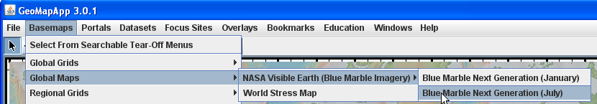
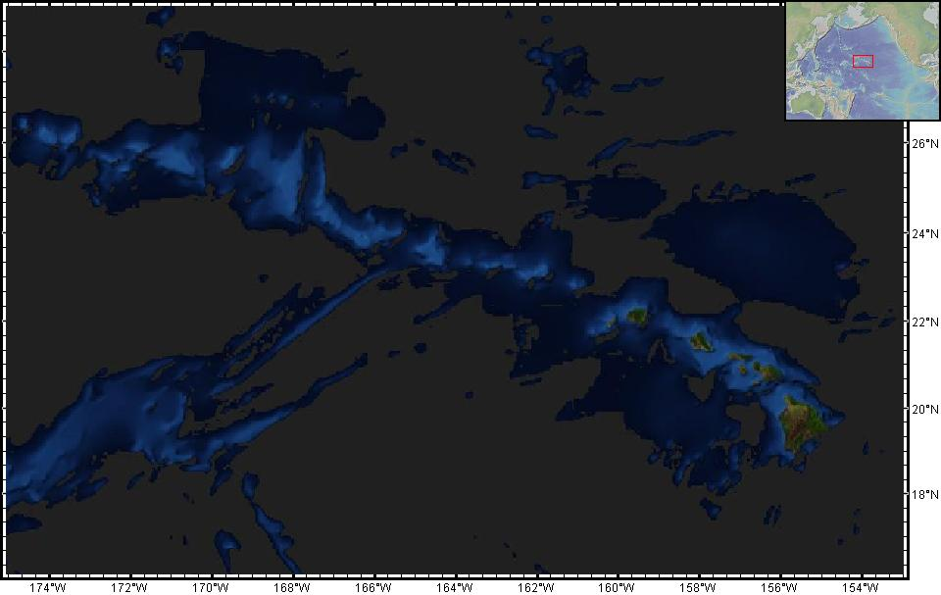
2. With the zoom tool turned on, click two or three times on the north Pacific Ocean. Then, to refine the area being viewed, place the cursor roughly at 175ºW, 28ºN and draw the zoom box to 153ºW, 17ºN. Remember that these longitude values are West of the Prime (Greenwich) Meridian. This will zoom the image to the region of Hawaii as shown in the picture to the right.

3. ♦ The Hawaiian islands are in the lower right corner of the map. Describe the color of the islands. You may need to tilt the computer screen to provide a better viewing angle.
This true-color image shows the islands as dark green and brown. The dark green color indicates dense tropical vegetation, and the brown color of the high volcanic peaks indicates sparsely vegetated or bare volcanic rock.

4. ♦ Describe the ocean color in the vicinity of the islands.
The shades of light blue are perhaps the most striking aspect of this true-color image. The light blue colors indicate the shallow ocean waters through which sunlight can penetrate and reflect off the ocean floor. These shallow waters tend to be biologically-rich and include important fishing grounds.
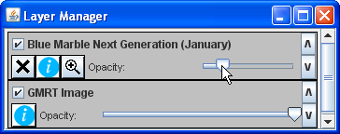
5. In the Layer Manager window, slide the opacity bar for the Blue Marble image to the left and right. Doing so reveals the underlying falsely-colored image of the GeoMapApp elevation base map which shows the shape of the planet as if there was no ocean water.
Like many maps, the GeoMapApp base map is colored according to elevation levels. Clicking on the Overlays tab and ticking the Color Scale box will display the color scale used for this base map. The base map is a two-dimensional representation of land elevations and seafloor depths, as if all of the world’s oceans were drained and then colored using the color scale. Since the colors of the base map are determined by depth and height values, the base map is fundamentally different to the true-color Blue Marble image that is a photographic view of the world taken in visible light.

6. ♦ In the vicinity of the islands, do the areas of ocean that have true-color shades of light blue correspond to obvious features underwater?
Yes. Areas of ocean that are light blue match well with shallow areas on the GeoMapApp elevation base map (colored with browns and whites). In shallow zones, not only can sunlight penetrate the water column and illuminate the seafloor, but the high biological productivity associated with upwelling currents produces organisms can also change the ocean water color.

7. In the Layer Manager window, click the button to get rid of the Blue Marble image.

8. An elevation profile – also known as a cross-section or transverse section – allows us to obtain a different view of a feature. It lets us look at the physical outline as if we had sliced the object so that we can look inside.

9. Below, is an example of an elevation profile (a cross-section view) taken across the Hawaiian island of Oahu. That island is where Honolulu – Hawaii’s state capital – is found.

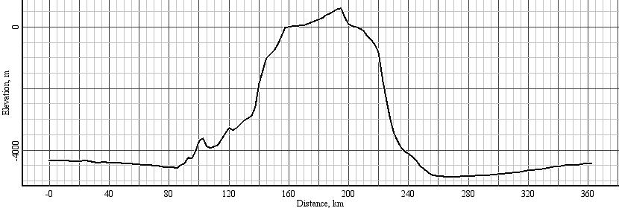
Sea
Level

9a. Sea-level, defined as having an elevation of 0m, is shown as the solid red line. Elevations above sea-level are typically defined as being positive upwards. Land is generally – but not always – above sea-level so land elevations are usually given as positive numbers.
Land heights are defined as being positive upwards. Example: 100m, 4000m. Did you know that some areas on land are actually below sea-level?! Examples include the Badwater region of Death Valley in California (-86m), the Qattara Depression in north Africa (-130m), and the land-locked Dead Sea basin (-423m). Amazing!

9b. Elevations below sea-level are called depths and usually defined as being negative downwards.
Example: 100m below sea-level would be written as -100m, and 4000m below sea level would be -4000m. So, the depth to the seafloor will be a negative number.

9c. In a coastal region, the total range of elevation is the sum of the highest land height and the lowest ocean depth. That is, the elevation range is the sum of the absolute values of the elevation extremes.
In the labelled profile below, Range = distance above sea level + distance below sea level = 700m + 4800m = 5500m.
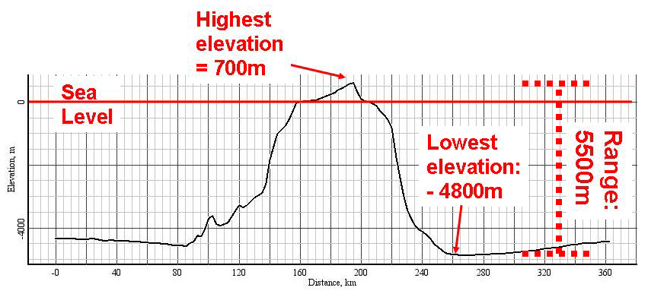
10. Time for you to create your own profile. In the GeoMapApp tool bar, click the profiling button, . This will load the elevation grid and activate the profile tool. You may have to wait a few seconds for this to happen.

11. ♦ You are going to create an elevation profile across the Big Island of Hawaii. Place the cursor on the map at 156.6ºW, 18.2ºN. Click on the map and, keeping the click button depressed, drag the cursor to 154.2ºW, 21.0ºN. Release the button and the elevation profile will appear in a new window. Your profile should look like the one below. Note the tremendous width (about 175km) of the volcanic island.
The easiest way to locate the start point of each profile on the GeoMapApp map is to use the read out of the cursor location that is given at the top of the GeoMapApp window in the second pair of brackets. (The first pair of numbers gives the location in degrees and decimal minutes. The second pair gives lat-lon values in decimal degrees.) Move the cursor until it lies at the start location. Click the map at that location and, keeping the click button depressed, drag the cursor to the end point location, again using the read out at the top of the window to locate that position. The profile line is drawn on the map and, when the cursor button is released, the profile window pops up.

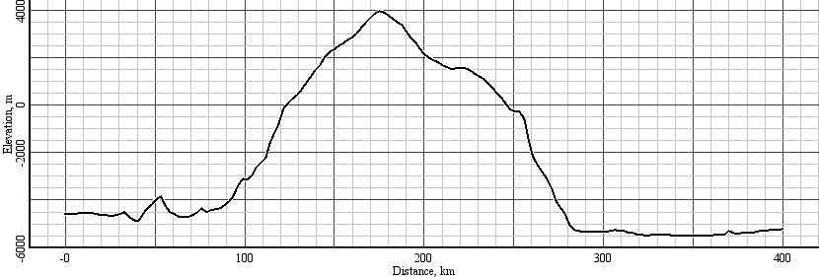

11a. The profile across the Big Island is drawn on the answer sheet as profile 1.
11b. ♦ On Profile 1 on your answer sheet, use a colored pencil to draw sea-level. Also shade the area of the island that is above sea-level. Now look carefully at the profile and Y-axis scale to estimate the height of the highest point of land above sea-level. Write the value in the appropriate box for Profile 1 (Big Island) in the table on your answer sheet. Look again at the profile and estimate the depth of the deepest seafloor. Write that value in the table. Calculate the range of elevation and insert the number in the table.
The Y-axis annotations are used to calculate the elevations. Highest land elevation is roughly 3965m. Deepest seafloor is about -5560m. Range = 9525m.

11c. The map below shows the location of profile lines 1 (Big Island), 2 (Maui), 3 (Oahu) across the islands as well as profiles 4 and 5 that are taken further along the volcanic chain.
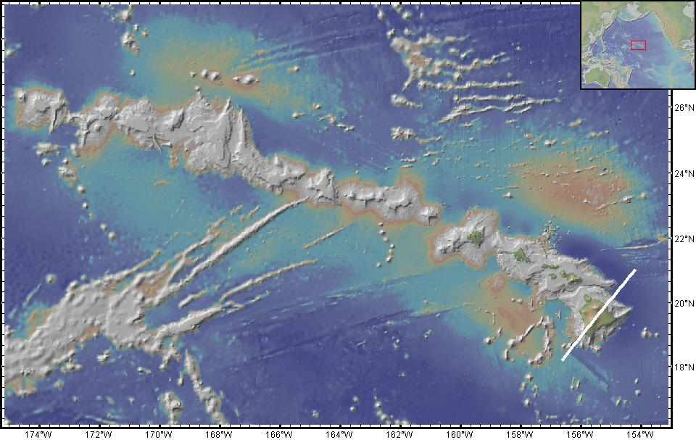
1
2
3
4
5

11d. ♦ As you did for the Big Island, study the profiles for lines 2, 4 and 5. On each profile, use a colored pencil to draw sea-level and shade the area of the island that is above sea-level. Estimate from the graphs the elevation of the highest and deepest parts of each profile (for profiles 2, 4 and 5). Calculate the range of elevation and write all of the values in the table on your answer sheet.
Profile # | Start longitude, latitude | End longitude, latitude | Maximum elevation (m) | Minimum elevation (m) | Total Elevation range (m)
1 - Big Island | 156.6W, 18.2N | 154.2W, 21.0N | 3965 | -5560 | 9525
2 - Maui | 157.0W, 19.4N | 155.4W, 22.3N | 2540 | -5780 | 8320
3 - Oahu | 159.0W, 19.7N | 157.0W, 23.0N | 700 | -4800 | 5500
4 | 165.0W, 21.7N | 163.8W, 25.1N | -20 | -4930 | 4950
5 | 171.3W, 23.8N | 170.2W, 27.3N | -25 | -4780 | 4805
Note that each profile is roughly 400km long and, for consistency comparisons, that each is aligned roughly parallel to the widest part of the volcanic edifice. Students need to pay attention to the Y-axis scale in order to correctly estimate the elevation values.

12. ♦ Use the profile information from the table as well as the shapes of the profiles themselves to describe how the shape and elevation range of the volcanoes change along the chain.
Volcanic islands in the SE – near the Big Island – tend to be broad and tend to stand high above sea level. Towards the NW, the islands become shorter, and, in places, narrower, and eventually are planed off at sea level. The different width of the volcanoes primarily reflects different eruption rates when the volcanoes were forming. Interesting side note: The 4169m-high Mauna Loa volcano – a Big Island active shield volcano that most recently erupted in 1984 – is actually shorter than Mauna Kea which rises an even more impressive 4205m above sea level. Mauna Kea is the highest mountain in the state of Hawaii and although there is still some chance of eruption, it is beyond its most active eruptive phase. The clear, rarified summit air of Mauna Kea is now home to world-class astronomical observatories. The barely comprehensible mass of these two huge shield volcanoes that form the Big Island causes the underlying Pacific plate to bend downward about 5-6 km – an isostatic process known as lithospheric flexure. Just think about this for a second – the solid rock forming the Pacific plate is warped downwards by a few kilometers due to the colossal mass of the volcanoes that sit on it. This process of flexure produces the characteristic “flexural moat” around the Hawaiian Islands. Another fascinating side note: Measured from the ocean floor to its summit, Mauna Kea is significantly taller than Mt Everest which stands a ‘mere’ 8848m above sea-level.

13. In the Global Grids window, click the button to dispose the elevation grid.

14. The Big Island of Hawaii is centered at 155.5ºW, 19.7ºN. Zoom in to the Big Island to a zoom factor of about 250 (the zoom factor is displayed in the upper right corner of the GeoMapApp window).
A note on zooming: Students may be tempted to keep on zooming – let them play a bit then have them return to a zoom factor level of around 250 (not less than 200 and not more than 300). This zoom level is recommended so that it is easy in the following steps to pan northwestwards to find the next island in the chain. A more precise way to zoom to the recommended zoom factor of about 250 is to zoom by clicking with the cursor on the map, then dragging the cursor diagonally to make a box. When the cursor is released and the map refocuses, check the zoom factor. Keep zooming to get to a zoom factor of about 250 with the map centred upon the Big Island. We recommend that once zoomed in, click the button to de-activate the zoom function.

15. ♦ Which one of the following words best describes the overall surface texture and general surface features of the Big Island? Smooth or Rough.
Texturally, even though there are high peaks and steep slopes on the Big Island, the surface texture is, overall, remarkably smooth. There are some valley-like features at the north tip. The two large volcanoes – Mauna Kea and Mauna Loa – are clearly seen near the centre of the island. Interesting side note: The Kilauea crater, an active volcano in Hawaii Volcanoes National Park, is located at 155.3W, 19.4N. Zoom in closer on Kilauea to check out the impressive surface expression of Kilauea. Remember to zoom out again for the rest of the activity!
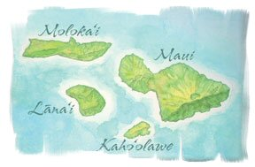
16. Click the pan button, , and move the GeoMapApp map to the next group of islands to the NW centered at 157ºW, 21ºN) – a cluster of four islands, Maui, Lanai, Molokai and Kahoolawe. See sketch map to the right.

17. ♦ Look carefully at the northwestern promontory of Maui (156.6ºW, 20.9ºN) and the island of Lanai (centered at 156.9ºW, 20.8ºN). Both areas display numerous deeply-incised ravines. What does this tell us about the amount of erosion, and what could be the agent of erosion?
The large number of ravines indicates much erosion. Many ravines on these volcanic islands start on the ridge line and cut deeply into the steep volcanic flanks before reaching the shoreline. Heavy precipitation in the form of rain results in streams and rivers being the main agent of erosion here.
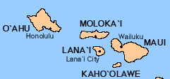
18. ♦ Now pan slightly towards the NW so that the islands of Molokai (centered at 157ºW, 21.2ºN) and Oahu (centered at 158ºW, 21.5ºN) are both displayed on the GeoMapApp map. (See sketch map to the right.) Write your evidence that active erosion is also occurring on the islands of Molokai and Oahu.
Yes, there is much evidence because these islands, too, are characterised by many deeply-incised ravines. In fact, we think that landslides that slumped off the northern side of the Molokai volcano caused a steepening of the headwalls which allowed more pronounced rain-driven erosion.

19. ♦ Look carefully at the shallow offshore regions around the coastlines of Molokai and Oahu. On the GeoMapApp map, these shallow areas are represented by shades of white and pale pink. Make a note of any features in these offshore areas that look similar to the ravines on the islands. Describe if there are obvious connections between the ravines and canyons on land and similar features below sea-level.
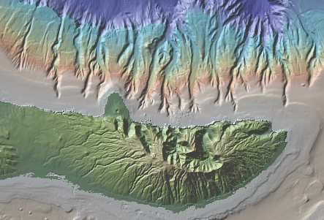
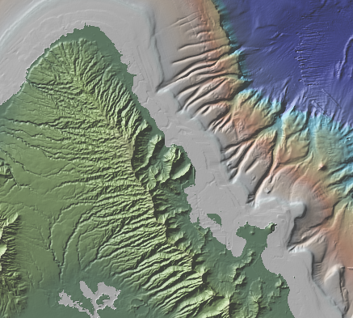
Close to the coastline, shallow shelf-like areas are formed of coral reefs and sediment that is deposited by streams and rivers. On the edges of the shelves and extending down into deeper water, the detailed seafloor topography (called “bathymetry”) reveals many very striking underwater canyons particularly on the north side of Molokai (left) and the northeast side of Oahu (below). On these shelves, there is no obvious connection between the onshore ravines and those that extend beyond the shelf edge. However, instabilities resulting, for example, from storms, strong currents and earthquakes may cause sediment to cascade down the slope into deeper water. The resultant rivers of underwater sediment deeply erode the edge of the shelves. In these images showing the

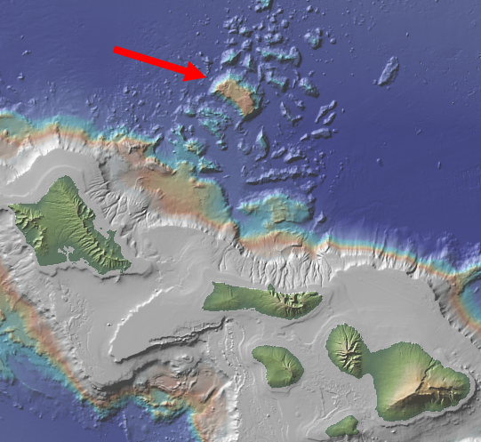
20. Look to the area on the deep seafloor directly north of Molokai and NE of Oahu. Many large blocky mounds and hummocks disturb the otherwise smooth deep ocean floor. A particularly pronounced block near 157ºW, 22ºN is estimated to have a gigantic volume of 5,000 km³ – about enough material to completely fill up the entire Grand Canyon! Amazing! These blocks and hummocks are the remains of underwater landslides that occurred around 1.4 mya; in this case they are thought to have been individual fast-moving debris avalanches where the flank of a volcano suddenly experienced catastrophic failure. Some gravel deposits were dumped 105,000 years ago on the island of Lanai by a tsunami produced by a huge landslide on from the Big Island’s Mauna Loa volcano which lies about 300km away! The resultant tsunami wave was GIANT – depositing the gravel 326m above sea-level!!! In other parts of the Hawaiian chain, landslides are produced by smaller-scale slumping events that result in less blocky terrain.

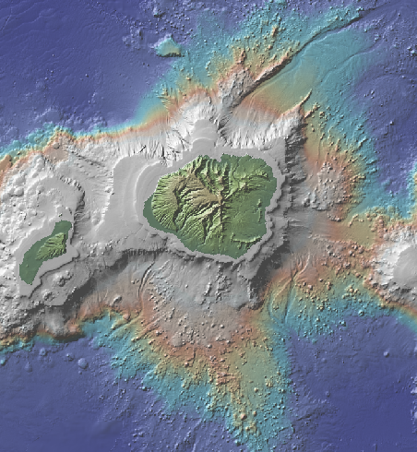
21. ♦ Pan to the NW to locate the island of Kauai (centred at 159º30’W, 22º10’N) and examine the seafloor to the north and to the south of the island. Is the deep seafloor very smooth or does it exhibit another texture? Compared to the features seen off Molokai and Oahu, is there evidence of landslide activity?
Yes. Large aprons with a distinctive knobbly texture are clearly visible to the north and south of the island. And some blocky terrain is seen due north. Large underwater canyons carve through the aprons. These areas of disrupted seafloor are interpreted as being the remains of landslides. Landslides are thought to have started occurring soon after volcano formation and to have continued well after the volcano became dormant. The landslides are generally aligned with fractures and rifts in the volcanoes.

22. ♦ Continue panning to the NW to locate the flat-topped underwater features. These are called seamounts (large ‘underwater islands’). Is evidence of erosion still clearly displayed or does it seem more muted?
Once the island has been eroded mainly by rain, streams and rivers down to sea-level, the effect os erosion by rain and streams is no longer is a factor. Some landslides may continue underwater – perhaps due to earthquake activity – but we see a general smoothing of the underwater canyons and channels.

23. Our working hypothesis is that the volcanoes that make up the Hawaiian islands and seamounts are thought to have formed at a mantle hotspot that pierces the Pacific plate. We can picture this by imagining a stationary candle and, above it, we move a piece of paper in a constant direction. The candle burns a straight line through the paper. Don’t try this at home! The Hawaiian hotspot currently lies just off the southeastern edge of the Big Island. The Pacific plate moves in a northwesterly direction as it overrides the hotspot. This means that the age of the volcanoes and seamounts increases – the volcanoes get older – the further we are from the hotspot.

24. ♦ Remember the shapes of the profiles taken earlier, and the observations we made on erosion and landslides? Assuming that the hotspot formation hypothesis is correct, and the volcanoes are older towards the NW, we would expect the amount of erosion, the shape of the islands and the occurrence of landslides to change along the chain. Explain if our observations are consistent with this model.
The observations are consistent, here’s why. The Big Island of Hawaii is close to the hotspot so is very young. On the map, the Big Island shows few signs of on-land erosion because it is so young. But, on the older islands towards the NW, erosion has had more time to take effect and we see striking examples of active on-land erosion in the form of numerous canyons that deeply erode the volcanic peaks and slopes. Spectacular examples of underwater landslides are also seen on the older islands to the NW –by virtue of being around for a longer time, these volcanoes are more likely to display landslide effects. So, all of these observations fit the hypothesis. Once the islands are eroded to sea level we cannot tell much more about erosion.

25. By carefully piecing together evidence from different lines of enquiry, as we have done in this activity, we build and test a model – a hypothesis – that best explains our observations. This process can take years, even decades!, and is all part of the scientific method. It may take a while to accomplish, but the results can be exciting!

