
Great Circle and Straight Line Distances

Student handout

Purpose In this activity, we investigate great circles and straight lines on maps, and distances along them, and use examples from routes flown by airlines.

At the end of this activity, you should be able to:

- Analyze and interpret maps and graphical data.
- Understand latitude and longitude and great circles.
- Examine the economics of routes used for commerce such as flight paths and shipping routes.

As you work through GeoMapApp Learning Activities you’ll notice a check box, , and a diamond symbol ♦ at the start of many paragraphs and sentences:

- Check off the box once you’ve read and understood the content that follows it.
♦ Indicates that you must record an answer on your answer sheet.

Equipment required: Calculator. Marker pen (e.g. Red Sharpie pen).

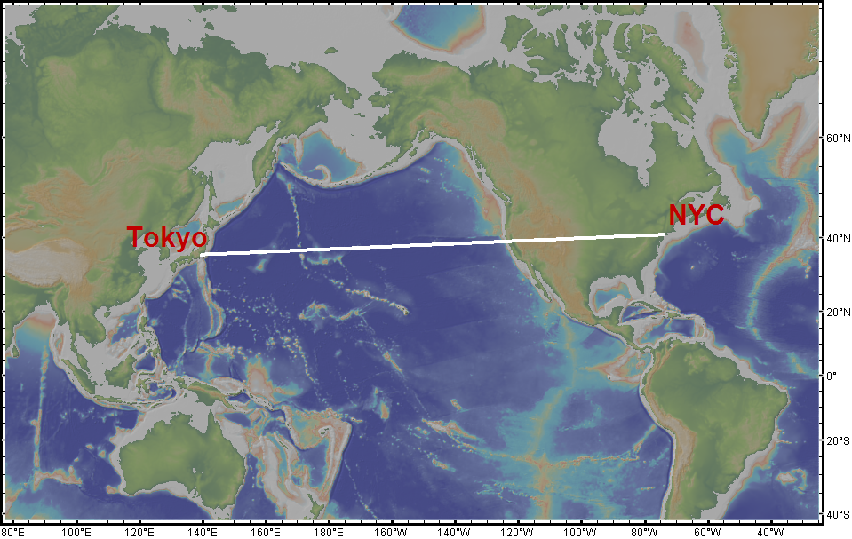
1. New York City (NYC) and Tokyo are at about the same latitude (NYC latitude is about 40 º 43’ N and Tokyo is about 35 º 41’ N). The map to the right shows a straight line connecting the two cities.

1a. ♦ At the latitude of those cities, the map above is about 21,300 km across. By estimating the length of the line compared to the width of the map, use the work space on your answer sheet to calculate the distance between NYC and Tokyo. Remember to show your work.

1b. ♦ Based upon the image shown in (1), explain whether or not you think that the distance calculated in (1a) is the shortest distance between the two cities.

2. The map below shows the path of an airline flight between NYC and Tokyo.
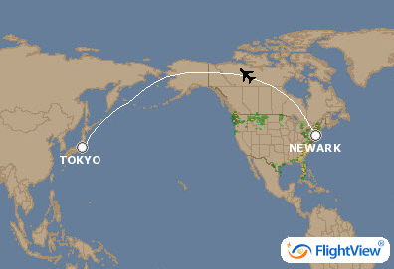

2a. ♦ Describe the shape of the flight path.
2b. ♦ Do you think that the flight path will be longer or shorter than the path shown on the map in question (1)? Explain your reasoning.
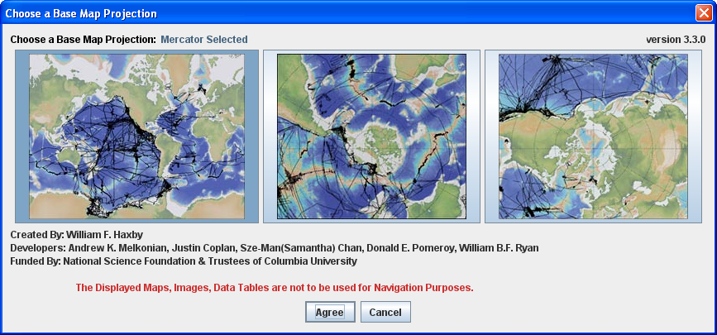
3. Start GeoMapApp. In the projections window, shown here, make sure that the left map is selected and click the Agree button.

When the map window opens, click on the zoom button button to activate the zoom-in tool and click once on the map on Alaska. That will zoom in on the map so that it looks similar to the image below:
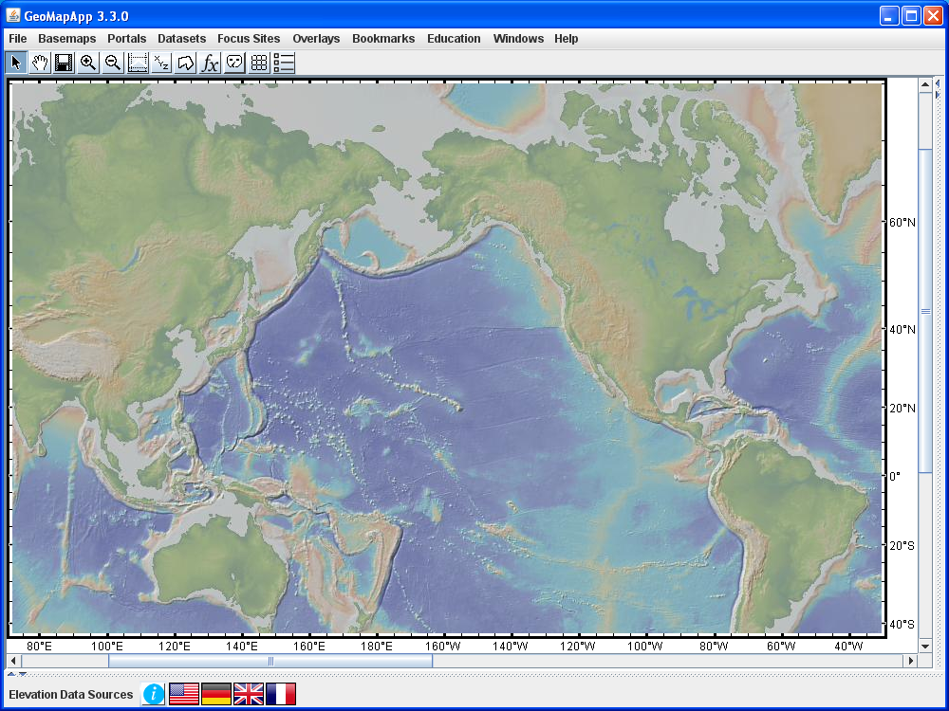

4. Activate the Profiling tool by clicking once in the tool bar on the button. Wait a few moments for the Processing window to disappear. Then, click on the map in the US northeast and drag the cursor over to Japan. When the cursor is released, a profile window comes up. It may look like the one shown below.

For the purpose of this activity, you will not need to study the profile graph. Instead, focus upon the distance given along the X-axis on the profile graph.
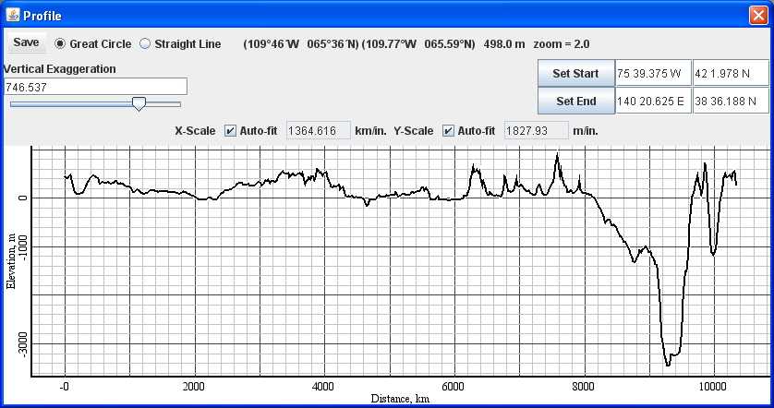

Find the portion of the Profile window with the Set Start and Set End controls. Change Set Start location to be 74 0 W (74 degrees and 0 minutes West) and 40 43 N (40 degrees and 43 minutes north) and click . Change Set End location to be 139 46 E (139 degrees and 46 minutes East) and 35 41 N (35 degrees and 41 minutes north) and click . The values are shown in the screen capture, below.

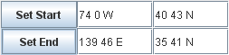

Find the portion of the Profile window that allows us to switch from a Great Circle to a Straight Line. Select Straight Line:

The Straight Line option shows a path on Earth’s surface that crosses meridians (lines of longitude) at a constant angle. On the Mercator map, it plots as a straight line, hence its name.

Look at the profile line on your map. Confirm that it looks like the one shown in question (1).

5a. ♦ In the Profile window, the distance along the straight line path is given as the length of the profile. Inspect the X-axis values on the graph to determine the length of the profile. Write the value on your answer sheet, and remember to give the units.

5b. ♦ Find the portion of the Profile window that allows us to switch from a Straight Line to a Great Circle. Select the Great Circle option. . Describe the shape of the track on the map.

5c. ♦ In the Profile window, the distance along the path is given as the length of the profile. Read off the length of the profile and write that value, with units, on your answer sheet.

5d. ♦ Calculate the difference in kilometers between the distance along the Straight Line and the Great Circle routes.

5e. ♦ Calculate the difference in distance as a percentage of the Straight Line distance, and show your work.

5f. ♦ The standard formula for speed is given by speed = distance/time. Assuming a typical airliner cruising speed of about 800 km/h, calculate the difference in flight time along the Straight Line and the Great Circle routes.

5g. ♦ A typical aircraft flying the New York to Tokyo route uses roughly 53,000 gallons of aviation fuel. There are 65 gallons per barrel of jet fuel. Calculate the number of barrels of jet fuel used for a typical New York to Tokyo flight.

5h. ♦ If the cost of one barrel of jet fuel is about $130, what is the total approximate cost of fuel for the flight?

5i. ♦ What would be the cost of fuel if the flight flew on a straight line route?

5j. ♦ What is the cost saving between the two routes? And, explain how, if you ran an airline, the cost difference and flight time difference might affect your decisions about choosing flight paths.

6a. ♦ We’ve looked at a flight in the northern hemisphere. The map on the next page shows two locations which have the same longitude values as NYC and Tokyo and the same latitude values except this time the latitudes are in the southern hemisphere. On the map on your answer sheet, use the marker pen to sketch the flight path that an airliner would most likely take between those two southern hemisphere locations.

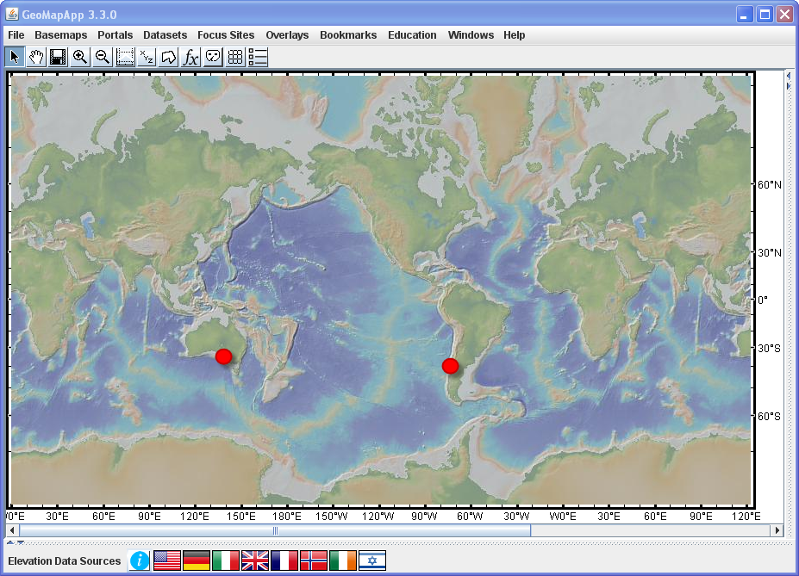

Now test your prediction: Use the GeoMapApp profiling tool to draw a profile on your computer between the approximate positions shown by the two red dots in the map above. When the profile window appears, move it out of the way so that you can see the white line on the map. That white line is the great circle route and is the one that would most likely be flown by an airliner.

6b. ♦ On your answer sheet, write down how your hand-drawn flight path compares to the great circle route between those southern hemisphere locations. Is it a close match? Does your hand-drawn line arc the same way?

7. Let’s now look at the difference between the great circle and straight line distances for points on Earth’s equator. In the profile window, change the start and end latitudes to be “0 0 S” as shown below and click and .
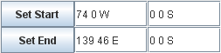

7a. ♦ Toggle backwards and forwards between the great circle and straight line paths. Look at the X-axis in the profile window and, on your answer sheet, write down the length of the track (the distance) along the great circle and along the straight line.
7b. ♦ You've probably noticed that, at the equator, the great circle and straight line paths over Earth’s surface are exactly the same. Explain why this is the case.

7c. ♦ For any other pair of points that lie on the same line of latitude, the great circle and straight line distances are different. Explain.

7d. ♦ Consider any two points that lie on the same line of latitude that is not the equator. Explain why a great circle path that connects the two points is arched towards the pole.

8. In the profile window, use the Set Start and Set End boxes, as shown below, to draw a north-south profile along the 74º W meridian from the equator to a location at 60 º N:
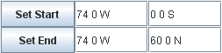

8a. ♦ Toggle backwards and forwards between the great circle and straight line paths. Look at the X-axis in the profile window and, on your answer sheet, write down the length of the track (the distance) along the great circle and along the straight line.

8b. ♦ You've probably noticed that, along a meridian, the great circle and straight line paths over Earth’s surface are exactly the same. Explain why this is the case.

8c. ♦ For any other pair of points that lie on the same line of longitude, the great circle and straight line distances are identical. Explain.

8d. ♦ In (8a) we considered two points that lay on the 74º W meridian – one point was on the equator and the second was at 60 º N. If we look at two new points having the same latitudes but that lie on any other meridian, would you predict the distance between them to be the same or different? Explain.

9. ♦ How has your thinking about distances on maps and over Earth’s surface changed since looking at that first map in question (1)?

