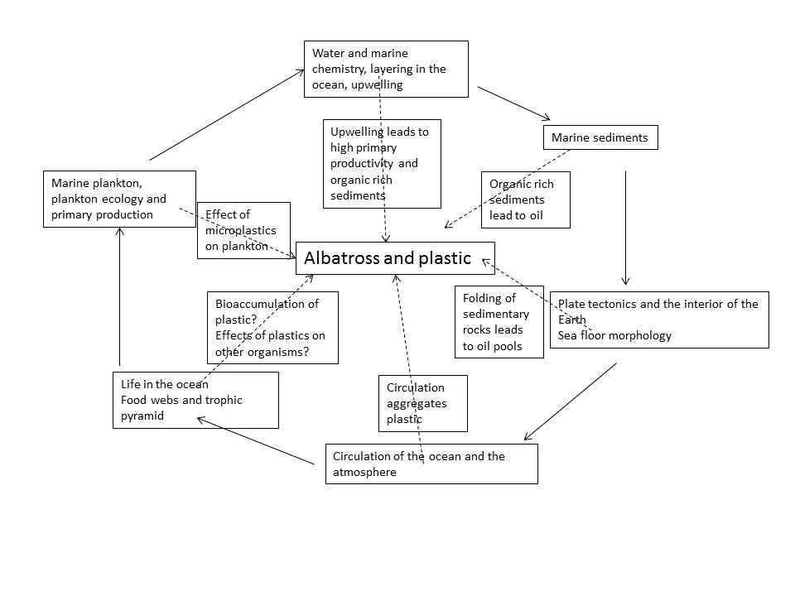

Outer textboxes are major content areas in course related to plastics and oil in the ocean. Solid arrows show progression through content, starting and ending with marine plankton. Dotted arrows go from major content through textboxes linking that content back to plastic in the ocean.

Consider adding to the mind map the ways in which students interact with the ocean system.

