Lodegepole Forest
Carbon Cycle Posters.

- Fasten each poster to the front of a box or sturdy bag.

- Place randomly around the room.

- Cut tickets out and place in appropriate boxes. The letters in the bottom right-hand side of the ticket tells you which box the tickets go in at the beginning of the game.

Example: LP = Living Plants, D = decomposers etc.

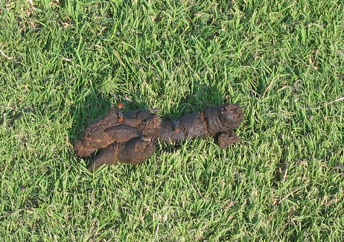
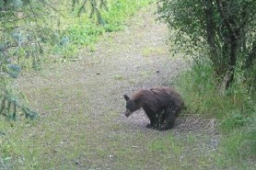
ANIMAL WASTE




ATMOSPHERE
SURFACE WATER

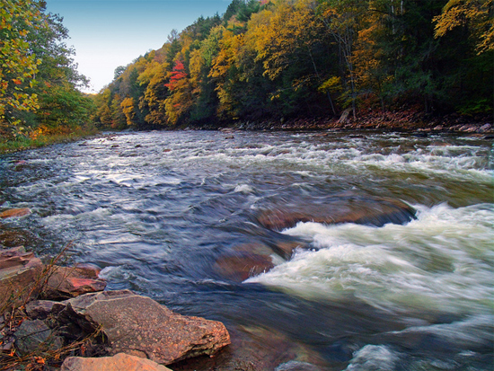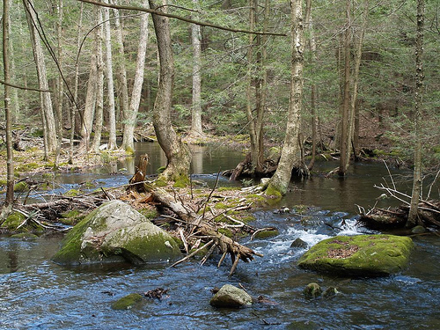

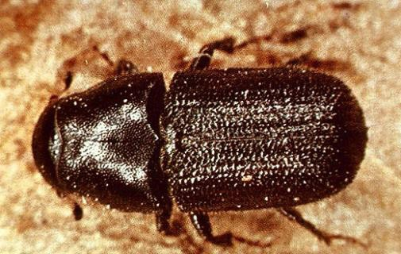LIVE ANIMAL CONSUMERS
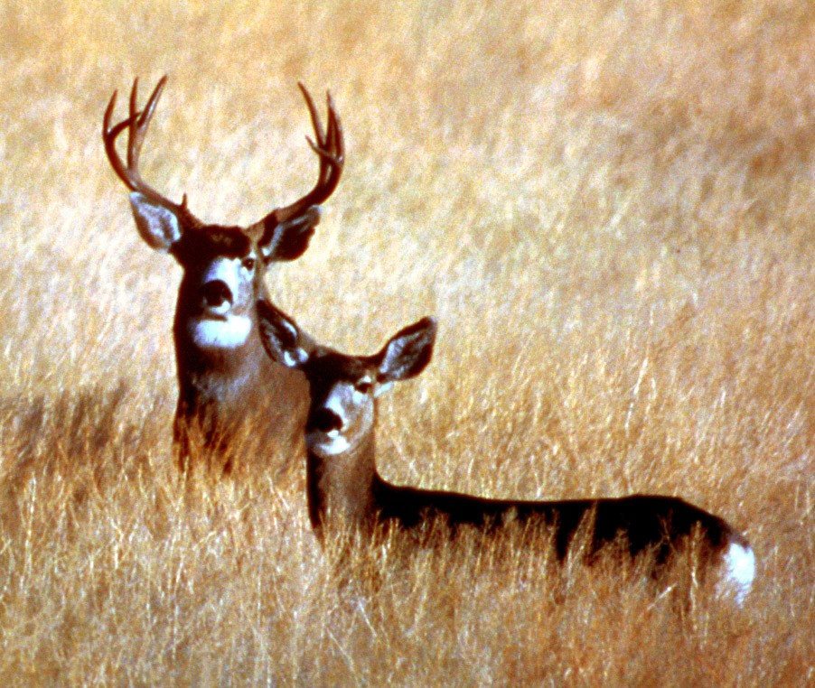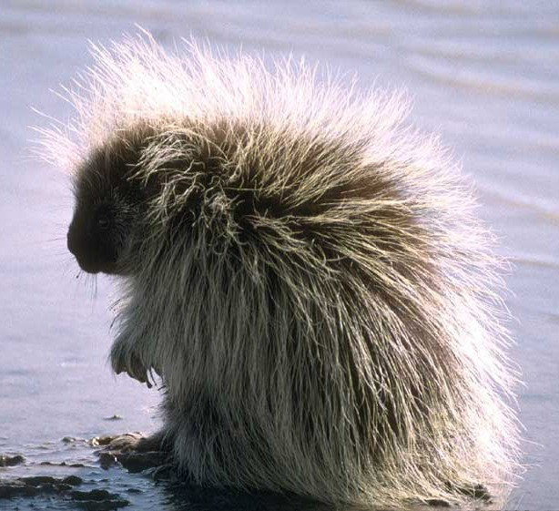
mountain pine beetle,
porcupine, mule deer
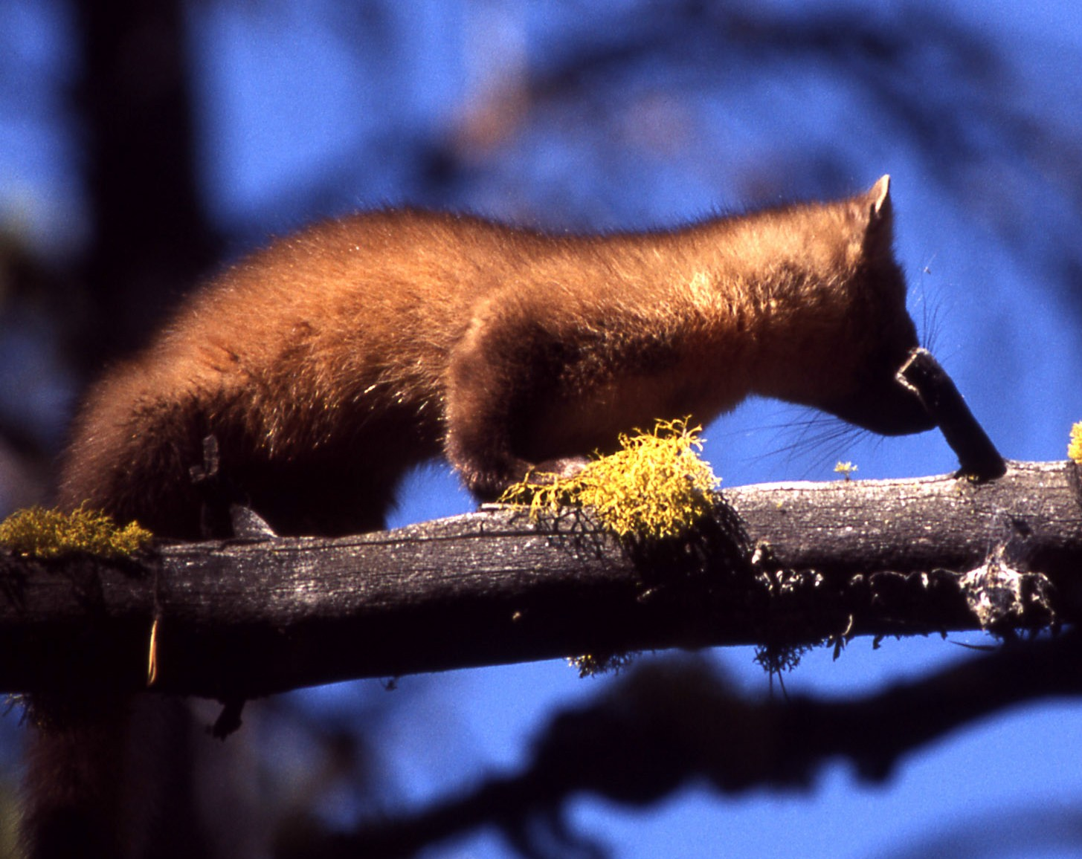
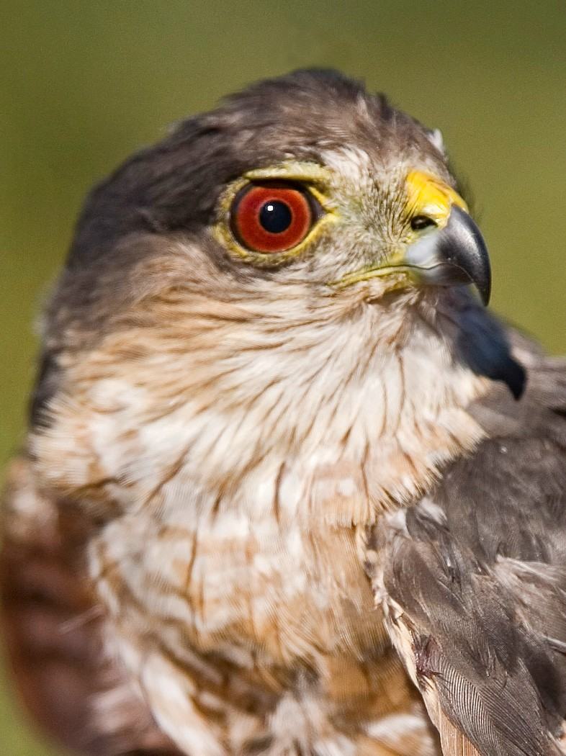
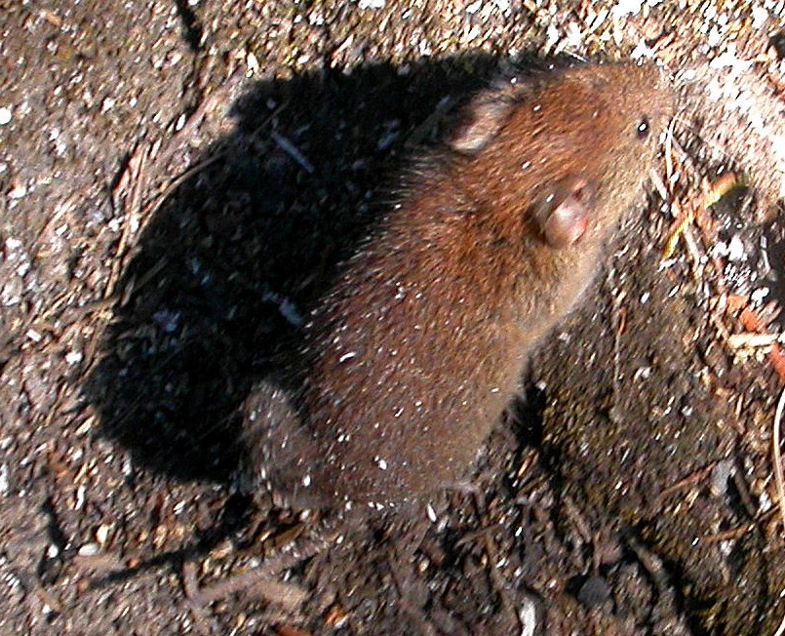
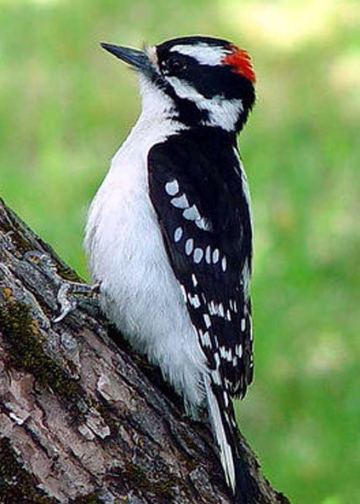

LIVE ANIMAL PREDATORS
Downey woodpecker
Pine martin
Sharp—shinned hawk
Southern red-backed vole

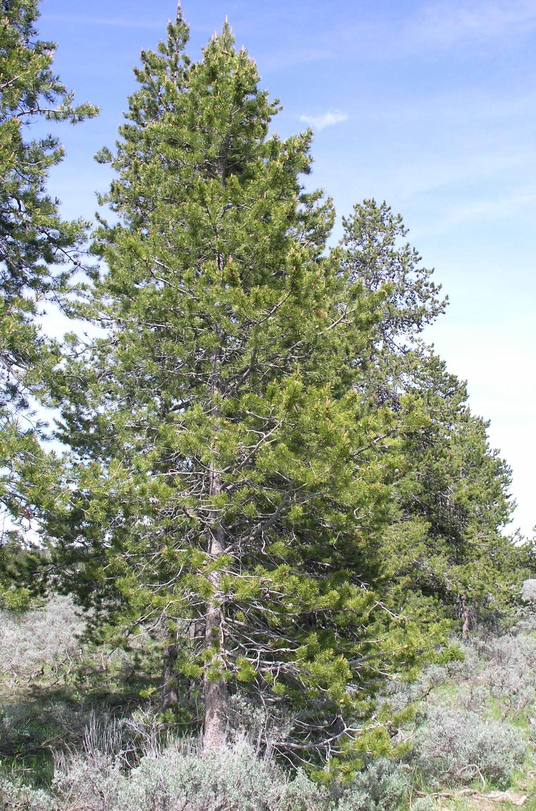
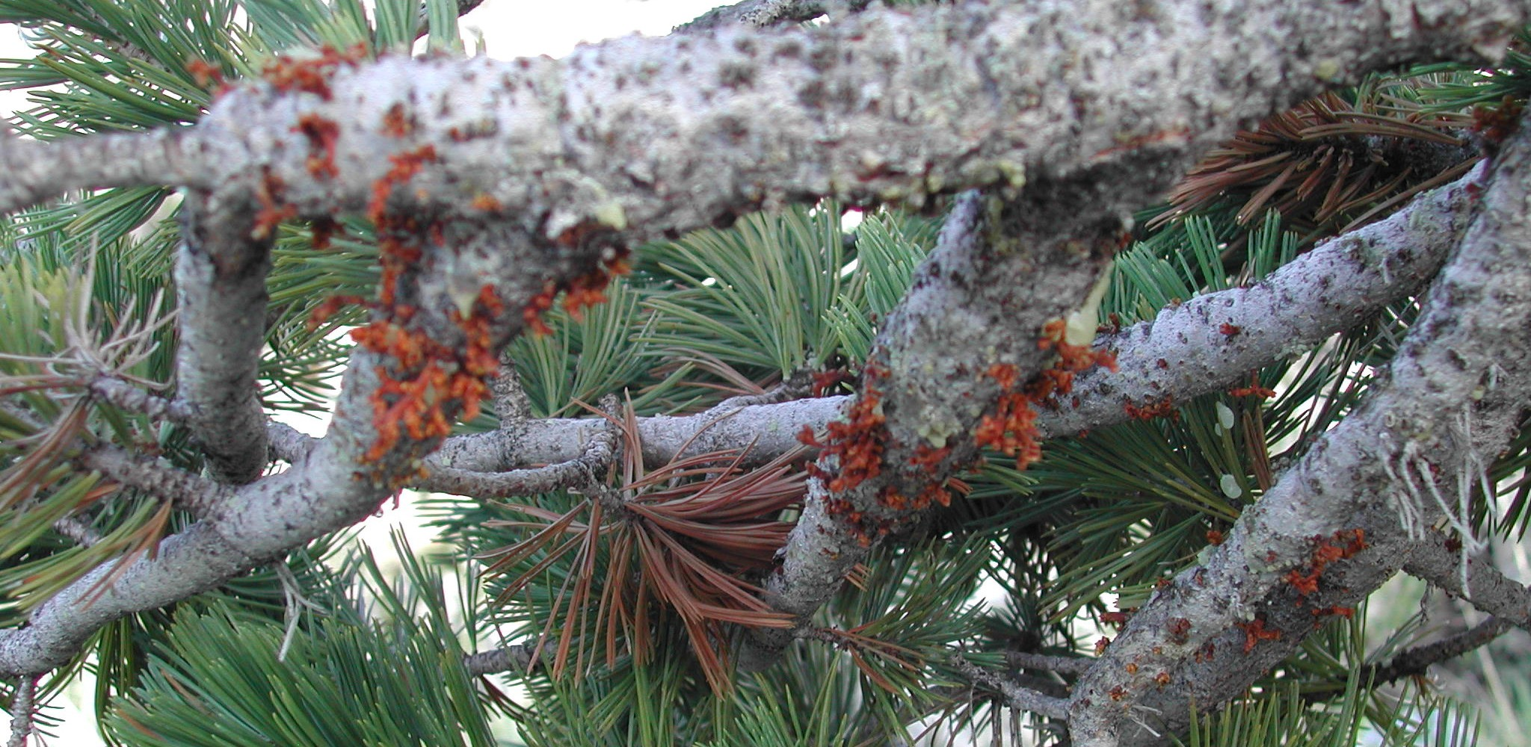
Live Plants

Lodgepole pine

Dwarf Mistletoe

DEAD PLANTS AND ANIMALS

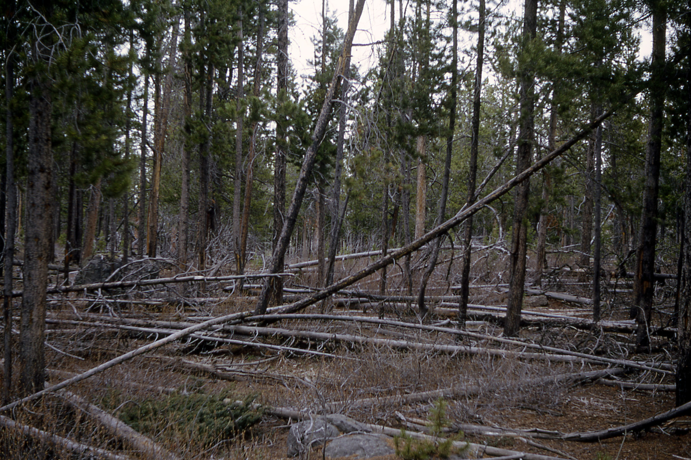

DECOMPSERS AND PARASITES

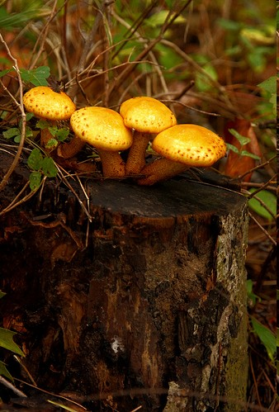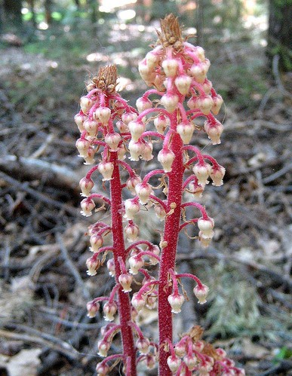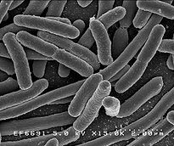
Honey Mushroom (right)
Pine Drops (left)
Soil Microbes (middle)

SOIL AND SOIL MICROORGANISMS

