Experimental Protocol: What is the Effect of Nutrients on Carbon Dioxide Uptake and Carbon Sequestration in Corn Plants Grown in Hydroponic Conditions: A Systems Thinking Approach (Student Instructions)

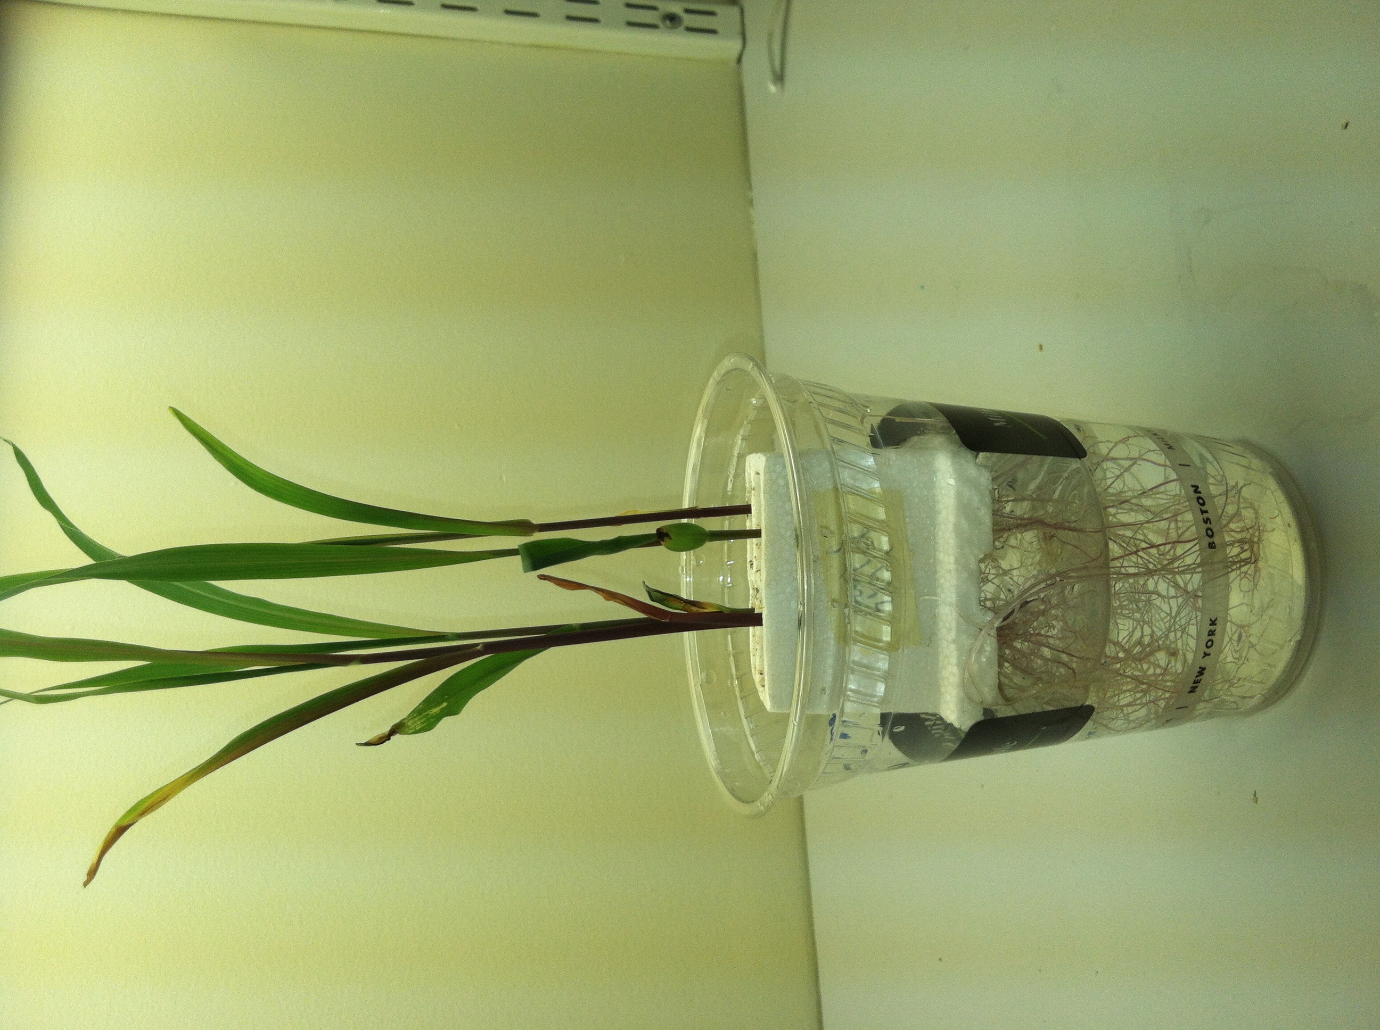
Research Question:
How does the availability of important nutrients such as nitrogen, phosphorus, and magnesium affect carbon uptake and storage in hydroponically grown corn plants?

Experimental Design and Systems Thinking:
In this experimental design, you will be using hydroponics – a soil-less method for growing plants. You will also be using “systems thinking” strategies and language to think about your experiment.

What are systems? “Systems” can be defined as having interacting, interrelated, and/or interdependent parts that form a complex whole. In this experiment, your “Corn Plant Growth System” consists of the corn seedling in its growth chamber (Styrofoam quad and the dry cup). As the corn seedling grows, you will be measuring changes to the system. Specifically, you will be measuring how much carbon the corn plant growth system gains from the air as it grows.

All systems have inputs and outputs:
- Inputs are added to the system.
- Outputs are produced by the system and leave the system.

You will think about your corn growth system in terms of inputs into the corn plant growth system and resulting outputs. In other words, what is added to the corn plant growth system from the outside(inputs), and what leaves as the corn plant is growing(outputs).

Pre-Lab Discussion Questions:
1. Why is it good experimental design to grow your plants hydroponically? What advantage will this have when you interpret the results of your experiment?

2. How can we think of the corn plant as a system? What are the inputs to the corn plant system and what are the outputs? With your group and/or class, draw a model of your corn plant growth system. Identify any inputs and outputs and put these on arrows going into and out of the system. For example, think about photosynthesis and respiration. What inputs to the system would photosynthesis create? What outputs would respiration create? Why? Share your diagrams and ideas with the class to make a corn growth system diagram with inputs and outputs that everybody can work with.

Pre-Lab Decisions:

You have three decisions to make before you begin the experiment.

Decision 1. Decide whether you will include the optional LOW and/or HIGH concentrations as part of your experimental design. How might the additional data help you in answering the research question?

Decision 2. Which of the experimental set-ups will serve as your control? Why?

Decision 3. In corn plants, full photosynthesis does not start until the third leaf appears. You have the option of massing out the corn growth system when the third leaf appears and using this as your initial mass. Discuss whether or not you want to use this option and why. How might using the data from this option help you in answering your research question?

Experimental Protocol:
Corn seedlings will be hydroponically grown under different concentrations of nutrients.

Hydroponic Corn Plant Growth System # 1. Corn plants grown with NORMAL concentrations of nutrients.
Hydroponic Corn Plant Growth System # 2. Corn plants grown with NO nutrients.
Hydroponic Corn Plant Growth System # 3. (optional) Corn plants grown with LOW concentration of nutrients.
Hydroponic Corn Plant Growth System # 4. (optional) Corn plants grown with HIGH concentrations of nutrients.

After approximately 10-24+ days of growth, the corn plant growth system will be massed to determine % change in biomass (g) of the plants. % change in biomass and an estimated gain of carbon that corn plants store as they grow will be calculated and graphed.

Materials:
Each class lab team should gather the following materials:

- Two – 4 hydroponic plant set-ups –
  - 2-4 c lear plastic cup 16/18 oz drinking cups
  - 2-4 Styrofoam planting quads
- 8 -16 healthy-looking corn seedlings - 4 per set-up.
- Small amount of perlite/vermiculite to cover seedlings in the planting quad.
- Distilled or filtered water. You will have less problems with mold if you use distilled water but filtered water works fine.
- Fertilizer nutrient solutions (normal, low, high) made with distilled or filtered water. Make a list of the nutrients in the fertilizer you are using. You can find this information on the fertilizer box. Keep in your lab notes because they may be important when you analyze your data and generate a conclusion.
- Graduated cylinder – 250 ml

Access to the following:
- Laboratory mass balance – to decigrams or milligrams
- Plant light source – Plant GRO Lights, 100 Watt bulbs or a sunny part of the room.
- Access to a spray mister filled with water and 1-2 drops of dishwashing liquid (for mold and mildew control.)

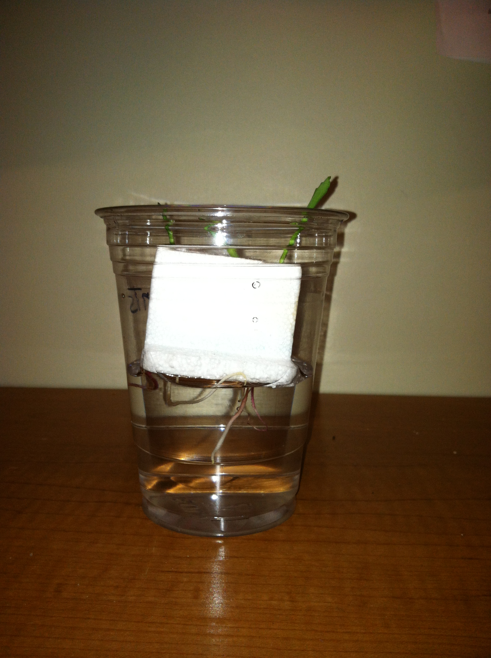

Planting
1. Construct 2-4 hydroponic plant growth systems. Place a Styrofoam planting quad into each plastic cup as indicated by picture above left.

2. Label your corn plant growth systems with nutrient concentrations (No Nutrients, Normal, Low, High”
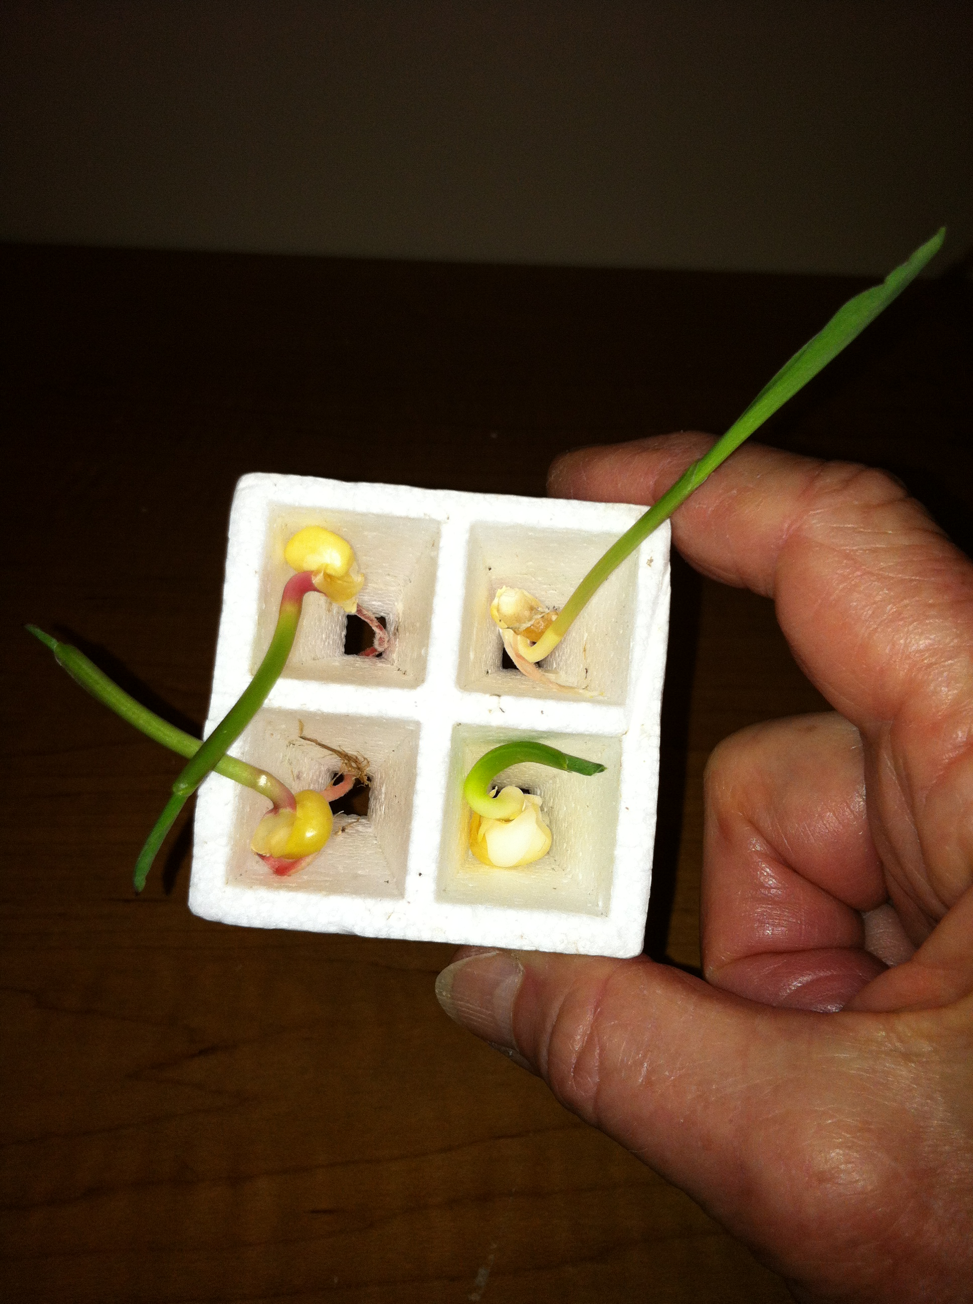.
3. Gently place one corn seedling into each space in the planting quads. Make sure that the roots are hanging down below the Styrofoam and that the main root is not broken.
4.Use some clean perlite/vermiculite mix to cover the corn seed as best you can. You only need a little. Use the spray mister to lightly spray the perlite/vermiculite.

5. Use a mass balance to determine the initial mass(g) of each “corn plant growth system.” Record this data in your data table.

6. Pour 240 ml of the correct nutrient concentration solution into the matching cup. MAKE SURE the solution concentration matches the label. Place the quad back into the cup. All of the roots need to be in the water so make sure the Styrofoam quad sits on top of the water. REPEAT for each experimental set up.

7. Place set-ups near a light source. Make sure plants are equidistant from the light source.

Discussion:
Why is it important to make sure the plants are equidistant from the light source?

Step 2: Observations and data
1. Observe your corn plant growth system every 2-4 days. Make note of any changes by writing, drawing and/or taking photographs. Pay careful attention to how each plant growth system is responding to the experimental variable (nutrient concentration.)

2. (optional) Look carefully for when the third leaf appears. When the third leaf begins to appear, pour the water out and dry the cup. Carefully and gently blot or shake excess water from roots. Mass out the dry cup and planting quad with four seedlings. Record data. Refill the reservoir with the appropriate nutrient concentration solution.

3. Always make sure there is ample water in the reservoirs. If the water reservoir gets low, add more water, making sure you bring the level of the water up to the bottom of the Styrofoam quad. Make sure you use the correct nutrient solution concentration in each cup.

Step 3: Final observations and data collection.

1. Let plants grow for several days after the third leaf appears. Make final observations of any changes you see in the growth system – including the leaves, roots and stems.

2. Measure the final mass of each experimental corn growth system and record. Pour out the water out and dry the cup. Carefully and gently blot or shake excess water from roots. Mass out each dry cup and planting quad with the four corn plants. These will be your final mass measurements for your corn growth systems.

3. Before you make the calculations in your data table below, have the following discussion with your lab group and/or your class.
Discussion:
Think about the change in mass(g) you have observed between the dry initial mass and the final mass of the plant growth system. Where do you think most of the mass of the grown plants has come from? Why?

5. Calculate the change in mass of the plants and the % change in mass. Record.

6. Calculate the approximate % of carbon stored in the dry corn plants. Note: Agricultural scientists have determined that carbon makes up approximately 44% of dry corn plants. You can use this data to calculate how much carbon was taken in by the plants and stored as the plants grew.

Data Table: % Change in BioMass in Corn Plants Under Different Nutrient Conditions.

Corn plant growth system  (corn, Styrofoam, cup) | Initial Mass of Corn Growth System (g) (seedlings, Styrofoam, cup) | Mass of corn plant system when third leaf has appeared. (plants, Styrofoam, cup)  (optional) | Final Mass of Corn Growth System (g) (plants, Styrofoam, cup) | Change in Mass of plants(g) | % Change in mass of plants  (*see formula below*) | BIOMass of Carbon stored in dry corn plants (**see formula below)
Variables | Measure | Measure (optional) | Measure | Calculate | Calculate | Calculate
With normal nutrient concentration
With no nutrients

With low nutrient concentration

(optional)

With high nutrient concentration
(optional)

Note: Your teacher may want you to put this data on a class data table and then determine the % change in mass from the class aggregate data.

If you have decided to measure the amount of carbon gained when the third leaf first appears, use this formula.

* % Change in mass formula: (If using this option)
The final mass(g) - mass when third leaf appears(g) X 100
initial mass (g)

If not, use this formula.

* % Change in mass formula:
The final mass(g) - initial mass(g) X 100
initial mass (g)

**Formula for determining the approximate mass of carbon stored in the corn plants:

- Multiply the Change In Mass of plants (g) by .44 to obtain the mass of carbon stored in the grown plants.

Part 4: Graphing the Data
Graph the % change in mass (g) of both experimental groups on a bar graph.
Graph the amount of carbon stored in the grown plant on a separate graph or on a double Y graph (Y¹, Y²) with the % change in mass. Note: Your teacher may want you to graph the aggregate data from the class.

Part 5: Analysis and Conclusion.

1. Review your “Research Question below.” Answer the research question in a conclusion using specific evidence from your graph.
How does the availability of important nutrients such as nitrogen, phosphorus, and magnesium affect carbon uptake and storage in hydroponically grown corn plants?
2. Which experimental growth plant system gained the most carbon and which gained the least? Why do you think that is?

3. Explain why plant nutrients – Nitrogen, Phosphorus, Magnesium are called “limiting factors.” What exactly are they limiting? Hint: You may need to review Lab 1B to answer this question.

Part 6: Taking your research further: Using your plant experiment to extrapolate to larger-scale forests.
Rising CO₂, Growing Forests?

Rising CO₂ concentrations in the atmosphere could alter Earth’s climate system, but it is thought that higher concentrations may improve plant growth through a process known as the “fertilization effect”. Forests are an important part of the planet’s carbon cycle, and sequester a substantial amount of the CO₂ released into the atmosphere by human activities. Many people believe that the amount of carbon sequestered by forests will increase as CO₂ concentrations rise. However, an increasing body of research suggests that the fertilization effect is limited by nutrients and air pollution, in addition to the well documented limitations posed by temperature and precipitation.

1. Could your plant experiment serve as a model for understanding how nutrients limit carbon uptake and storage operate on a much larger scale – that of a forest? Why or why not?

2. For homework, research the effects of soil nutrients (N, P, Mg, S, Fe ) and other limiting factors on forest growth and carbon uptake and storage.
- Using ScienceDaily http://www.sciencedaily.com as a research tool, find at least one report of an experiment that helps you answer this question - “Can we depend on forests to solve the problem of increased atmospheric CO₂ leading to climate change?” Hint: good tags to use are soil nutrients and carbon uptake (sequestration), nitrogen and carbon uptake in forests

- Here is an example to get you started: Soil Nutrition Affects Carbon Sequestration In Forests http://www.sciencedaily.com/releases/2006/12/061213174613.htm

- Bring in your ScienceDaily report in and share with your group or class in the following discussion:

Discussion:
- Briefly describe the experiment.
- What does the experiment tell you about the ability of forests to store increasing amounts of CO2 from the air?
- Do these experiments conflict with the results that you saw in your plant growth experiment? If so, how?
- What advice would you give a reforestation project in your community if one of the goals of the project is to reduce CO2 in the air?

