FREE WORKSHOP
On Combating Student Misconceptions in Economics
For Economics Faculty at Community Colleges
Why attend?
- Bringing community college economists together to share teaching techniques and to learn from others
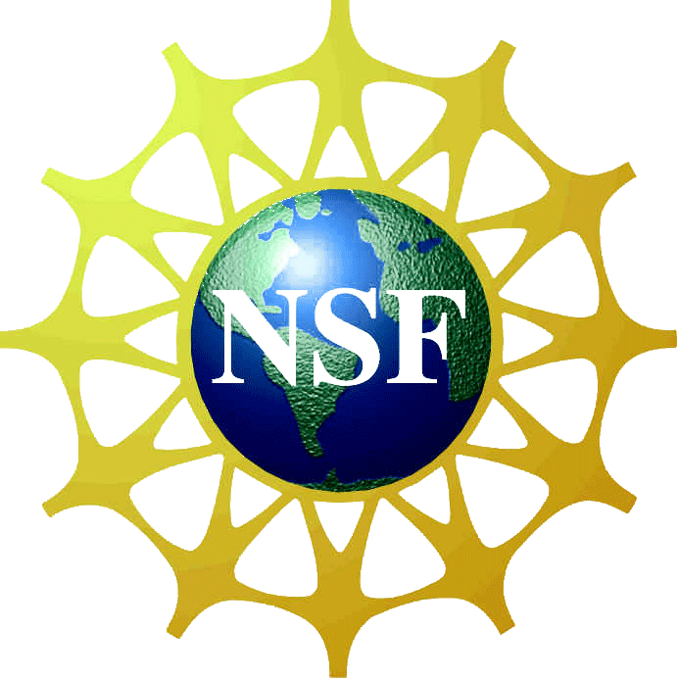
- List of shared best practices will be collected and distributed to all participants
- Supported by NSF Project Economics at Community Colleges: http://serc.carleton.edu/econ/2yc/index.html
- Submit follow-up teaching activity to the NSF Project web site and receive $100 stipend

When: Friday, October 25th 2013
Schedule: 9:30 – 10:00 a.m. Registration/Coffee and refreshments
10:00 – 10:30 a.m. Welcome & Introduction to Workshop
10:30 – 11:00 a.m. Presentation on Student Misconceptions by Workshop Organizers
11:00 – 12:00 p.m. Break-Out Sessions
12:00 – 12:30 p.m. Lunch (provided by host)
12:30 – 1:00 p.m. Information about Follow–up Activity
1:00 – 2:00 p.m. Break-Out Sessions to Develop Follow-up Teaching Activity
2:00 – 2:15 p.m. Coffee and Refreshments
2:15 – 3:00 p.m. Discussion/ Sharing Best Practices
Location: Tim & Jeanne’s Dinning Commons/Tekoa Room
Westfield State University
577 Western Ave
Westfield, MA 01086
For further information and to register please contact Susanne Chuku at
413-577-8041 or schuku@westfield.ma.edu.

