Keep in time!
By Matt Vonk
University of Wisconsin River Falls
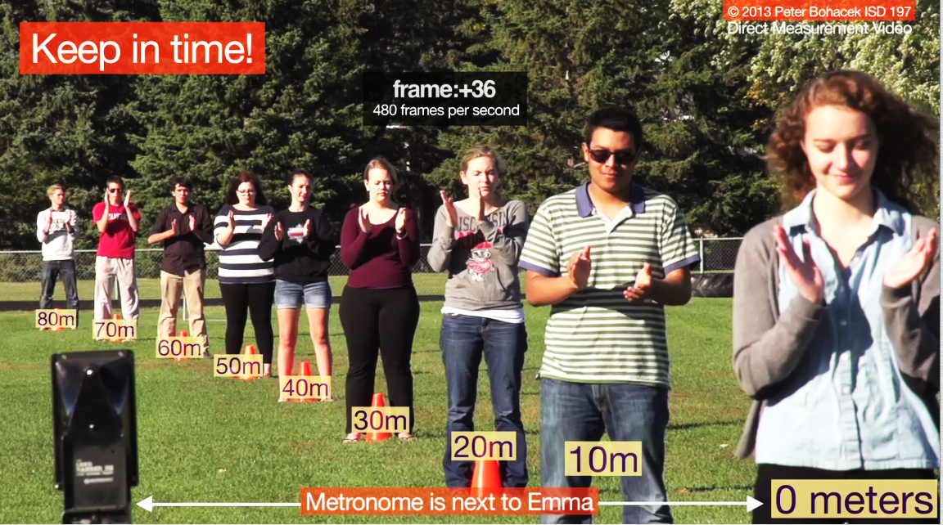
- Watch the video “Keep in time” video.

In this video students have their eyes shut and try their best to clap at the same time that they hear each pulse from the metronome. Students who watch this video sometimes think that the students in the video were waiting until they heard the metronome beat to react, but they weren’t, they were clapping together with the periodic beats they heard.

The video shows a group of students lined up on a football field clapping in time with a metronome.

- Why don’t the students clap at the same time?

Because the sound from the metronome takes a while to get to them. The farther away they are from the metronome, the longer it takes the sound to reach them.

- When you use the video to measure the speed of sound in air, what value do you get?

You could measure the velocity using adjacent students but in order to average over individual discrepancies it is better to compare the claps of the first and last student. We are able to see two complete cycles in the video.

In the first cycle Emma (the first student) claps at frame 72, and Max (the last student) claps at frame 174. That means it took the sound pulse 102 frames to travel 80 m. The velocity is 80 m/102 frames x (480 frames/1 sec) = 376 m/s.

In the second cycle Emma claps at frame 300 and Max at 408. That yields a slightly lower velocity of 80 m/108 frames x (480 frames/1 sec) = 359 m/s.

That’s in good agreement of the expected value of around 345 m/s.

For even greater accuracy I measured the clap time for every student for both metronome pulses and then made a graph of distance vs. time, so that the slope was the speed of sound. (see spreadsheet and graphs below)

Notice that the results from these graphs, which take into account all of the students and not just the first and last student, are 338 m/s (slope of left graph) and 347 m/s (slope of right graph) which are much closer to the expected value of 345 m/s than the quick and dirty method I used above. It may be useful to have your students go through the process of solving it graphically or you may prefer to use the more intuitive and quicker approach of using just the values from just the first and last student.

A linear fit uses two fit parameters the slope and the Y-intercept. Usually when I fit something to a straight line it’s the slope that interests me, but it can be fun to think about what the Y-intercept represents in this case. Looking at the graphs above, the dotted fit-line represents the consensus among the nine clappers about when the sound pulse from the metronome passed each point.

That means that points that lie above the line represent claps that occurred before the sound pulse from the metronome actually got to them (they anticipated the pulse a little too much), and claps that occur below the line represent claps that happened after the pulse got to the student.

The 3.9 m Y-intercept in the first graph means that Emma (the first clapper) clapped when the wave pulse was already 3.9 m past her. Since sound travels so quickly the actual delay was still only a tiny fraction of a second, but in some sense the Y-intercept represents the group consensus of the performance of the first clapper. You’ll notice she only missed the wave pulse by 2.1 m on the next clap (see graph above right).

You may notice that when I re-measured my values for the graph I got slightly different values for Emma and Max’s claps. (Previously I got 72 and 300 for Emma’s claps and this time I got 70 and 298). So don’t be surprised if your students have slightly different values than the ones that I got.

- What do you think the farthest student hears?

Although we didn’t expect it, Max (the last student) ran up afterwards and said, “Guess what I heard?”

Since each of the students in front of him clapped when the sound wave from the metronome went by them, and since the sound of the claps traveled at the same speed as the sound from the metronome, all of the sound (metronome and all of the claps) reached Max at the same time.

- What do you think the closest student (Emma) hears?

On the other hand, for Emma the sound of the metronome was heard first (along with her own clap), but later she could hear the delayed sound of the claps from the students behind her.

- How long after Emma claps will she hear the farthest student’s clap?

The sound of the metronome takes around 105 frames to travel from Emma to Max. (105 is the average of 102 and 108 that we measured above). So it will take an additional 105 frames for the sound to get back to Emma.

The total delay will be around 210 frames x (1 second / 480 frames) = 0.44 seconds!

