Keep in time!
By Matt Vonk
University of Wisconsin River Falls
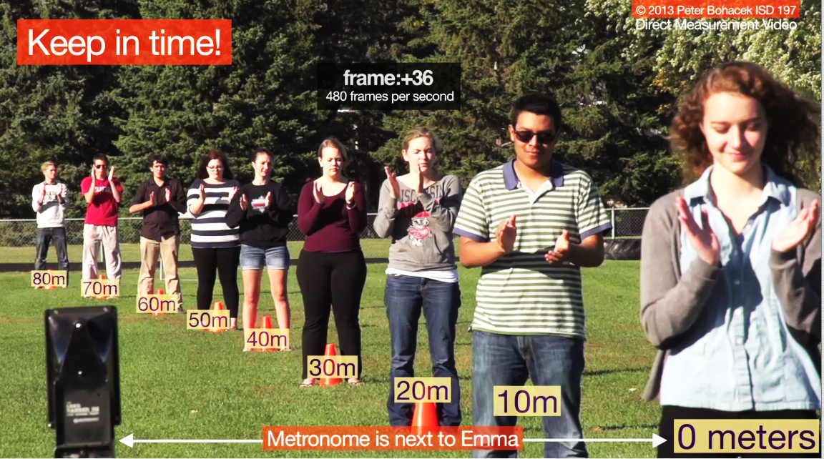
- Watch the video “Keep in time” video.

The video shows a group of students lined up on a football field clapping in time with a metronome.

- Why don’t the students clap at the same time?

- When you use the video to measure the speed of sound in air, what value do you get?

- What do you think the farthest student hears?

- What do you think the closest student (Emma) hears?

- How long after Emma claps will she hear the farthest student’s clap?

