California State University, Bakersfield
From the 2003 5-Year Program Review

Results of an assessment of the students’ accomplishment of program learning goals and objectives

There has never been a greater need for geosciences in our universities. Global population growth and the impact of growing technology throughout the world have greatly increased our need to understand the mutual interactions of Earth processes and society. Statistics from the US Departments of Labor and Education indicate a serious undersupply of Earth Scientists needed for the US workforce (Figure 2). As a result of this need, the State of California revised their K-12 science content standards to include Earth Sciences as one third of the required content.
California State University at Bakersfield is an institution especially in need of a strong geoscience program because of our service area’s above-average population growth, because our economy is based on exploitation of natural resources (especially water, soil, and fossil fuels), because our physical surroundings are conducive to geologic hazards such as earthquakes, landslides, flash floods, and because the newly enacted CA Science Standards require a dramatic increase in the Earth Science education of future teachers.
Only geoscientists have the diverse, yet substantive, training enabling us to easily comprehend the complexities of the interactions between the physical Earth and its inhabitants. Geoscience majors, armed with a unique technical expertise, unavailable to other disciplines, are best suited to address the problems related to resource utilization and development of our physical surroundings. They are particularly well prepared for jobs as environmental scientists, schoolteachers, exploration geologists, hydrologists, resource managers, urban planners, and technical consultants. The Geology program will provide majors and non-majors alike with an extraordinarily good background to prepare them to understand our increasingly complex technical world and to act as responsible citizens and voters with regard to critical environmental and resource management policy issues.

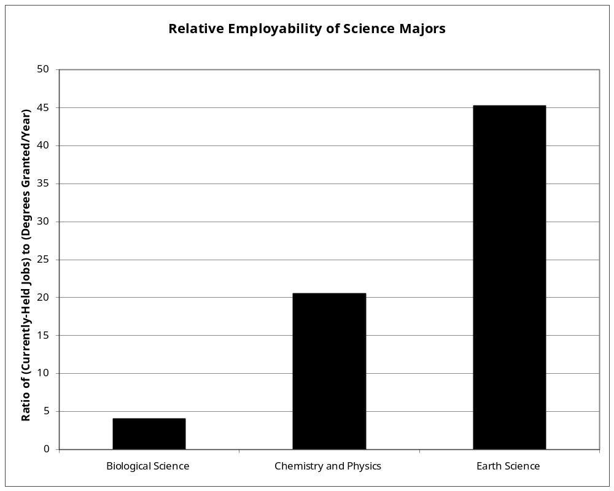
Figure 2. Relative employability of science majors expressed as a ratio of currently-held jobs to degrees granted per year. Statistics are from US Dept. of Labor and US Dept. of Education web pages gathered in July of 2003. Bioscience jobs include Biological Scientists and Technicians, Chemistry and Physics jobs include Astronomers, Physicists, Atmospheric and Space Scientists, Chemists and Chemical Technicians, Earth Science jobs included Geoscientists, Hydrologists, and Geological Technicians. Note: if medical-related jobs were included and given to Biological Sciences (none to Chemistry) and health degrees included with Bioscience degrees, then the Biological Science ratio would rise to ~6.5. Jobs which could be equally well filled by any of the majors (e.g., K-12 science teachers) were not included in this analysis.
These results are particularly impressive considering that degrees in the Biological and Physical Sciences offer much higher employability than most other majors at CSUB.

Outcomes Mission of the Geology Program
Our mission is to provide an academic resource for the education of our students in Geology, and to serve as a professional resource for the campus and service area community for dealing with critical resource and environmental issues. In fulfilling this mission, our specific aims are to provide an outstanding education for our majors in preparation for the diverse career opportunities available to them and to provide the local community with a substantive expertise to help solve problems critical to the future development of our service region. Critical to this mission are the following goals and objectives.

GOAL I. Students will have basic knowledge and understanding of the content of modern geology.

Objective 1, Students will be able to explain the nature of tectonic forces in the Earth’s crust and their effects on most geological processes.
Criteria: Students will be rated on a field mapping exercises and associated paper regarding their ability to recognize and interpret deformed rocks in the context of tectonic forces. Students will be graded on questions in exams from most geology classes concerning the role of the plate tectonic paradigm in each of the earth science subdisciplines.

Objective 2. Students will understand and be able to explain geologic time and fossil record.
Criteria: Students will be rated on associated laboratory exercises and required senior thesis projects.

Objective 3. Students will understand and be able to explain basic surficial processes and human interrelationships with Earth’s surface.
Criteria: Students will be rated on associated laboratory exercises and required senior thesis projects.

GOAL 2. Students will acquire knowledge and demonstrate skills to collect and analyze Earth’s minerals and rocks.

Objective 1. Students will demonstrate the skills necessary to gather and interpret field and other types of geologic data.
Criteria: Students will be rated on a field trip for sample collection and a paper on interpretation of data. Students will be rated on construction and interpretation of geologic maps.

Objective 2. Students will be able to identify samples of basic mineral and rock material found on Earth’s surface.
Criteria: Students will take a laboratory exam on the identification of
Unlabeled specimens.

Objective 3. Students will understand and be able to explain the basic physical and chemical attributes of Earth’s minerals and rocks.
Criteria: Students will take a laboratory exam on the identification of
Unlabeled specimens.

Objective 4. Students will be able to explain how Earth’s basic minerals and rocks form chemically and physically.
Criteria: Students will take a lecture exams and be required to write a review paper relevant to this objective.

GOAL 3. Students will understand the philosophical, mathematical and physical science foundations of geology.

Objective 1. Students will demonstrate the ability to test multiple working hypotheses in the application of the scientific method to the geosciences.
Criteria: Students will engage in this activity during field trips in most classes, during a required senior research project, and in the culminative field mapping course taken and assessed at other universities.

Objective 2. Students will demonstrate the mathematical and computer skills necessary to interpret geological data and to communicate scientifically.
Criteria: Students will be tested in laboratory activities relavent to this activity in the more quantitative classes (e.g., Structural Geology, Geochemistry, Geophysics) during a required senior research project, and in all courses using our GeoTechnology Training Center.

Objective 3. Students will demonstrate a basic understanding of the physical science foundations of geology. Criteria: Students will be tested in laboratory activities relavent to this activity in the more quantitative classes (e.g., Mineralogy, Structural Geology, Geochemistry, Geophysics

Assessment Strategy
1. The department adheres to the philosophy that a major part of our assessment of student outcomes takes place in the grading of exams, course exercises, oral presentations and research papers. As is the case for most science and mathematics programs, such assessment instruments are tied in a straightforward manner to clearly defined course goals and objectives outlined in the syllabi, in textbook chapter headings and subheadings, and in supplemental laboratory assignments.
2. A second, but no less important, assessment instrument is the student’s performance in the required senior field course that represents a culminative experience and, in the case of our B.S. students, is evaluated by professors from other universities. In this course, students use the skills and knowledge obtained throughout the rest of our required curriculum to formulate a field problem, acquire, interpret, and present data in map, note, and cross-section form. Furthermore, they synthesize all of the above in conjunction with conclusions, in a final report. Although the course content of the field camp varies from institution to institution, in general, the students' performance is assessed with regards to vast majority of the Goals and Objectives outlined in the previous section. The acquisition and interpretation parts of the field camp is an especially valuable part of this course in that it tests the students ability to follow the methodology of multiple working hypotheses in the pioneering format first formalized by Chamberlain. This methodology embodies the essence of scientific inquiry in all of the natural and social sciences. This field course is five-six weeks long and is taken at other institutions insuring that our students are assessed during this culminative experience by faculty from an independent institution.
The above assessment strategy was well received by both the WASC committee and by Dr. Everett Mann, an appointed CSUB faculty member in charge of the development of student outcomes assessment strategies across the campus. The following letter from Dr. Mann summarizes this positive feedback.

3. Our third principal assessment instrument applies to both B.S. and M.S. candidates. They are all required to complete a research project in the form of a senior or M.S. Thesis. All such students are required to complete and report on original research. Most such works are presented in reviewed venues including local, regional or national meetings of professional societies. Some have led to peer-reviewed publication in professional journals.

Assessment Results
As described in the previous section, one of the best features of our Summer Field Camp assessment instrument is the fact that our student outcomes are assessed by faculty from other institutions. Figure 4 contains the average grade received by our students in this course over the past several years. It is evident from this data that our students are well prepared for this culminative experience during their coursework and related instruction a CSUB Geology students.

Mean Grade | σ | N
3.68 | 0.60 | 29
Figure 4. Essential statistics of Geology majors' performance at field camp culminative experience taught by other universities during the past several years. These include Indiana U., Southern Utah U., Cal Tech, Portland State U., LeHigh U., Lousiana State U., Fresno State U., and Oregon State U. Note that the mean grade is underestimated due to inaccuracies associated with assumption of Gaussian distribution of a data set constrained by an upper limit (4.0) near the mean.

Other evidence supporting the quantitative data in Figure 4 consists of informal feedback from instructors of these field camps. For example, in a conversation with Dr. Gillespie of our department, Dr. F. Lohrengel of Southern Utah University (SUU) commented that our students typically come to field camp better prepared than most. The comparison population consists of students from several other universities including U. Tennessee, Louisiana State U., Stephen F. Wright U., and SUU.
Also, Rob Swartz, one of students who attended the prestigious field camp of the University of Indiana in the overthrust terrain of Wyoming, was asked to return the following year to be one of the TA's for the course. This is an honor rarely extended to students outside of UI.
Finally, Dr. R. Brady of CSU Fresno provided the following feedback regarding one of our students in an email correspondence with Dr. Negrini of our department.

"…. his theoretical and regional tectonics and general structure were fine--maybe his regional tectonics was better than that of our students. When we discussed mechanics of failure in Point Reyes, as I recall, he caught right on as to what was happening with the various stresses and fluid pressure ….. He had no problem (relative to the others) with map reading …… He precociously asked penetrating questions of me and other students, read all the materials he could get (we had a good portable library), and worked his butt off. He was a delight to have in the field and on the mobilizations, consistently ready to lend a hand. His interpretations were "geo-logically" solid, and his maps, complete (not leaving holes in the brushy areas". He learned quickly, improved consistently, and was regarded as a highly desirable field partner….. I do believe the course was demanding and that I am a rigorous grader. His course score of 92% is excellent. In the syllabus, I defined "A work"as: "completing all work assigned on time and at a standard that demonstrates professional standards of in product and technique" and "performance demonstrates sustained, sound logic and creative geologic interpretations throughout the 3 projects."

The above assessment from Dr. Brady is high praise considering that he is known for his notoriously hard grading and also was CSU Fresno's Outstanding Professor a few years ago. However, while Dr. Brady's assessment of this student was mostly positive, he did include the following constructive criticisms of this student.

"….. I remember that his hand specimen description and interpretation were not so good, nor were his overall field skills which tended to be a bit sloppy (incomplete and sloppy notes, imprecise and sloppy map). So, I suppose, I'd say he was plenty strong in everything except petrology and basic field mapping ….. Patrick's positive attitude and work ethic put him clearly in the "top performer's" category, but he had to make up for what I believe was a lack of prior field experience relative to the CSUF, CSUH, and CSUS students. But, that he did in spades ….. Critically, his field notes tended not to be systematic and were a bit sloppy (difficult for his partners to read which was the goal/criterium). This did improve through the projects, however."
All of the above points point towards a deficit of field experience in our program, a problem area of which we are familiar and will attempt to improve over the next few years.
In conclusion, our students perform very well in our culminative assessment instrument when compared by professors from other universities to students from other universities. This finding is consistent with the performance of our students in the required senior research course which often results in presentations at regional and national conferences of professional societies and, also, coauthorships in articles in our peer-reviewed journals (see Appendices 2-3). In fact one of these students, Michael Quilliam, won the Outstanding Student Presentation Award at the 2001 West Coast meeting of the American Association of Petroleum Geologists in Long Beach, CA. In winning this award, this student, a senior, outcompeted graduate students from major research institutions (e.g., USC and Stanford).

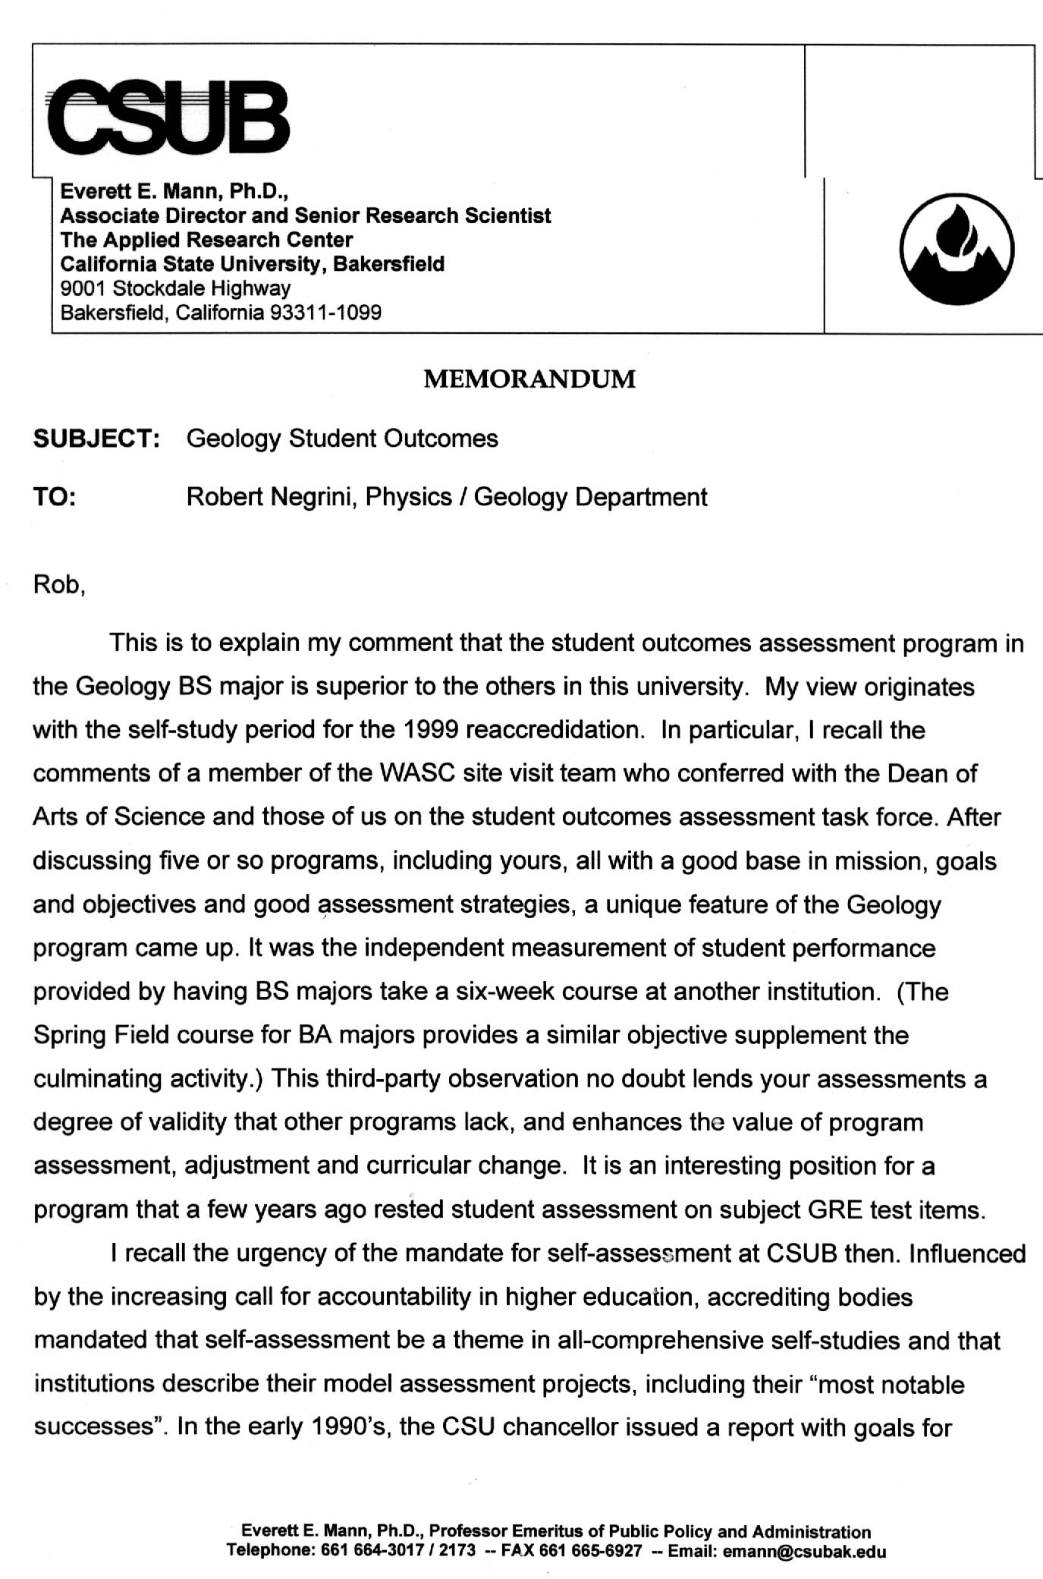
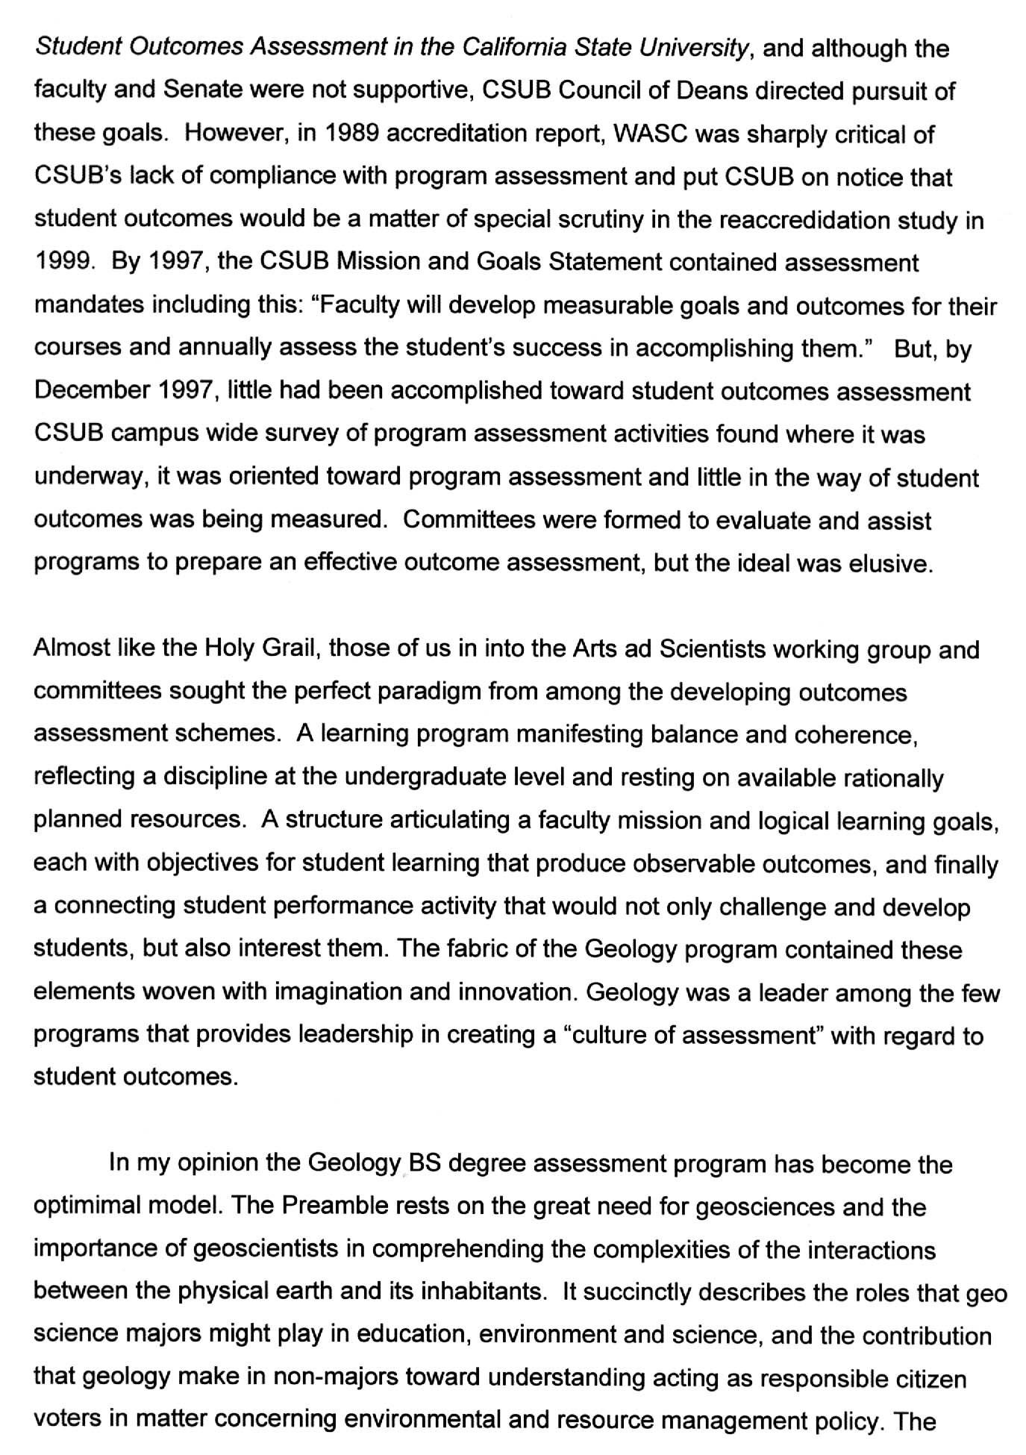
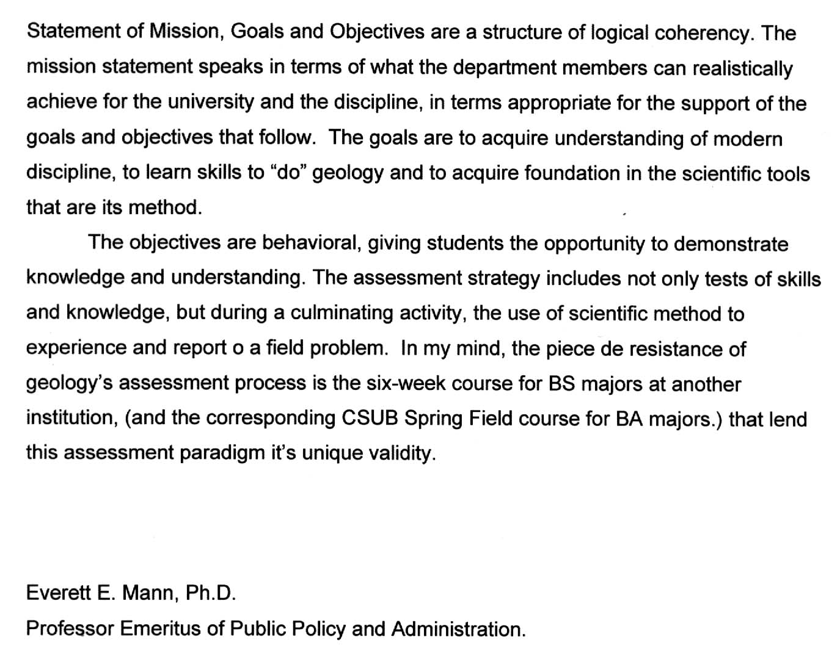
Assessment Results
Figure 3. Letter from Dr. Everett Mann assessing the Geology Program's outcomes assessment plan.
As described in the previous section, one of the best features of our Summer Field Camp assessment instrument is the fact that our student outcomes are assessed by faculty from other institutions. Figure 4 contains the average grade received by our students in this course over the past several years. It is evident from this data that our students are well prepared for this culminative experience during their coursework and related instruction a CSUB Geology students.

Mean Grade | σ | N
3.68 | 0.60 | 29

Figure 4. Essential statistics of Geology majors' performance at field camp culminative experience taught by other universities during the past several years. These include Indiana U., Southern Utah U., Cal Tech, Portland State U., LeHigh U., Lousiana State U., Fresno State U., and Oregon State U. Note that the mean grade is underestimated due to inaccuracies associated with assumption of Gaussian distribution of a data set constrained by an upper limit (4.0) near the mean.

Other evidence supporting the quantitative data in Figure 4 consists of informal feedback from instructors of these field camps. For example, in a conversation with Dr. Gillespie of our department, Dr. F. Lohrengel of Southern Utah University (SUU) commented that our students typically come to field camp better prepared than most. The comparison population consists of students from several other universities including U. Tennessee, Louisiana State U., Stephen F. Wright U., and SUU.
Also, Rob Swartz, one of students who attended the prestigious field camp of the University of Indiana in the overthrust terrain of Wyoming, was asked to return the following year to be one of the TA's for the course. This is an honor rarely extended to students outside of UI.
Finally, Dr. R. Brady of CSU Fresno provided the following feedback regarding one of our students in an email correspondence with Dr. Negrini of our department.

"…. his theoretical and regional tectonics and general structure were fine--maybe his regional tectonics was better than that of our students. When we discussed mechanics of failure in Point Reyes, as I recall, he caught right on as to what was happening with the various stresses and fluid pressure ….. He had no problem (relative to the others) with map reading …… He precociously asked penetrating questions of me and other students, read all the materials he could get (we had a good portable library), and worked his butt off. He was a delight to have in the field and on the mobilizations, consistently ready to lend a hand. His interpretations were "geo-logically" solid, and his maps, complete (not leaving holes in the brushy areas". He learned quickly, improved consistently, and was regarded as a highly desirable field partner….. I do believe the course was demanding and that I am a rigorous grader. His course score of 92% is excellent. In the syllabus, I defined "A work"as: "completing all work assigned on time and at a standard that demonstrates professional standards of in product and technique" and "performance demonstrates sustained, sound logic and creative geologic interpretations throughout the 3 projects."

The above assessment from Dr. Brady is high praise considering that he is known for his notoriously hard grading and also was CSU Fresno's Outstanding Professor a few years ago. However, while Dr. Brady's assessment of this student was mostly positive, he did include the following constructive criticisms of this student.

"….. I remember that his hand specimen description and interpretation were not so good, nor were his overall field skills which tended to be a bit sloppy (incomplete and sloppy notes, imprecise and sloppy map). So, I suppose, I'd say he was plenty strong in everything except petrology and basic field mapping ….. Patrick's positive attitude and work ethic put him clearly in the "top performer's" category, but he had to make up for what I believe was a lack of prior field experience relative to the CSUF, CSUH, and CSUS students. But, that he did in spades ….. Critically, his field notes tended not to be systematic and were a bit sloppy (difficult for his partners to read which was the goal/criterium). This did improve through the projects, however."

All of the above points point towards a deficit of field experience in our program, a problem area of which we are familiar and will attempt to improve over the next few years.
In conclusion, our students perform very well in our culminative assessment instrument when compared by professors from other universities to students from other universities. This finding is consistent with the performance of our students in the required senior research course which often results in presentations at regional and national conferences of professional societies and, also, coauthorships in articles in our peer-reviewed journals (see Appendices 2-3). In fact one of these students, Michael Quilliam, won the Outstanding Student Presentation Award at the 2001 West Coast meeting of the American Association of Petroleum Geologists in Long Beach, CA. In winning this award, this student, a senior, outcompeted graduate students from major research institutions (e.g., USC and Stanford).

IIE – Program impact on CSUB’s external community

The geology program impacts the external community in many ways: training students to become productive employees in the local economic community, providing opportunities for collaboration between faculty/students and the local geoscience community, involvement of geology faculty with local and regional science organizations, providing information of interest to local news organizations, and working with local school districts.

a. Although many geology graduates opt to continue their education through graduate studies, many find work in the local geoscience industry after completing their undergraduate or graduate degrees at CSUB. Geology program alumni are employed by AERA Energy, Occidental Petroleum, ChevronTexaco, Nuevo Energy, Kern County Water Agency, California Department of Water Resources, and U. S. Bureau of Land Management, as well as a number of smaller oil companies, geological consulting firms and geotechnical/engineering companies. In addition, most students work part time in local geoscience industry while obtaining their degrees.

b. Faculty and students frequently collaborate with local industry and regulatory agencies on projects of mutual interest. For example, department faculty are now engaged in a detailed geological study of the Kern Water Bank (funded by the U. S. Department of Agriculture and the California Department of Water Resources). Faculty and students are currently working on research projects in conjunction with Occidental Petroleum and ChevronTexaco. Other collaborative projects have been carried out with TriValley Corporation, TRC Corporation, Nuevo Energy, Kern Valley Hospital, Kern County Water Agency, and Kern County Waste Management Department.

c. Department faculty have served on the governing boards of a number of local and regional science organizations. These include San Joaquin Valley Water Coalition, San Joaquin Geological Society, Pacific Section of the American Association of Petroleum Geologists, Kern County Science Foundation, and California Well Sample Repository.

d. All of the current faculty have been interviewed by local news organizations (Bakersfield Californian, local TV news) on geological topics of interest to the local community.

e. Faculty have been involved in a number of projects with local schools. These include the Kern County Science Foundation and Science Fair, the Bakersfield City Schools SCALE Project, and most recently a $400,000 grant from the NSF to involve local middle and high schools in a study of climate history of the southern San Joaquin Valley.

http://www.cde.ca.gov/standards/science
Chamberlain, T.C. 1897: The method of multiple working hypotheses, Journal of Geology, v. 6, pp. 837-848. Reprinted in Science, 1965, v. 148, pp. 754-759.

