Effects of Ocean Acidification Activity

Many ocean species are very sensitive to the pH of the water they live in—whether it is acidic, neutral, or basic. This is particularly true of organisms that secrete skeletons of soluble minerals such as calcium carbonate.
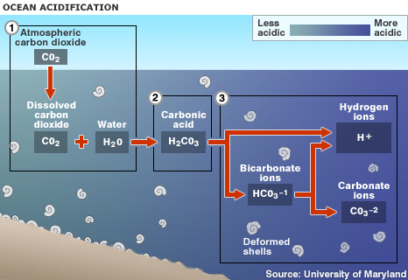
The primary controlling factor for the pH of ocean water is carbon, especially its acidic form, carbonic acid (H₂CO₃). This weak acid is familiar to nearly everyone because it is what gives the fizz to soda. This acid is formed by the combination of one water molecule with one carbon dioxide molecule (H₂O + CO₂ = H₂CO₃). In the ocean carbon actually acts as a buffer—meaning it helps moderate the pH by responding to additions of acid or base through the dissolution or precipitation of the mineral calcite (CaCO₃). Notice the similarity in the formulas of carbonic acid and calcite. The usual form of carbonic acid in water (in soda or in the ocean) is bicarbonate ion (HCO₃⁻) and hydrogen ion (H⁺). It is the free hydrogen ion that actually makes it an acid. Here are two diagrams that illustrate the reactions.
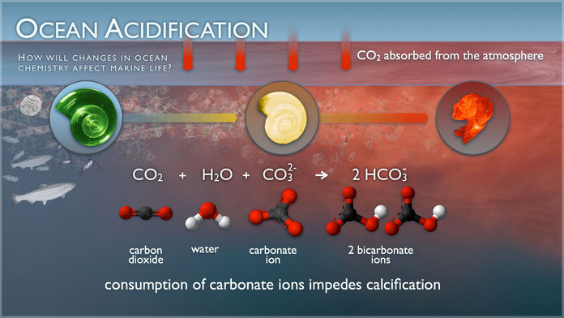
The reactions can run in either direction. These diagrams show the direction the reactions take when extra carbon dioxide is added to the system. You can read more about carbonic acid at http://en.wikipedia.org/wiki/Carbonic_acid. Pay particular attention to the effects that increased acidity have for the secretion and maintenance of skeletons by marine creatures. You can also view a video on this at http://coralreef.noaa.gov/flash/video/722_oceanacidification_withvo.f4v.
Questions
1. Show the reaction that takes place when carbonic acid reacts with calcite sediments or skeletons.

2. How does the addition of acid to the ocean affect the ability of calcite-secreting organisms to create and maintain their skeletons?

3. How might the speed of pH change in the ocean affect the ability of marine organisms to adapt to such changes?

Answers:
1. H₂CO₃ + CaCO₃ > Ca²⁺ 2H⁺ + 2CO₃—.

2. Higher acidity tends to dissolve calcite skeletons that have already been formed, and it makes it much more difficult for organisms to extract minerals from the water to build skeletal material.

3. Given time, the oceans tend to compensate for changes in chemistry, and species are able to adapt and evolve to survive in new conditions. Sudden changes make these reactions more difficult and can potentially lead to extinctions.

