Atmospheric Carbon Dioxide Activity

Preliminary
Watch the following video: http://earththeoperatorsmanual.com/segment/4

Background
In 1957, a scientist by the name of Charles David Keeling began taking continuous measurements of atmospheric carbon at Mauna Loa, Hawaii. He was the first person to document that levels of atmospheric carbon are increasing. There is a scientific consensus that global temperatures are increasing along with carbon dioxide. Human activities such as deforestation, fossil fuel burning and land-clearing for agriculture, among others, may be contributing to these global trends.
Scientists are building a consensus about how Keeling’s carbon dioxide curve may be linked to global warming. When human activities contribute to the amount of Greenhouse Gases in the atmosphere, we are enhancing the natural Greenhouse Effect. The increase in Earth’s surface temperature reveals this trend. Although the change in temperature since the 1800’s is not noticeable to most humans (0.6 degrees Celsius), the warming has already begun to have an effect on other living organisms. The habitat ranges of some species have begun to shift as a result, putting some populations in danger of extinction (Krajick, 2004).
Take a look at the figure below which shows the results of Keeling’s work at Mauna Loa. Notice that the monthly mean (red) oscillates while the long-term trend (black) shows a gradual increase. Thus there are both year-to-year (interannual) and month-to-month (intraannual) changes. We will investigate both in this activity.
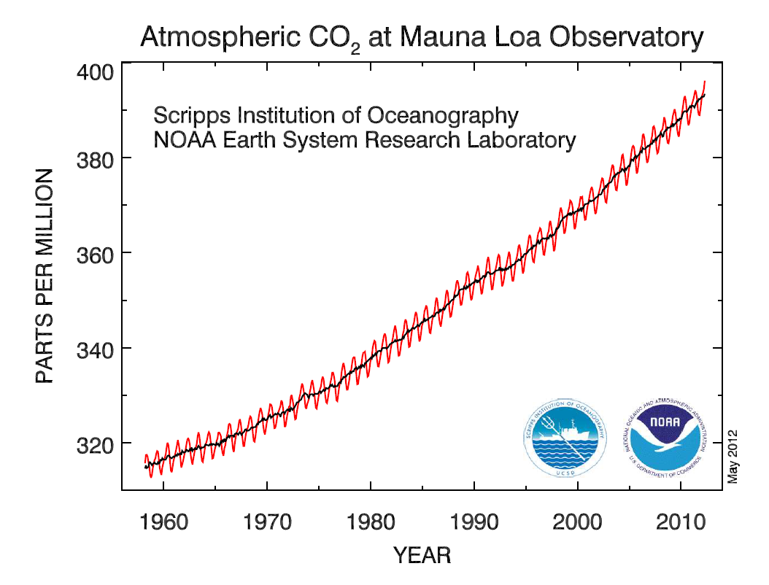
http://www.esrl.noaa.gov/gmd/ccgg/trends/#mlo_full
Part I – Interannual Changes in Atmospheric Carbon Dioxide Concentration

- What overall trend is seen in Keeling’s graph?

- Why do you think that scientists consider Keeling's data, which was collected at a single location in Hawaii, to represent atmospheric carbon in the entire northern hemisphere?

- Determine the rate of increase of atmospheric CO₂ concentrations for each decade in figure 1. Hint: find the slope of the mean atmospheric concentration for each decade. Recall slope is rise over run.
Decade | Rate of atmospheric CO₂ concentration increase per year
1960-1970
1970-1980
1980-1990
1990-2000
2000-2010

- What general trend do you observe with your data?

- From this graph, what was the atmospheric CO₂ concentration in 2010?

- Based on your data, determine by how many years will it take for CO₂ concentrations to double from the value 2010? For example, if the beginning value were 300 ppm, and the rate of increase were 3 ppm/year, it would take 300/3 = 100 years to increase by 300 ppm (i.e., double). Show your work.

- As you noted in question 2, the rate of increase for the last ten years was higher than the rate for the 10 years before, and that the rate may continue to increase in the future. If the rate increases in the future, will the time needed to double the atmospheric CO₂ concentration increase, decrease, or stay the same? Circle the correct answer.

Part II – Intraannual Changes in Atmospheric Carbon Dioxide Concentration
The figure below provides a more detailed look at the most recent Mauna Loa atmospheric data. The dashed red line with diamond symbols represents the monthly mean values, centered on the middle of each month. The black line with the square symbols represents the same, after correction for the seven-year average seasonal cycle.
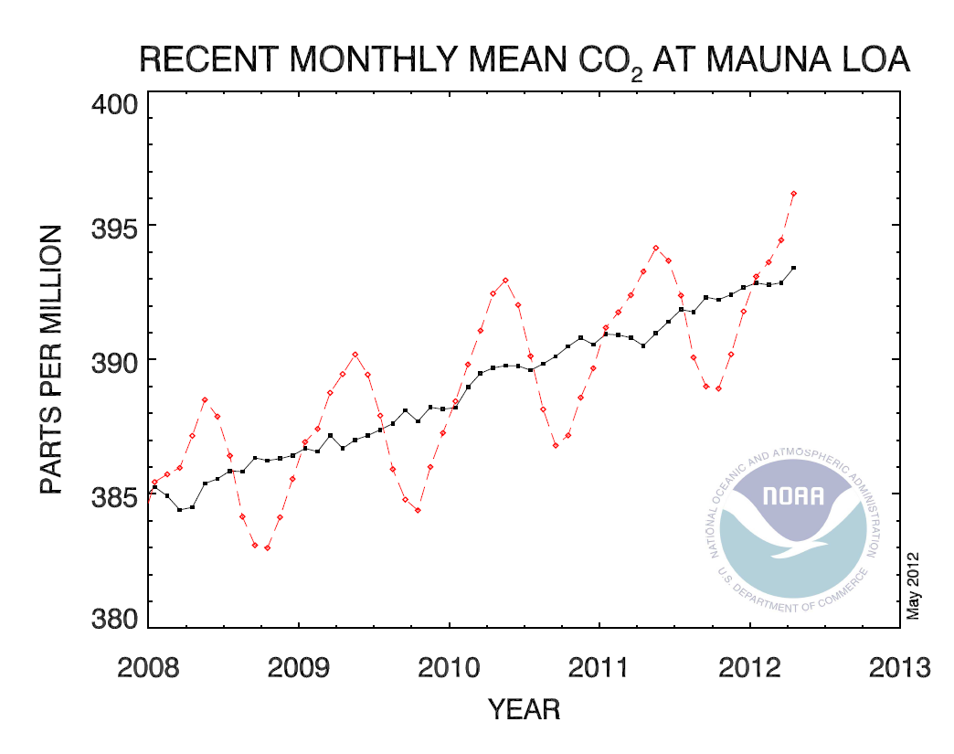
http://www.esrl.noaa.gov/gmd/ccgg/trends/#mlo_full
- During which season does the intraannual (red) curve increase?

- Think about seasonal changes in our ecosystems. The ecosystem looks different during the summer than during the winter. This is due primarily to photosynthesis. Based on the conditions that plants require in order to photosynthesize, can you think of reasons why photosynthesis increases during a particular season?

- What affect does this have on atmospheric carbon?

References
http://icp.giss.nasa.gov/education/modules/carbon/topic2/topic2rwp.pdf
http://www.esrl.noaa.gov/gmd/ccgg/trends/#mlo_full
http://serc.carleton.edu/introgeo/interactive/examples/co2.html

