Name: ____________________
The Earth Energy Balance
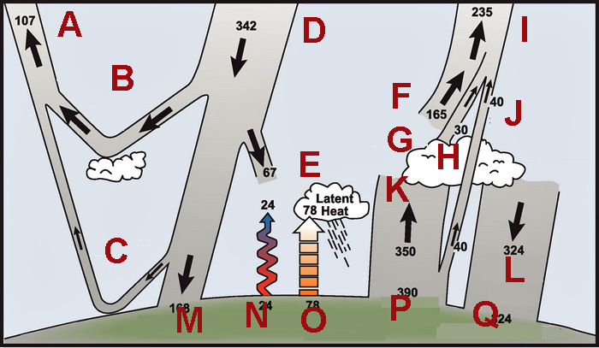
Your Task: Match the letters above with the correct description below
Letter | Description
I | Outgoing longwave radiation
B | Reflected by clouds, aerosols, and atmospheric gases
G | Emitted by clouds
D | Incoming solar radiation
O | Evapo-transpiration
J | Atmospheric window
A | Reflected solar radiation
L | Long wave infrared radiation emitted downward by greenhouse gases and clouds
N | Conduction
C | Reflected by the surface
Q | Absorbed by the surface
F | Emitted by the atmosphere
H | Clouds/Greenhouse gases
K | Absorbed by greenhouse gases and clouds
E | Absorbed by the atmosphere
M | Absorbed by the surface
P | Surface emission of long wave infrared radiation

Note: The first column is to be left blank when administering to students

