The Greenhouse Effect: Why is the Earth’s Surface
So Much Warmer than the Earth as Seen from Space?

Objectives:
- Understand and apply the idea of a balanced (long-term global average) heat budget to explain how the greenhouse effect works.
- Understand and apply the idea that adding greenhouse gases to the atmosphere unbalances the earth’s heat budget and contributes to observed global warming.

Some Things That You Should Already Know:
- The composition of the atmosphere.
- A basic law of radiation: the warmer an object is, the more radiation it emits.
- The difference between solar and terrestrial (longwave infrared) radiation.
- The types of radiation that clouds and individual gases in the atmosphere do and don’t absorb (and emit) well.
- What happens to solar radiation and to longwave infrared radiation when they strike clouds.
- The principle of conservation of energy, expressed as a heat budget and applied to the earth as a whole.
- The global average temperature of the earth’s surface (15°C, or 60°F) vs. the temperature of the planet as a whole based on the amount of radiative energy that the earth emits to space (−18°C, or −0.4°F).

Introduction
We learned earlier (“What Is the Earth’s Average Temperature?”) that the temperature of the earth as a whole (atmosphere and surface combined), averaged over a year, typically changes only a little from year to year, so the planet’s annual average heat budget must approximately balance. Based on satellite measurements of incoming and reflected solar radiation, and supported by satellite measurements of longwave infrared (LWIR) radiation emitted by the earth to space, we concluded that the temperature of the planet as a whole must average about −18°C (−0.4°F).
However, the global average surface temperature, averaged over a year, is typically around 15°C (60°F), which fully 33°C (60.4°F) warmer. Moreover, the earth’s surface emits much more LWIR radiation (390 W/m²) than the earth as a whole emits to space (235 W/m²).
Why is the earth’s surface so much warmer than the planet as a whole (viewed from space)? What happens to the LWIR radiation emitted by the surface, since much of it doesn’t reach space? In this activity, we try to answer these questions and apply the answers to understand what happens to the earth’s temperature when greenhouse gases are added to the atmosphere.

To help us answer these questions, we will refer to Figure 1 below, which shows:
- how much solar radiation arrives at the top of the atmosphere and how much of it the earth’s surface and atmosphere reflect and absorb (left-hand side of the diagram);
- how much LWIR radiation the earth’s surface, greenhouse gases, and clouds emit and absorb (right-hand side of the diagram);
- how much heat conducts from the earth’s surface into the atmosphere and how much heat gets transferred from the earth's surface into the atmosphere by evaporation then condensation of water (to make clouds) (lower center part of the diagram). (Note these two mechanisms of heat transfer don’t involve absorption or emission of radiation, while the others above do.)

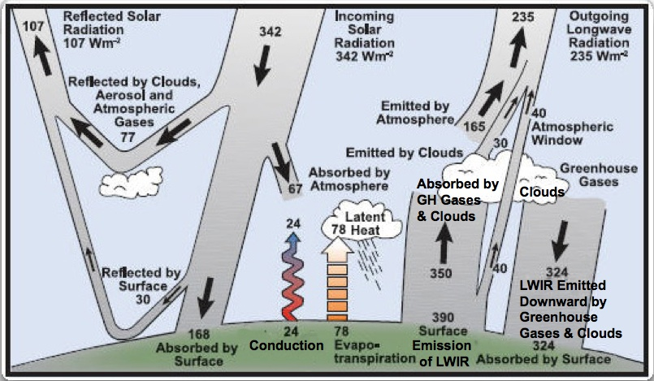
Figure 1: The long-term, global average energy budgets for the earth’s surface and for the atmosphere (adapted from Trenberth et al., 2009).

The numbers in Figure 1 represent energy “fluxes”, expressed in Watts per square meter (W/m²). They tell us how rapidly energy strikes, passes through, reflects from, is absorbed by, or is emitted from each square meter of (horizontal) area. The numbers are long-term, global averages of observations recorded by satellites and surface-based instruments.
Figure 1 shows that 342 Watts/m² of solar radiation arrive at the top of the earth's atmosphere (averaged over the entire earth for many years). Of that total, clouds, air molecules, and the earth’s surface reflect 107 Watts/m² back to space. That is, the earth does not absorb 107/342 x 100% = 31% of the total incoming solar radiation. (Note that solar radiation reflected back to space is not converted into heat, so it does not contribute to the earth’s heat budget.)

Instructions and Questions:
Your instructor will assign you to groups of two to four people. For each of the questions below, try to agree among yourselves upon a response. Be prepared to explain your reasoning for each one.

Questions:
- How much solar radiation actually reaches the earth's surface through the atmosphere? What happens to the rest of the solar radiation that arrives at the top of the atmosphere?
[Optional quantitative question: What percentage of the solar radiation arriving at the top of the atmosphere actually reaches the surface?]
- How much solar radiation does the earth’s surface actually absorb?
[Optional quantitative questions: What percentage of solar energy arriving at the top of the atmosphere is actually absorbed by the earth's surface? What percentage of the solar radiation reaching the surface does the surface reflect (and hence not absorb)?]
- Compare the amount of LWIR radiation emitted by the earth's surface to (a) the amount of solar energy arriving at the top of the earth's atmosphere, and (b) the amount of solar energy absorbed by the surface.
- How much LWIR radiation emitted by the earth’s surface escapes directly to space (without being absorbed in the atmosphere)? What happens to the rest of the LWIR radiation that the surface emits?
[Optional quantitative question: What percentage of the LWIR radiation emitted by the earth's surface escapes directly to space?]
- In Figure 1, do the amounts of radiative energy entering and leaving the top of the atmosphere balance? (This is, in effect, the energy budget for the planet as a whole.) Explain your reasoning.
- Does the surface energy budget balance? If so, what is the largest source of energy for the surface? What is the main way by which the surface loses heat?
- Does the atmosphere's heat budget balance? If so, what is its primary source of heat (on the average)? What is its primary means of getting rid of heat?
- Figure 1 shows that the surface, greenhouse gases, and clouds all emit LWIR radiation directly space. Which one of these emits most of the radiation that the earth loses to space?
- Compare the amount of radiation emitted by the earth's surface to the amount that the earth as a whole emits to space.
- Based on (a) the balanced heat budgets that you've just analyzed in some detail, and (b) the basic law of radiation that says that the warmer an object is, the more radiative energy it emits, explain why the earth's surface is necessarily so much warmer than the temperature of the planet treated as a whole, as seen from space. (This is the greenhouse effect.)
- Suppose that all gases that absorb LWIR radiation (notably water vapor and carbon dioxide, but other, less important ones, too) were removed from the atmosphere. What implications would this have for the surface temperature, if the heat budget were balanced?
(Note that removing water vapor would also mean that no clouds could be present, either, which would reduce the amount of solar radiation that the earth reflects to space. For simplicity, ignore this—the answer will be qualitatively the same.)
- Suppose that more carbon dioxide (CO₂) were added to today's atmosphere. (Humans are doing this by burning coal, oil, and natural gas—that is, fossil fuels—and by cutting down forests.) The additional CO₂ would rapidly mix throughout the atmosphere, so CO₂ would increase by the same percentage everywhere.
(a) How would more CO₂ in the atmosphere affect absorption of LWIR in the atmosphere?
(b) As a result of the change in LWIR absorption in the atmosphere, how would the average temperature of the atmosphere respond? (Explain in terms of an imbalance between the gains and losses of heat by the atmosphere.)
(c) As a result of the change in atmospheric temperature, what would happen to the amount of radiation that the atmosphere emits (both upward and downward)? (Explain.)
(d) As a result, what would happen to the temperature of the surface? (Explain in terms of an imbalance between the gains and losses of heat by the surface.)

References
Trenberth, K., J. Fasullo, and J. Kiehl, “Earth’s Global Energy Budget”, March 2009, BAMS.

