Exploring Foraminifera Assignment

Goals for this Activity  - Students will become familiar with a microorganism common to the world's oceans at present and throughout much of geologic time.  - Students will develop an interest in fossil organisms and an appreciation for their role in the web of life, science, and human industry.  - Students will develop skills in using the Internet, working with digital images, and presenting information using tables. | Objectives for this Activity  - Students will be able to explain the characteristics and lifestyles of foraminifera, their use in science and industry, and the methods of the scientists who study them.  - Students will be able to conduct Internet searches, retrieve images and information, reference them correctly, and format work using a table.  - Students will produce an illustrated page of information and present it to inform classmates.
You will choose one of the topics shown at left (or an alternate related topic approved by your instructor) and produce a page (formatted by using a table) in Word that shows images and explanations of your topic. All information must be referenced as to the website from which it was obtained using APA style. For example, each web page below has been correctly referenced. [General form: Author, A. A. (2000). Title of work. Retrieved month day, year, from source.] More info at http://www.apastyle.org/elecsource.html  Below are some links that may prove useful to you. You should conduct additional searches.  Be sure to include at least four images and four vocabulary words with definitions on your page. | Possible Topics  - Body parts of a foram and their functions;  - Place in the food chain: what forams eat and what eats them;  - Relationship of forams to other life forms;  - Environments in which they live;  - Famous scientists who worked with forams and their methods;  - Use of forams in industry (oil exploration);  - Use of forams in determining geologic time scale;  - Life cycle and Reproduction;  - Method of collection of forams and study;  - Models of forams and use in education
University of California Museum of Paleontology:  http://www.ucmp.berkeley.edu/foram/foramintro.html  Referenced in APA Style:  Wetmore, K. L. (1995). University of California Museum of Paleontology: Introduction to the Foraminifera. Retrieved June 18, 2006, from http://www.ucmp.berkeley.edu/foram/foramintro.html | 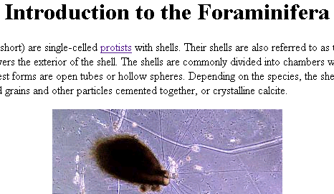
University College London (UCL), Microfossil Image Recovery and Circulation for Learning and Education (MIRACLE), and the Joint Information Systems Committee (JISC): http://www.ucl.ac.uk/GeolSci/micropal/foram.html  Referenced in APA Style:  Olney, M. (2002). University College London Micropaleontology Unit: Foraminifera. Retrieved June 18, 2006, from http://www.ucl.ac.uk/GeolSci/micropal/foram.html | 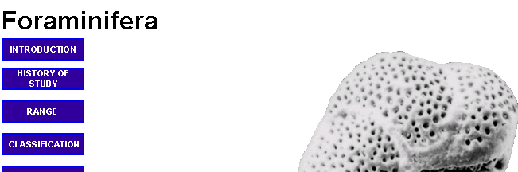
Smithsonian National Museum of Natural History: http://www.nmnh.si.edu/paleo/foram/  Referenced in APA Style:  Rye, R. T. (n. d.). Smithsonian National Museum of Natural History, Department of Paleobiology: The national collection of Foraminifera (and other microfossils). Retrieved June 18, 2006, from http://www.nmnh.si.edu/paleo/foram/ | 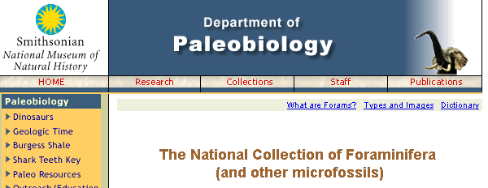
United States Geologic Survey (USGS):  http://geology.er.usgs.gov/paleo/forams_b.shtml  Referenced in APA Style:  United States Geologic Survey. (1999). Benthic foraminifers. Retrieved June 18, 2006, from http://geology.er.usgs.gov/paleo/forams_b.shtml | 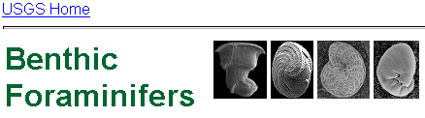
Texas A & M University:  http://oceanworld.tamu.edu/students/forams/index.html  Referenced in APA Style:  Zink, S. (2004). Ocean World: Forams. Retrieved June 18, 2006, from http://oceanworld.tamu.edu/students/forams/index.html | 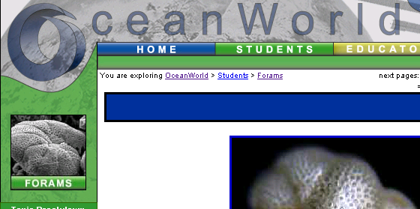
Kane Scientific Company:  http://hoflink.com/~kane/index.html  Referenced in APA Style:  Kane Scientific Company (1993). Welcome to the Kane Scientific Company. Retrieved June 18, 2006, from http://hoflink.com/~kane/index.html | 
Microscopy UK:  http://www.microscopy-uk.org.uk/mag/indexmag.html?http://www.microscopy-uk.org.uk/mag/artnov98/bdforam3.html  Referenced in APA Style:  Parmentier, J., & Darnton, B. (1998). The collection and mounting of foraminifera. Retrieved June 18, 2006, from http://www.microscopy-uk.org.uk/mag/indexmag.html?http://www.microscopy-uk.org.uk/mag/artnov98/bdforam3.html | 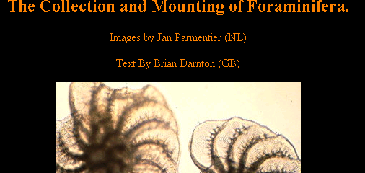
Tohoku University Museum  http://rin.hiroba.org/foraminifera/  Referenced in APA Style:  Hayashi, H. (2003). Figures collection of planktonic foraminifera. Retrieved June 18, 2006, from http://rin.hiroba.org/foraminifera/ | 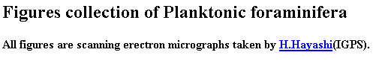
British Geological Survey (BGS):  http://www.bgs.ac.uk/education/Fossilfocus/FORAMS/page2.html | 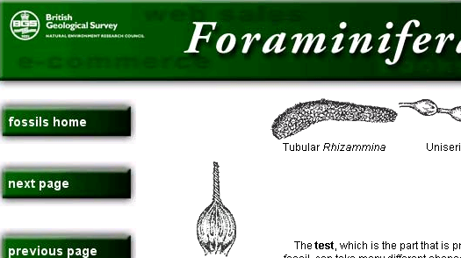

How to Capture Images and Insert them into a Word Document

There are two ways to capture images. One way is to place your cursor over the image and right-click with your mouse (This is if you have a PC). If you are using a recent Macintosh, you place the cursor over the image and hold down the "control" key as you click. A window will appear. Choose "Save Image As..."  Another window will appear and you can browse to determine the place (on your hard drive or on a disk) that the jpeg file will be saved. | 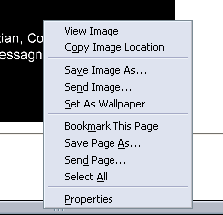
Place the picture into a table so that its position is anchored on the page and so that you can write in the cell beside it. The images and explanations on this page were made in a table.  To make a table, go to "Table" on the top tool bar. Then choose "Insert" and "Table". | 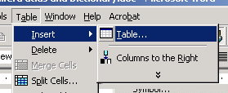
A new window will appear. Choose the number of columns and rows that you need. Usually 2 columns works well.  Then press "OK" at the bottom of the window. | 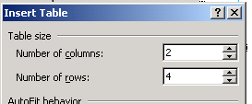
Place your cursor in the part of the table where you want to place the picture. Choose "Insert" on the top tool bar, then "Picture" and then "From File". Then browse to find the jpeg file on your hard drive or on a disk and insert it into the document. | 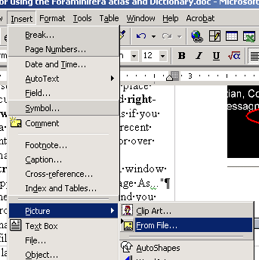
The second way to capture images off the Internet is to use the "Print Screen" key on your computer keyboard. This will copy the entire screen image onto the computer's clipboard memory. Then open an image drawing/editing program like"Paint" and paste the image. |  | 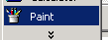
Usually, you get a message saying the image in the clipboard is larger than the bitmap. Say "Yes" because you do want to enlarge the bit map.
Then select a rectangle of the image that you want to insert into a Word file. Use the "Control" key and the "X" key to cut the image piece and then use "Control" and "V" to paste it where you want it.  This was the method used in making these directions. |  | 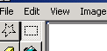

How to Add Color to a Table

Color makes a page more interesting and pleasing. You can add color to a table by selecting all or part of it. Then choose "Format" from the top tool bar and "Borders and Shading..." | 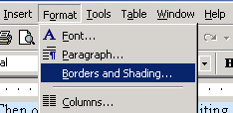
A new window will appear. First, choose the color of the table's border and lines that separate the parts of the table. Choose the tab that says "Borders." | 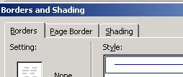
In the middle of the window is a blank labeled "Color." There is a drop-down menu that will allow you to choose a color for the border lines. You can also vary the line width. There are many other choices available - you should experiment with these to produce the look you want. | 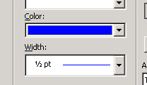
 | 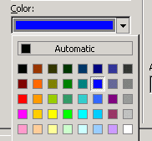
Similarly, you may choose colors for the shading inside the cells of the table. Choose the "Shading" tab on the Borders and Shading window. | 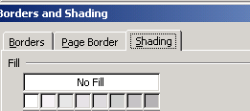
Then choose the color you want from the chart, or press "More Colors" for more choice or to customize the shade. A new window will open. You can customize the color by choosing "Custom" and moving either the black triangular arrow or the white cross hair. | 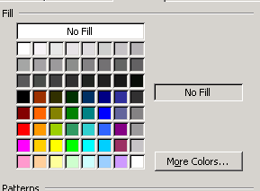

Rubric for Scoring the Exploring Foraminifera Assignment

Criteria | Yes | Borderline | No
Has the page been turned in on time? | -0 | -¼ -½ -¾ | -1
Are the student's name and the general topic of the page shown at the top of the page? Does everything fit on one page? | 1 | ¾ ½ ¼ | 0
Was the page constructed with the use of a table with two or more columns and several rows? | 1 | ¾ ½ ¼ | 0
Has all the information been referenced in APA style? The list of referenced pages should be near the bottom of the page and information should be cited with the author's or authors' last name(s) and date in parenthesis. | 1 | ¾ ½ ¼ | 0
Are at least four images shown on the page? Do these images illustrate and enhance the given facts or information? | 1 | ¾ ½ ¼ | 0
Are at least four relevant terms defined on the page? | 1 | ¾ ½ ¼ | 0
Is the format, layout, and color scheme of the page visually pleasing? | 1 | ¾ ½ ¼ | 0
Is the information on the page well organized and explained (rather than confusing or unclear) so that readers can learn new ideas from the page? | 1 | ¾ ½ ¼ | 0
Is the information scientifically correct and as complete as possible considering the one-page limitation? | 1 | ¾ ½ ¼ | 0
Is the page free of spelling errors, grammar errors, and punctuation errors? | 1 | ¾ ½ ¼ | 0
Was the presentation of the page and its information to classmates organized, logical, and clear? | 1 | ¾ ½ ¼ | 0
Total Score out of 10 possible points.

