Name Saharan paleolakes
Class Wednesday, November 15

Over the past few weeks, we’ve seen some tantalizing clues that the Sahara has not always been as dry as it is today. Wouldn’t it be neat to know how long ago it was wetter? And how much wetter it was? Were humans around then? Could they have made a living in what is now a hyperarid desert? Were rainfall changes in any way connected with the rise of Ancient Egyptian civilization? Was it warmer or colder when it was wetter in the Sahara, and can we make any predictions about what global warming will do to the Sahara? Fortunately, we have the geological and archaeological record to help us out!

Let’s start by thinking about what you already know about when it was wetter in the Sahara in the recent past:

- When we studied groundwater in the Sahara, what did you learn from the ages of Saharan groundwater about periods of higher rainfall in the Sahara?

- When we studied the Libyans Great Man-Made River Project, you learned about the sources of aggregate that the Libyans used to make the concrete pipes. What evidence is there in the aggregate sources for higher rainfall in the recent past in the Libyan Sahara?

- What additional things did you learn about in the homework that suggest higher rainfall in the past in the Sahara?

Taoudenni
For homework, you read about the salt mines at Taoudenni. On the next page, you'll find a stratigraphic column from the Taoudenni area, and you'll find a map of the area on page 4. The stratigraphic column shows a representative sequence of sediments in a particular place, with the oldest sediments at the bottom of the column and the youngest at the top (kind of like a core sample). These sediments have been interpreted to represent sediments deposited in a lake that periodically became hypersaline and occasionally dried out altogether. What features of the sedimentary record support that interpretation?

What information might we like to know about these sediments that isn't included in the stratigraphic column and key?

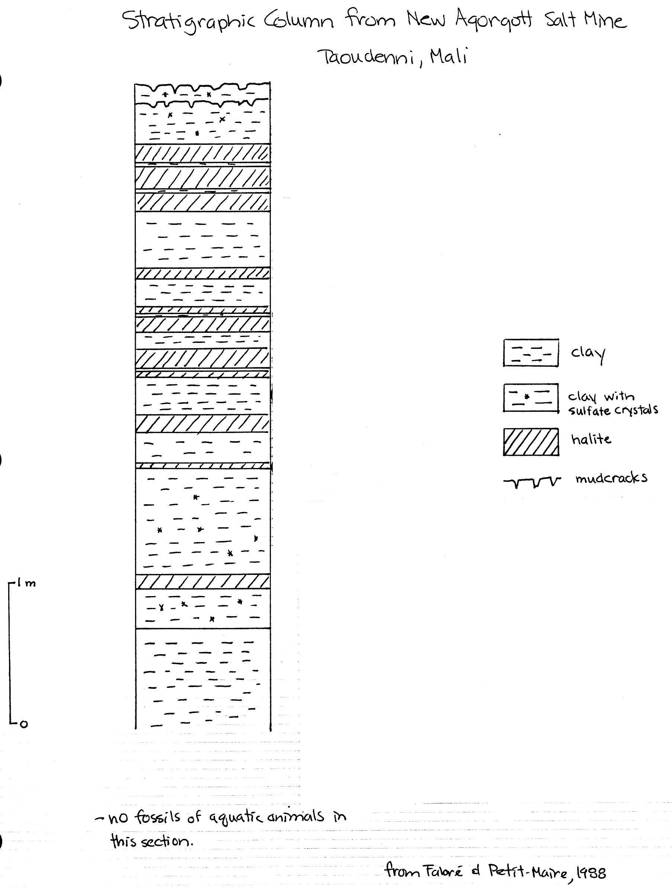

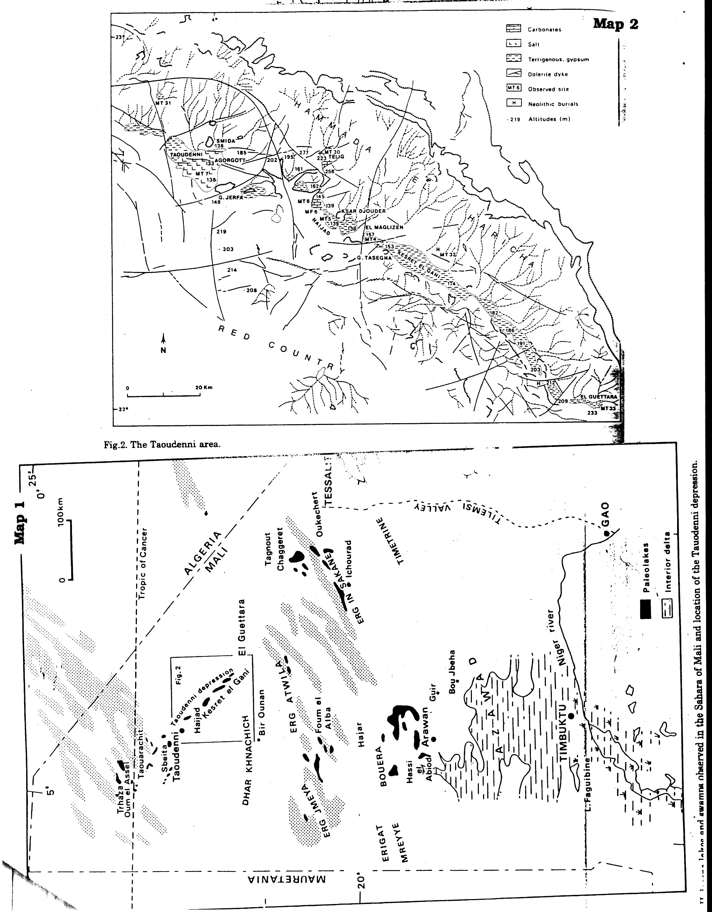
Your job:

- To study the sediment record at four other sites scattered across the Sahara.
- Develop a picture of what the Sahara was like when rainfall was higher.
- Draw conclusions from the features in the sediments about when rainfall was higher than it is today and when it was lower.
- Compare the four sites to develop a more complete picture in time and space across the Sahara.
- Use the geological record to make predictions about the impact of global warming on the Sahara.
- Look for correlations between climate events in the Sahara and historical events in Ancient Egypt.

The data:
Starting on page 9, you will find data from four other sites scattered across the central Sahara. These data include the following:

– a stratigraphic column showing sediment types
– radiocarbon dates, including what the dates were obtained on and where the samples were located in the section
– fossils, including microfossils, found in sediments in the section
– information on large animal populations and human activities, evidence for which may come from the immediately surrounding area rather than the section itself.
– information on floral remains, which may come either from vegetal remains (either in situ or having floated out onto a lake and sunk) or from pollen preserved in the section. Shape and size of pollen vary from species to species, and pollen analysis (palynology) of sediments can provide valuable information about what species were in the vicinity of the sample site. How representative a sample is of the actual vegetation depends upon 1) how far the wind carried pollen from various species and 2) whether conditions were right for preservation of pollen in the sediments.
– a map on page 8 showing modern vegetation (floristic) zones in North Africa, with lists of important plant species from each zone.

Your team assignment:
– locate your site on the map of the Sahara that I’ve given you.
– examine the data from your site. You will find reference information on various rock and sediment types at the end of this handout.
– develop a picture of what your site must have looked like at various times.
– establish the major changes in the environments of deposition (e.g., change from beach to dune to lake bottom to whatever), with evidence for those changes, and the timing of those changes.
– assess what your section suggests about rainfall changes in the area and why, and what the timing of changes appears to have been.

Once your group has worked through your column, have me check over your conclusions. Then, decide how to go about conveying all of the points listed above, starting with a descriptive picture of what the area must have looked like at various times. Remember that you are a geologist charged with conveying a detailed and convincing argument clearly supported by specific pieces of data (e.g., pollen, radiocarbon dates, sediment type, etc.). Be sure that everyone on your team is prepared to convey the following to a mixed group:
– the overall evolution of your paleolake, with evidence for your conclusions, including what the lake area looked like at various times (e.g., vegetation, animals, lake, mudflat, dunes, and so on). Be sure to be prepared to describe the rock types contained in your column.
– a summary of the timing of the major changes in rainfall, including any evidence that you did not cover in the first part.

In your mixed group:

Each person will teach the rest of the group about the two items listed above. Then, as a group, compare the four sites, and discuss the following:

- What do the four sites suggest about changes in rainfall over time across North Africa? Be specific about the timing of changes. Make a list of points below, and we will list them on the board.

- The current Sahara-Sahel boundary lies at approximately 17°N latitude (roughly through Timbuktu). Where would you place the Sahara/Sahel boundary in Early Holocene time, between 7500 and 8000 ybp? Explain the reasoning behind your answer.

- Are the conclusions you have drawn using the information from the paleolakes consistent with what you knew earlier (and listed on page #1) about wetter and drier times in the Sahara?

- Here are two more geological observations for you to consider:

  - At about 18,000 ybp (Late Pleistocene, at the height of the last major glacial advance), the Sahara/Sahel boundary lay at about 10°N latitude. Worldwide temperatures were significantly colder then than they are today.
  - The Early Holocene, by contrast, was a time of warmer temperatures worldwide than either the Late Pleistocene or the modern era. The Early Holocene is commonly referred to as the "Early Holocene Climatic Optimum".

Based on the geological record preserved in the Sahara from the Late Pleistocene, Early Holocene, and present, what might you predict for rainfall conditions in the Saharan region if global warming results in long-term worldwide temperature rise? Explain your answer, and provide evidence.

Major Floristic Regions Of North Africa With Characteristic Pollen Taxa

III – Saharan: desert with very limited pollen flora. Wadis typically contain Tamarix, Cornulaca, Calligonium, Fagonia, Salvadora, Maerua.

IV – Sahelian: sparsely wooded desert grassland and thorny shrubland; grades into Saharan type in the north and to Sudanian type in the south.

Acacias of various species are ubiquitous (these are the thorny trees of the Sahel); also Commiphora, Blepharis, Balanites, and the shrub Tribulus.

Rainfall determines which annual and perennial herbaceous plants and shrubs form the ground cover in a particular place. In the wetter parts of the Sahel, Graminae (grasses) and Cyperaceae (plants that grow on and stabilize inactive sand dunes) dominate. In drier (notice that I spelled this correctly this time, and didn’t use “dryer”, as in washer and dryer, like I did last time...) parts, Chenopodiaceae and Amaranthaceae dominate.

V – Sudanian: wooded savanna and dry forest. The most common tree taxa are Grewia and Piliostigma. Other species of plants include Celtis integrifolia, Combretaceae, and Lannea.

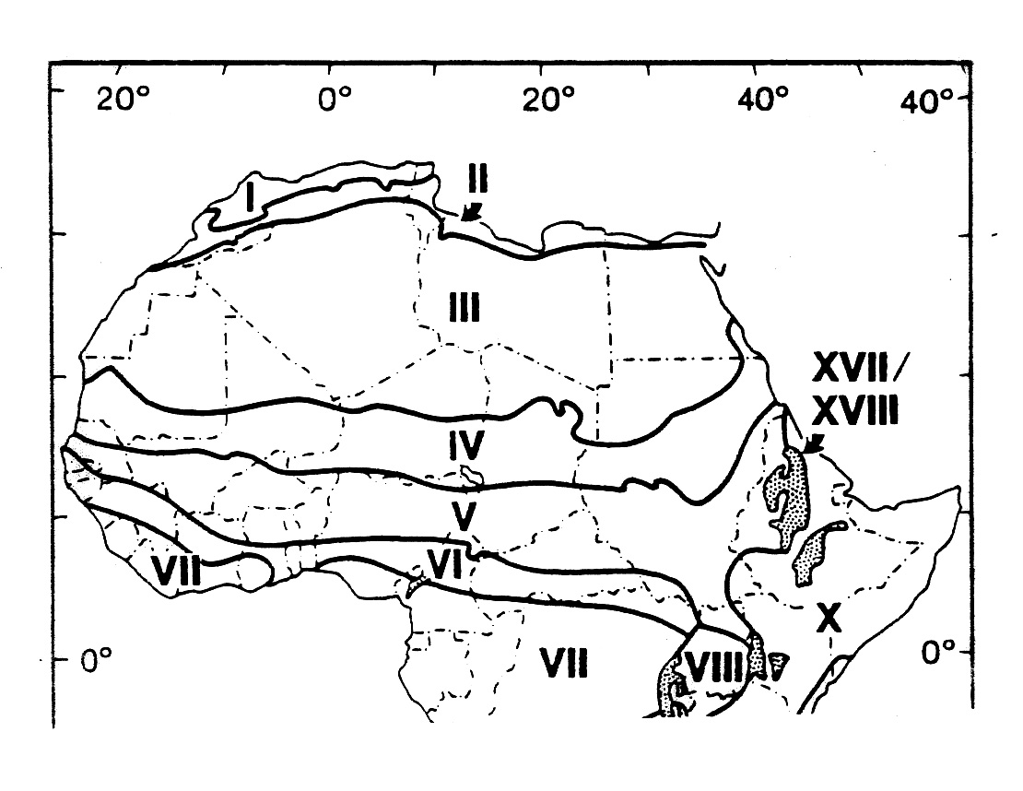

Team #1 Haijad, in the Taoudenni Depression

Taoudenni Depression is a internally-draining basin that currently contains no surface water, seeps, or springs. During the Holocene, however, many lakes and marshes developed in the area, as show in figure 1. The Taoudenni paleolake that we looked at earlier today is the most well-known of all of these lakes, because it was hypersaline and left behind salt deposits that have been exploited for centuries. The other lakes in the Depression do not have associated salt deposits.

Haijad paleolake lies about 20 km southeast of Taoudenni paleolake (figure 2) and at a slightly higher elevation. Modern rainfall in the Haijad area averages less than 5 mm per year, and vegetation is virtually non-existent.

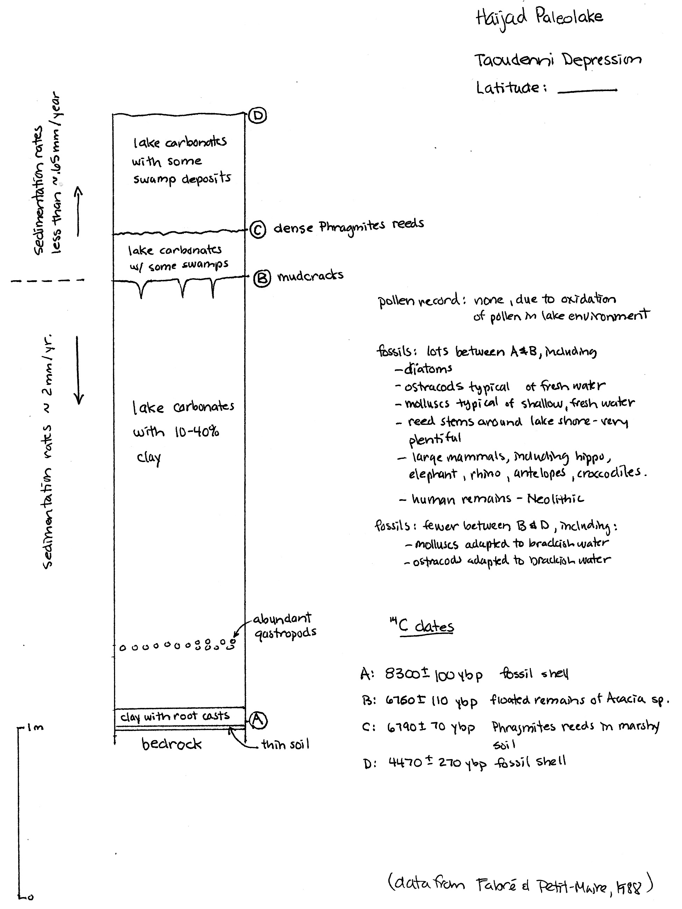
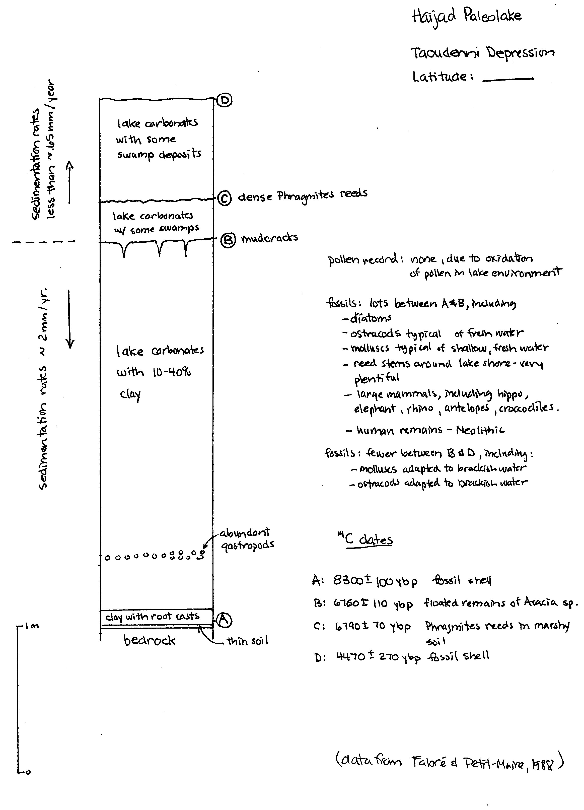
Team #2 Adrar Bous, in the Ténéré Desert

Adrar Bous is large area of exposed bedrock located in the drifting sands of the Ténéré Desert about 65 km east of the Aïr Mountains of northern Niger. Locate Adrar Bous on your large map. Agorass N’Essoui paleolake that formed in a small depression on the south side of Adrar Bous (locate the paleolake on figure 3).

Modern rainfall in the Adrar Bous area averages well less than 50 mm per year, and vegetation is virtually non-existent.

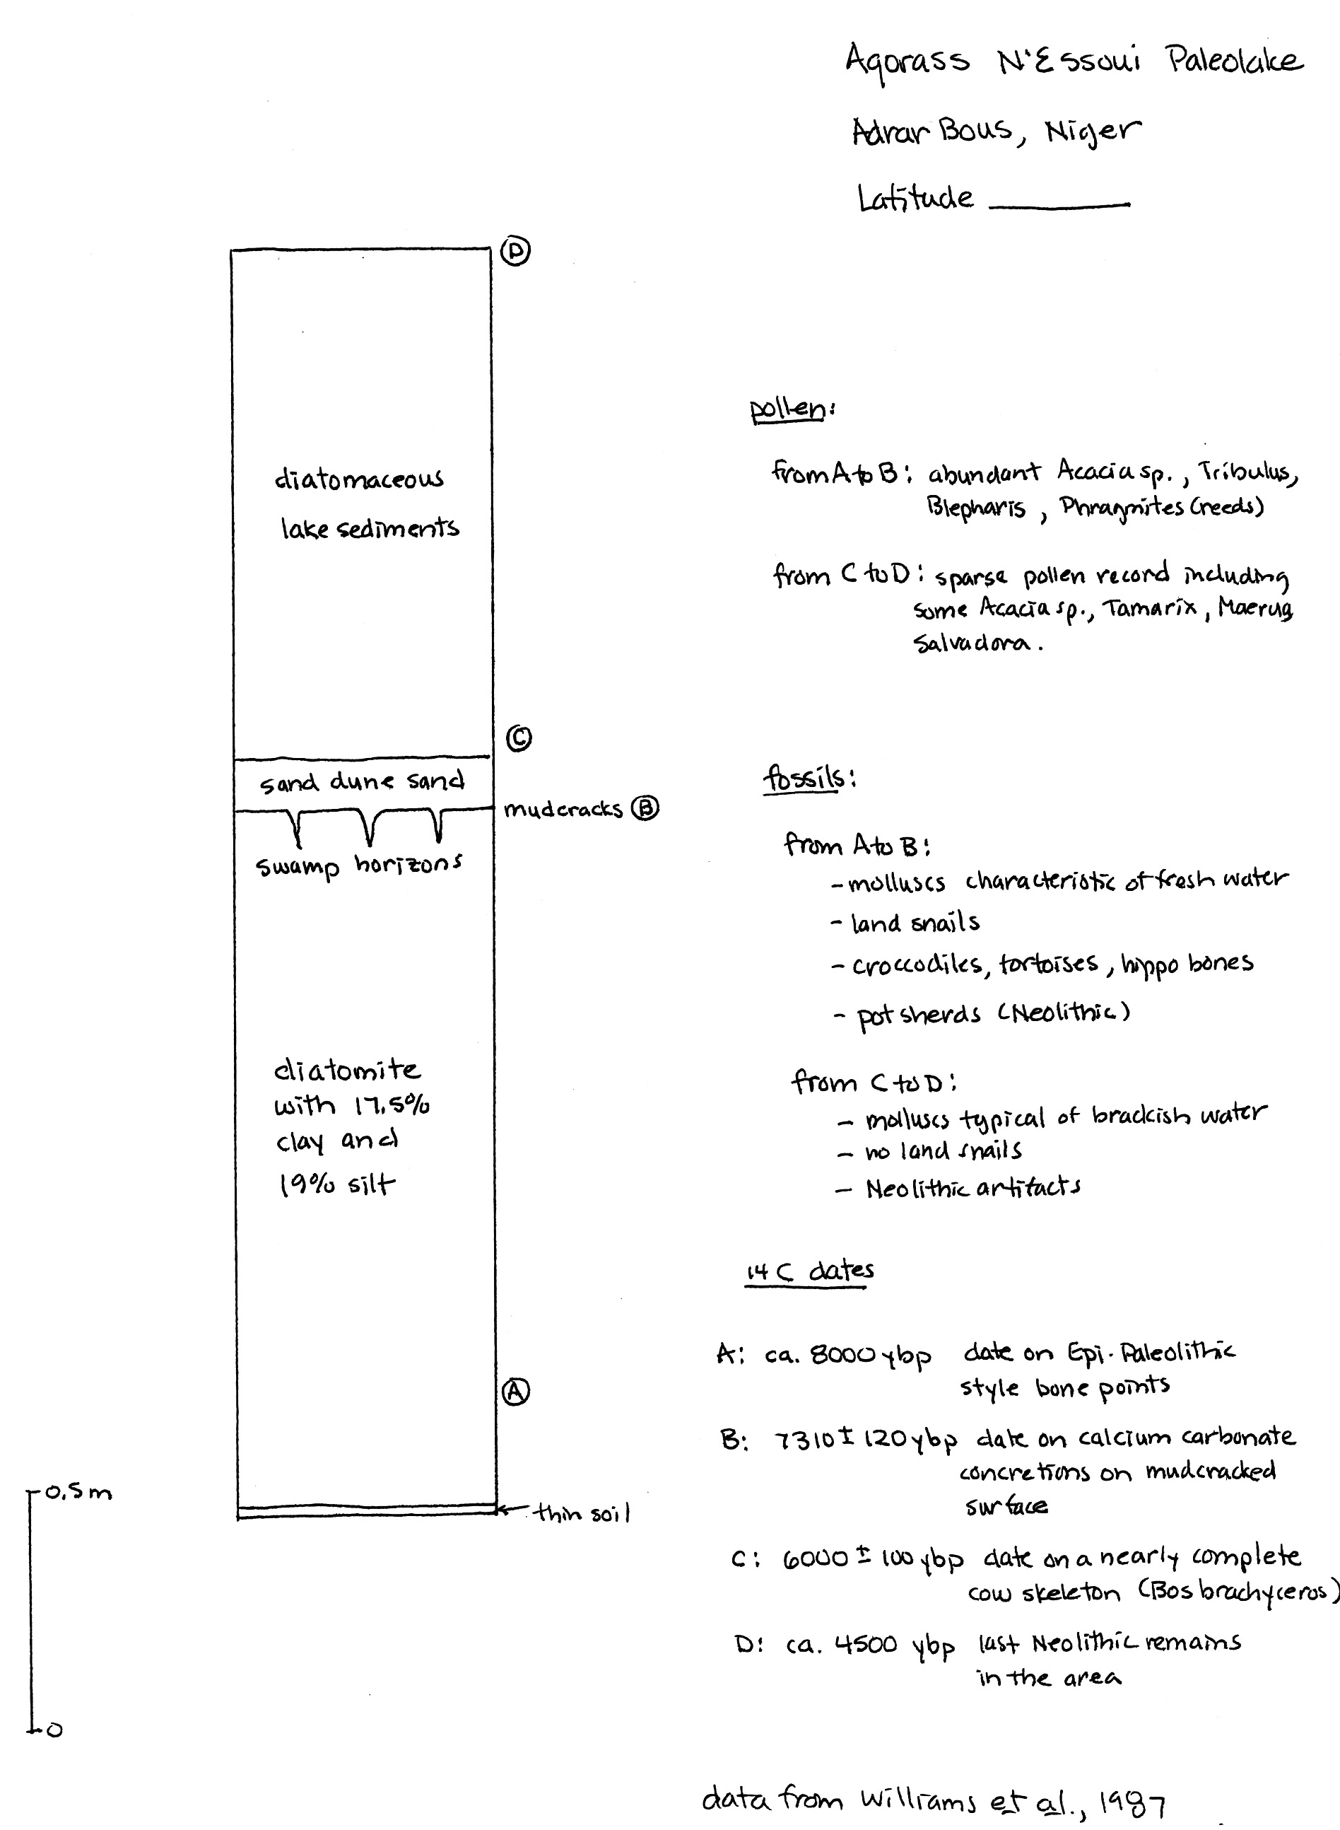
Tam #3 Selima, in northern Sudan

Selima paleolake is on the margins of what is now an uninhabited oasis in northern Sudan near the Egyptian border (figure 4). Selima paleolake lies just south of the “radar rivers” we talked about in class. Locate Selima on your large map of the Sahara.

Before the end of the slave trade in 1898, Selima was a major watering place on the trade route from Darfur, Sudan to Assyut on the Nile. The oasis depression does not contain a modern lake.

Selima is located within the Darb el Arba’in Desert (remember the "route of the 40 days" that goes from Assiut, Egypt through El Kharga and Baris Oases and west of the Toshka Depression into the Sudan). The area now averages less than 10 mm of rainfall per year.

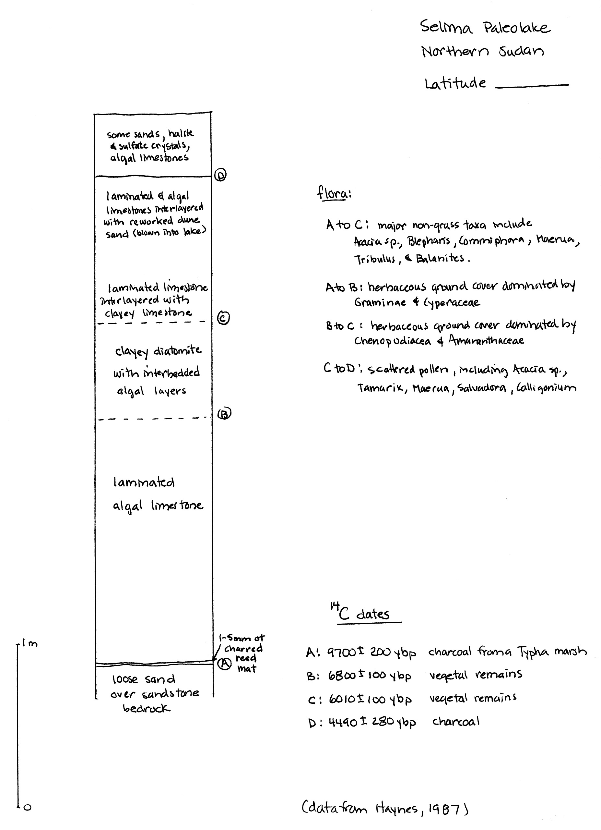
#4 Teams Oyo, in northern Sudan

Oyo paleolake lies in an area of northern Sudan that contains evidence of many paleolakes, as well as a paleoriver, Wadi Howar. Locate Oyo on your big map of the Sahara.

Figure 5 is a wonderful map summarizing many of the features of the region at the time the paleolake was present at Oyo and shows clearly that Oyo is not unique. This area is now an arid to semi-arid desert averaging less than 20 mm of rainfall per year.
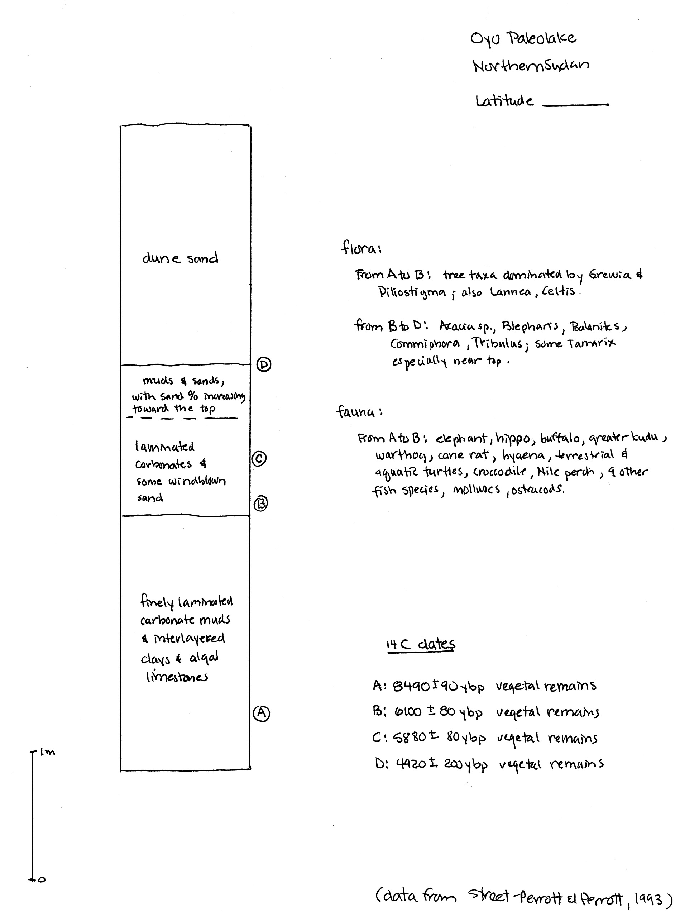
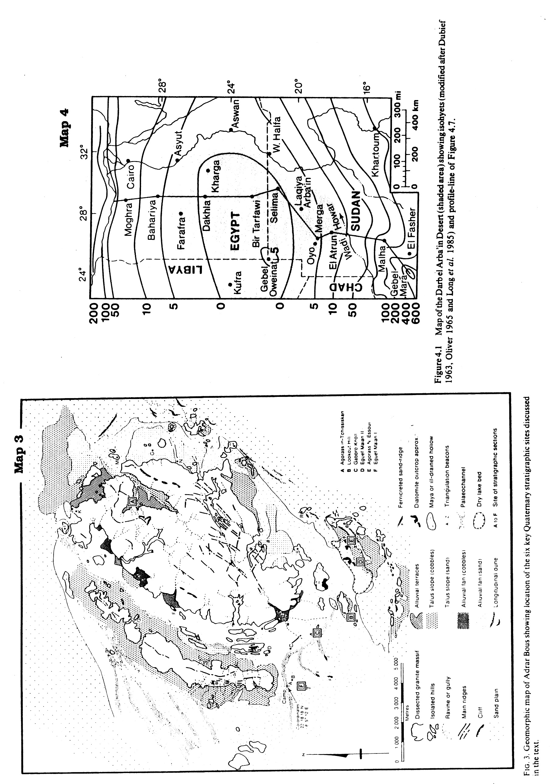
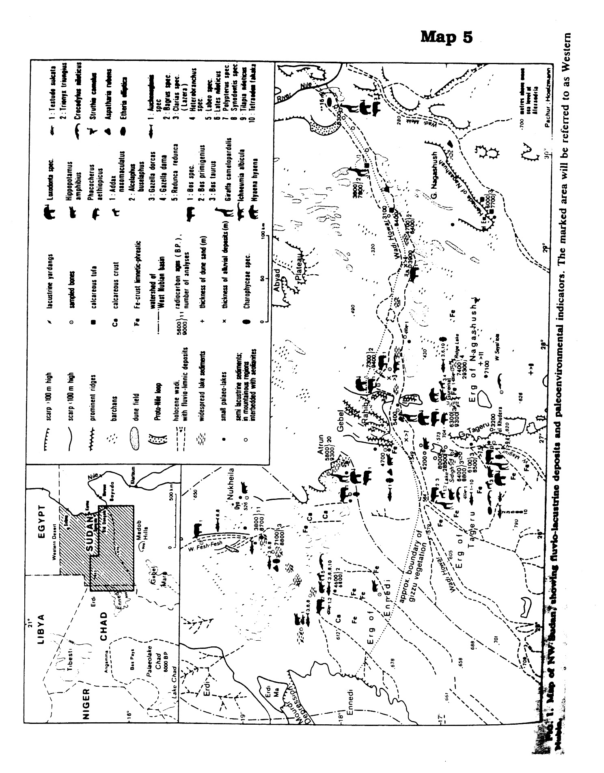
Reference information:

laminated clay or silt and clay: fine particles of quartz and clay minerals weathered from pre-existing rock enter the lake via permanent or intermittent streams and settle slowly out of the quiet lake waters, forming fine layers of clay or silt and clay. Sedimentation rates give a clue to rainfall – the higher the rainfall, the greater the amount of clay washing into the lake. Look at the sample.

limestones: limestones are rocks made up of the mineral calcite (CaCO₃ – a carbonate mineral); they don’t form by the accumulation of particles weathered from pre-existing rock and transported to the site of deposition. Rather, carbonate sediments that become limestones are formed at or near the site of deposition by biologic or chemical processes. Lacustrine limestones typically form from either biogenic precipitation of calcite or biogenically-induced precipitation of calcite. In the first case, organisms extract calcite directly from lake water to build their skeletons, which accumulate as carbonate sediments when the organisms die. In the second case, photosynthesis changes the chemistry of the lake water by removing CO₂. Calcite becomes less soluble and precipitates out. If precipitation results in finely layered sheets of carbonate, the sediment is called a laminated carbonate mud. If the carbonate sediment occurs in lumpy mats cementing algae together, such a sediment is called an algal carbonate sediment. Carbonate sediments eventually harden into limestones. Look at the sample.

diatomaceous sediments: Single-celled microorganisms called diatoms extract silica (SiO₂) from lake water to form tests in which they live. Come up to the front of the room, and have a gander through the microscope at some of these little beauties. While the diatoms are alive, they float around in the water. When they die, their tests sink to the bottom of the lake and accumulate as sediment. If very little other sediment is accumulating along with the diatoms, layers of pure diatomaceous sediment may form. If clay or carbonate is accumulating too, the sediment will be mixed. If you have a swimming pool at home, your swimming pool filter likely is filled with diatomaceous earth – the stuff makes a nice, fine-grained, inert material for filtering your pool water. Diatomaceous sediment hardens into a rock known as a diatomite. Look at the sample.

evaporites: If a lake lies in an isolated basin where significant evaporation is taking place, the concentration of dissolved salts can increase, making the lake brackish (slightly salty) or saline (very salty). As the lake becomes saltier, minerals will begin to precipitate out and accumulate in the sediments. Sediments consisting largely of minerals precipitated by evaporation are called evaporites. Minerals that are less soluble will precipitate first. Sulfate minerals (containing sulfur and oxygen) are common early precipitates. Salt (NaCl – sodium chloride, or table salt), on the other hand, is so soluble that huge quantities of water must evaporate away before the lake water is concentrated enough that salt begins to precipitate out and accumulate on the lake bottom as layers of salt. Animals and plants are pretty unhappy about living in this kind of a lake. Look at the sample.

halite and sulfate crystals in sediments: Sediments deposited in salty lakes undergoing evaporation can have halite (NaCl) crystals or sulfate (gypsum) crystals (CaSO₄.2H₂O) that have crystallized from the salty pore waters in the sediment.

