PHCC GOL106
Virginia Museum of Natural History
Field Trip 1: Tectonics, Rocks, Evolution, and Geologic Time

Geologic Time

The Earth is immensely old; so old that it is difficult to conceptualize. A first thing we will do is to model all of geologic time (4.5 billion years) into space, specifically 30 meters (98.4 feet).

As we walk out the geologic timeline, record the information in your chart. You will later look at the museum exhibits to find specimens from as many time periods as you can. Notice where, relative to all of geologic time, they fall.

Eon | Era | Period/Epoch | Museum specimen

For the museum specimen section it is important to note that periods are further subdivided into Epochs. The Paleogene Period is subdivided into the Paleocene, Eocene, and Oligocene Epochs, and the Neogene Period is subdivided into the Miocene, Pliocene, and Pleistocene Epochs. It is the Epoch names that are recoded with some of the specimens in the museum.

As you complete the remainder of the activity, record the ages of events and organisms so we can add them back to the timeline.

The permanent exhibits at the Virginia Museum of Natural History provide us with an opportunity to review and explore many of the concepts we’ve looked at in historical geology so far. You will use the exhibits in the Hahn Hall of Biodiversity, Uncovering Virginia, and How Nature Works to answer questions about a range of topics.

Unless a one-word answer is sufficient to answer a question, be sure to answer your questions in complete sentences. It is fine to use a separate sheet of paper to answer the questions should you need more space.

How Nature Works: Energy Within the Earth Hall
Tectonics
There are two types of convergent boundaries and one type of divergent boundary. According to the exhibit what are these called? Please be specific with your answer.

Describe the motion and the plates involved in each?

According to the panels, what region/place in Virginia has experienced these types of motion in the past?

When did these happen?

What types of rock are associated with each type of plate motion?

Use the video beside the garnet peridotite for the following questions.
What forces drive the movement of the plates?

Why is ocean crust “consumed”?

What mountains formed between 300 – 250 million years ago?

Uncovering Virginia: Grundy
Rocks
To the right of the case containing the plant fossils is a model of a cross-section from the quarry in Grundy. You’ll notice a siltstone, coal seam, and a mudstone. What feature do you notice at the top of the cross section? What does it indicate? (Be as specific as possible.)

Uncovering Virginia: Chippokes
Rock Dating
As you look at the rock units displayed in this exhibit you’ll notice at the top of each section is an arrow pointing out gaps in time.

What is the name of this type of unconformity?

What could have caused these gaps in time?

Great Hall, Hahn Hall, Uncovering Virginia: Solite, Carmel Church, and Saltville
Evolution
You learned about two important patterns in evolution, namely convergent evolution and homologous structures.

If you recall, convergent evolution occurs when unrelated organisms have similar looking body plans that evolved completely independently of one another. One example has been the evolution of flight. There are examples at the museum of at least three type of organisms that evolved the capability of flight, yet are completely unrelated to one another. Find an example from at least two groups of fliers and write them down. You get extra credit if you find all three. (We will discuss in class what their various ancestors were.)

Another example of convergence is swimming. All aquatic and near-aquatic life forms have evolved a similar body plan, one that streamlines for maneuvering through the water. Again, there are three completely unrelated tetrapod (amphibians, reptiles, birds, and mammals or the four legged animals) groups that have become obligate swimmers (totally or nearly totally marine) on display at the museum that show this body plan. Find at least two of them and write them down. (Extra credit for three.)

Homologous structures, on the other hand, demonstrate a common origin. In this case, related organisms show similarities in body morphology. Among the most famous example of this is the vertebrate forelimb. All tetrapods have a similar structure in their forelimbs, which indicates their descent from a common ancestor. In the Great Hall you can see this by looking at the arm on the cast of a human skeleton (visible in the archaeology lab window), at the arms of the Allosaurus, and at the flippers of the whale hanging from the ceiling. There are at least 6 other examples in the museum. Find at least four of them and write them down. (You have to be able to see the bones.)

How Nature Works: Energy from the Sun Mounted Wall specimens

Remember cladograms, are diagrams that show hypotheses about evolutionary descent. The closer two organisms are, or the more closely connected by lines, the more closely related they are. So, in the diagram below, everything circled together is related fairly closely. The Steenbok, Springbok, Grant’s Gazelle, and Oribi, for instance, are all closely related to one another. All of those are more closely related to the Southern Reedbuck, Peku, and Waterbuck than they are to anything else. The Common Eland, Greater Kudu, Nyala, and African Buffalo are the most distantly related to all of the other animals.
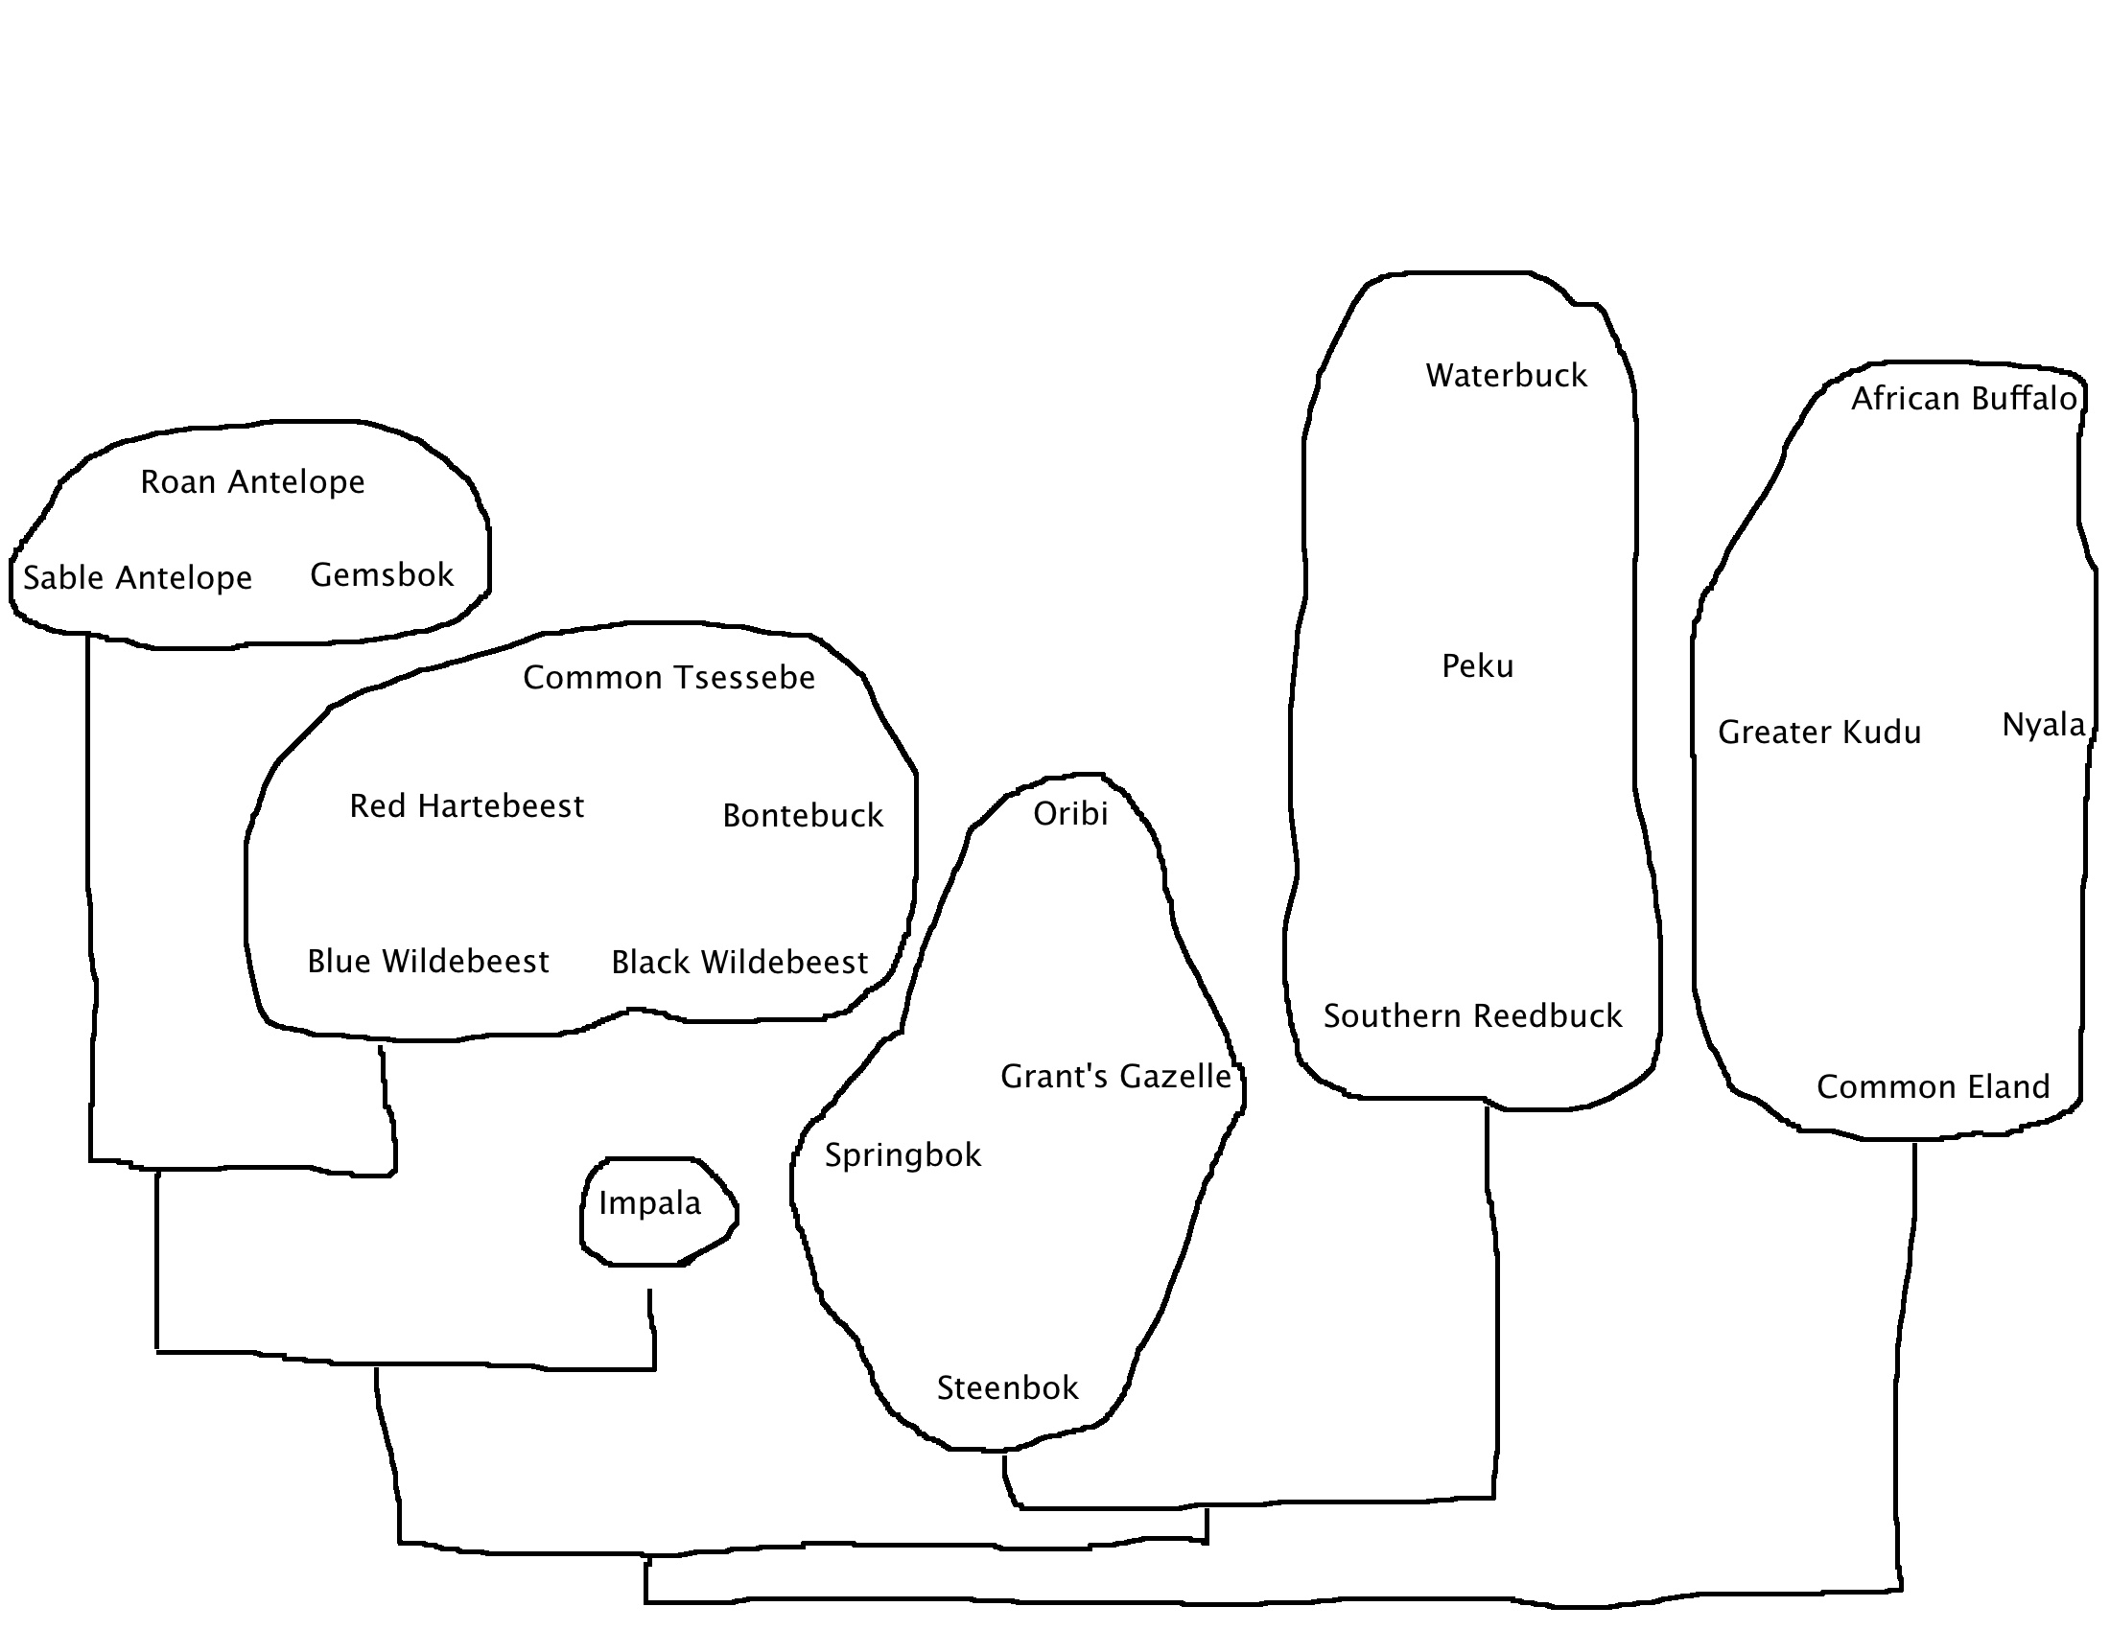
Look at the members within each sub-family (the animals circled together) and write down some traits that they share.

Can you see some ways that all of the other animals are similar to one another yet different from the four animals all the way on the right (those being the most distantly related)?

What are some traits that all of the animals share, since everything on the wall descended from a common ancestor?

