Other Jigsaw Assignments and Templates
Barbara Tewksbury
Hamilton College
btewksbu@hamilton.edu

Template #1 for using the jigsaw technique
(analysis of this template appears on page 2)

Smelting in Pre-colonial Africa

When thinking about minerals in Africa, we tend to link African mineral exploitation to the Europeans. People commonly believe that civilization and technology on the African continent were practically nonexistent until Europeans began to explore the region. In reality, pre-colonial African societies flourished south of the Sahara, and Africans were both culturally and technologically active long before European nations invaded the African continent. Some very recent archaeological evidence even suggests that smelting of metallic ores may have originated in Africa, not in Eurasia as everyone has assumed for years.

Everyone reads: Herbert, Eugenia, 1984, Red gold of Africa: Madison, WI, Univ. of Wisconsin Press, p. 3-11.

Write short answers to the following: What are metallic ores? What is smelting, and why is it necessary? How did smelting likely originate? Are all metallic ores equally easy/difficult to smelt? Bring two copies of your answers.

Team 1: the metallurgists
Write a summary outlining the smelting process described in the article listed below and indicate what happens chemically during the various steps of preparing and smelting iron ore in traditional fashion. Bring two copies of your summary to class.

Van Noten, Francis and Raymaekers, Jan, 1988, Early iron smelting in Central Africa: Scientific American June 1988, p. 104-111.

Team 2: the ritualists
Write a summary outlining the smelting process described in the articles listed below and indicate what the ritualistic significance is of the various steps in preparing and smelting iron ore in traditional fashion. Bring two copies of your summary to class.

Rowlands, Michael and Warnier, Jean-Pierre, 1993, The magical production of iron in the Cameroon Grassfields, in, Shaw, T., Sinclair, P., Andah, B., and Okpoko, A., eds., The archaeology of Africa: London, Routledge, p. 520-530.
Collett, D.P., 1993, Metaphors and representations associated with precolonial iron-smelting in eastern and southern Africa, in, Shaw, T., Sinclair, P., Andah, B., and Okpoko, A., eds., The archaeology of Africa: London, Routledge, p. 502-504.

In class: In class, you will be paired with a person from the other team. Compare what you learned about the ritualistic and metallurgical aspects of smelting. What does “ritual” mean? Which ritualistic aspects have a basis in metallurgy? What does each of those steps accomplish? Which steps are purely ritual?

Follow-up written assignment: After class, write a short paper answering the questions listed under “in class”; turn it in on Friday.
Analysis of template #1 for the jigsaw assignment

This is a very simple jigsaw assignment with only two teams and with little guidance on pre-class preparation other than to answer a few simple questions and prepare a summary (see template #2 for contrast). Here are a few things to note:

• Written preparations are collected at the start of class (students bring two copies to class, one to turn in and one to work with during class).
• At the start of class, I divide the class into their respective teams to share ideas about how they will convey what they know to a member from the other team and to clear up any confusions. Because this is a two-team assignment, each team consists of nearly a dozen people. During the team meetings, I divide each team up into smaller subteams of 3-5 so that they can work effectively. At the beginning of class, then, the class is divided into teams of 3-5, with several team #1’s and several team #2’s. My TA’s and I circulate to make sure that each team is on the right track before forming mixed groups.
• After all teams are ready, students pair up with a member from the other team. If there are an odd number of people in the class, one group will have three instead of two.

Template #2 for using the jigsaw technique
(analysis of this template appears on page 8)

Climate in Iceland over the past 1000 years

For the next several weeks, we will be looking at climate changes, glaciers, and the spectacular intersection between glaciers and volcanoes in Iceland.

Iceland has what can be termed a “threshold climate” – minor changes in temperature can mean major effects on the population that include crop failure and expansion of glaciers. Reconstructing climate and changes in climate can be done in a number of ways. We’ll investigate 4 ways of reconstructing climate change in Iceland over various portions of the last 1000 years, and we’ll consider the limitations of using glacial fluctuations as a proxy for climate change.

Team #1: using historical records to reconstruct climate

Read the following article:

ﬁórarinsson, Sigur› ur, 1956, The thousand years struggle against ice and fire: Reykjavík, Bókaútgáfa Menningarsjó› s, p. 5-20, 35-40.

Prepare a handout that shows periods of warmer and cooler climate in Iceland over the past 1000 years, along with what evidence ﬁórarinsson used to draw those conclusions.

Come prepared to teach the rest of the class about the following issues:

a) What is drift ice, and where does it come from? How do the marine currents around Iceland control both the climate of Iceland (which is considerably warmer than one would expect for its latitude – modern Reykjavík has a winter climate not all that different from New York City) and the distribution of drift ice in a typical year in Iceland?
b) In terms of a climate threshold, why are severe ice years particularly devastating for Iceland?
c) ﬁórarinsson attempts to put together a historical picture of drift ice since the Time of Settlements. What are the limitations of this type of reconstruction, which is based on written historical documents? What overall conclusion does ﬁórarinsson draw about drift ice over the last 1100 years in Iceland?
d) How have people used changes in cereal cultivation as a proxy for changes in climate? What are the potential problems in drawing correlations between changing crops and changes in climate? What does ﬁórarinsson conclude?
e) What do historical records suggest about the positions of the margins of outlet glaciers of the Vatnajökull since the Time of Settlements?

Team #2: using historical records to reconstruct climate

Read the following article:

Ogilvie, A.E.J., 1992, Documentary evidence for changes in the climate of Iceland, A.D. 1500 to 1800, in, Bradley, Raymond S. and Jones, Philip D., eds., Climate since AD1500: New York, Routledge, p. 92-117.

Prepare a handout that illustrates what the documentary evidence suggests about climate in Iceland between AD1500 and 1800 and what evidence is used to draw the conclusions.

Come prepared to teach the rest of the class about the following issues:

a) The article states that the place in Iceland with the highest precipitation between 1931 and 1960 was as Kvisker, in south Iceland, with an annual average of 3300 mm. By contrast, Myvatn in north Iceland annual average was 394 mm. How much is that in inches per year, and how do these values compare to annual precipitation in Clinton? Why does less rain fall in the north and northeast of Iceland than in the south?
b) What is sea ice or drift ice, and where does it come from? Why is the extent of sea ice near Iceland used as a proxy for direct climate records?
c) What kinds of written sources exist that give information useful to reconstructing climate, and what types of information are available? How does one go about reconstructing climate from the types of information discussed in the article?
d) What does the documentary evidence suggest about temperature and sea-ice variations between AD1500 and 1800 in Iceland, and what does that suggest about the climate overall in Iceland in this time period?
e) What are the limitations in using documentary evidence as a proxy for determining climate?

Team #3: dating moraines using lichenometry

Read the following articles (read them in the following order):

Kugelmann, Ottmar, 1991, Dating recent glacier advances in the Svarfa› ardalur-Skí› adalur area of northern Iceland by means of a new lichen curve, in, Maizels, J.K. and Caseldine, C., eds., Environmental change in Iceland: Past and Present: Amsterdam, Kluwer Academic Publishers, p. 203-217.
Caseldine, Chris, 1985, The extent of some glaciers in northern Iceland during the Little Ice Age and the nature of recent deglaciation: The Geographical Journal,.v. 151, p. 215-227.

Prepare a handout showing what lichenometry indicates about time periods of glacial advance and recession in northern Iceland over the past 150 years or so. Be sure you also have maps to illustrate your points.

Come prepared to teach the rest of the class about the following issues:

a) What is lichenometry, and how does it work? How did Kugelman develop a lichen growth curve for northern Iceland?
b) Why do moraines lend themselves so well to being dated using lichenometry? What magnitude error (± how many years) does Kugelman suggest for morainal dates where he tested his lichen curve in ﬁveradalur? How does this compare to Caseldine’s error bars?
c) How do moraines form, and what do they tell us about the behavior of a glacier at a particular time?
d) What do the ages of moraines in Tröllskagi indicate about glacier positions over the past 150 years or so? Why can’t the studies be extended farther into the past?
e) How might temperature changes influence the a glacier? To what extent do you think morainal positions and the behavior of a glacier margin can serve as a proxy for climate changes?

Team #4 using remote sensing:

Read the following articles:

Williams, Richard S., Hall, Dorothy K., Sigur› sson, Oddur, and Chien, Janet Y.L., in press, 1997, Comparison of satellite-derived with ground-based measurements of the fluctuations of the margins of the Vatnajökull, Iceland: 1973-1992: Annals of Glaciology, v. 24.
Williams, Richard S., Jr., 1987, Satellite remote sending of Vatnajökull, Iceland: Annals of Glaciology, v. 9, p. 127-135.

Prepare a handout showing what remote sensing of the Vatnajökull indicates about the positions of the various outlet glacier margins between 1973 and 1992. A map would be a really good base to use for such a handout – make sure it has the names of all of the outlet glaciers on it (Williams et al. have a nice one in their 1997 paper).

Come prepared to teach the rest of the class about the following issues:

a) What kinds of interesting things did the satellite images reveal about the Vatnajökull that are difficult to study on the ground?
b) How is remote sensing used to compare positions of glacial margins over time? What are the difficulties and limitations?
c) What happened to the margins of the various outlet glaciers of the Vatnajökull over the 20-year time period covered by the study?
d) What do you think the limitations are of using glacier margin positions as a proxy for climate?

Team #5: the problem of glacial surges

Read the following article:

ﬁórarinsson, Sigur› ur, 1964, Sudden advance of Vatnajökull outlet glaciers 1930-1964: Jökull, v. 14, p. 76-89.
ﬁórarinsson, Sigur› ur, 1969, Glacier surges in Iceland, with special reference to the surges of Brúarjökull: Canadian Journal of Earth Sciences, v. 6, no. 4, p. 875-882.

Come prepared to teach the rest of the class about the following issues:

a) What is a glacial surge, how fast does a glacier move during a surge, how long do surges typically last, and what does a glacier look and sound like during a surge?
b) Which glaciers of the Vatnajökull have exhibited surge-type behavior in the 20th century?
c) What might cause a glacier to surge?
d) What do you think the limitations are of using glacier margin positions as a proxy for climate information?

Please bring the following to class on Wednesday:

– detailed written answers to the questions for the reading assigned to you, plus the handout we asked you to prepare. This must be an individual effort – each person must turn in his/her own work.These questions are designed to help you to be sure that you understand the reading and don’t miss any important points. If you do not understand anything in your article(s), please come see one of us early (not Wednesday noon).
– In class on Wednesday, you will have 5-10 minutes to explain the important aspects of the topic you have prepared to a group of people who have prepared other topics. In order to prepare to teach them, do the following after you have prepared your handout and answers to your questions. Use the form on the next page. Again, this must be an individual effort.

– Step back, and look at the article(s) and the answers to your questions. Write three to four sentences that summarize the most important message(s) you want to convey about your topic. You will start with this summary when you teach your group.

– Decide what information you will present to your group in order to support your main points and to explain the topic clearly. Make a list or outline of those topics, as well as specific data/information not on your chart that you will need when you elaborate on what appears in those topics. Remember that you must not simply recite your summary page – you must sort out what picture you want to paint and muster the evidence that your summary statements are correct.

Preparation for teaching – remember that you will have only 5 minutes to talk!!

Name Team # & topic

Summary statement (three to four sentences summarizing the most important messages you want to convey about the article(s) you read.

Outline of topics plus additional facts/data (this outline must contain the topics that you need to cover in order to elaborate on your summary statements and to provide evidence that your summary statements are reasonable; include any additional facts, data, or tidbits that are not on the handout you prepared)

Analysis of template #2 for the jigsaw assignment

This jigsaw assignment provides more guidance to prepare students for peer teaching than does template #1.

Purpose of the jigsaw:

• To have students construct an approximate temperature curve (average temperatures higher than, lower than, or similar to today) for Iceland for the past 1000 years based on a variety of climate proxies.
• Each student studies a different proxy, and the group puts the data together to construct the curve. No one student would have time to study all of the proxies, so this is an ideal assignment for the jigsaw technique.

Part I: preparation before class

• Questions to guide reading: If you want to students to come well-prepared for peer-teaching, you should provide them with specific questions to answer as they do the reading. If you don’t, they will likely not prepare in the manner you would if you were reading the article and will not be adequately prepared to teach the topic to someone else. The questions in this assignment provide that kind of preparation.
• Preparation of a handout: For a topic involving graphs, photos, maps, etc., a handout is a valuable addition to help a student in peer teaching. This assignment requires students to prepare an appropriate handout and bring enough copies for his/her mixed group.
• Preparation of a teaching sheet: When asked to peer teach in the mixed group, many students will simply say, “The answer to question #1 is .....; the answer to question #2 is....”. This is not what you would do if you were teaching. You would step back from a topic and ask what the most important message was and then decide how to convey it. Asking students specifically to do this improves the quality of peer teaching. This template has a “teaching sheet” that asks for a summary statement plus the ideas that help support that statement. This can be completed ahead of time, or teams can be asked to discuss it and complete it during the team meetings at the start of class. The rule for students, then, is to use the teaching sheet, rather than the list of preparation questions, to make the points during peer teaching.

Part II: in class

• This assignment is the same as template #1 for both beginning-of-class team meetings and mixed groups.

Part III: group assignment

• The group puts the temperature curve together on a large sheet of shelf paper on the basis of shared information and discusses several questions listed on the last page of the template.
• The group receives a group grade on the basis of their temperature curve and answers to discussion questions. Individuals receive an additional grade on their preparation and handout.
Template #3 for using the jigsaw technique
(analysis of this template appears on page 27.

Holocene Paleoclimate Variations in the Sahara
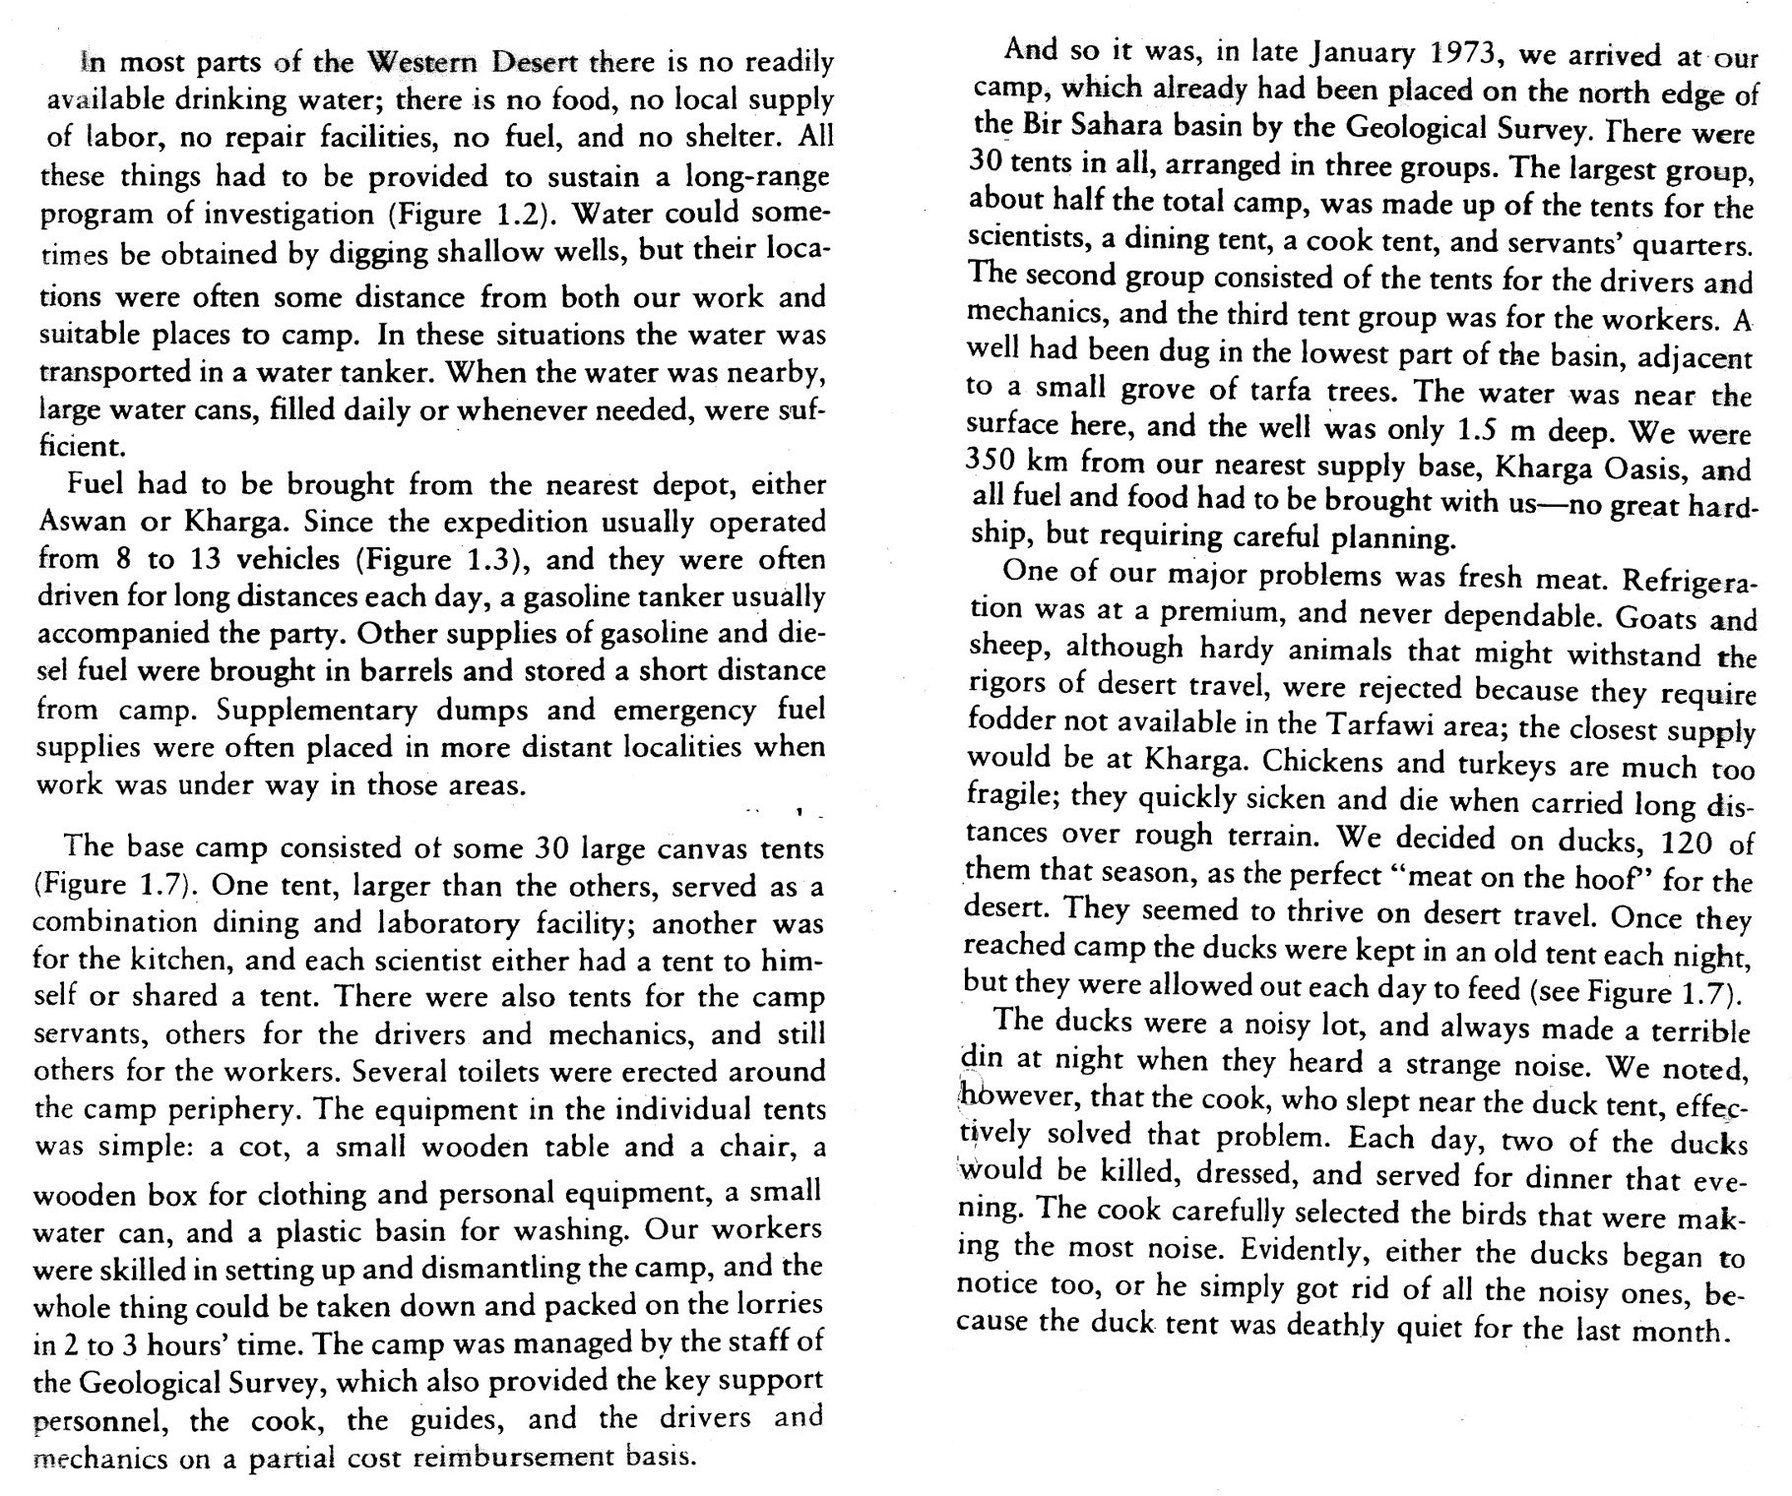
Evidence for climate change in the Sahara
The expedition to this region was not aimed at studying the sand dunes and sheets; rather, it was aimed at studying the remains of prehistoric people who actually lived in this area. At excavation sites as bleak and uninviting as the photos you have already looked at, expedition members found thousands of stone tools, clusters of grinding stones and fire-blackened rocks, bones of gazelles, and human burial sites. There is nothing to burn in the area today, nothing to grind for food, no water to drink, no animals to eat (unless you bring your own ducks). The area clearly must have been wetter in the past in order for people to have survived. Many pieces of evidence suggest that this is so. First, this area is very near the “radar rivers” of the eastern Sahara, which indicate clearly that the climate was much wetter in the past. Second, deposits of sediments predating the sand sheets and dunes at the sites contain abundant evidence for wetter climates. For example, a sequence of sediments in Bir Sahara contains dark layers of burned vegetation, layers of lake sediments, and a conspicuous layer of light sand with dark casts of plant roots. Other areas show pancakes of eroded lake (or lacustrine) limestones.

Evidence such as this can be found all over the Sahara in areas that are completely inhospitable today. In the relatively recent past, lakes and swamps dotted the depressions between inactive sand dunes in the great ergs (sand seas) throughout large parts of the Sahara, and the grasslands of the Sahel spread hundreds of kilometers north, forming blankets of continuous vegetation in areas where nary a blade of grass exists today. Evidence also exists for time periods that were even drier than the modern climate, when the inhospitable climates of the Sahara extended much farther south than they do today. No one questions whether the Sahara was wetter at some times in the past and drier at others. The big questions have been how wet, how dry, and when?

We would need a time machine to be able to actually measure temperature or rainfall at some time in the past or to see ancient vegetation and animal life. Too bad we don’t have one! We can, though, still establish temperature and rainfall patterns and deduce what vegetation and animal life must have been like in the past if we know what clues to look for in the geologic record. Fortunately for us, climate changes leave traces we can read.

Being able to work backwards from the sediments preserved at a site to the kind of environment in which they must have been deposits is one of the primary keys to reconstructing paleoenvironments.

Taoudenni
Let’s take an excursion to the Sahara of Mali. Hop up and take a look at the Michelin road map of North Africa that’s posted on the bulletin board. Find Tomboctou (Timbuktu), Mali – it’s at about 3°W, 17°N. Now, go north along the progressively sketchier track until you’ve gone well over 500 km and reached a place called Taoudenni. Have a look around Taoudenni – this is a place truly in the middle of nowhere. What is the latitude of Taoudenni?

Less than 5 mm or rain falls annually at Taoudenni! That’s less than ¹/₄" of rain every year! This is not an hospitable place. What’s at Taoudenni that anyone would want?? Salt. Yup – people have been mining salt at Taoudenni and at other sites in the Sahara for centuries, and salt caravans have been an integral and vital part of trade in North and West Africa. The deposits are still worked today in the same way that they were worked in the 16th century, and camel caravans still carry salt 500 km south across the desert to Timbuktu.

The salt deposits lie right at the surface in a depression 4 km across or so within the larger Taoudenni Depression (map page 9) and amount to a staggering total of about 7 million tons of salt! Well. Salt doesn’t just fall out of the sky. What does the presence of salt suggest about past conditions in the Sahara? Explain.

Data from other sites in the Sahara
On the pages 6-13, you will find data from 4 sites scattered across the central Sahara. These data include the following:

– stratigraphic column showing sediment types
– radiocarbon dates, including what the dates were obtained on and where the samples were located in the section
– fossils, including microfossils, found in sediments in the section
– information on large animal populations and human activities, evidence for which may come from the immediately surrounding area rather than the section itself.
– information on floral remains, which may come either from vegetal remains (either in situ or having floated out onto a lake and sunk) or from pollen preserved in the section. Shape and size of pollen vary from species to species, and pollen analysis (palynology) of sediments can provide valuable information about what species were in the vicinity of the sample site. How representative a sample is of the actual vegetation depends upon 1) how far the wind carried pollen from various species and 2) whether conditions were right for preservation of pollen in the sediments.
– a map on page 5 showing modern vegetation zones in North Africa, with lists of important plant species from each zone.

Your team assignment:

– locate your site on the map of the Sahara that I’ve given you.
– examine the data from your site. You will find reference information on various rock and sediment types at the end of this handout.
– develop a picture of what your site must have looked like at various times.
– establish the major changes in the environments of deposition (e.g., change from beach to dune to lake bottom to whatever), with evidence for those changes, and the timing of those changes.
– assess what your section suggests about overall patterns of climate change in the area and why, and what the timing of changes appears to have been.

Once your group has worked through your column, have one of us check over your conclusions. Then, decide how to go about conveying all of the points listed above, starting with a descriptive picture of what the area must have looked like at various times. Remember that you are a geologist charged with conveying a detailed and convincing argument clearly supported by specific pieces of data (e.g., pollen, radiocarbon dates, sediment type, etc.).

Major Floristic Regions Of North Africa With Characteristic Pollen Taxa

III – Saharan: desert with very limited pollen flora. Wadis typically contain Tamarix, Cornulaca, Calligonium, Fagonia, Salvadora, Maerua.

IV – Sahelian: sparsely wooded desert grassland and thorny shrubland; grades into Saharan type in the north and to Sudanian type in the south.

Acacias of various species are ubiquitous (these are the thorny trees of the Sahel); also Commiphora, Blepharis, Balanites, and the shrub Tribulus.

Rainfall determines which annual and perennial herbaceous plants and shrubs form the ground cover in a particular place. In the wetter parts of the Sahel, Graminae (grasses) and Cyperaceae (plants that grow on and stabilize inactive sand dunes) dominate. In drier (notice that I spelled this correctly this time, and didn’t use “dryer”, as in washer and dryer, like I did last time...) parts, Chenopodiaceae and Amaranthaceae dominate.

V – Sudanian: wooded savanna and dry forest. The most common tree taxa are Grewia and Piliostigma. Other species of plants include Celtis integrifolia, Combretaceae, and Lannea.

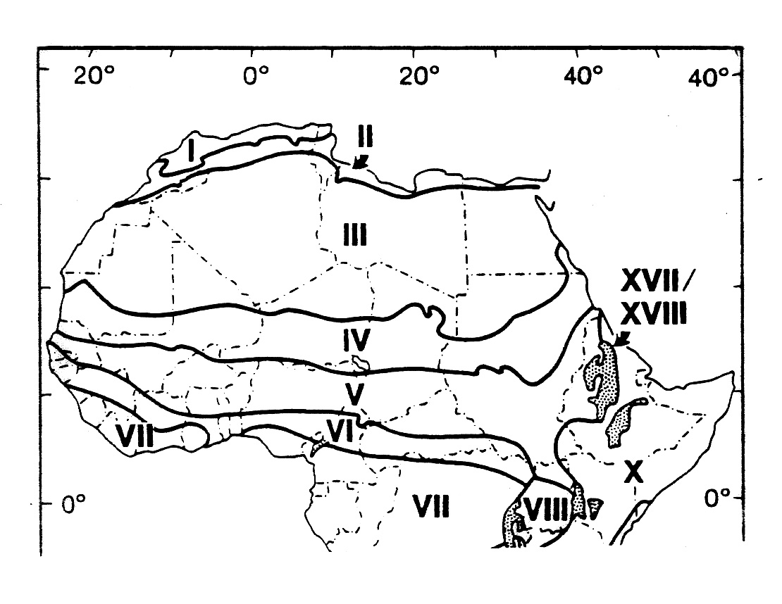
#1 Teams Haijad, in the Taoudenni Depression

Taoudenni Depression is a internally-draining basin that currently contains no surface water, seeps, or springs. During the Holocene, however, many lakes and marshes developed in the area, as show in figure 1. The Taoudenni paleolake that we looked at earlier today is the most well-known of all of these lakes, because it was saline and left behind salt deposits that have been exploited for centuries. The other lakes in the Depression do not have associated salt deposits.

Haijad paleolake lies about 20 km southeast of Taoudenni paleolake (figure 2) and at a slightly higher elevation. Modern rainfall in the Haijad area averages less than 5 mm per year, and vegetation is virtually non-existent.

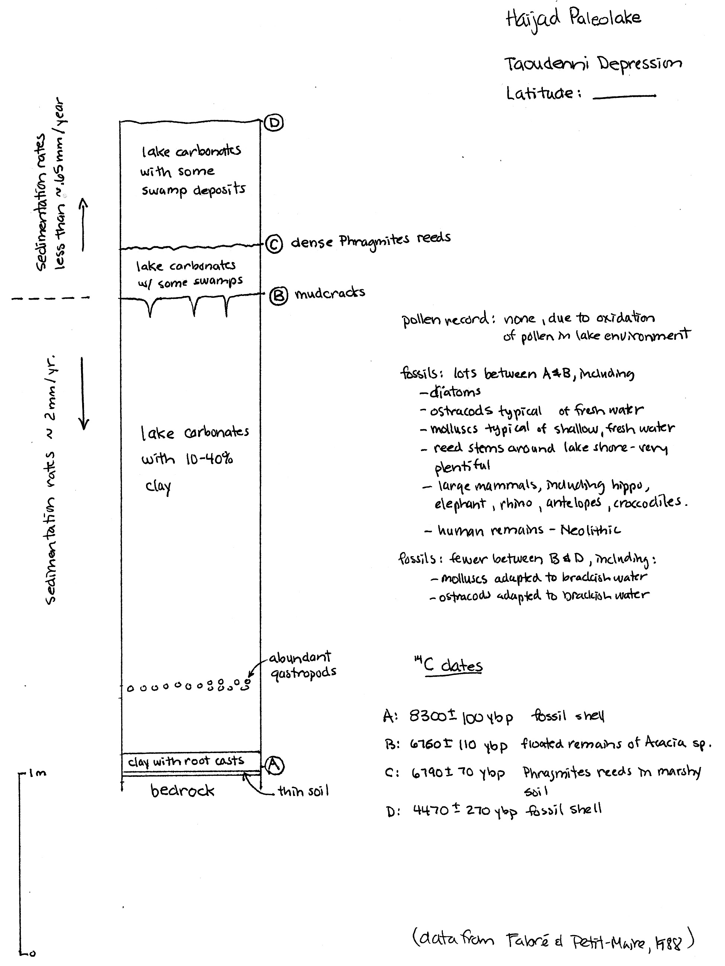
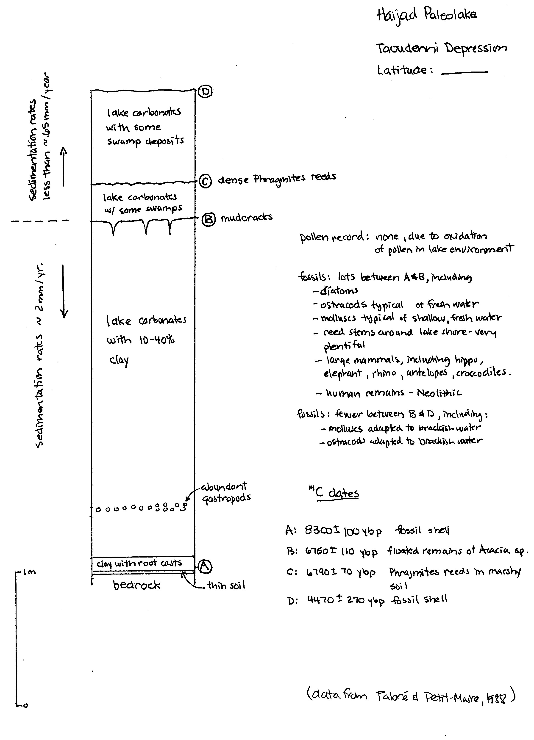#2 Teams Adrar Bous, in the Ténéré Desert

Adrar Bous is large area of exposed bedrock located in the drifting sands of the Ténéré Desert about 65 km east of the Aïr Mountains of northern Niger. Locate Adrar Bous on your large map. Agorass N’Essoui paleolake that formed in a small depression on the south side of Adrar Bous (locate the paleolake on figure 3).

Modern rainfall in the Adrar Bous area averages well less than 50 mm per year, and vegetation is virtually non-existent.

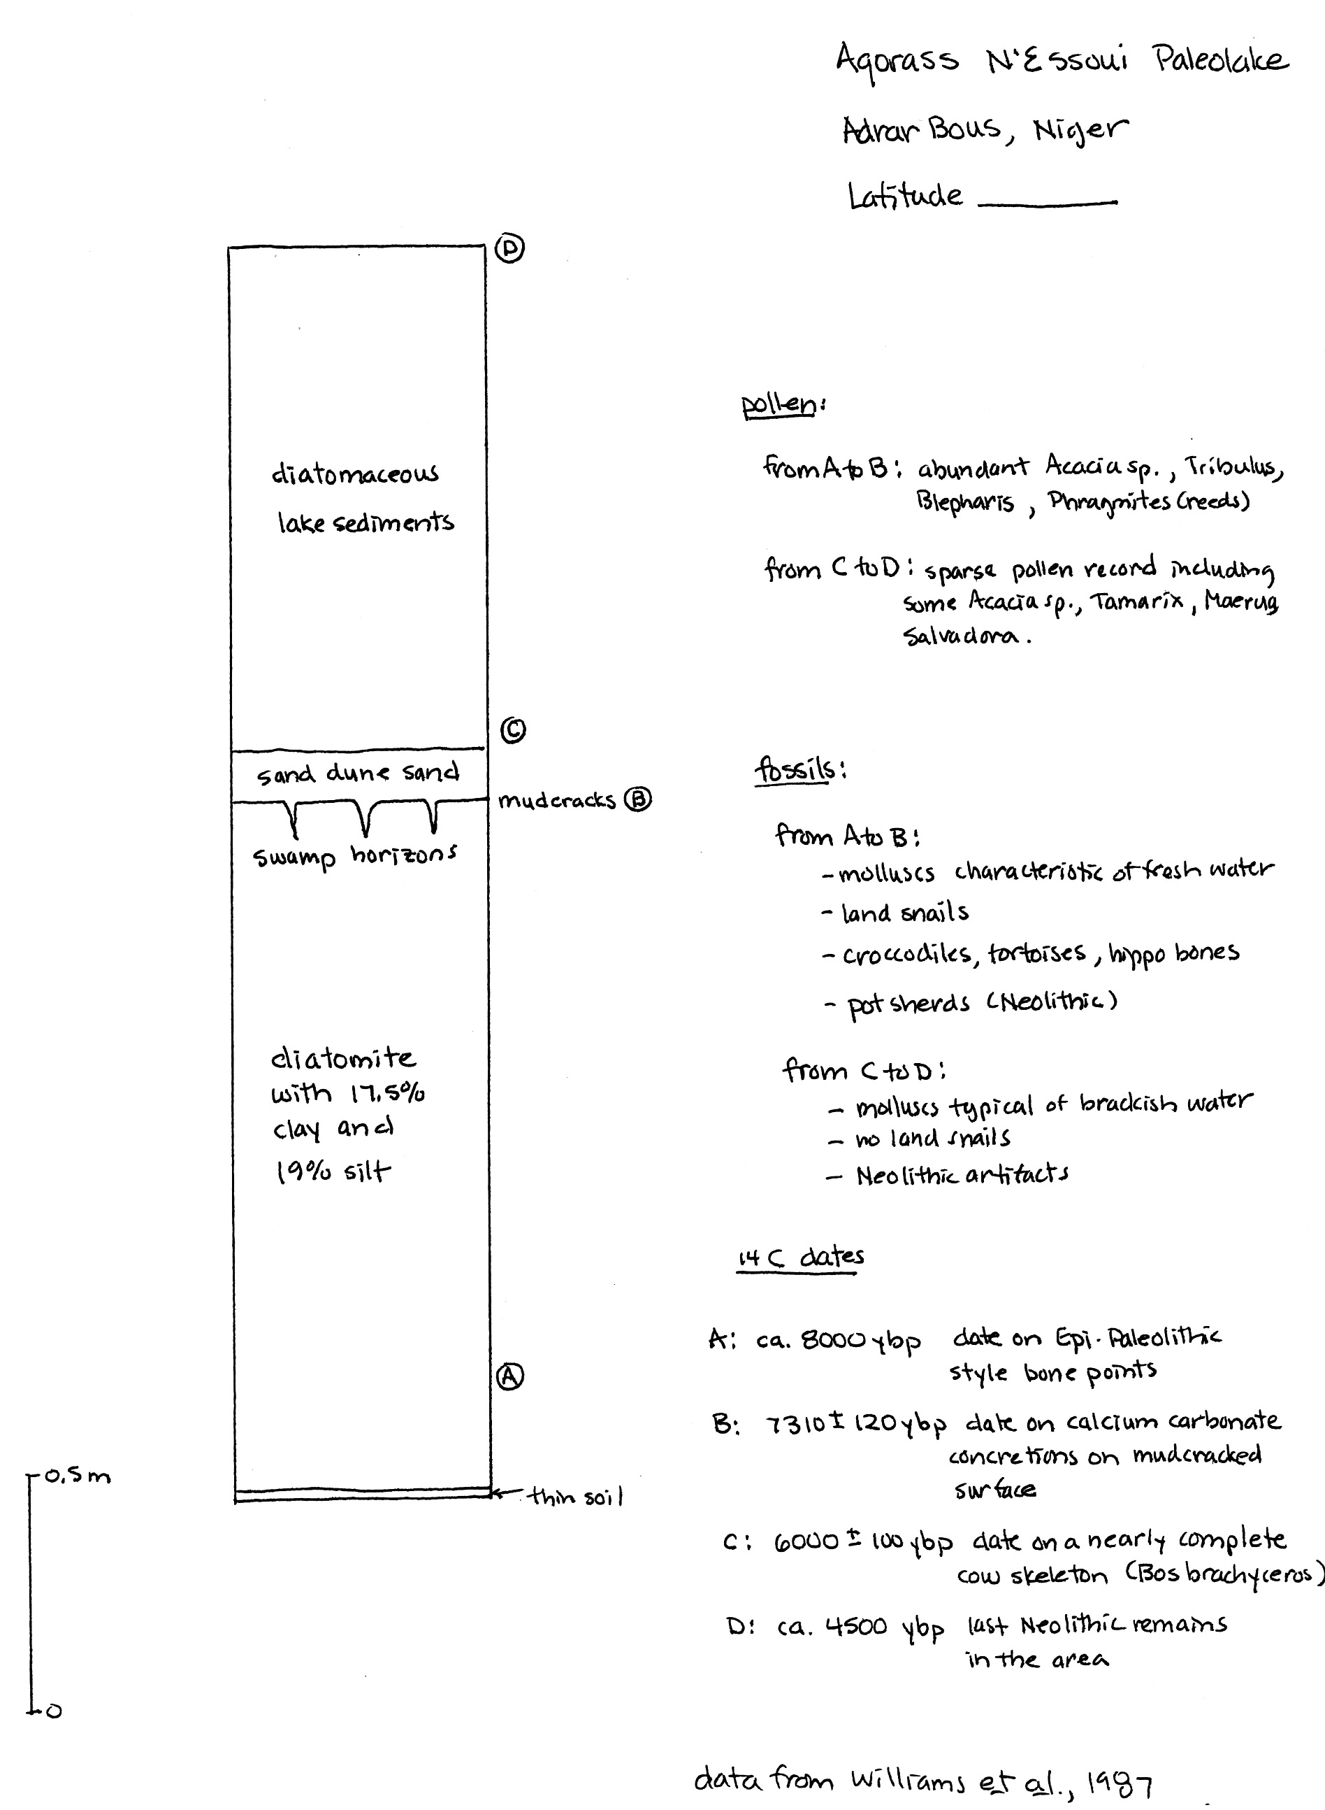
#3 Teams Selima, in northern Sudan

Selima paleolake is on the margins of what is now an uninhabited oasis in northern Sudan near the Egyptian border (figure 4). Selima paleolake lies just south of the “radar rivers” we talked about in class. Locate Selima on your large map of the Sahara.

Before the end of the slave trade in 1898, Selima was a major watering place on the trade route from Darfur, Sudan to Assyut on the Nile. The oasis depression does not contain a modern lake.

Selima is located within the Darb el Arba’in Desert, which averages less than 10 mm of rainfall per year.

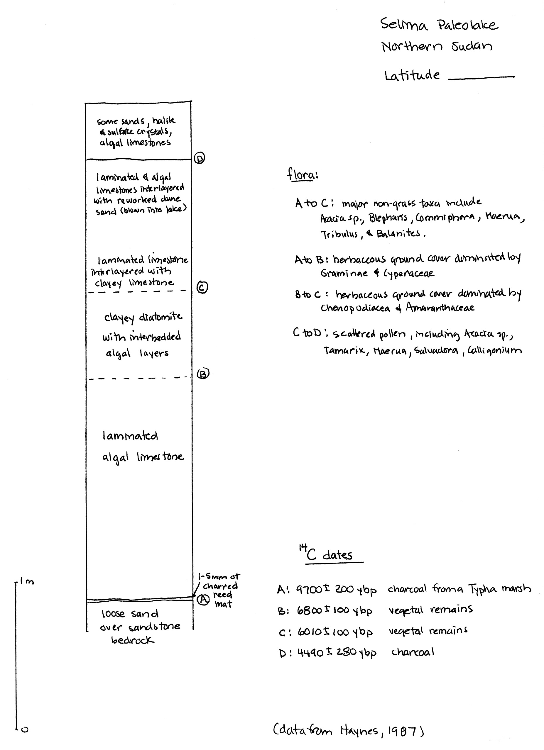
#4 Teams Oyo, in northern Sudan

Oyo paleolake lies in an area of northern Sudan that contains evidence of many paleolakes, as well as a paleoriver, Wadi Howar. Locate Oyo on your big map of the Sahara.

Figure 5 is a wonderful map summarizing many of the features of the region at the time the paleolake was present at Oyo and shows clearly that Oyo is not unique. This area is now an arid to semi-arid desert averaging less than 20 mm of rainfall per year.
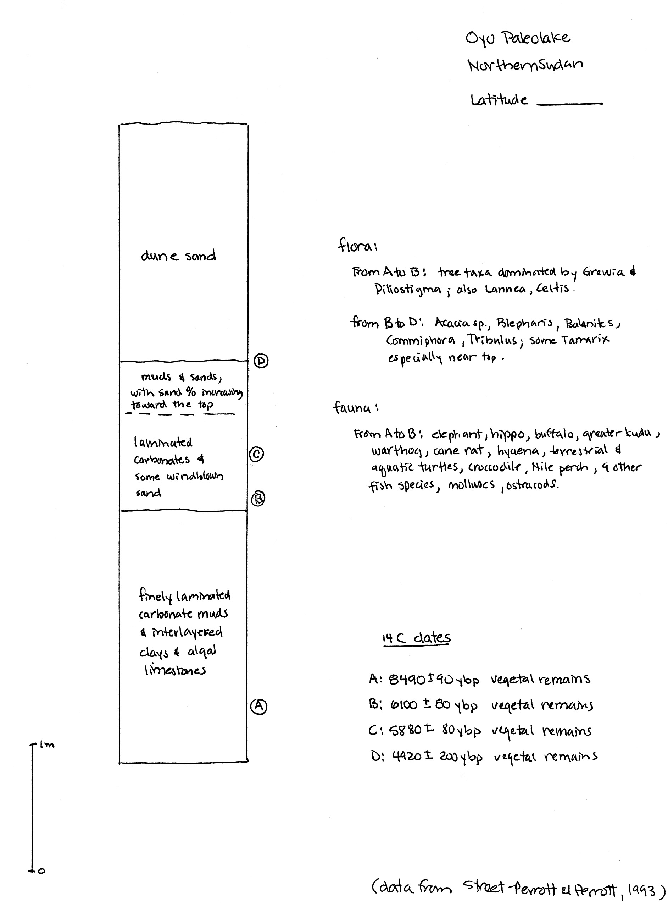
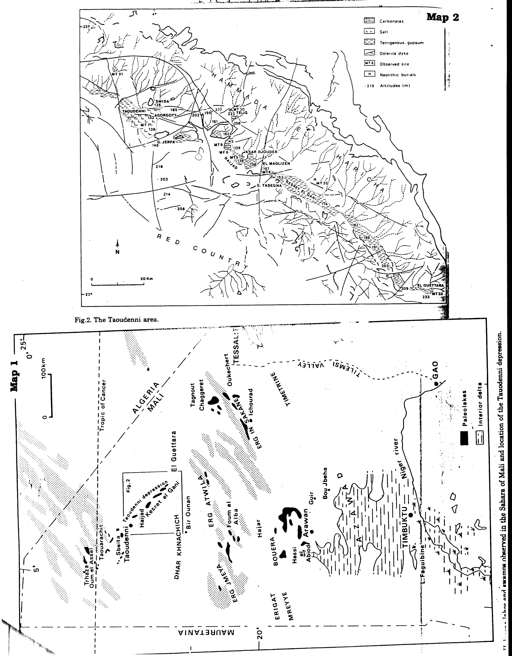
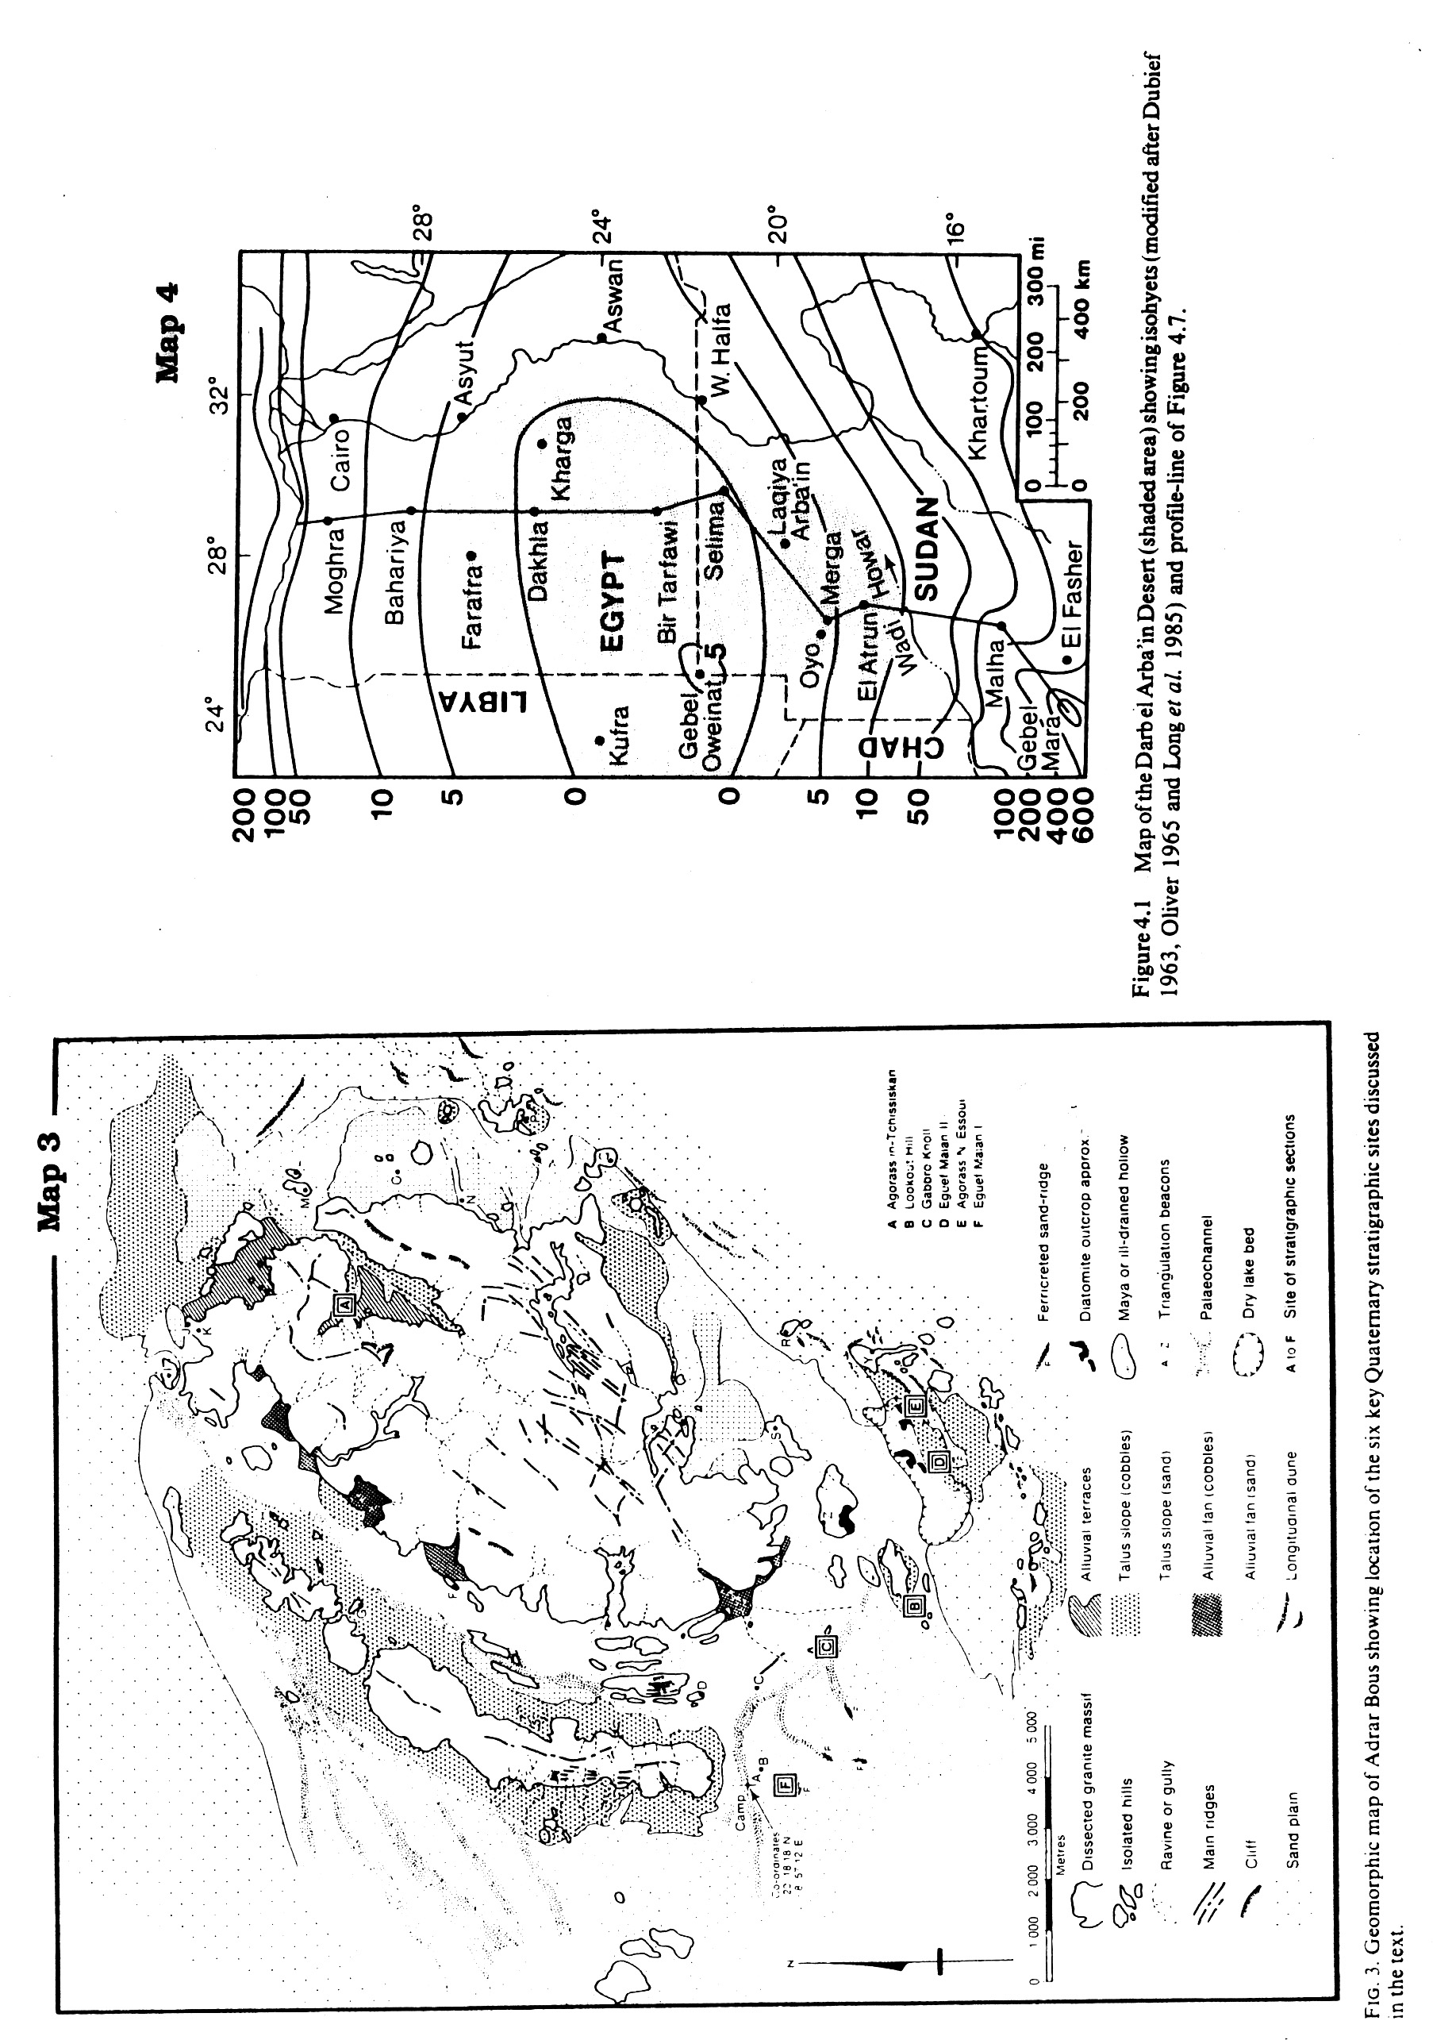
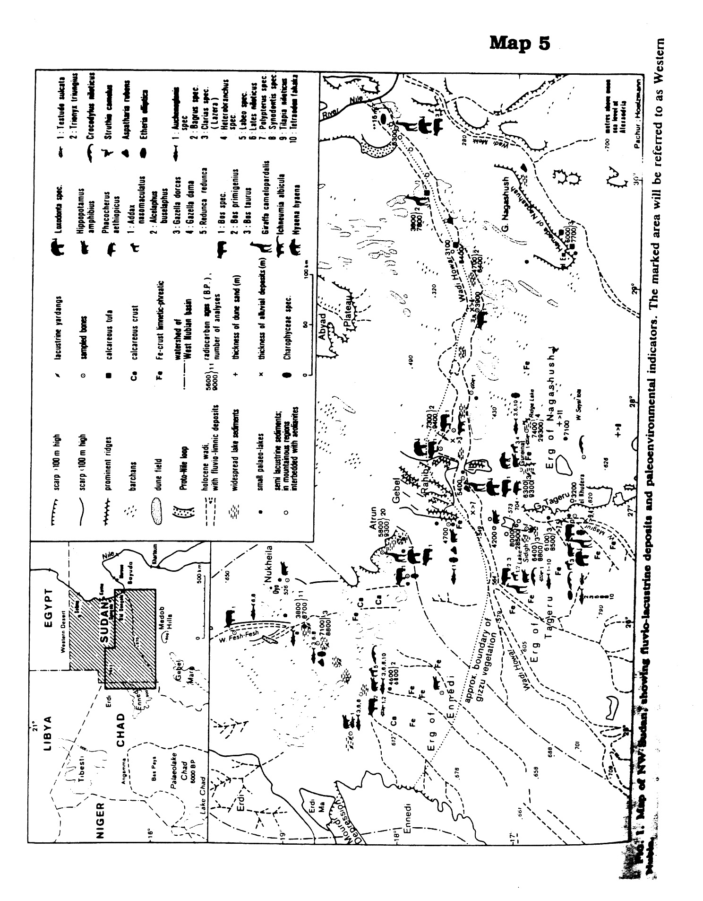
Reference information:

laminated clay or silt and clay: fine particles of quartz and clay minerals weathered from pre-existing rock enter the lake via permanent or intermittent streams and settle slowly out of the quiet lake waters, forming fine layers of clay or silt and clay. Sedimentation rates give a clue to rainfall – the higher the rainfall, the greater the amount of clay washing into the lake. Look at the sample.

limestones: limestones are rocks made up of the mineral calcite (CaCO₃ – a carbonate mineral); they don’t form by the accumulation of particles weathered from pre-existing rock and transported to the site of deposition. Rather, carbonate sediments that become limestones are formed at or near the site of deposition by biologic or chemical processes. Lacustrine limestones typically form from either biogenic precipitation of calcite or biogenically-induced precipitation of calcite. In the first case, organisms extract calcite directly from lake water to build their skeletons, which accumulate as carbonate sediments when the organisms die. In the second case, photosynthesis changes the chemistry of the lake water by removing CO₂. Calcite becomes less soluble and precipitates out. If precipitation results in finely layered sheets of carbonate, the sediment is called a laminated carbonate mud. If the carbonate sediment occurs in lumpy mats cementing algae together, such a sediment is called an algal carbonate sediment. Carbonate sediments eventually harden into limestones. Look at the sample.

diatomaceous sediments: Single-celled microorganisms called diatoms extract silica (SiO₂) from lake water to form tests in which they live. Come up to the front of the room, and have a gander through the microscope at some of these little beauties. While the diatoms are alive, they float around in the water. When they die, their tests sink to the bottom of the lake and accumulate as sediment. If very little other sediment is accumulating along with the diatoms, layers of pure diatomaceous sediment may form. If clay or carbonate is accumulating too, the sediment will be mixed. If you have a swimming pool at home, your swimming pool filter likely is filled with diatomaceous earth – the stuff makes a nice, fine-grained, inert material for filtering your pool water. Diatomaceous sediment hardens into a rock known as a diatomite. Look at the sample.

evaporites: If a lake lies in an isolated basin where significant evaporation is taking place, the concentration of dissolved salts can increase, making the lake brackish (slightly salty) or saline (very salty). As the lake becomes saltier, minerals will begin to precipitate out and accumulate in the sediments. Sediments consisting largely of minerals precipitated by evaporation are called evaporites. Minerals that are less soluble will precipitate first. Sulfate minerals (containing sulfur and oxygen) are common early precipitates. Salt (NaCl – sodium chloride, or table salt), on the other hand, is so soluble that huge quantities of water must evaporate away before the lake water is concentrated enough that salt begins to precipitate out and accumulate on the lake bottom as layers of salt. Animals and plants are pretty unhappy about living in this kind of a lake. Look at the sample.

halite and sulfate crystals in sediments: Sediments deposited in salty lakes undergoing evaporation can have halite (NaCl) crystals or sulfate (gypsum) crystals (CaSO₄.2H₂O) that have crystallized from the salty pore waters in the sediment.

Analysis of template #3 for the jigsaw assignment

This jigsaw assignment is a good example of 1) a jigsaw that does not require out-of-class preparation and 2) a jigsaw in which students gain the benefits of close examination of one set of data and exposure to similar but not identical data sets.

Purpose of the jigsaw:

• The purpose is two-fold: 1) to gain experience in reconstructing paleoclimates using the rock record and 2) to determine the timing of rainfall changes in the Sahara between 10,000 and 4,000 ybp and to subsequently correlate those changes with the development of Egyptian civilization. Both could be done via lecture, but students can “think like geologists”, analyze the data themselves, and come to the conclusions themselves in approximately the same length of time that it would take to do a complete lecture on the subject.

Part I: in-class preparation

• The class is divided into teams, and each team analyzes its own strat column, drawing conclusions about rainfall changes and marshalling evidence.

Part II: in-class peer teaching

• During peer teaching in mixed groups, students discover that the evidence is different for different strat columns (faunal in some, floral in others, sedimentologic in others) and that difference columns show different rainfall patterns. These kinds of differences make for a good jigsaw – each student doesn’t need to do a detailed analysis of all four columns in order to get the point, but each would be missing the variations unless he/she learned something about each column.

Part III: group assignment

• The group then puts together evidence form all four columns and evaluates the timing and pattern of climate change in the Sahara. Because there is not a clear “right answer”, different groups arrive at somewhat different conclusions (having placed more weight on certain differences and similarities than others), and all-class discussion at the end is a way to bring out the various possible conclusions.

