Case example: Structural control of giant
rock avalanches in Argentina

Hermanns and Strecker (1999) have identified colossal Quaternary rock avalanche deposits (sturtzstrom) in Argentina on satellite images. Rock avalanches are produced by sudden failure of a large mass of bedrock and catastrophically fast mobilization of the mass. It is much like a rock slide in origin but the mass breaks up and mixes with air in much the same way that a snow avalanche does. The rock avalanche roars down slopes at tens to hundreds of kilometers per hour.

The rock avalanches described in the study are truly enormous and involve between 3 x 10⁶ m³ and 375 x 10⁶ m³ of material (yes, that’s 3 to 375 million cubic meters of material!). In order to put that into perspective, do the following back-of-the-envelope calculations. Show all of your work, and be sure to show units.

- A good-sized one-family house has a footprint of about 9 x 9 m, and each floor is roughly 3 m high. If such a house has two floors, what is the total volume of the house in cubic meters?

How many houses would it take to make a total volume of 3 x 10⁶ m³? How about 375 x 10⁶ m³?

- The Hamilton College Field House is approximately 100 m x 50 m x 8 m. What is the total volume of the Field House in cubic meters?

How many Field Houses would it take to make a total volume of 3 x 10⁶ m³? How about 375 x 10⁶ m³?

In the map on page 3, you will see some of the rock avalanche deposits that Hermanns and Strecker mapped, along with the inferred scarps at the sources. Go to -27.172950, -66.171079 in Google Earth (this is Argentina, so make sure you have entered the lat/lon correctly and wind up in the right place!). This is the same area as shown in the map on page 3 – be sure that you zoom out a bit so that you can find both the rock avalanche deposits and the source regions that are shown on the map. Also be sure that you have a sense of the topography. The map also includes additional information about regional geology, plus stereonets that show the orientations of features in the bedrock in the source regions of the rock avalanches.

The authors suggest that earthquakes were responsible for triggering the rock avalanches. It is clear though, that, regardless of the trigger(s), the rock avalanches were sourced primarily in certain rock types in the region. Your job is to address the question of why the Sierra Aconquija rock avalanches were sourced dominantly in granite. Explain, and provide evidence.

And second, is this an area of the world that is likely to be vulnerable to earthquake activity that might have triggered these rock avalanches? Why or why not? Explain your evidence.

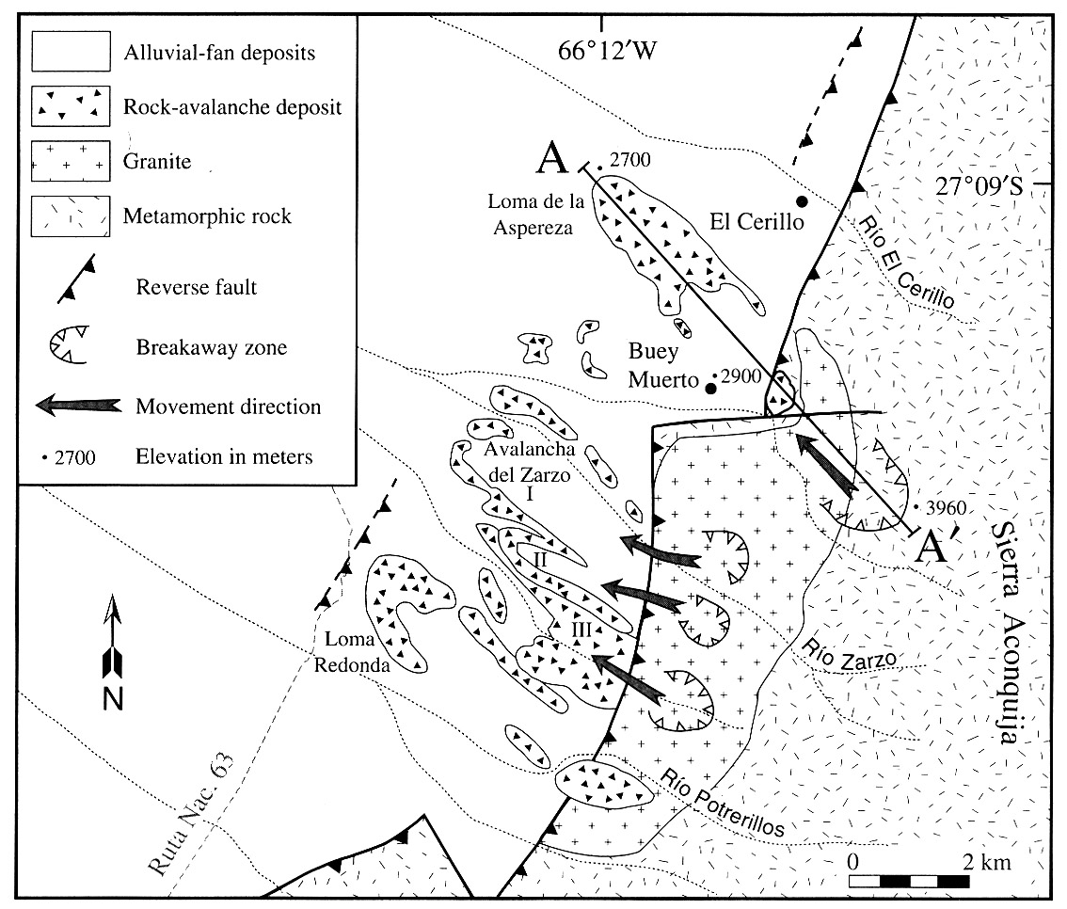
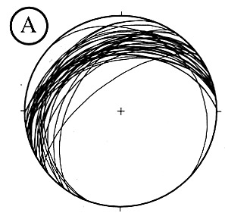
Data from the Southwestern Sierra Aconquija Slides:

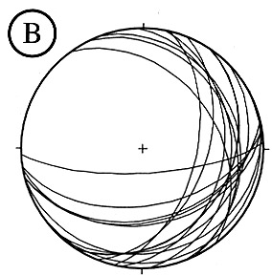

(Hermanns and Strecker, 1999)

Regional Geology:

- Sierra Aconquija is a 100 km-long basement block composed of biotite schist, augen gneiss, and granite.
- A geologic map with a few elevations in meters is shown above.
- Topographic relief between the valley and the range of 2500-3000 m occurs along the entire range front.
- Breakaway zones for the rock avalanches occur only in the area of granitic basement rock. The five best-preserved rock avalanches are shown on the geologic map above. These five avalanche deposits have an estimated volume of between 5 and 65 x 10⁶ m³.

Structural Geology

- Stereonet A above shows the orientations of exfoliation (sheeting) joints that occur only in the granite.
- Stereonet B above shows the orientations of schistosity in the metamorphic basement rocks.

