GEL 3300 Lab #2: Measuring Strain

The objective of this lab exercise is to use strain markers to determine the orientation of the finite strain ellipse for a deformed rock that contains deformed fossil brachiopods, let’s call them spirex such as this:

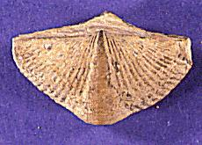

Since all of our fossils are deformed, we don’t know a priori the original length of any of the sides, but we do know that the angle between the two “axes” of the fossil was originally 90˚, so we can evaluate angular strain and shear strain. You will need a protractor, a ruler, and a calculator to complete this exercise.

1) Eventually we will construct a Mohr Strain diagram, but first, let’s make sure we all know what we’re doing.

- In the drawing below, the un-deformed ‘spirex’ is shown in gray, and after deformation is shown in black. The angle between lines A and B was 90˚ before deformation. Measure the angle between B₀ (B before deformation) and B₁ (B after deformation). This angle is the angular shear, Ψ, along line A. Remember there is a sign to this angle (+ / -); the angular shear along line B is the same magnitude, opposite sign as the angular shear along line A.

Ψ_{A} :

- Shear strain, γ, is the tangent of angular shear (γ = tan(Ψ)). Using our above measurement will give us the shear strain in the A direction.

γ_{A} :

- Recall from lecture that the stretching, S, is the change in length of a line after deformation. S is the ratio of L₁/L₀, or the length after deformation (L₁) divided by the length before deformation (L₀). Measure the stretching in the A and B directions by measuring the length of the fossil along lines A₀, A₁, B₀, and B₁ (A₀ and A₁ are parallel and right on top of one another).

L_{A0}: L_{A1}: S_{A}:
L_{B0}: L_{B1}: S_{B}:

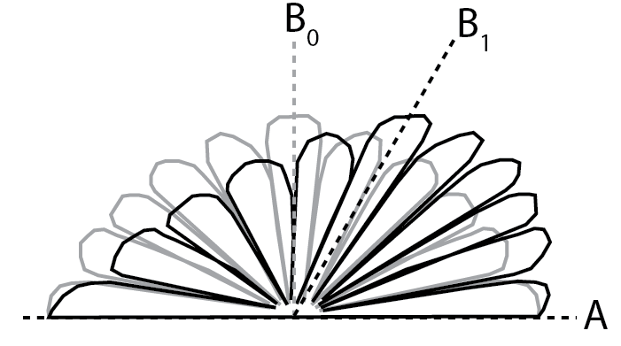
- Now recall that quadratic elongation, λ, is equal to S². And reciprocal quadratic elongation, λ’, is equal to 1/λ. Calculate these in the A and B directions for our fossil.

λ_{A}: λ’_{A}: λ_{B}: λ’_{B}:

At this point, we have measured and calculated the variables used in the Mohr Strain diagram, but we have yet to identify the principal axes of our strain ellipse so we cannot yet use the strain equations, or create a Mohr Strain diagram. To do that we need to find a fossil that was oriented such that the A and B directions are perpendicular both before and after deformation (the definition of principal strain axes).

2. In real rocks we often are not so lucky to know the exact size of our original fossil (strain marker). On the final page of this lab are a bunch of ‘fossils’ that were oriented in different directions before deformation. In order to do this exercise, we have to make a few assumptions.
Simplifying assumptions are a very important part of how we develop a physical understanding of complex processes such as deformation. It is important to know what assumptions have been used. For this exercise we are going to use 4 assumptions: 1) Homogeneous deformation, 2) Plane strain or 2-dimensional deformation (this means we are assuming to have a plane that is parallel to the maximum and minimum stretching directions, and that no strain occurs in directions out of the plane. In a rock this could be thought of as a plane that is perpendicular to the foliation and parallel to the lineation), 3) no change in volume (i.e. no dilation) and 4) All of these fossils started off the same size (this assumption is only for this exercise, and is not a commonly used or valid assumption).

- Measure the following on each of the fossils: Orientation of the fossil (e.g. measure the acute angle between the flat edge (line A) of the fossil and the long edge of the page. The grid on the page should make this easier); the angular shear along line A (the flat edge of the fossil. This is the same measurement you did on the above fossil when you measured the angle between line B₀ and B₁); the length of the flat edge of the fossil (length along line A); the length of the fossil along line B (this is the length of the middle ‘petal’ of the fossils). Use a calculator to calculate the shear strain along line A for each fossil.

Fossil # | Orientation of line A (˚) | Angular Shear, Ψ (˚) | Length along A (cm) | Length along B (cm) | Shear Strain along A (γ = tan(Ψ))

- The fossils with the least shear strain along line A must be oriented with line A very close to the maximum, S₁, or minimum, S₃, stretching directions (principal strain axes). Using your measurements of fossil orientation, what are the orientations of S₁ and S₃?

S₁: S₃:

And the lengths of line A in these directions?

L_{A1}: L_{A3}:

- These lengths represent the lengths of the axes of our finite strain ellipse. From this we can calculate the original length of line A before deformation, because by definition the finite strain ellipse was a circle before deformation. Remember we made the assumption that all these fossils were the same size before deformation, so L_{A1} and L_{A3} were equal before deformation, and we can use the equations for area of a circle to calculate the original L_{A}:

L_{0A} = √(L_{A1}*L_{A3})

L_{0A}:

- Use this value to calculate S_{A}, λ_{A}, and λ’_{A} for each fossil. [S_{A} = L_{A}/L_{0A}; λ_{A} = S_{A}²; λ’_{A} = 1/λ_{A} ] Now using the values of γ from above, calculate γ_{A}/λ_{A}.

Fossil # | S_{A} | λ_{A} | λ’_{A} | γ_{A}/λ_{A}

- Now you have everything you need to construct a Mohr Strain diagram. On a piece of graph paper, plot each of your fossils on a graph with λ’_{A} on the x-axis, and γ_{A}/λ_{A} on the y-axis.
Do these points plot roughly in a circle?

- Using the strain equations, plot points on the graph for θ_{d} = ±15˚, ±30˚, ±45˚, ±60˚, ±75˚, and ±90˚. The strain equations are:

The values for λ’₁ and λ’₃ are the values of λ’_{A} for the two fossils that are oriented nearly parallel to principal axes of finite strain ellipse. You calculated these in table 2.

