Case Example: Increase in volcanism at the beginning of the Holocene on Reykjanes, Iceland
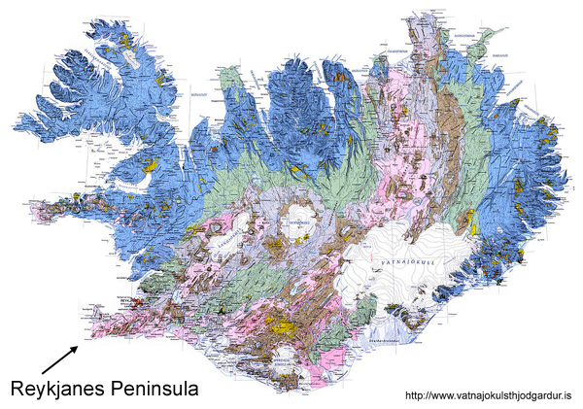
At the beginning of the Holocene, rates of volcanism jumped dramatically in Iceland. Between about 9000 and 8000 ybp (years before present), about 40 km³ of lava erupted on Reykjanes, which is the southwest peninsula of Iceland where the Mid-Atlantic Ridge comes ashore. Eruption rates dropped sharply at about 8000 ybp. In the 8000 years since then, less than 20 km³ of lava has erupted on Reykjanes.

In order to evaluate models for the sharp and temporary increase in rates of volcanism, we need to understand a bit about mantle melting at divergent plate boundaries. Mantle melting occurs when hot solid mantle rises by solid state convection. As the solid mantle convects upward, lithostatic pressure decreases, and the mantle partially melts. This occurs because the partial melting temperature of peridotite decreases with decreasing pressure. How much magma is generated by decompression depends on the amount of the pressure decrease. All other things being equal, a larger decrease in pressure results in a larger percentage of partial melt.

The mantle can be suddenly depressurized by a large meteorite impact (which excavates a large cavity and thins the crust) or by melting of large ice sheets, which can occur geologically quite rapidly. Both can trigger melting if the mantle is already hot enough. Deglaciation of New York State at the end of the Pleistocene didn’t trigger volcanic eruptions, for example, because the mantle isn’t hot enough under New York State for the difference in pressure to carry the rocks into the field of partial melting.

The situation is different in Iceland. The Mid-Atlantic Ridge rises out of the North Atlantic at the Reykjanes Peninsula in Iceland (see map above right). Under Iceland, the mantle is already partially molten, and a decrease in pressure might be expected to generate even more magma. The Early Holocene increase in rate of eruption has, in fact, been attributed to rapid decompression of the mantle as the Pleistocene ice cap melted at the end of the last ice age.

Let’s work out whether the pressure change could have conceivably been enough to make a noticeable difference in the amount of magma available to erupt. Here are the data:

- The percentage of melt in the mantle beneath Iceland increases by about 0.3% for each km that the mantle rises toward the surface. Alternatively, you can think of this as about a 0.3% increase for each km of rock removed at the surface.
- The average density of the rocks overlying the partial melt zone is about 3.0 gm/cm³.
- The Pleistocene ice sheet in Iceland was about 2 km thick. Because we’re making lots of assumptions and just ball-parking a calculation, use a density of 1.0 gm/cm³ for the ice.

Start by calculating by what % mantle melting would increase if 2 km of ice (not rock!) were removed from the load on the Icelandic mantle. Show your work.

The volume of mantle involved in partial melting beneath the Reykjanes Peninsula in southwest Iceland is on the order of 40 km long, 20 km wide, and 100 km thick. In km³, how much additional magma could be produced by rapid deglaciation? Don’t forget to convert properly from the percent increase that you determined above to a decimal before you do your calculations! Show your work.

Evaluate the hypothesis that deglaciation was responsible for the difference in rate of volcanism in the Early Holocene in comparison to the rest of the Holocene. Provide a carefully reasoned argument supported by your calculations.

The theoretical volume of magma that you calculated doesn’t match the actual volume of lava erupted on Reykjanes. Offer and explain at least two reasons why this might be the case.

