Cover page

Sedimentation and Tectonics: Geologic History of the Appalachian Basin

Bosiljka Glumac
Department of Geology
Smith College
Northampton, MA 01063
(413) 585-3680
bglumac@email.smith.edu

To demonstrate potential links between sedimentation and tectonics students first examine a suite of samples from the southern Appalachians with the goal of interpreting depositional environments and reconstructing a history of relative sea level change. Next, the students compile stratigraphic information for 5 different regions throughout the Appalachian basin and construct burial curves using a sediment backstripping program. The observations and conclusions about sea level change and variable basin subsidence rates are then related to possible tectonic causes to reconstruct the geologic history of the Appalachians.

The actual assignment given to students:

SEDIMENTOLOGY Name: _________________________________
GEOLOGY 232
Partner(s): ______________________________

Plate Tectonics and Sedimentation - Geologic History of the Appalachian Basin:
Basin Analysis - The Big Picture!

Petrography of Sedimentary Rocks from the Southern Appalachian Basin

Work in pairs or small teams to answer the questions on this worksheet. Turn in the completed worksheet at the end of the class meeting.

Samples 1 through 6 are examples of sedimentary rocks from the southern Appalachian Basin that were deposited along the eastern margin of North America during the Paleozoic. The table below shows the stratigraphy of the area where the samples came from. The samples represented in the suite are indicated with an asterisk (*). Some additional information about the deposits not represented in the suite is given.

While examining these samples you should keep in mind that you will be asked to reconstruct the history of relative sea level change for the southern Appalachian Basin. For the final write-up you will also be considering the relationships between the tectonic evolution and the sedimentation history of this basin.

Age | Stratigraphy | Description
Devonian to Early Mississippian | Chattanooga Shale and Grainger Formation | black shale and distal turbidite siltstones overlain by deltaic deposits
Silurian to Devonian | Regional Unconformity
Early Silurian | Clinch Sandstone* | See sample 6
Late Ordovician | Juniata Formation* | See sample 5
Late Ordovician | Martinsburg Formation | fining-upward layers composed of coarse fossil lags at the base grading upward into fossiliferous packstone and bioturbated shale; hummocky cross-stratification present
Late Ordovician | Moccasin Formation | peloidal packstone/wackestone to mudstone containing restricted biota, vertical burrows, fenestrae, mudcracks, and intraclasts
Middle Ordovician | Chickamauga Group* | See sample 4
Early to Middle Ordovician | Regional Unconformity
Late Cambrian to Early Ordovician | Knox Group* | See sample 3
Middle to Late Cambrian | Conasauga Group* | See sample 2
Early Cambrian | Rome Formation* | See sample 1

Sample 1 Rome Formation, Early Cambrian

• Classify this sample: ____________________________________________________

• Identify sedimentary structures present.

• Besides the sedimentary structures present in this sample, the Rome Formation is famous for its salt (halite) casts and trilobite trace fossils. Combine this information and your petrographic observations to interpret the depositional environment of the Rome Formation. Support your answer.

Sample 2 Conasauga Group, Middle to Late Cambrian

• Classify this sample: ____________________________________________________

• Interpret the environment of deposition for this sample. Support your answer.

Sample 3 Knox Group, Late Cambrian to Early Ordovician

• Classify this sample: ____________________________________________________

• Identify the sedimentary structures present in this sample.

• Interpret the environment of deposition for this sample. Support your answer.

Sample 4 Chickamauga Group (Benbolt Formation), Middle Ordovician

• Classify this sample: ____________________________________________________
• Interpret the environment of deposition for this sample. Support your answer.

Sample 5 Juniata Formation, Late Ordovician

• Classify this sample: ____________________________________________________
• What is the environmental significance of the characteristic color of this sample?

• The rocks of the Juniata Formation are usually nonfossiliferous and contain abundant evidence of desiccation (polygonal mudcracks), isolated vertical burrows, small-scale ripple cross-lamination, rip-up clasts, and very rare skeletal fragments (brachiopods). The upper part of the Juniata has well developed red paleosol (ancient soil) horizons. Combine this information with your observations to interpret the environments of deposition for the Juniata Formation. Support your answer.

Sample 6 Clinch Formation, Early Silurian

• Classify this sample: ____________________________________________________
• Identify the sedimentary structure(s) present.

• In the field, the Clinch Formation is characterized by medium-scale planar-tabular and trough cross-beds up to 1 to 2 m thick. These layers are interbedded with: 1) massive, densely bioturbated (burrows of suspension feeders) sandstone layers; 2) horizontally laminated and ripple cross-laminated sandstone interbedded with cm-thick, gray-green shales; and 3) rare conglomeratic layers as pebble lag deposits. Combine this information with your petrographic observations to interpret the environments of deposition for the Clinch Formation. Support your answer.

After examination of samples 1 through 6:

• Combine the information from the table on page 1, showing the stratigraphy of the southern Appalachian Basin, with your observations and all other available information, to describe the history of relative sea-level change (transgressive and regressive events) recorded in the sedimentary rock succession of this basin. Start on the bottom of the page and work your way up from the Rome Formation (Early Cambrian) to the Chattanooga Shale and Grainger Formation (Devonian to Early Mississippian). Make sure to refer to all of the sedimentary rock units and unconformities from the table on page 1.

Age: | Stratigraphy: | Environmental Interpretation: Sea-level change:
Devonian to Early Mississippian | Grainger Formation  Chattanooga Shale
Silurian to Devonian | Regional Unconformity
Early Silurian | Clinch Sandstone
Late Ordovician | Juniata Formation
Late Ordovician | Martinsburg Formation
Late Ordovician | Moccasin Formation
Middle Ordovician | Chickamauga Group
Early to Middle Ordovician | Regional Unconformity
Late Cambrian to Early Ordovician | Knox Group
Middle to Late Cambrian | Conasauga Group
Early Cambrian | Rome Formation

SEDIMENTOLOGY
GEOLOGY 232

Plate Tectonics and Sedimentation

Basin Subsidence and Burial History of the Appalachian Basin

Basin Analysis - The Big Picture: To subside or not to subside? Subside!

Objectives: 1) to use the computer program Subside! in sedimentary basin analysis; 2) to examine the relationships between tectonics and sedimentation; 3) to conduct a large-scale (big picture) stratigraphic study of the Appalachian sedimentary basin.

Procedure: You will work in groups on revealing the geologic history of parts of the Appalachian Basin based on data from COSUNA (Correlation of Stratigraphic Units of North America) Charts:

Group A: Alabama, Southern Appalachian Region, Column 7

Group B: Virginia, Southern Appalachian Region, Column 24

Group C: Southeastern Ohio, Northern Appalachian Region, Column 7

Group D: New York, Northern Appalachian Region, Column 31

For the assigned stratigraphic column, from the COSUNA chart, compile a data sheet containing information on age, thickness, and lithology of the geologic units present (see an example data sheet for Eastern Tennessee; please note that these data were compiled from several different sources, not just the COSUNA chart). Obtain information on numerical age for the geologic units and unconformities from the COSUNA chart through interpolation. If the thickness of geologic unit is shown as a range of values, report an average thickness. You will have to keep the number of beds below 40 because this is the maximum number that the computer program Subside! allows.

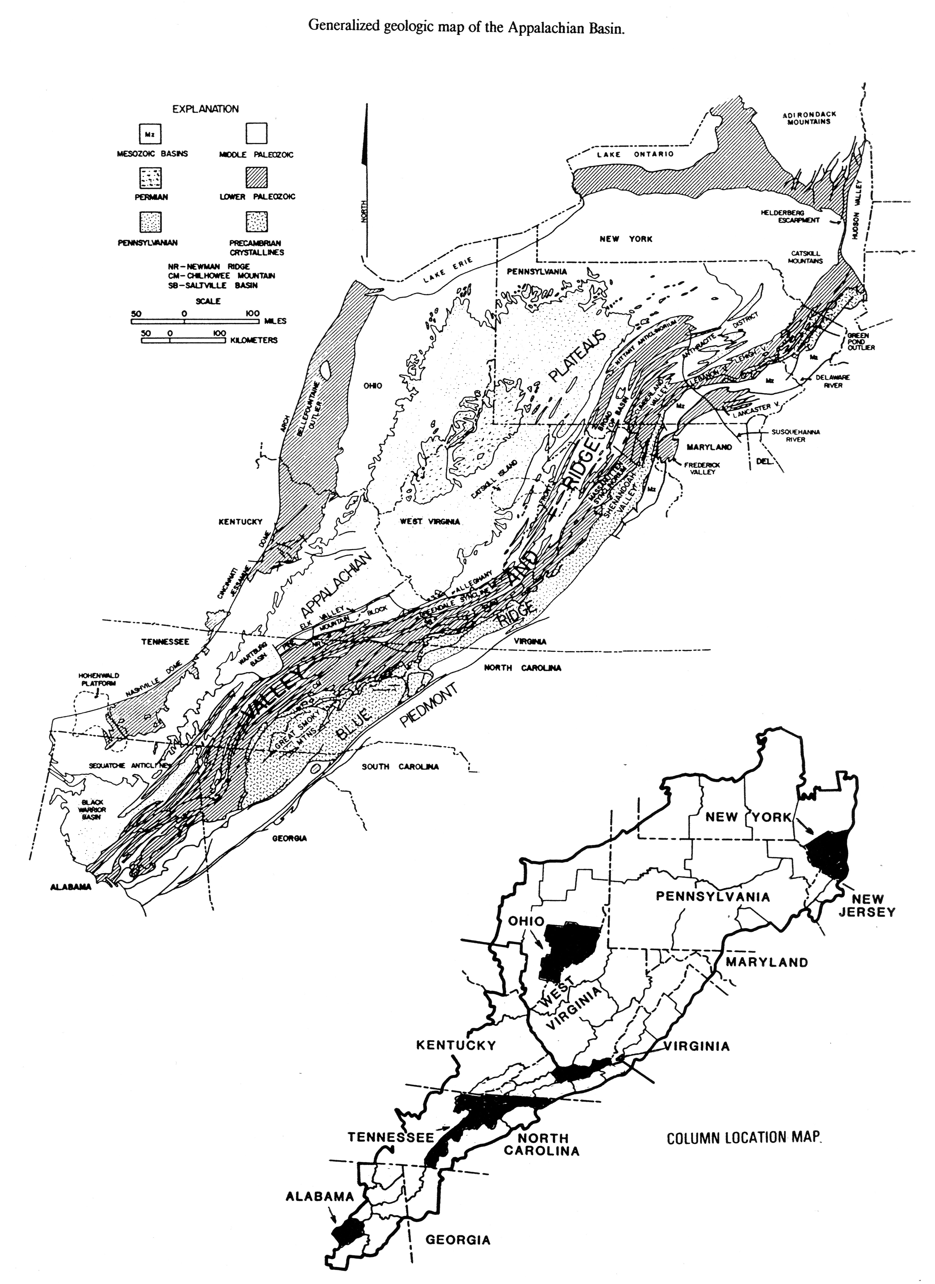

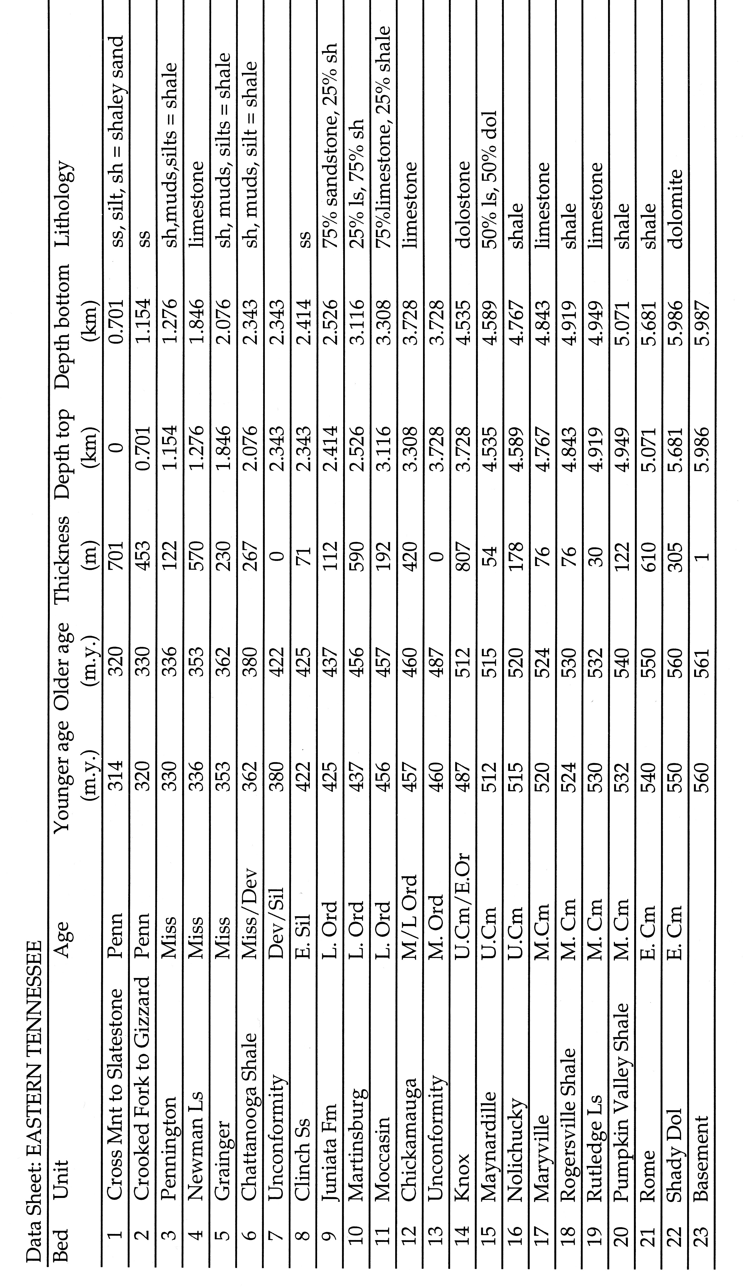

SEDIMENTOLOGY
GEOLOGY 232
Plate Tectonics and Sedimentation

Basin Subsidence and Burial History of the Appalachian Basin
Basin Analysis - The Big Picture: To subside or not to subside? Subside!

Constructing Burial Curves using Basin Analysis Program Subside!

Using the program Subside! each team will construct two burial curves:

1) for eastern Tennessee based on the data sheet that you were provided with;
2) for your geographical area along the Appalachian basin based on the COSUNA chart.

You will use these plots to answer a series of questions as the final part of this theme.

Procedure/Instructions:

1. Complete your data sheets based on the COSUNA charts. If you are using Excel, print a copy of your data sheet. Be sure to set your print area to print the data sheet(s) only. Avoid printing pages and pages of empty Excel sheets.

2. The program Subside! has the following options for lithologies and sediment parameters:

Lithology | c* (1/km) | Sediment grain  density | Porosity
Shale | 0.51 | 2.72 | 0.63
Sand | 0.27 | 2.65 | 0.49
Chalk | 0.71 | 0.71 | 0.70
Shaley Sand  (50% shale; 50% sand) | 0.39 | 2.68 | 0.56
Limestone | 0.52 | 2.71 | 0.51
Dolomite | 0.22 | 2.85 | 0.30
* c is a constant that refers to changing porosity with depth

For the geologic units that represent a mixture of two or more lithologies you will have to calculate sediment parameters using the information from the table above. For example: a lithology that is composed of 25% shale and 75% limestone:

Lithology | c* (1/km) | Sediment grain  density | Porosity
25% shale; 75% limestone | (0.25*0.51) + (0.75*0.52) | (0.25*2.72) + (0.75*2.71) | (0.25*0.63) + (0.75*0.51)

3. Open Subside! by going to the Geology Apps folder on the dock at the bottom of the computer screen.
Find the Subside folder and open it.
Double click on the Subside! Icon
Begin Session with Subside!

4. On the menu bar go to Subside! and select Input Data. Start entering data for each bed from your data sheet. Start at the youngest (uppermost) bed. Use the Tab key or the mouse to move between windows. If the lithology does not match any given, select “other” and enter the determined sediment parameters.

Click on Set after entering the data for each bed. Notice that for the subsequent beds the information on the “Youngest age” and “Depth to top” will already be set on the screen. You will only have to enter information on the “Oldest age”, “Depth to bottom”, and lithology.

Enter unconformities as beds with a thickness of 0.00001 km (the lithology does not matter). Do that by typing 1 at the fifth decimal place at the depth to bottom that is already shown on the screen.

The program plots only bed tops. In order to have the bottom layer plotted, you should include an artificial basement layer at the base (its thickness, lithology, and age are irrelevant). After entering data for the basement click on Last bed.

Enter the data very carefully. If you make a mistake the program will crash during computation and you will have to re-enter the data.

5. Give your file a name and save it.

6. You will then be asked to choose between two plotting parameters: Plot Effective Subsidence or Plot Corrected Subsidence. The difference between the two is that the former calculates the data for plots by just decompacting and removing the sediment load, whereas the latter does the same, but also moves the basement, at the time of initial basin sedimentation, to sea level. Choose Corrected Subsidence for this exercise.

- In the Subside! menu select Uncompacted Stratigraphy vs. Time. This plots a burial curve that shows the burial depth for each bed as a function of time after correcting for compaction.

If you get an error message there is a problem with your input data. Recheck your data and enter them again. If you know exactly where the mistake is you may select Edit Stratum Data from the Subside! menu. Note that the program does not allow for easy viewing of the data entered and that it might be easier to carefully re-enter the data then to be correcting bed by bed.

Note that the values on the X (Time) and Y (Depth) axis of the plot are not nice, round numbers. Go to Plot Setup in the Subside! menu and select the maximum and minimums, and the number of divisions for each axis to make the data more presentable. To re-plot the data go to the Edit menu and select Cut to erase the old plot and then go to Subside! and select Uncompacted Stratigraphy vs. Time again. It may take several attempts to get the axes labeled the way you would like them.

If at any time you need to create a new plot based on your saved file select Open Subside File in the Subside! menu. Select and open your file. Select Calculate Points in the Subside! menu, followed by selecting Plotting Parameters (Corrected Subsidence) and Uncompacted Stratigraphy vs. Time plot.

8. You are now ready to print your plot. You will need to take a picture of part of the screen with your plot. To do this press Command-Shift-4, then drag to select the area your want to print. A numbered picture file will appear on your desktop after you release the mouse. Open this file and print it. On the print out, write the names of your team members and indicate what geographical area along the Appalachian chain the plot represents. Along the X axis indicate the boundaries for the geologic periods of the Paleozoic era and label each period. Obtain this information from the COSUNA chart.

SEDIMENTOLOGY Name: _____________________________________
GEOLOGY 232
Partners: ___________________________________
Plate Tectonics and Sedimentation
Geologic History of the Appalachian Basin
Basin Analysis - The Big Picture
In-class Activities
Recall the stratigraphy of the southern Appalachians that you had a chance to study from hand samples and thin sections in the lab. Examine all five burial curves constructed for the various regions along the Appalachian basin, and the handouts with figures that illustrate the tectonic evolution of the Appalachians. Answer the following questions in the space provided.

- Based on your interpretations of the suite of samples from the southern Appalachians determine the plate tectonic setting for each formation (or groups of formations), and discuss the potential link between interpreted sea-level history and tectonic history of the southern Appalachians.

- Examine the burial curve for eastern Tennessee. Relate this plot to the geologic history of the Appalachian basin by indicating along the horizontal axis the timing of major orogenic events, and the conversion from a divergent (passive) to a convergent (active) continental margin setting. Discuss the observed correlation between the changes in the subsidence rate in the basin and the tectonic history of the southern Appalachians.

3. Follow the same procedure as in the previous question (question 2) but this time focus on the burial curve for the region in the Appalachian basin that your team had a chance to examine.

- Compare the burial curves for all five areas along the transect from the southern to northern Appalachians. What are some implications of the observed differences and similarities? Give specific examples.

5. What are some possible sources of error in the constructed plots?

6. Assume an average geothermal gradient of 25˚C/1 km and an average surface temperature of 20˚C. Calculate a maximum burial temperature to which the sedimentary rocks in eastern Tennessee and in your study area have been exposed. What are some implications of reconstructing the increase in temperature with progressive burial of sedimentary successions? For one example see figure below.

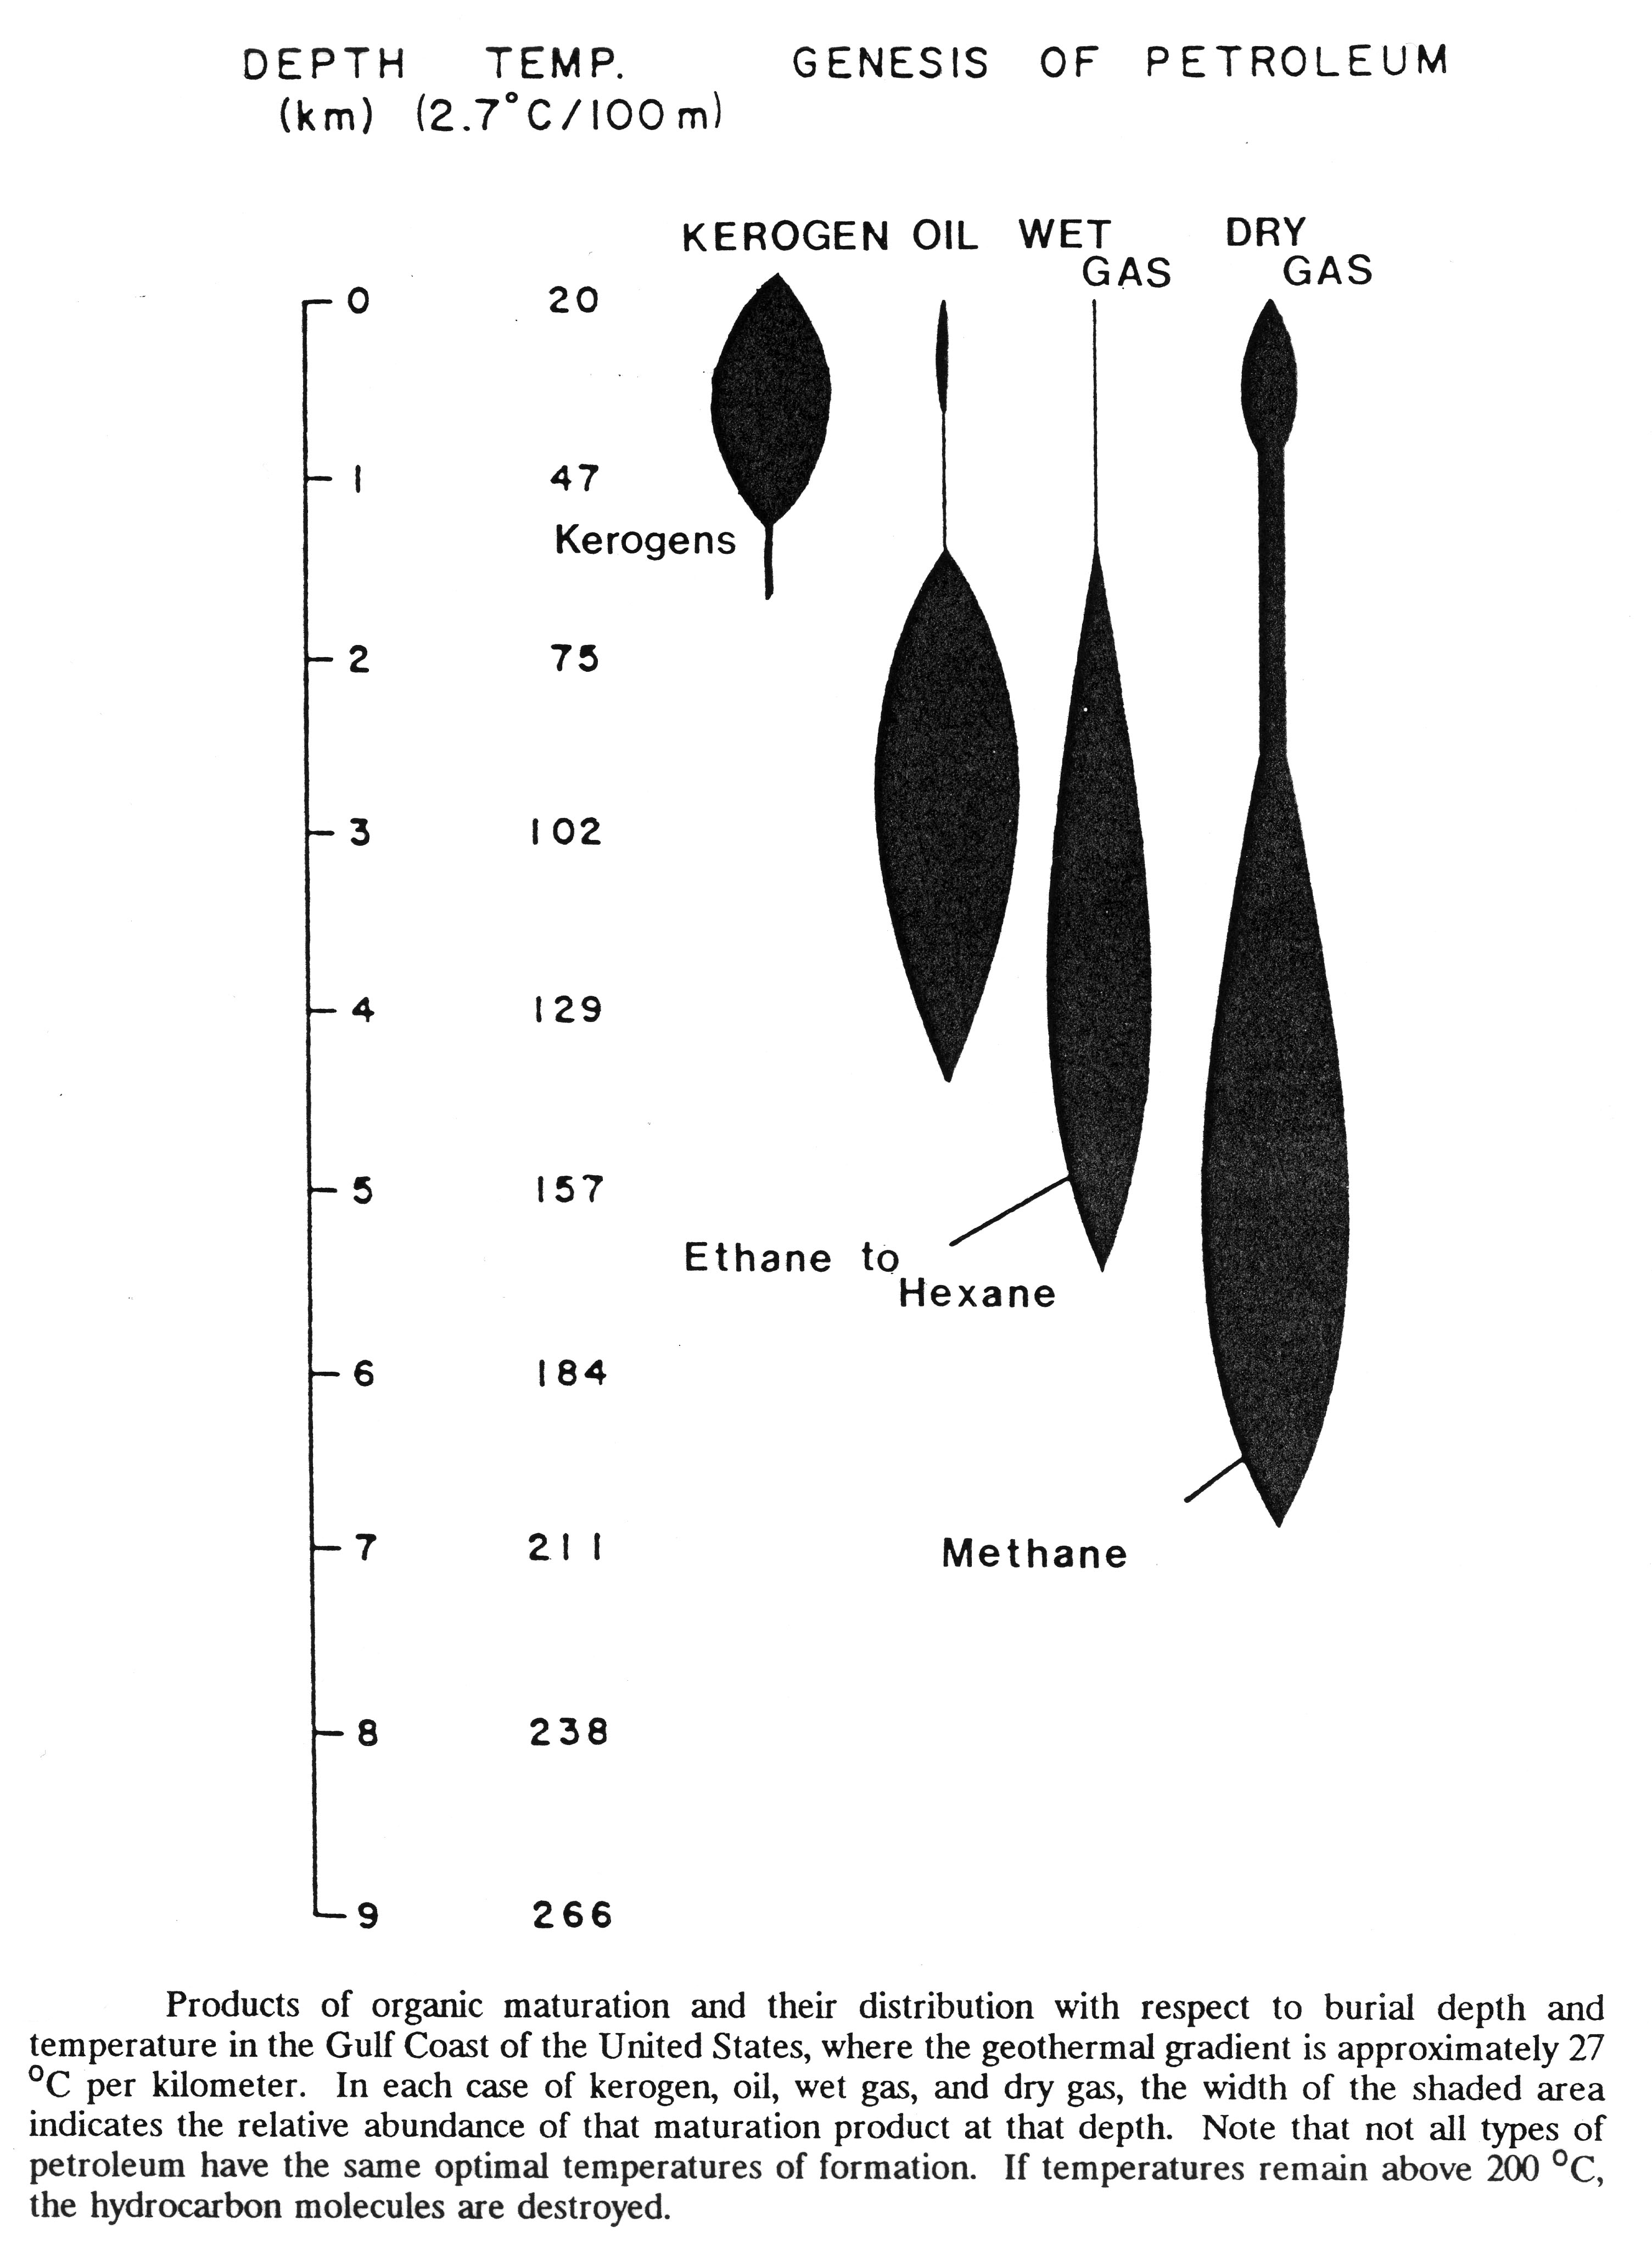
7. Interpret the plate tectonic setting for the three areas that we examined in this course:
- Deerfield Basin,
- Plum Island,
- New York.
Discuss how the differences (and any possible similarities) in sediments and sedimentary rocks present in these three areas can be linked to the tectonic history of the eastern part of the North American continent.

