INTRODUCTION TO SEISMIC DATA III: EXPLORING FOR OIL AND GAS USING SEISMIC DATA

Objective: This is the third, and final, lab in a three part series intended to introduce you to seismic data and complement your understanding of geophysical concepts from lecture. In the previous labs you have completed the following:

- Navigated a three-dimensional seismic survey using inlines, crosslines and the z-axis (time/depth)
- Placed the seismic survey in a regional geologic context based on location using Google Earth
- Interpreted structural features in a seismic survey thoughout the volume

The purpose of this lab is to apply what you have learned so far to a hydrocarbon-filled interval; in this case, you will look at biogenic gas pockets. To gain a complete understanding of the system, you will integrate both seismic data and well data in OpendTect.

Part I: BIOGENIC GAS IN THE NORTH SEA

Shallow biogenic gas systems are common in offshore seismic surveys. Early gas generation begins soon after deposition of a source rock, and the gas may migrate into overlying reservoir units. In very shallow sediments, biogenic gas pockets may be mapped as drilling hazards, which could increase the risk of an offshore blowout.

In the North Sea seismic volume, a number of gas indicators are present, and biogenic gas pockets appear as bright spots. Recall that the F3 seismic block is an area of interbedded sandstones and shales, which are interpreted to be the result of fluvio-deltaic processes operating over the last 25 Ma.

____ On your computer, launch OpendTect. Do not select additional plug-ins when prompted. Once the application is open, choose Survey > Select/Setup from the top toolbar. Select the F3_Demo Survey from the window and click OK. The seismic survey is now loaded for you to view in the main window.

____ Bring up an inline and load the attribute All Lines. (Refer to the previous lab if you need to review the steps to bring up inlines or load data.)

____ In the Tree Scene on the left of the screen, select Fault > Add. In the menu that appears, select your Fault B (the regional fault) from the previous exercise. This will load the Fault B plane for viewing.

____ Navigate to Inline 240 and change the All Lines color bar to Grey scales. Notice the bright spot east of the fault plane on this inline. Your screen should look similar to the one below.
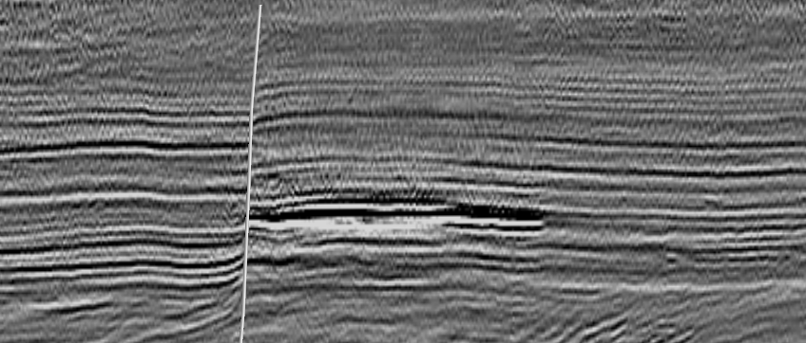

Carefully study the seismic volume in the area around this bright spot and answer the following questions.

Q1. What is the geologic interpretation of this seismic bright spot? (Note: Think back to what hydrocarbon features are present in this seismic volume. You may want to refer to the F3 Seismic Block information page on the OpendTect website.)

__________________________________________________________________________________________

Q2. Use the top toolbar and green arrows to navigate through the seismic volume. What is the lateral extent of this gas pocket, i.e., the inline range, crossline range and time (z-axis) range?

__________________________________________________________________________________________

__________________________________________________________________________________________

Q3. Looking at Inline 240, the Fault B appears to be sealing the western margin of the gas pocket. Is the fault plane acting a seal throughout the entire gas pocket? How does the fault plane permeability change?

__________________________________________________________________________________________

__________________________________________________________________________________________
Q4. In the space below, carefully sketch a 3D schematic of the gas pocket. Does the feature appear to have internal compartments? If so, do your best to draw the layout of the entire feature.

Part II: INTEGRATING WELL DATA WITH 3D SEISMIC

Now that you have explored the geometry of a biogenic gas pocket, it’s time to test the seismic volume against well data from the North Sea.

____ For this second exercise, bring up Inline 700 and Crossline 860. Your screen should look similar to the following.
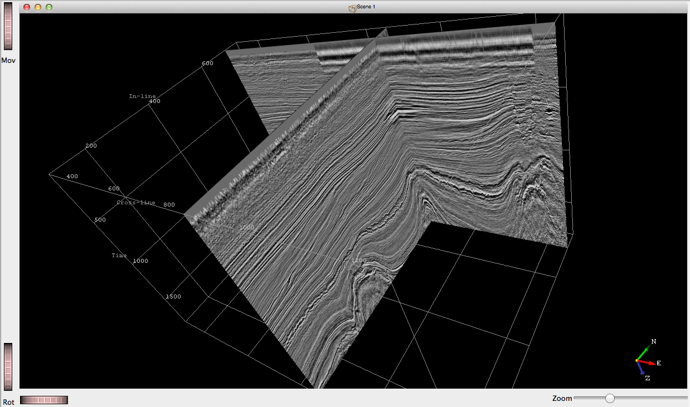

Note the bright spot (circled) where the two lines intersect. Navigate using the inlines and crosslines to answer the following questions.

Q1. What is the lateral extent of this gas pocket, i.e., the inline range, crossline range and time (z-axis) range?

__________________________________________________________________________________________

__________________________________________________________________________________________
Q2. What kind of permeability trap is this? (i.e., structural, stratigraphic, diapiric) How do you know?

__________________________________________________________________________________________

__________________________________________________________________________________________

____ In the Tree Scene on the left of the screen, select Well > Add. Highlight all available wells to add them to the display.

____ Rotate or navigate to view Inline 700 from the North. Notice that Well F03-2 penetrates the gas pocket. Your screen should look similar to the one below.

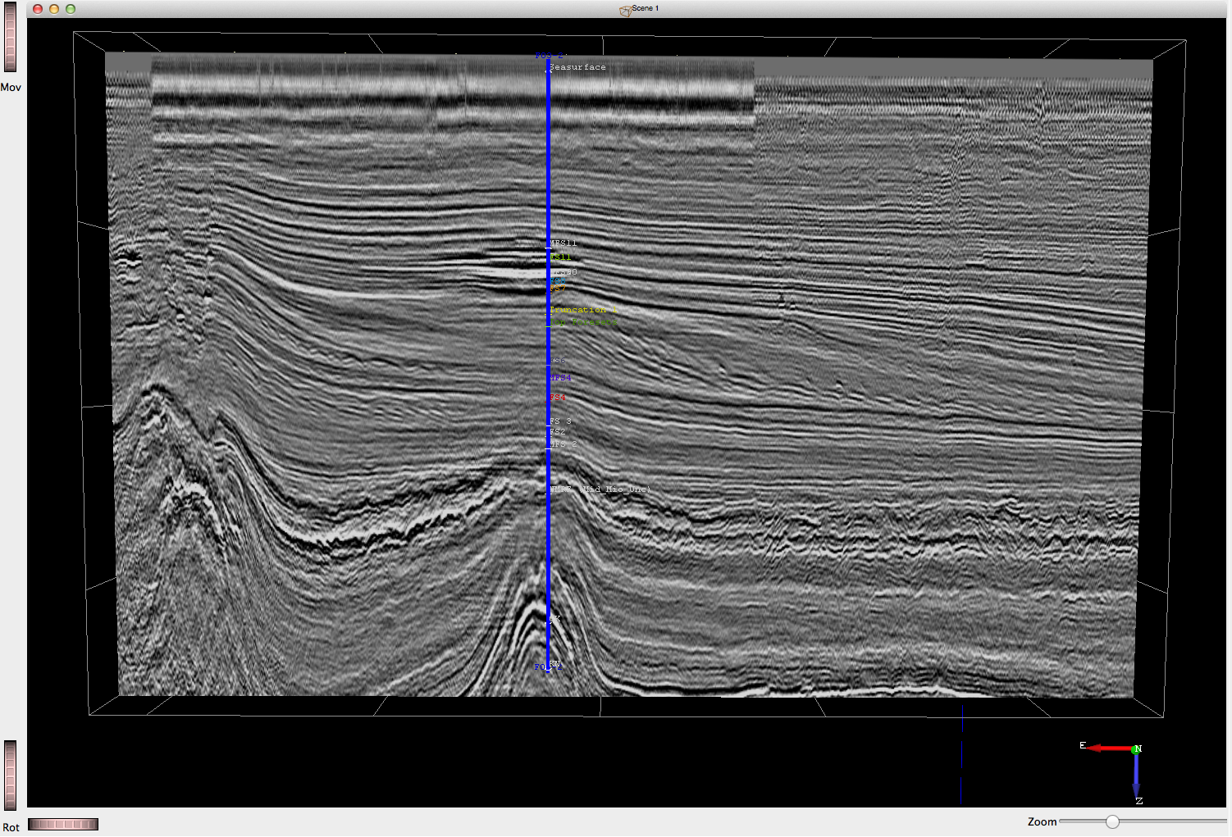

____ In the Tree Scene, right click on Well F03-2 and select Display > Properties. This will bring up a menu for displaying well data such as wireline logs, horizon markers that have been picked, etc.

____ Use this menu to display the Gamma Ray and Density logs however you would like. Play with the color bars and line thicknesses to determine what works best for you.

____ In the seismic window, hover your mouse over the track of Well F03-2. Notice that the bottom toolbar will display values for the wireline logs you have selected.

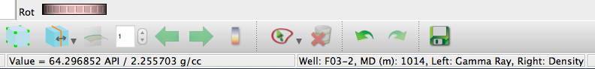

Use these features to answer the following questions and interpret the geology of the F03-2 well.

Q3. Note that the shallowest sediments in this volume (time < 400) have a very distinctive gamma ray appearance. What is the range of gamma ray values in this section? What is the likely lithology and how do you know?

__________________________________________________________________________________________

__________________________________________________________________________________________
Q4. Note that the shallowest sediments in this volume (time < 400) have a very distinctive gamma ray appearance. What is the range of gamma ray values in this section? What is the likely lithology and how do you know?

__________________________________________________________________________________________

__________________________________________________________________________________________

Q5. EXTENDED ASSIGNMENT. In the space below, draw a DETAILED sketch of the biogenic gas interval. (You do not need to draw the entire well). On your sketch, include:
- Your interpretation of the geometry of the gas pocket(s)
- Your interpretation of the geology of prominent layers in the gas pocket interval
[Note that you cannot use the raw seismic image, i.e. the colors of the seismic, to indicate any given lithology. These values are travel times. Thus, you must use the well data AND the seismic image to interpret the geology.]

Congratulations! You have completed a geologic interpretation of a hydrocarbon system in the North Sea. You have integrated 3D seismic data and well log data to support your interpretation!

