INTRODUCTION TO SEISMIC DATA II: THE BASICS OF SEISMIC INTERPRETATION

Objective: This lab is the second in a three part series intended to introduce you to seismic data and complement your understanding of geophysical concepts from lecture. The previous lab focused on seismic surveys, which are an important tool in geophysical exploration and prospecting.

Now that you have an understanding of how a seismic survey is oriented in space – e.g., inlines, crossline, z-axis (time/depth) – it is possible to explore the geometries of rocks and fluids in the subsurface.

The purpose of this lab is to characterize the geology within a 3D seismic volume. You will use OpendTect, an open source software package, to view and interpret large-scale structural geology features within the subsurface volume.

Part I: STRUCTURAL GEOLOGY OF THE F3 SEISMIC BLOCK

The seismic survey you will work with for this exercise is the same survey used in the first lab, the F3 Block volume from the North Sea. Recall that this is an area of interbedded sandstones and shales, which are interpreted to be the result of fluvio-deltaic processes operating over the last 25 Ma.

____ On your computer, launch OpendTect. Do not select additional plug-ins when prompted. Once the application is open, choose Survey > Select/Setup from the top toolbar. Select the F3_Demo Survey from the window and click OK. The seismic survey is now loaded for you to view in the main window.

____ Bring up an inline and load the attribute All Lines. (Refer to the previous lab if you need to review the steps to bring up inlines or load data.)

____ For this lab, you will use the top toolbar to navigate precisely through inlines and crosslines. First, be sure the inline is selected (highlighted) in the Tree Scene on the left of the screen. Then, define a line number in the box shown below and click enter. To move through the data in intervals, e.g., to look at every 10th inline, use the step tool with the green arrows.

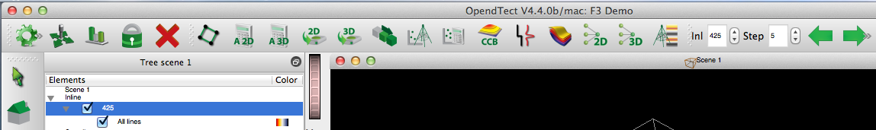

____ Use these tools to navigate to Inline 325. Your screen should look like the one below.

____ Use your mouse to zoom in and out, noting the two circled areas below, labeled A and B.
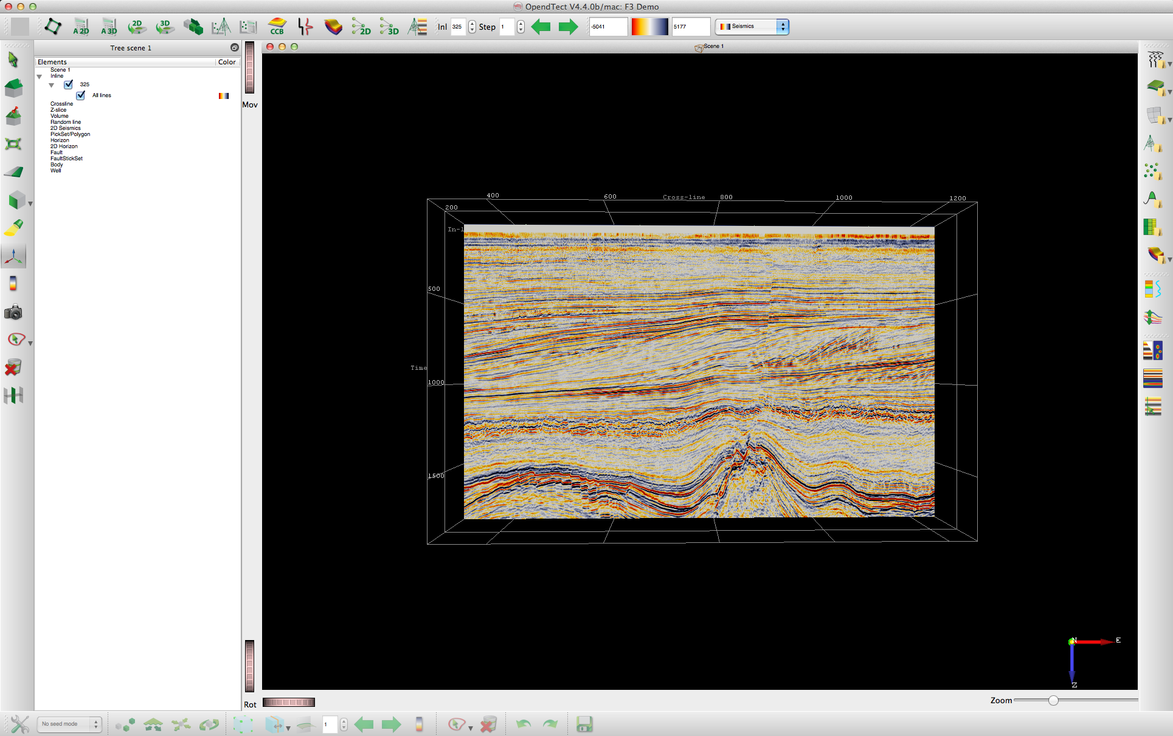
A
B

Q1. What kinds of structural features are shown in the circled regions? Are these features characteristic of regional extension or compression?

__________________________________________________________________________________________

__________________________________________________________________________________________
Q2. Trace the uppermost extent of the feature circled B in Inline 325. Does this feature appear to reach the surface of the F3 Seismic Volume? Why or why not?

__________________________________________________________________________________________

__________________________________________________________________________________________

Q3. Trace the lowermost extent of the feature circled B in Inline 325. Where does this feature terminate? What type of structure is located at the base of the B feature? (Note: Think back to what geologic features are present in this seismic volume. You may want to refer to the F3 Seismic Block information page on the OpendTect website.)

__________________________________________________________________________________________

__________________________________________________________________________________________

Q4. What is the relative timing of features A and B compared to each other? In other words, which feature(s) are older? In the space below, write a short essay explaining your logic.

__________________________________________________________________________________________

__________________________________________________________________________________________

__________________________________________________________________________________________

__________________________________________________________________________________________

__________________________________________________________________________________________

__________________________________________________________________________________________

Part II: SEISMIC INTERPRETATION OF FAULT PLANES

One of the advantages of working with seismic data is the ability to visualize complex geometries in a three-dimensional space. In this section, you will trace the 3D extent of fault planes within the F3 seismic volume.

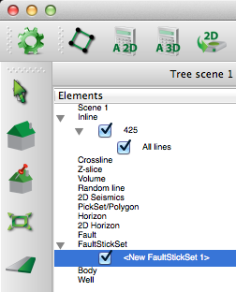
____ Navigate to Inline 325 and be sure that the attribute All
Lines is displayed.

____ In the Tree Scene on the left, click on FaultStickSet
and select NEW. This will add a new series of fault sticks
named < NewFaultStickSet 1>.

____ Fault sticks are a method for picking fault planes. In
this case, let’s begin by picking the fault plane that you
identified as the B feature in the previous lab section.

____ With the <NewFaultStickSet 1> highlighted in the Tree
Scene, use your mouse to select a few points along the
B fault.

Once you have selected a few points along the fault, your screen should look like the one on the following page.
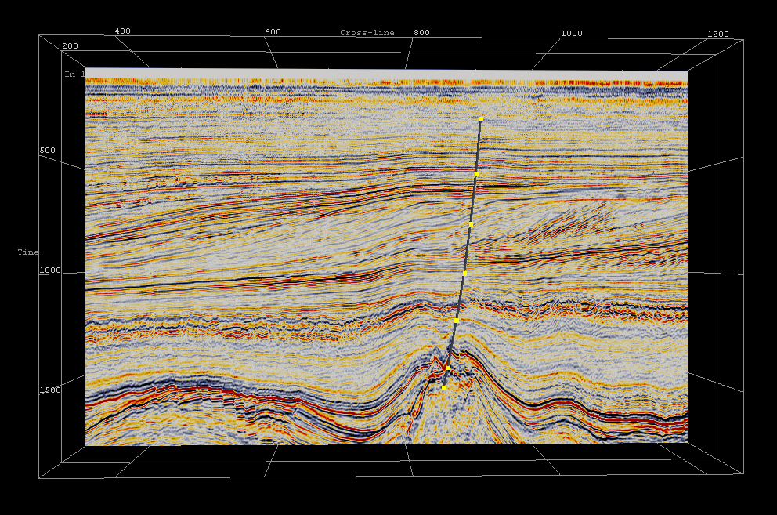

This is the essence of seismic interpretation. You have just interpreted a fault plane from seismic data!

____ Now you will continue interpreting the fault along multiple inlines. In the Tree Scene, select Inline > 325 and be sure it is highlighted. Then, along the top toolbar, set the Step value as 10, and click the LEFT arrow.

____ are now displaying data on Inline 315. You can no longer see your fault interpretation on Inline 325 because it is behind the current displayed line. You can use the green arrows to navigate back and forth along the inlines.

____ In the Tree Scene, select the <NewFaultStickSet 1> and be sure it is highlighted. Then, use your mouse to interpret the fault on Inline 315. These points will be added to the NewFaultStickSet 1.

____ Once you have added a fault stick on Inline 315, return to the Tree Scene and uncheck the box next to Inline 315. This simply turns the Inline off. Your screen should look similar to the one below.
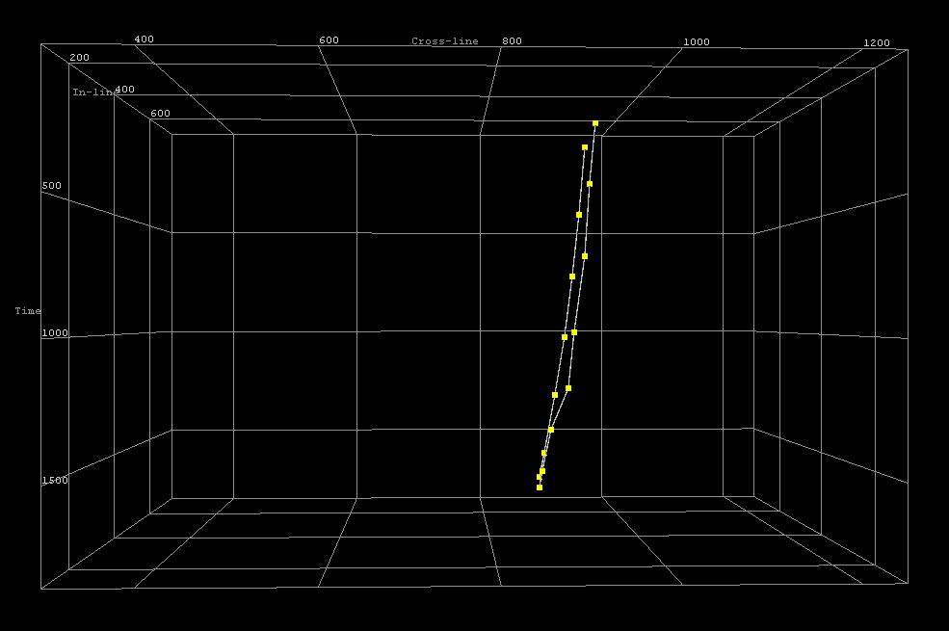

Every time you add a fault stick to the <NewFaultStickSet 1>, you are creating a 3D object.
In this case, the object in space is a three-dimensional fault plane.

____ Turn the display of Inline 315 back on in the Tree Scene. Carefully repeat steps 4 and 5 to pick fault sticks throughout the seismic volume by stepping the inline in increments of 10. Trace the fault through as many seismic lines as possible or until you can no longer identify the fault discontinuity.

Q1. When you have completed picking fault sticks, right click on the <NewFaultStickSet1> and select Save. Please save your work as YourInitials_FaultBStickSet.

What is your fault stick set saved as? __________________________________________________________

____ Now that you have a series of fault sticks, it is possible to create a fault plane to cut the seismic volume data. Begin by turning OFF any Inline or Crossline displayed on the screen. You should be able to see all your fault sticks.

____ In the Tree Scene, highlight your fault stick set. Then, on the bottom of the screen, select the Lasso Tool.

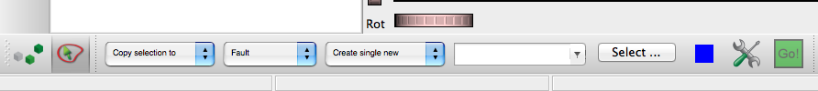

____ Click and hold down your mouse button as you ‘lasso’ all of the fault sticks you picked for Fault B. The selected sticks and points should turn a different color once they have been lassoed.

____ You will now use the menu along the bottom of the screen to create a new fault plane from the fault sticks you have selected. In the first dropdown menu, select Copy Selection to. In the second dropdown menu, select Fault. In the third dropdown menu, select Create single new. Finally, click ‘Select’ and enter a new name for your fault. When all of these items are set, click the green box labeled GO.

____ Note that a blue fault plane appears, which merges fault stick points throughout the volume for Fault B.

Q2. What is your fault saved as? ______________________________________________________________

Q3 EXTENDED ASSIGNMENT. Return to the area circles as A in the image on page 2. Using what you have learned, interpret a series of at least four fault planes (there are many).

Provide the names of your saved fault sticks and faults below.

Fault Stick Names Fault Names

Q4. How does the geometry of Fault B differ from Fault A?

__________________________________________________________________________________________

__________________________________________________________________________________________

Q5. How deep might you expect the faults in area A extend beneath the seismic volume? In other words, if you had an additional block of seismic below the F3 volume, what might you expect to see?

__________________________________________________________________________________________

__________________________________________________________________________________________

Congratulations! You have completed 3D fault interpretation.
The next lab in this series will focus on oil and gas exploration.

