Geology 210 – Surface Processes and Hydrogeology
Lab #4 - Hillslopes!

In lecture, we examined G.K. Gilbert’s classic description of hillslopes in equilibrium and derived theoretical equations to describe diffusive processes on such hillslopes. Implicit in these equations are predictions of how the slope of the hill and the thickness of the regolith change with distance downslope; the equations also predict a general convex hillform. In today’s lab we will “ground truth” these theoretical predictions by collecting slope and regolith thickness data on Preston Hill (the hill the University is build on).

Here are the equations we derived in class for you to consider:

(1) $q\left(x\right)=-κ(\frac{∂H}{∂x})$ Transport Law

(2) $\frac{dH}{dt}=-\frac{dq}{dx}$ Continuity equation (1-D)

(3) $ρ_{r}W=\frac{dq}{dx}$ Steady-state equation (1-D)

where q is the flux of material, κ is the rate constant, H is the elevation, ρ_{r} is the density of the regolith, and W is the weathering rate.

Before we begin, make two simple hypotheses regarding (1) how the thickness of the regolith and (2) the slope of the hillside might change as we move from high elevation to low elevation. Please state how your predictions are supported by the above equations.

1.

2.

Make a simple sketch illustrating your hypotheses:

Stop 1: Top of Preston Hill

- Find yourself on the topographic map.
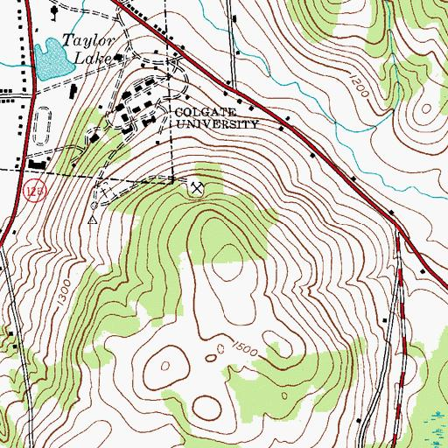
- Sketch the regolith profile and its relationship to the bedrock. Be sure to include a scale and differentiate the regolith as appropriate (you don’t need to overdo it!)

- Fill in the following:
Approximate elevation (ft) | Average regolith thickness (ft) | Average slope

Be sure to take several slope measurements to get a good idea of the general slope.

Stop 2: Stream cut

- Find yourself on the topographic map.

- Sketch the regolith profile and its relationship to the bedrock. Be sure to include a scale and differentiate the regolith as appropriate (you don’t need to overdo it!)

- Fill in the following:
Approximate elevation (ft) | Average regolith thickness (ft) | Average slope

Be sure to take several slope measurements to get a good idea of the general slope.

Stop 3: Road cut near the base of the hill

- Find yourself on the topographic map.

- Sketch the regolith profile and its relationship to the bedrock. Be sure to include a scale and differentiate the regolith as appropriate (you don’t need to overdo it!)

- Fill in the following:
Approximate elevation (ft) | Average regolith thickness (ft) | Average slope

Be sure to take several slope measurements to get a good idea of the general slope.

Summary:

On the next page, use the data you collected during this lab to carefully sketch a profile of the hill (using your elevation and slope data – be as accurate as you can!). Include relative thickness of the regolith (does not have to be to scale).

Compare your data and sketch to your hypotheses and your hypothesized sketch from the beginning of lab. Were your hypotheses valid? Discuss.

