Differentiation of Magmas By Fractional Crystallization

Objective
The objective of this exercise is to gain first-hand knowledge of the process of magmatic differentiation by fractional crystallization. The activity also provides an opportunity to utilize your knowledge of mineral stoichiometry, the IUGS classification system, and spreadsheets.

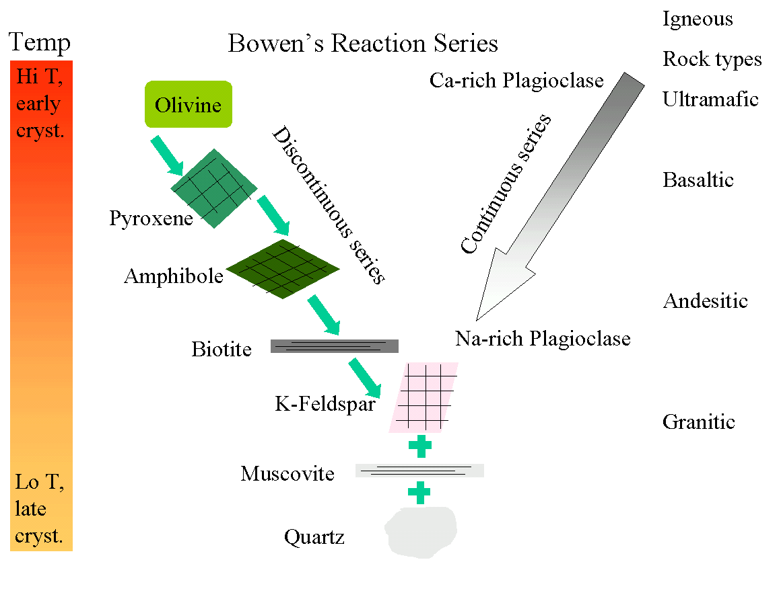
A Bit of History and Terminology
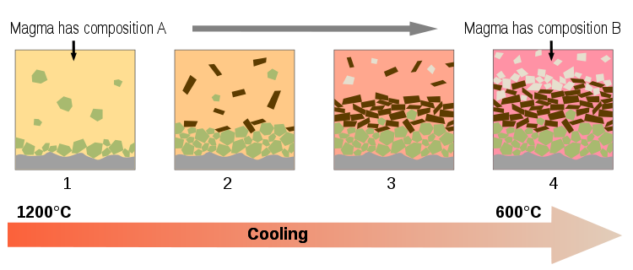
In the introductory geology course you learned about Bowen’s reaction series and the importance of crystal-melt fractionation in generating the spectrum of observed igneous rock compositions (e.g., basalt, andesite, rhyolite). Magmatic differentiation is the process by which diverse rock types are generated from a single magma. Differentiation is accomplished by crystal-melt fractionation, a two-stage process that involves the formation and mechanical separation of compositionally distinct phases. In 1844 Charles Darwin described flows from the Galápagos Islands in which the lowest flows contained greater proportions of feldspar crystals. These observations led Darwin to propose that density differences between crystals and melt would result in mechanical separation of these two phases and the formation of different magma types. This process, known today as gravity settling, was the focus of detailed experimental studies by N.L. Bowen. Today, several additional mechanisms of crystal-melt fractionation are also recognized, including: flow segregation, filter pressing, and convective melt fractionation.

Name: ________________________

Constructing the Magma Chamber
1. Each major cation (e.g., Si, Ti, Al) will be represented by a different M&M color. Count out the appropriate number of M&M’s for each cation (refer to data sheet). Mix the M&M’s and pile them in your magma chamber.

Crystallization and Fractionation of the Magma
2. Before you begin, note the general proportions of the different cations (colors) in the magma chamber. Determine the composition and stoichiometry of each of the minerals involved in the crystallization process using the first table.
3. For the first increment of crystallization, move the appropriate number of M&M’s from the magma chamber to the “floor” of the magma chamber. For each cation, record the number that remains in the magma chamber in the appropriate table.
4. For each increment of crystallization, move the appropriate number of cations (M&M’s) from the melt to the floor of the chamber and fill in the table. (Note: it is helpful to group the cations that were removed in each crystallization step in separate layers. In other words, move the M&M’s that were crystallized during the first step the furthest away from the magma chamber; cations from each additional crystallization step will be successively closer to the magma chamber.)
5. After each crystallization step, you should observe the proportions of the cations (colored M&M’s) in the remaining liquid and in the cumulus layers, recording this data in your tables as well.
6. Before your experiment is dismantled (or consumed), describe the general trends you observed during the fractional crystallization of the magma.
Analyzing the Results
7. Complete each data table and enter your data into a spreadsheet.
8. Generate x-y plots of the following:
a. % Al, Mg, Fe, Ca, Na, K, and Ti remaining in the melt versus % Si remaining in the melt
b. % Si and Mg remaining in the melt versus fraction of liquid remaining (% Magma)
Reflecting on What You’ve Learned
9. Describe the changes in rock composition (proportions of cumulus minerals) that result from each increment of crystallization. Refer to your graphs as needed.
10. Describe the chemical changes that result in the residual magma after each increment of crystallization.
11. Which aspects of this model magma chamber are realistic? Which are not? Discuss the ways that the model might be made more realistic.

