Crystal and “glass” formation from a melt and a glimpse into archaeometallurgy through the eyes of a binary eutectic phase diagram

Goals:
- To investigate crystallization processes and the formation of amorphous material.
- To link the cooling process with movement on a phase diagram
- To apply crystallization and quenching processes and binary phase diagram information to a non-geological material (slag).

Part 1:

The investigation of crystallization processes and the formation of amorphous material

Some specialty candles have a crystalline appearance to them. As the candle burns and melts the wax, the crystals disappear (i.e. melt). These crystals reform once the wax cools. This process is not unlike what happens when crystals form in a geological melt.

Student Quest:
Pour small amounts of wax into the aluminum dishes. Try cooling the samples using
different techniques (e.g., ice cooled, table cooled, cooled while floating in a beaker of boiling water).

Questions:
1. What did you observe?
(i.e., what determined crystal size or the presence of crystals?)
2. Is it possible for you to form crystal-free wax, if so, how?
3. How did the bulk composition of your wax change as you did your experiments?

Part 2:

Glass as a geological material

Materials:
Petrographic microscopes
Thin sections and hand samples of glass bearing-materials

Student Quest:
In part one, you found that fast cooling could inhibit crystal growth. This process happens in nature when a melt cools too fast for atoms to organize into crystalline structures as is sometimes the case in volcanic environments. Spend time looking at the prepared thin sections and hand samples and answer the following questions.
1. How do you identify glass in a hand-sample?
2. How do you identify glass in a thin section?
3. Explain how you can tell when the glass formed in relation to the crystals.
4. Could glass form in plutonic environments? Why or why not?

Part 3:

Crystallization and quenching processes and binary phase diagram information for slag

As you were reminded in part 2, the formation of glass certainly happens in nature. The same processes of quenching (stopping the crystallization process due to swift cooling) also forms glass in non-natural systems. This is very much the case during the formation of slag.

Why study slag?
Slag is important to modern metallurgists, since it indicates how effective a smelting process is. For historians and archaeologists, slag is an invaluable insight into the smelting activities of ancient people. The area of slag mineralogy and petrology is not completely new to geologists. N.L. Bowen, of the famed “Bowen’s Reaction Series” studied iron-rich pyroxenes in slag in 1933. Geologists are well equipped for slag research, since we have insights into crystallization processes and we are familiar with complex chemical systems and the phase diagrams that show crystallization history.

Student Activity:
The activity/worksheet on the following pages is designed to give you practice in using and extracting information from a simple binary phase diagram.

Lab Discussion:
-When using the binary eutectic diagram to look at the cooling history and composition
of a slag what assumptions do we make?
-If this slag formed from tin smelting and cassiterite was the ore, what do you think the
other original ingredients were? Where is the SiO₂ from?

References:
Bowen, N.L. (1933) Crystals of iron-rich pyroxene from a slag: Journal of the Wash. Academy
of Sci., 23, 87-94.

Prince, A.T. (1951) Journal of the American Ceramic Society, 34(2) 46.
(Also in Levin, E.M., Robbins, C.R., and McMurdie, H.F. (1964) Phase Diagrams for Ceramists: The American Ceramic Society, Columbus, fig. 920.)

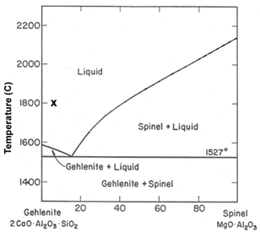

The T-X plot to the right represents the relationship between gehlenite (Ca₂Al₂SiO₇) and spinel (MgAl₂O₄). These minerals occur in high T, low P metacarbonates. These are also common minerals found in meteorites and metallurgical slags.

Use the gehlenite-spinel binary phase diagram to answer the following questions.

Fig. 2. Gehlenite-spinel system (after Prince, 1951).

1) What are the melting temperatures of pure gehlenite and pure spinel?

2a) If we have a melt that plots on this phase diagram at X, what is its bulk composition?

2b) At what temperature will the first crystals form as melt X cools and what is the composition of these crystals?

2c) At 1530°C, what is the composition of the liquid?

2d) At 1530°C, how much liquid is present and how much of the system is crystalline?

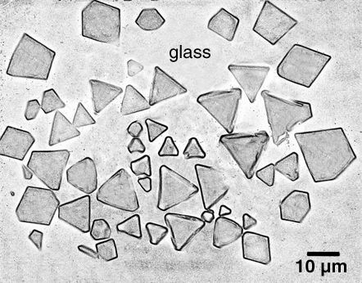
Above is a simplified image showing the mineralogy of a tin slag from Great Britain. This slag contains only pure spinel and glass. In the picture, all of the euhedral crystals are spinel and the surrounding material is glass. The glass formed when the system was quenched (i.e. cooled so quickly that the liquid could not form any more crystals). You can also of a quenched system as a snapshot of the cooling melt at a specific temperature.

3a) Let’s say you analyzed the glass and found that it had a composition equivalent to 30% spinel + 70% gehlenite. Use the gehlenite-spinel phase diagram to determine the quenching temperature.

3b) Take a look at the picture above and estimate the relative amounts of spinel and glass.
_______________% Glass and _______________% spinel

4) Based upon the %’s above and the temperature you determined in 3a, what is the bulk composition of the slag?

