Stratigraphy

Three cores were collected from an Oligo-Miocene sequence of rocks in the ocean. A total of thirteen species of foraminifera were collected from throughout these cores. Eight taxa are benthic forams, and their preferred habitat (in depth) is shown below. The other five are planktic forams with restricted periods of time over which they were abundant. The occurrence of the planktic forams correlated with time, is also shown below.

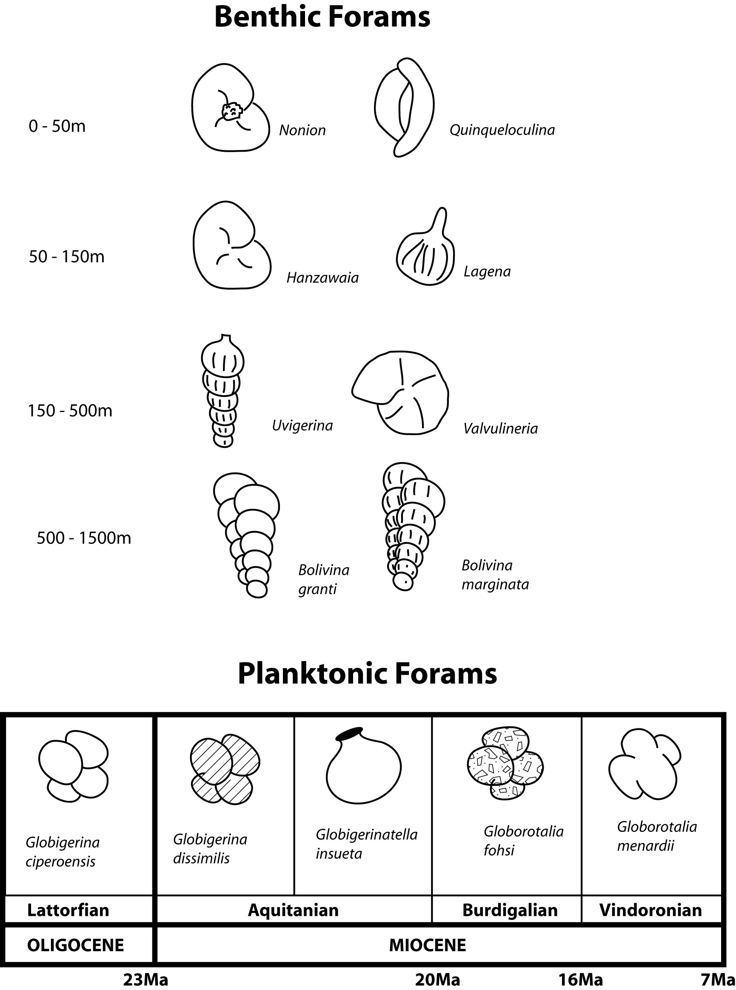

Using the known distributions of these forams as a guide, divide this section into parts based upon the depth of deposition or the age of deposition. Keep in mind that 1) gravity works, and 2) old specimens may be reworked.

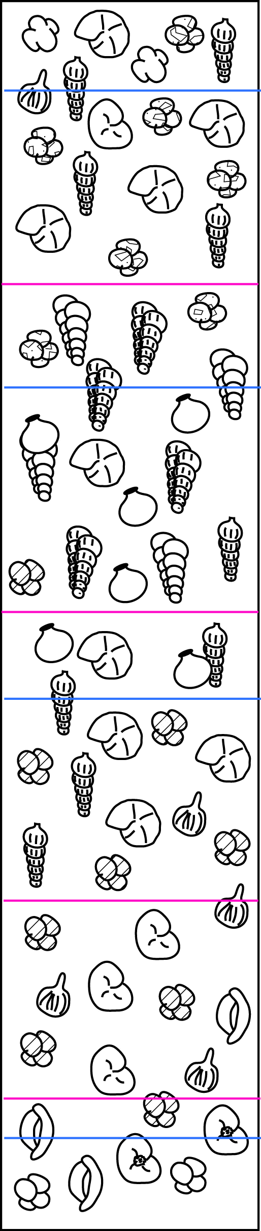
Using these forams as references, correlate the following sections by LITHOLOGY.

A B C
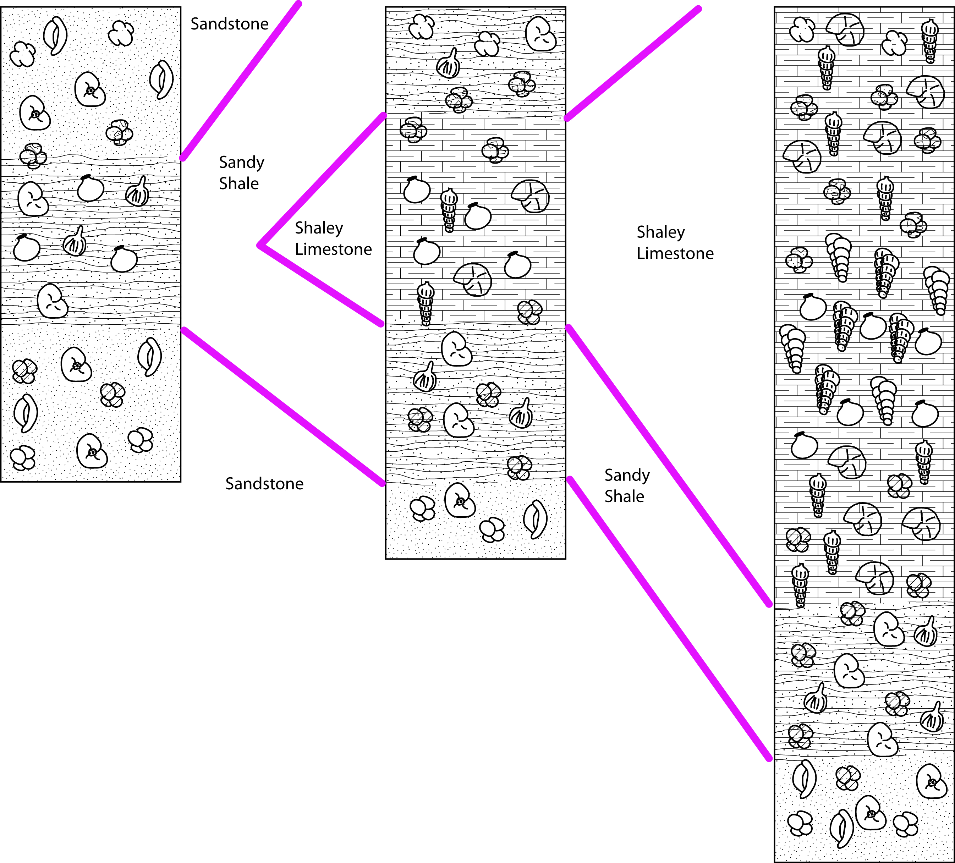

Using these forams as references, correlate the following sections by WATER DEPTH during deposition using benthic forams.

A B C
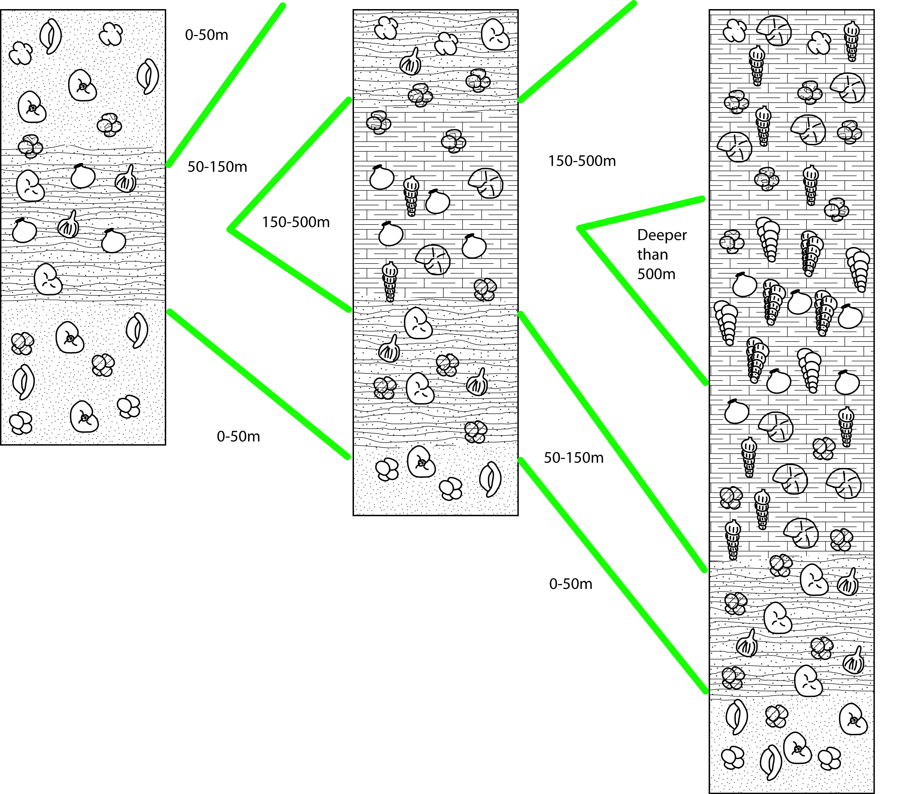

Using these forams as references, correlate the following sections by AGE using planktonic forams.

A B C
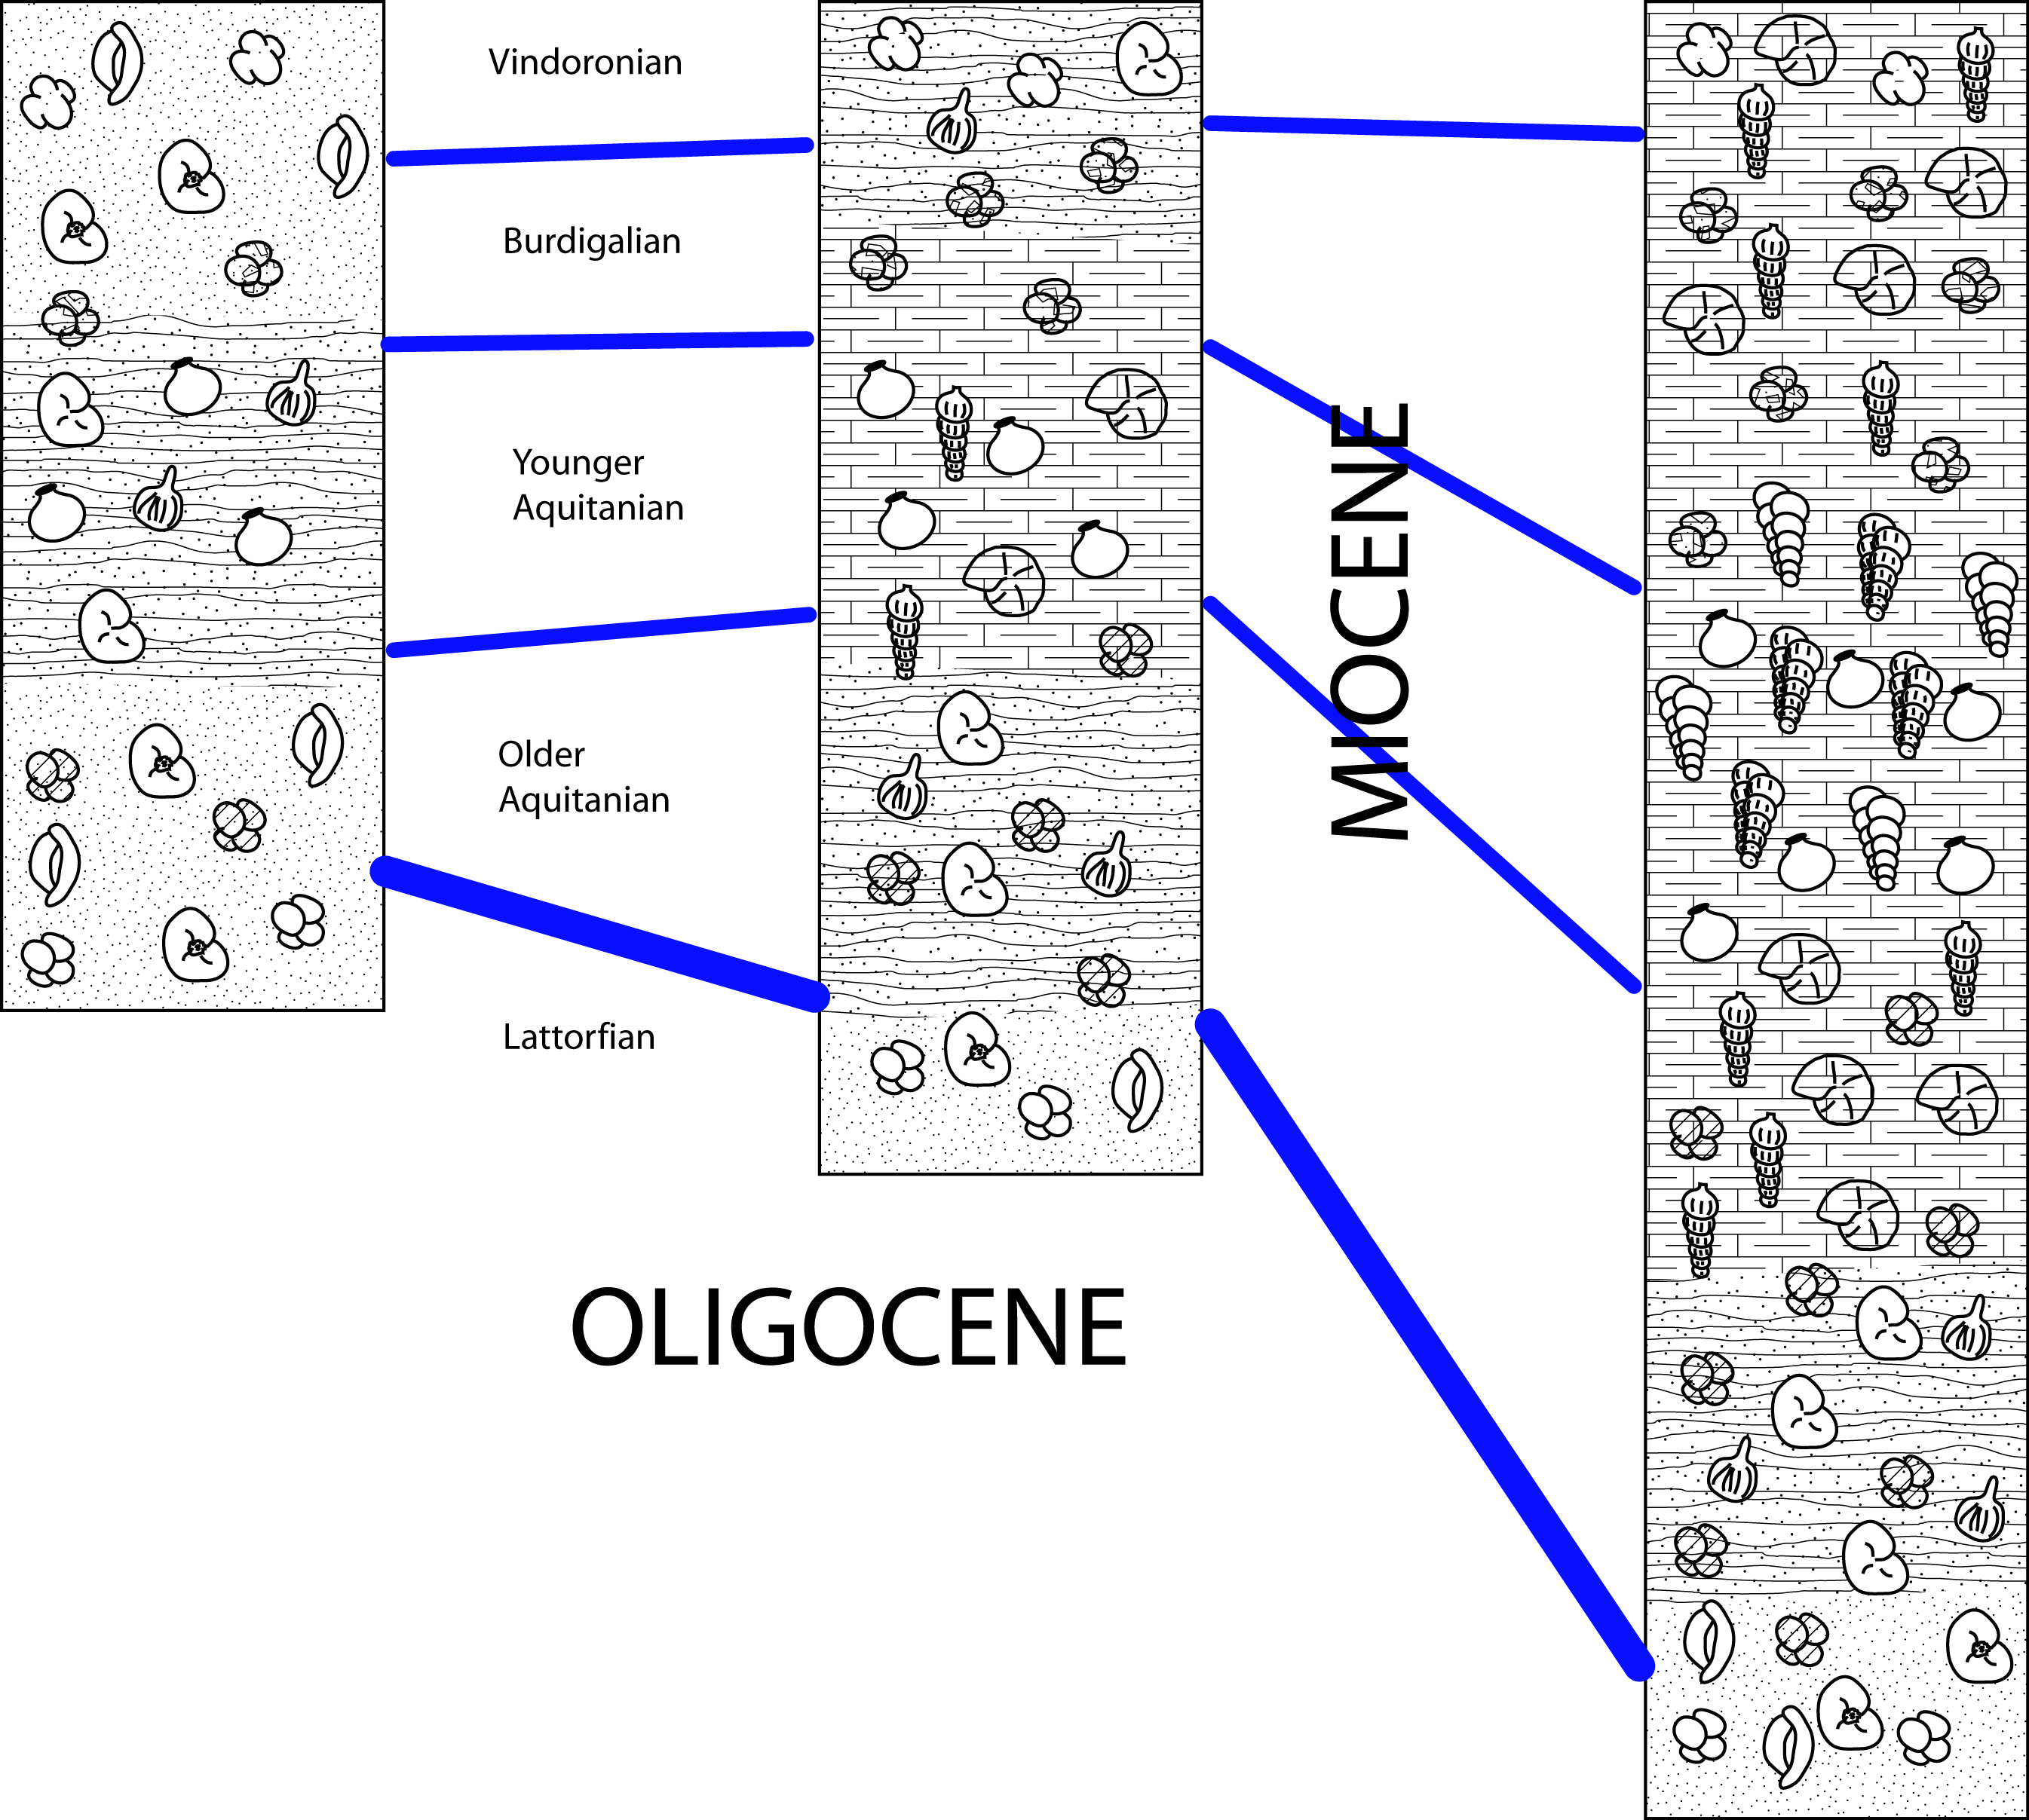

EXERCISE 7 – CORRELATION NAME______________________________

Recently, an ash layer (pink) was discovered and is known to be correlative through the three sections (that is, it is the same age in all three sections). Does this adjust any of your prior correlations?

A B C
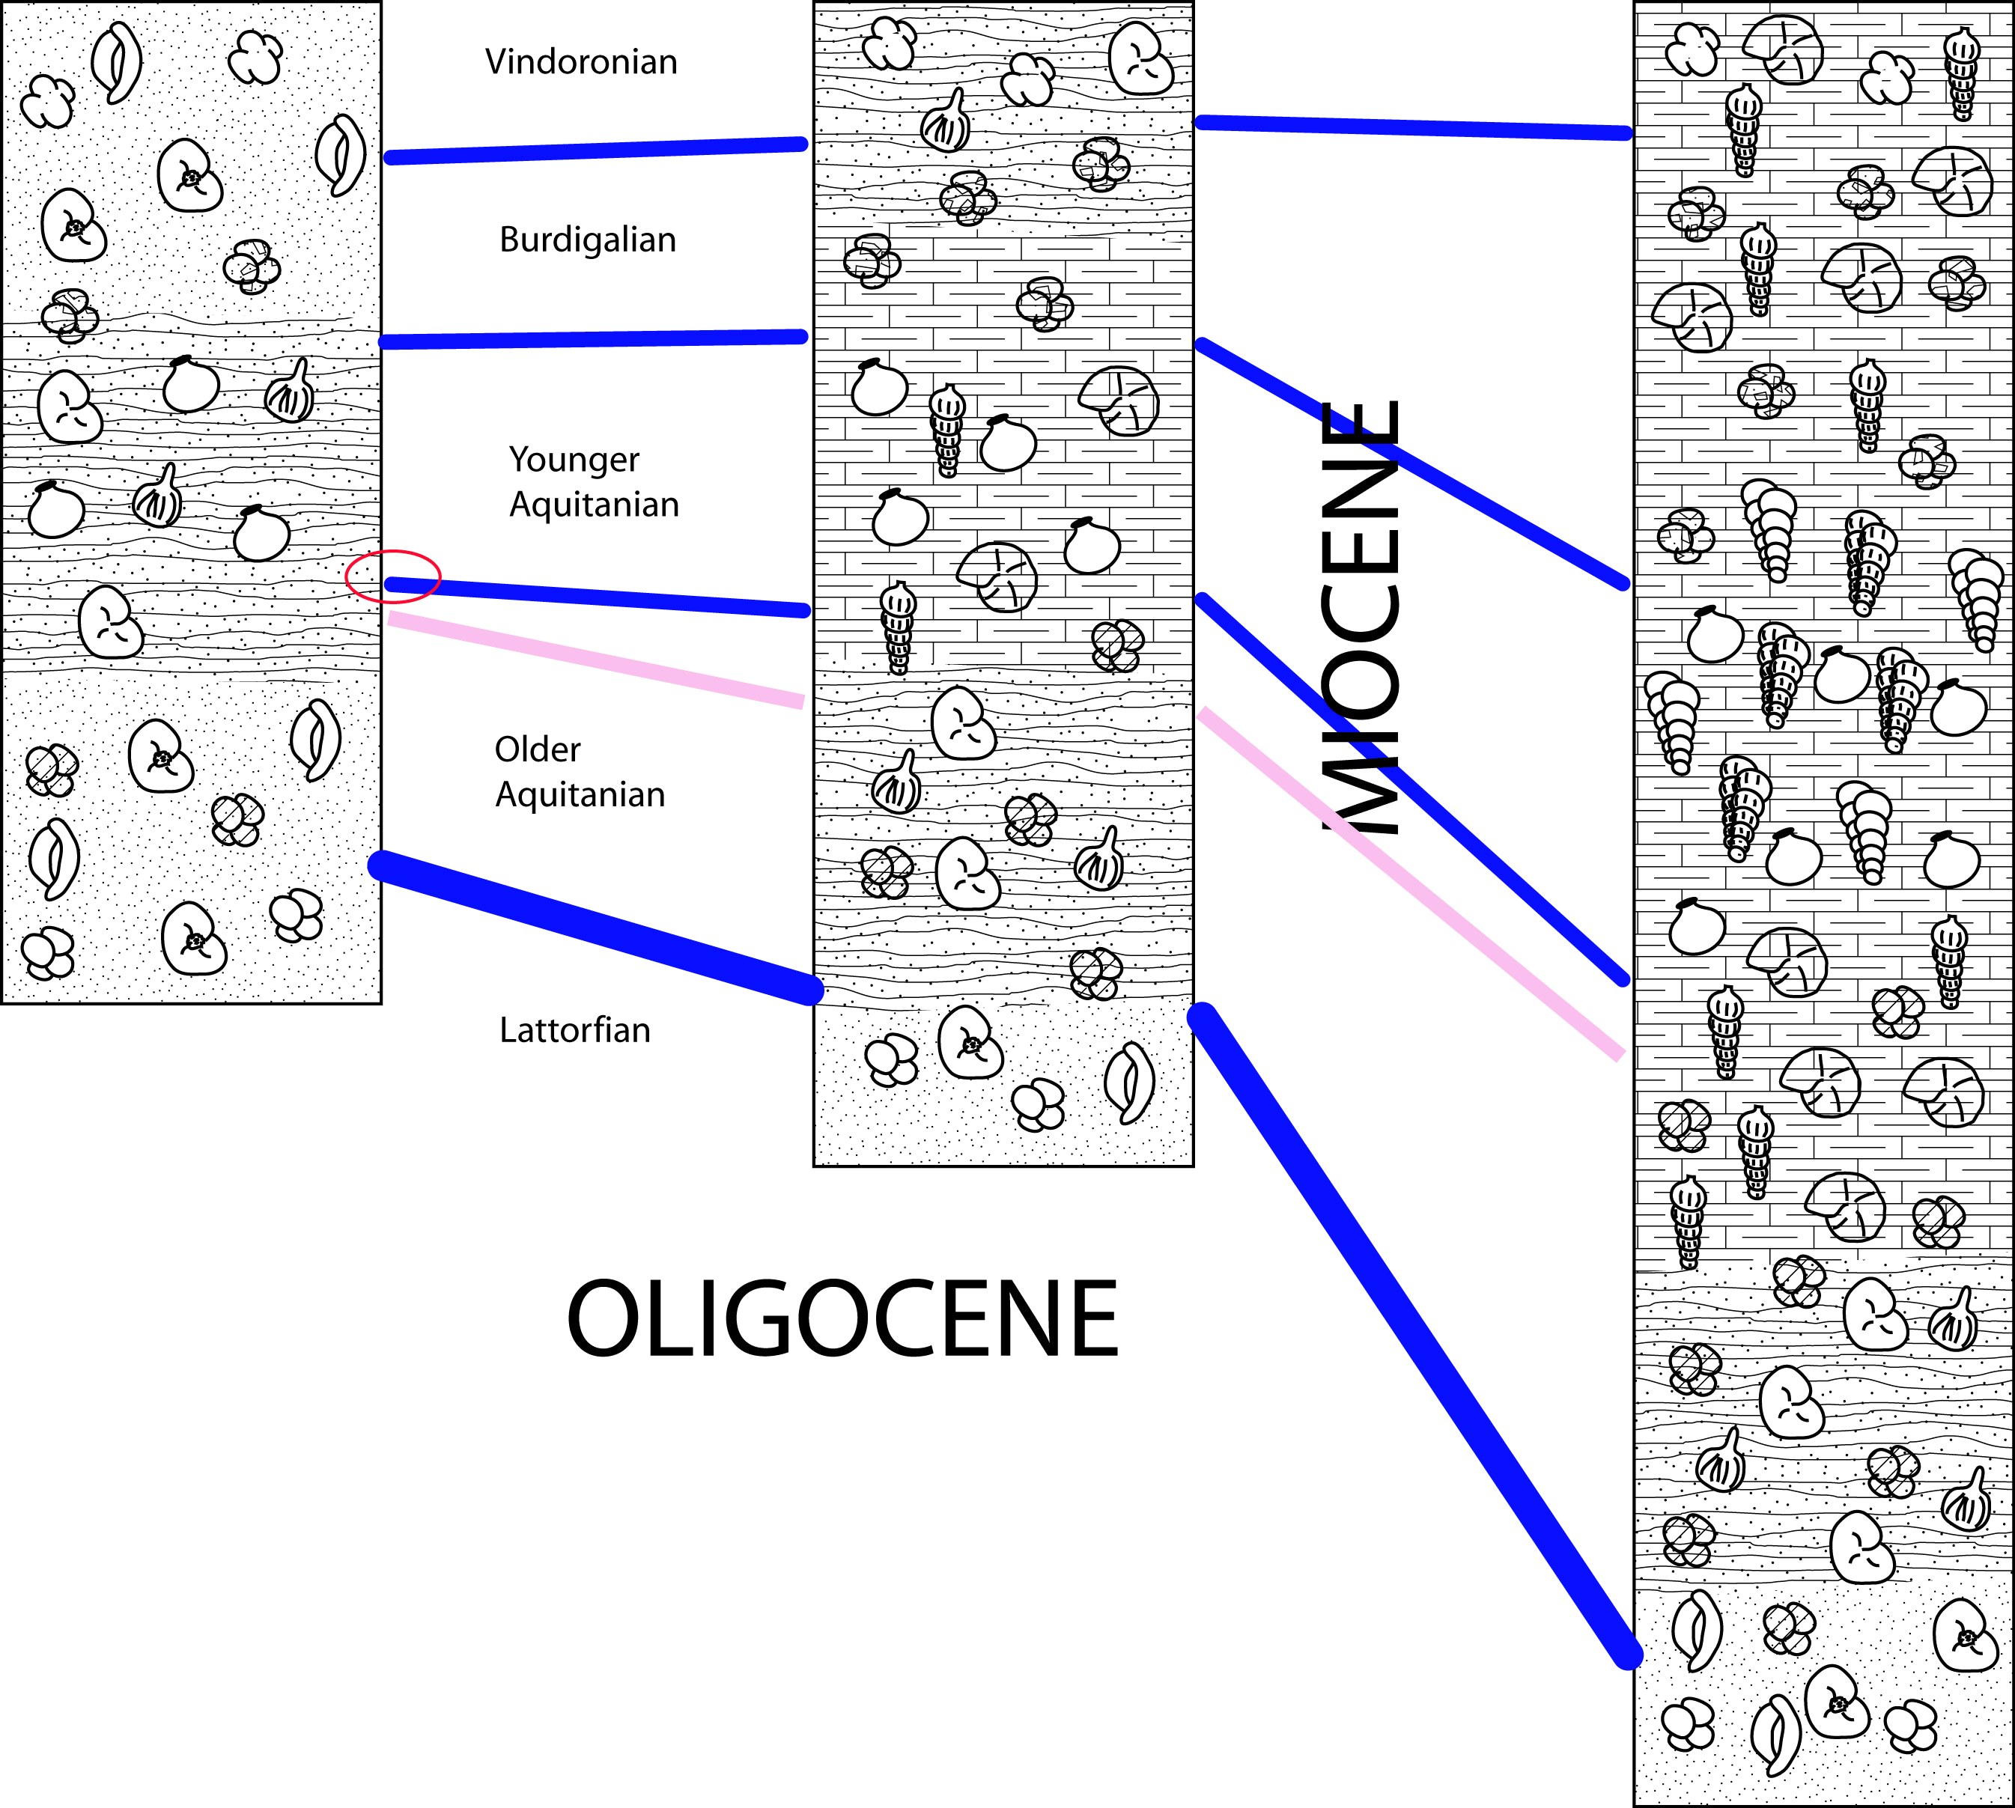

Look at the blue-shaded parts of the sections. In these areas there is an increase in the abundance of course-grained sediments. What do you suppose could have caused this?

Can you develop an interpretation of these sections? If section A is to the West and section B, then C, are to the East, where might one expect to find fossils representing the deepest parts of the ocean? Why? What might a researcher expect to find if they go in the opposite direction?

