Field Trip to Ashfall Fossil Beds
Ashfall is a unique fossil site within easy driving distance of the University of South Dakota. Fossil preservation is exceptional and provides a vivid snapshot of how animals lived and died on the Great Plains 12 million years ago.
The goals of the field trip are to understand:
1) The diversity of animals in the Miocene Epoch (Clarendonian Land Mammal Age) of the Great Plains and how they compare with animals living in the area today.
2) What the animals reveal about the Miocene climate and plant life of the region.
3) The causes of death and preservation of this fossil assemblage.
4) How biases in preservation caused some animals to be over-represented and others to be under-represented compared with the living fauna.
Activities
Tour the Ashfall excavations and examine the skeletons in the Hubbard Rhino Barn and the associated museum exhibits in the visitor center, or examine the online materials at http://ashfall.unl.edu/ and http://www-museum.unl.edu/research/vertpaleo/ashfall.html.
Questions to Address
What animals are preserved in the greatest numbers at Ashfall? Describe the relative abundance and special relationships of males, females, and juveniles.

Give the number and a brief description of the horse species that have been found at Ashfall. Describe how these horses differ from the modern horse.

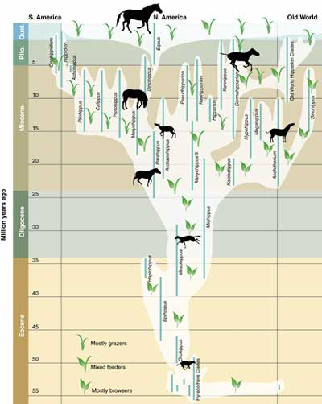
Examine the above diagram of horse diversity over time and the associated feeding habits. What do the horses at Ashfall indicate about the plant community of the are in the Miocene?

What non-mammalian species have been found at Ashfall, and what do they indicate about the climate and temperature?

What is the source of the ash that killed and preserved this assemblage of animals, and what evidence is this explanation based on?

What animals died early and late in the ashfall event? How long did it take for the last animals to succumb, and what evidence is this based on?

How does the relative abundance of animals in the ashfall layer differ from the more scattered remains from deeper layers of the park? What factors in the ashfall event likely caused some species to be so abundant and others so rare?

