Primary Production in the Oceans: Building a Carbon Comparator
Joceline Boucher, Corning School of Ocean Studies, Maine Maritime Academy joceline.boucher@mma.edu

Summary
This activity provides a “hands-on” visualization of marine primary production in terms of relative rates and chemical representation.

Context
Audience Any undergraduate course that explores or refers to primary production. I use the activity in a marine geochemistry course. Note: the activity would be difficult to do in a large class; the instructor could instead pass around a preassembled carbon comparator.

Skills and Concepts Students Must Have Mastered The activity can be done at an introductory level (no required knowledge of stoichiometry) or at an intermediate level (students do their own stoichiometric calculation).

How the Activity is Situated in the Course The activity immediately follows a brief review of primary production. The activity, once completed, also helps initiate discussion of carbon transfer and recycling in the oceans. The hands-on portion takes about 20 minutes; the activity and ensuing discussion together require a 50 minute class period.

Goals
Textbooks typically cast marine primary production in a global context – i.e. the oceans account for roughly 50% of photosynthetic production on earth. The main goal of this activity is to help students place marine productivity in equally memorable spatial and temporal contexts. Students start by recalling the photosynthetic equation and use it to translate primary production into glucose-equivalents. Groups then weigh masses of glucose, corresponding to the productivity of different environments, into transparent vials. Together, the class considers productivity variations in the oceans by matching vials to their representative environments.

A related goal is for students to visualize carbon production and transfer in the oceans. The instructor can encourage this by also assigning rates of export production or carbon burial to groups. The mass of glucose representing diurnal export production per square meter in most ocean environments will seem strikingly small to students (and instructors!).

Lastly, students can place the vials in a transparent container for easy viewing, transport, and comparison; hence the term, “carbon comparator”. For this I use a wide-mouth glass jar in which the vials fit snuggly.

Equipment and Supplies
A. Per Class  Portable balance (to 0.1 or 0. 01 g; ideally  one for every two student groups)  One spatula per balance  5 pound bag of sugar  Meter stick  Labeling tape and/or marker(s)  Transparent container to hold vials | B. Per Student Group  Index card  20 mL glass scintillation vial with cap  Weighing paper  Weighing boats or other vessels to transport  small amounts of sugar  (Groups assigned export production will need the + 0.1 g balance.)
Activity Outline
- Instructor questions students about primary production: What does the term mean? How does it relate to photosynthesis? How can photosynthesis be represented by a chemical equation?

- With help from students, the instructor writes a simple equation for photosynthesis on the board:
CO₂ + H₂O $\underset{→}{light}$ organic matter + O₂

- The instructor shows the bag of sugar and asks how it relates to the formula.
Students suggest that glucose can approximate organic matter in the equation:
6CO₂ + 6H₂O $\underset{→}{light}$ C₆H₁₂O₆ + 6O₂

- The instructor shows the meter stick and asks students how much organic matter they think each square meter of ocean surface produces daily. (Students may suggest the amount will vary by type of environment and availability of nutrients and light.)

- Introductory class: instructor writes a conversion factor on the board: 1 gram carbon = 2.5 grams glucose
Course with students who took chemistry: students calculate the conversion factor:
1 gram carbon * 180 grams glucose/72 g carbon = 2.5 grams glucose
or (1 g C * 1 mol C/12 g C) * (1 mol glucose/6 mol C) * (180 g glucose/1 mol glucose) = 2.5 g glucose

- Students form into groups (2-5 students each). Each group receives an index card with a rate of primary production (see next page) expressed in grams C/m² day, but with no other information. The writing is large enough to be visible in the back of the room.

- Students calculate the mass of glucose corresponding to their assigned rate. Students weigh and transfer this mass to a vial and label the vial.

- The instructor draws a rectangle on the board, representing the ocean with labels for different environments (coastal, upwelling, open ocean etc.). As groups finish, they place their vials and index cards on the chalk tray.

- Responding to student suggestions, the instructor rearranges the vials and index cards on the chalk tray under the corresponding environments. (Alternatively or also, students could construct a table summarizing the different rates.)

- Various discussion points are possible, including:

- productivity differences between environments (I usually show an animation of global chlorophyll over an annual cycle and ask students to explain the patterns)

- a small amount of carbon delivered to the deep sea on a daily basis keeps the benthos and aphotic zone “fed”. (Interesting comparison, with the bag of sugar present: the average person in the U.S. consumes 77 pounds of sugar per year = 15.6 five pound bags = 35 kg = 35,000 grams.)

- lesser amounts of carbon are preserved in sediments (typically < 1% of surface production) so most carbon is recycled.

- relationships between gross/net/new/primary production; secondary production; tertiary production; export production (see image, next page).

Estimates of Marine Primary Production

Environment | % of oceans | Chlorophyll  (mg m⁻³) | Net Primary  Production  (g C m⁻² year⁻¹) | Net Primary  Production  (g C m⁻² day⁻¹) | Export  Production  (g C m⁻² day⁻¹) | Source
Oligotrophic | 30 | <0.1 | 42ª | 0.12 | 0.022^{b} | Carr et al
Mesotrophic | 66 | 0.1-1 | 146ª | 0.400 | 0.11^{b} | Carr et al
Eutrophic | 4 | >1 | 387ª | 1.06 | 0.39^{b} | Carr et al
Estuarine | (0.47 x 10⁶ km²) | typically >1 | 190 + 50 | 0.52 + 0.14 |  | Smith and  Hollibaugh
Coral Reefs | 0.005 | Low (planktonic) | 890 | 2.4 |  | Pauly and Christensen
Salt Marshes |  |  | 2471 + 1532 | 6.8 + 4.2 |  | Smith and Hollibaugh
Kelp Forest^{c} |  | 3-10 | 1170  1130 | 3.21  3.09 |  | Carter
a. estimated from global satellite chlorophyll data for 1998
b. calculated from Laws et al. (2000) average model export (“ef”) ratios, and Carr et al. (2000) net production values.
c. top number is average annual Laminaria and Ekelonia kelp production; bottom number is annual average phytoplankton production within kelp beds near Cape Town, South Africa.

Sources
Carr, M. E., Friedrichs, M. A., Schmeltz, M., Noguchi Aita, M., Antoine, D., Arrigo, K. R., ... & Yamanaka, Y. (2006). A comparison of global estimates of marine primary production from ocean color. Deep Sea Research Part II: Topical Studies in Oceanography, 53(5), 741-770.

Carter, R. A. (1982). Phytoplankton biomass and production in a Southern Benguela kelp bed system. Marine ecology progress series. Oldendorf, 8(1), 9-14.

Laws, E. A., Falkowski, P. G., Smith, W. O., Ducklow, H., & McCarthy, J. J. (2000). Temperature effects on export production in the open ocean. Global Biogeochemical Cycles, 14(4), 1231-1246.

Pauly, D., & Christensen, V. (1995). Primary production required to sustain global fisheries. Nature, 374(6519), 255-257.

Smith, S. V., & Hollibaugh, J. T. (1993). Coastal metabolism and the oceanic organic carbon balance. Reviews of Geophysics, 31(1), 75-89.

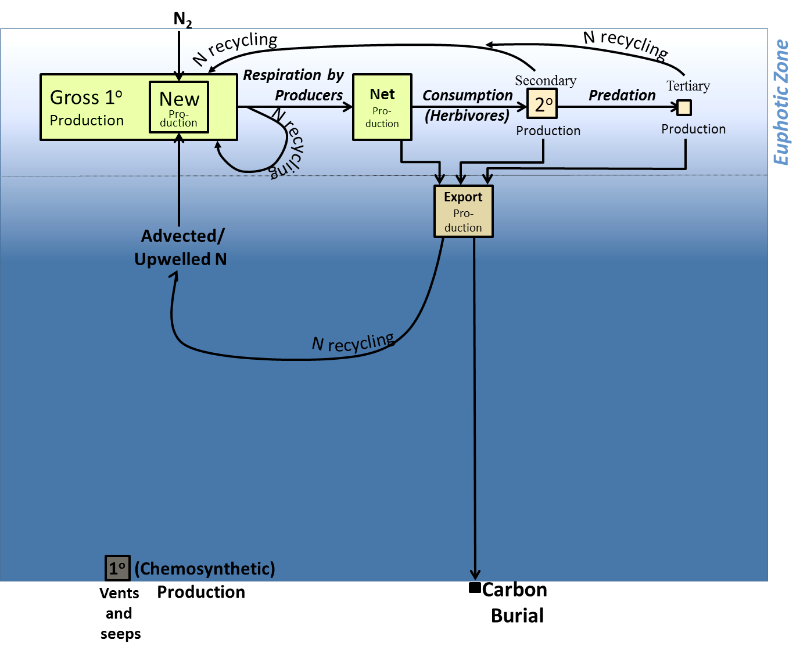

Notes:
Total marine production approximately equals total terrestrial production.

Photosynthetic production accounts for less than 99.9% of all production on Earth.

Export production approximately equals new production.

Less than ~2% of surface production ever reaches the deep sea.

Less than ~1% of surface production ends up buried.

Approximately 8% of global annual primary production currently goes towards sustaining world fisheries.

Productivity in salt marshes and kelp forests is within the productivity ranges found in tropical rainforests, the most productive terrestrial biomes.

The high productivity of coral reefs, also known as Darwin’s paradox, is exceptional given that reefs exist in oligotrophic environments. This is at least partly due to efficient nutrient recycling (via tightly coupled surface waters and benthos), the ability of corals and other invertebrates to recycle nutrients from ingested prey, and physical factors (turbulence and roughness) enhancing nutrient uptake from seawater.

