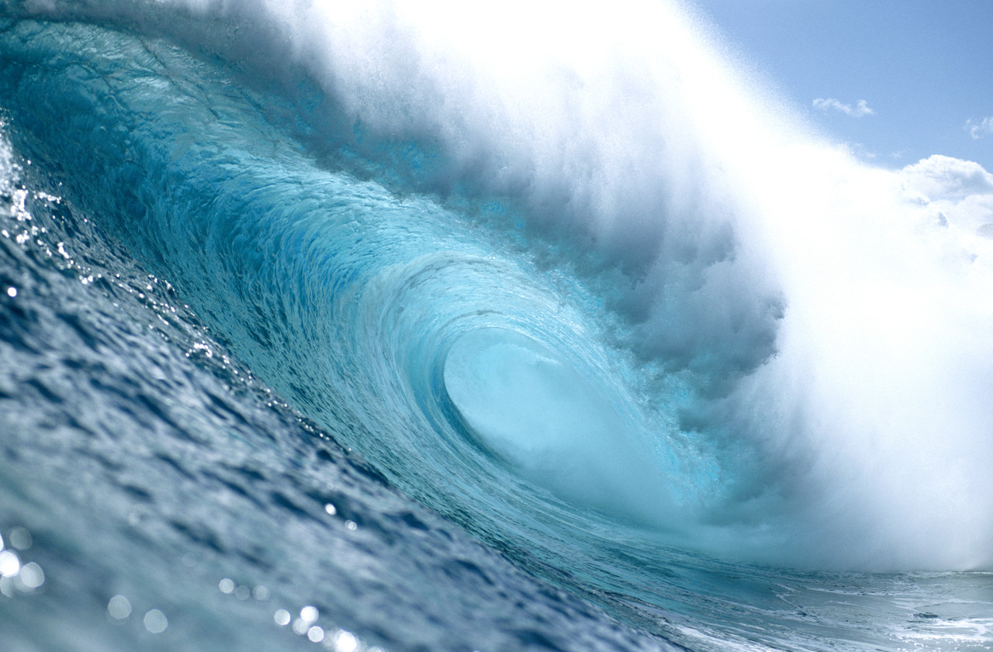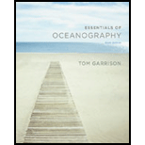
Introduction to Oceanography
GEOL V11
FALL 2012

Mandatory Field Trip: Saturday, Nov. 17

SECTION:
70002; Tuesday & Thursday, from 12:00 pm to 1:15 pm,
building & room: SCI-106

INSTRUCTOR:
Cindy Lampe
Office: SCI-121; Hours: Tues. & Thurs. from 1:15 pm to 1:45 pm or by appointment
Phone Number: voice mail 805-654-6444, mailbox #2902
E-mail: CLampe@vcccd.edu (Please state in subject line: Oceanography Student)

REQUIRED TEXT:
Essentials of Oceanography, 6th Edition; by Tom Garrison, publisher: Brooks and Cole, Belmont, California, 2012.
Hardcopy ISBN: 978-0-8400-6155-3
or “ebook” online from www.brookscole.com (www.cengage.com/highered/)

OPTIONAL:
- video set can be ordered for individual use, $35 at intelecom.org

ATTENDANCE:
Your class attendance, both physical and mental, is essential in order to pass this course! If you miss class, are late for class, or leave class early, you are responsible for the material that was covered during your absence and for making-up any assignments or exams. In other words, contact me or a classmate to get the assignment, to arrange for a make-up exam, or to get any other important information discussed in class!
No texting allowed, turn off all cell phones, iPods, etc. and remove earphones during class time!

METHOD OF EVALUATION:
Assignments - worth a total of 100 points.
Field Trip – worth 50 points
4 Mandatory Exams (100 points each; the lowest score from the first 3 exams will be dropped).
Mandatory make-up exams must be taken as soon as possible. It is your responsibility to arrange a time with me to take the make-up exam!
Exam 4 will be given during Finals Week. Final Exam Time: Tuesday, Dec. 11th at 12:30 pm
(It is NOT comprehensive).
Exam 4 can NOT be DROPPED!!!
Extra credit will be assigned throughout the semester.

GRADING POLICY:
Based on 450 points.
A - 90 to 100%; B - 80 to 89%; C - 70 to 79%; D - 60 to 69%; F - 59% or below
Cheating or plagiarism will result in a 0 (zero) for that exam, project or extra credit and may be reported to the Dean for further disciplinary action.
Do NOT leave the room during an exam for any reason!
The only materials allowed during an exam are pencils, pens, erasers, scantron #882, and the exam.
Taking any portion of the exam out of the classroom, at any time, for any reason, will result in a grade of 0 (zero) for that exam!

CORE COMPETENCIES:

1. Apply lessons from the past or learned knowledge to new situations.
2. Apply principles of scientific reasoning to solve problems.
3. Defend a logical hypothesis to explain observed phenomenon.
4. Employ vocabulary of the subject studied.

STUDENT LEARNING OUTCOMES:

- Students will identify, define and/or locate (1) the three types of plate tectonic boundaries and (2) the tectonic/geomorphologic (surface) elements related to each of the three boundaries. These items will be tested either by locating the various elements on maps and/or by interpreting information/data from written questions. The purpose of this part of the class is to have students appreciate and understand the entire plate tectonics model as it relates to the spatial distribution of earth’s seafloor features and history.

- Students will identify, define and/or describe the spatial elements/features of the oceans as they relate to global pressure systems, salinity patterns, shallow/deep life communities, coastal/seafloor sediments and human usage. Students will be tested based on locating the elements on maps of earth and/or by interpreting written questions containing the same information.

TENTATIVE SCHEDULE:

Week/Dates___ Subject ______ Chapter________

1 / Aug. 16 An Introduction to Oceanography

2 / Aug. 21 & 23 Origin of the Ocean Chapters 1 & 2
& History of Marine Science

3 / Aug. 28 & 30 Earth Structure and Plate Tectonics Chapter 3

4 / Sept. 4 & 6 Earth Structure and Plate Tectonics continued “

5 / Sept. 11 & 13 EXAM 1
Ocean Basins Chapter 4

6 / Sept. 18 & 20 Ocean Sediments Chapter 5

7 / Sept. 25 & 27 Water Chapter 6

8 / Oct. 2 & 4 Water continued “

9 / Oct. 9 & 11 EXAM 2
Atmospheric Circulation Chapter 7

10 / Oct. 16 & 18 Atmospheric Circulation continued “

11 / Oct. 23 & 25 Ocean Circulation Chapter 8

12 / Oct. 30 & Nov. 1 Ocean Circulation continued “

13 / Nov. 6 & 8 Waves Chapter 9
EXAM 3

14 / Nov. 13 & 15 Tides Chapter 10
Nov. 17 FIELD TRIP

15 / Nov. 20 & 22 Tides continued “
No Class Thursday - Thanksgiving Day!

16 / Nov. 27 & 29 Coasts Chapter 11

17 / Dec. 4 & 6 Life in the Ocean Chapter 12

18/ Dec. 11 EXAM 4 on Tuesday, Dec. 11th at 12:30 pm

