Is That True?

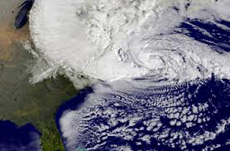

Hurricane Sandy was the largest Atlantic hurricane on record, as well as the second costliest Atlantic hurricane, only surpassed by Hurricane Katrina in 2005. She formed on October 22, 2012 and ravaged parts of the Greater Antilles and Bahamas before heading up the US East Coast making landfall again near New Jersey on October 30. At it’s maximum, she had 1-minute sustained winds of 110mph (175 kph) and a record low pressure for the western hemisphere of 940 mbar (27.76 in Hg).

Reporters were quick to ask the question about why Sandy was so massive. NBC News, with a backdrop containing the words, “The New Normal?” aired a video claiming, “Most scientists have no doubt of the overall cause” of Hurricane Sandy and attributed its massive size to “global warming”. You can view the video here:

http://www.msnbc.msn.com/id/8004316/ns/video/#49616092

And… what do YOU think?

Is that true? Is Hurricane Sandy associated with global warming? Spend some time researching what was said and why SCIENTISTS believe it is (or is not) related to global warming. Provide a brief 1pg summary (typewritten) about the evidence to support this claim and evidence that exists to deny it. This evidence should include some real data about hurricane frequency over time. Choose data that you feel are valid and appropriate to support your conclusion and construct an excel plot of these data to be turned in with your summary. Be sure to include a list of sources used in this assignment.

