OCEANOGRAPHY 100 Sample Exam Questions SEQUENCE________
Coastal Stabilization Structures Exercise
Mr. Trujillo

A. Multiple choice: Choose the best answer.

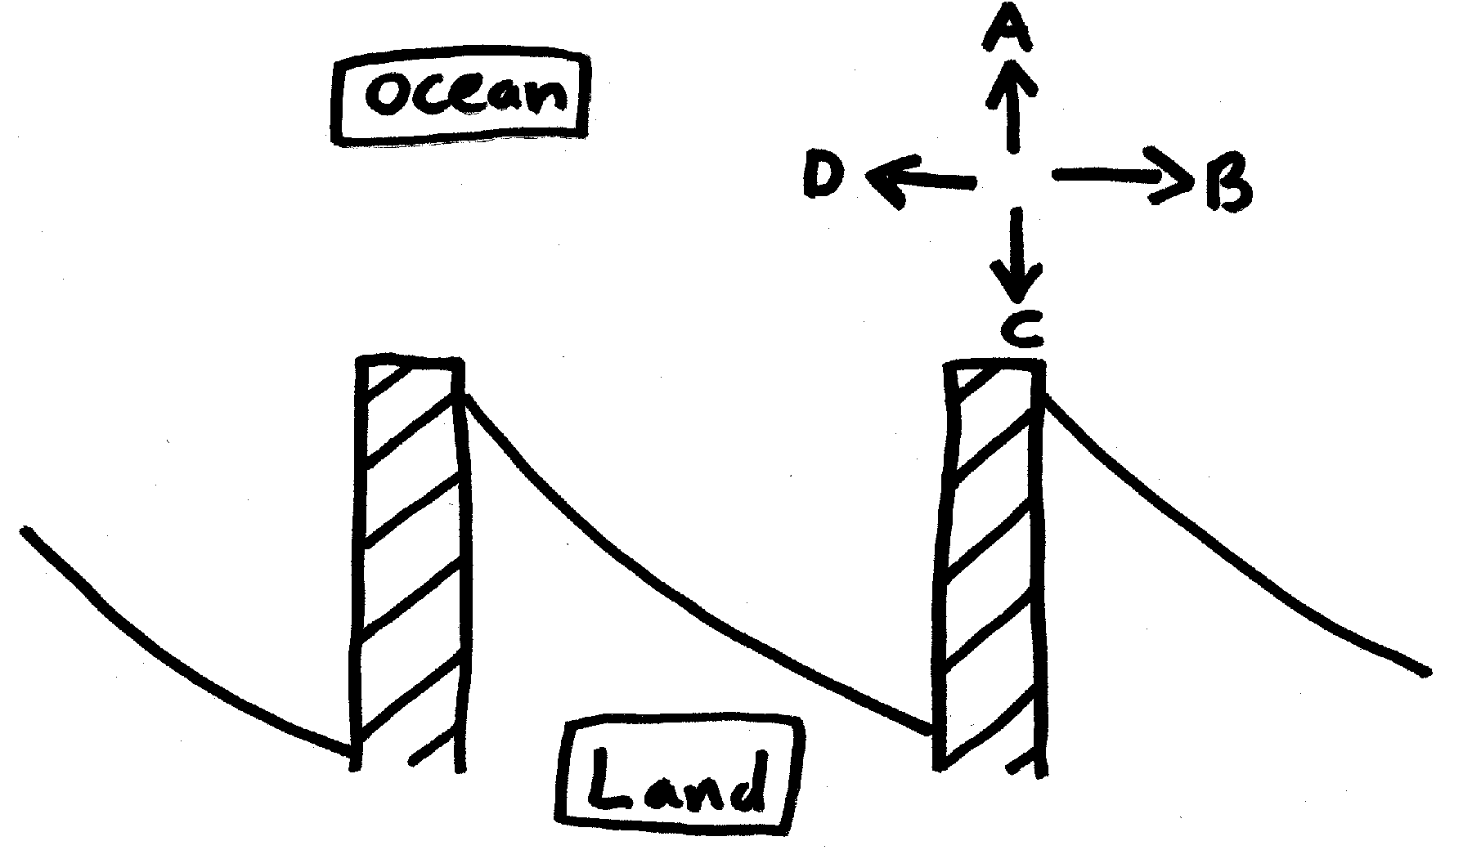1. Based on the aerial view of the coastal structures below, determine the direction of longshore drift: (NOTE: the shoreline was originally a straight shoreline.)
a. arrow A shows the average direction of longshore drift
b. arrow B shows the average direction of longshore drift
c. arrow C shows the average direction of longshore drift
d. arrow D shows the average direction of longshore drift

2. The coastal structures in the question above are called:
a. jetties d. berms
b. groins e. coastal stabilizers
c. breakwaters

3. In Santa Monica, a breakwater was built parallel to shore out beyond the surf zone, with the hope that (1) it would protect anchored small boats from the incoming waves, while (2) it would not interfere with the longshore flow of sediment in the surf zone. Before the breakwater was destroyed, did it accomplish both of its objectives?
a. yes, it accomplished both
b. it did allow for the unobstructed longshore flow of sediment, but it did not adequately protect the boats
c. it did protect the boats, but it interrupted the sediment flow
d. neither objective was accomplished

4. Which longshore drift management technique was implemented at Santa Monica before the breakwater was destroyed?
a. the breakwater was redesigned to be more solid
b. sand was dredged from behind (inshore of) the breakwater
c. a wave machine was installed at the breakwater
d. groins were built downstream from the breakwater
e. none of the above

B. True/False: Answer (a) for true, or (b) for false.

5. Longshore drift (also called longshore transport) describes the movement of sand within the surf zone in a zigzag fashion that is caused by wave refraction.

Answers to questions:
1. d
2. b
3. c
4. b
5. a

