Your Name ______________________
Partner’s Name ______________________
Challenge: The Coriolis effect and the six-cell global circulation model and the Indian Monsoon.

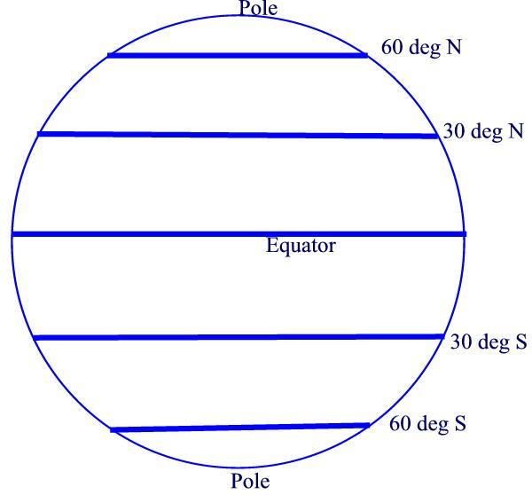

Complete the diagram above by placing the information below in its correct position on the above globe.

1. ITCZ 2. Subtropical high 3. Horse latitudes

4. Wind vector direction: 5. Wind vector direction:
(all that apply) (all that apply)

6. Wind vector direction: 7. Wind vector direction:
(all that apply) (all that apply)

Oceanography Name _____________________________________

Explain the Indian monsoon.
- Use the maps below to help illustrate your explanation by showing the position of the ITCZ during the dry and wet monsoons.
- Add arrows to show prevailing wind directions over the Indian subcontinent.
- To the right of each map, add a cross-sectional sketch that shows the influence of surface wind direction on cloud formation or dissipation.

Dry Monsoon

Wet Monsoon

Describe, with at least 2 examples from the videos we watched in class, of the ways Indian people's lives are so influenced by the shifting ITCZ.

