**Seasonal variation in light, mixing depth and primary productivity in temperate northern hemisphere waters**

Photosynthesis by algae in the ocean represents approximately half of all global primary production and supplies a large part of the oxygen that we breathe. These algae are tiny which helps them stay afloat in the surface waters where the sunlight is strong enough to allow photosynthesis. In temperate latitude winters, lower light intensity and deeper mixing result in light limiting conditions and hence low primary productivity. In summer, as the waters stratify, mixing decreases and light intensity increases alleviating the light limitation.

Marine algae also require nutrients, just as plants in your garden do. The nutrients that marine algae require are phosphate, nitrate and silicate. These are typically in low concentrations in the surface waters of the ocean, and at higher concentrations at depth. When mixing brings these nutrients to the sunlight surface waters phytoplankton proliferate.

At temperate latitudes in the North Atlantic there is a seasonal cycle in phytoplankton productivity with a bloom occurring in the spring, and a smaller bloom in the fall. This is linked to seasonal cycles in sunlight intensity and mixing of the ocean water. In this exercise we examine these cycles to gain a deeper understanding of linkages between phytoplankton productivity and physical oceanographic processes.

**Goals**

In this exercise we will work with light, temperature, and phytoplankton biomass data to;

* Become more skilled in reading and interpreting semilog graphs, temperature profiles, and time series plots.
* Practice unit conversions.
* Gain an understanding of *k*, the attenuation coefficient for nondirectional light.
* See how the depth of the photic zone and the surface mixed layer varies seasonally at temperate latitudes and how this relates to seasonal phytoplankton productivity dynamics.

**Light**

Sunlight penetrating the ocean surface can be attenuated by the water, organisms in the water, dissolved organic molecules from organism’s wastes and decay, and suspended particles. The importance of some of these depends on the biological residents of the water and the proximity to a source of suspended sediment. Figure 1 (below) shows two examples of light attenuation versus depth. Were you to measure light attenuation in your local ocean you would likely collect data that would result in a different line on this graph.

**Becoming familiar with the graph**

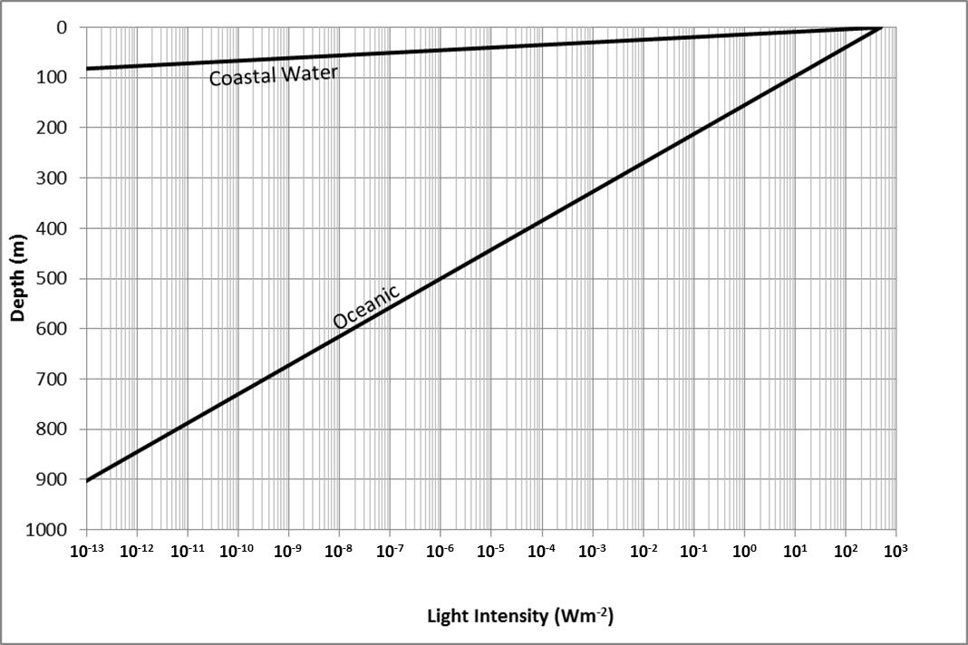

Figure 1. Light attenuation in oceanic and coastal waters.

1. The photic zone is defined as the surface layer where light intensity is strong enough so that photosynthesis by marine algae exceeds respiration (the bottom of the photic zone is also called the compensation depth). This is approximately the depth at which the light intensity is equal to 1% of the summertime light intensity at the surface.

The plot shows that the light intensity at the surface is about 500 W/m2. At what depth is the light intensity 1% of this value in;

* Oceanic water
* Coastal water

2. Deep sea fish need about 3 x 10-12 W/m2 to see*.

Read the graph to determine the depth of total darkness for fish in oceanic water.

3. Humans require 10-9 W/m2 to see*.

Read the graph to determine the depth of total darkness for humans in deep ocean water.

Read the graph to determine the depth of total darkness for humans in coastal water

*(From: Seawater: Its composition, properties and behaviour, by The Open University, 1995).4. The table below gives some light intensity data measured at an ocean station.

Plot the data on the graph in Figure 1 and label the line station 1.

|  |  |
| --- | --- |
| **Depth (m)** | **Measured light**  **intensity(W m-2)** |
| 0 | 300 |
| 100 | 14.9 |
| 200 | 0.74 |
| 300 | 0.037 |
| 400 | 0.0018 |
| 500 | 9.18 x 10-5 |
| 600 | 4.57 x 10-6 |
| 1000 | 2.81 x 10-11 |

Compare station 1 to the plots for coastal water and oceanic water.

Do you think station 1 is a coastal or an oceanic station? Why?

**Determining k**

The graph can be used to determine *k*, the diffuse attenuation coefficient for nondirectional light. *k* is a measure of the amount of light that is absorbed and/or scattered as light passes through the water. Clear oceanic waters have very low *k* values while turbid coastal waters have high values.

To determine *k* we need to manipulate a formula that relates light intensity at the light source, light intensity at some distance from the source and *k*.



Where *Iz*  = light intensity at a distance z from the source. In this exercise z is depth in the ocean.

*Io* = light intensity at the source. In this exercise this is light intensity at the surface of the ocean.

*e* = natural log

*k* = light attenuation coefficient

z = distance from the light source. In this exercise z is the depth at which Iz is measured.

The above formula can be simplified to this, which can be easily solved with a calculator.



**Equation 1**

**Hint**- be sure to divide *Iz* by *Io* before taking the natural log!

Use Equation 1 to solve for *k* for the coastal water, oceanic water and water at station 1 plotted in Figure 1.

Keeping in mind that lower *k* values indicate clearer water while higher *k* values indicate that the water is more turbid, of the coastal water, oceanic water and water at station 1, which has the most turbid water? What do you think makes it turbid?

6. The table below (From: The Oceans, by Sverdrup, Johnson and Fleming, 1942) is a listing of average solar radiation at the sea surface (I0) for different months in the temperate northern hemisphere ocean. This exercise will illustrate how the photic zone depth varies with month.

Convert the table values to the same units as those used on the graph.

(1W = 0.239 g cal/sec). **Be smart about it** and determine the conversion factor, then just apply it to all the values in the first column of numbers.

**Determining the conversion factor.**

1 g cal/cm2/min = ? W/m2

Write the conversion factor in the indicated place in the table. Then use it to complete column 3.

Once you have completed column 3 determine the light intensity at the bottom of the photic zone in the summer (in the northern hemisphere this will be the June value). Take 1% of this value and write it in each cell in column 4.

Calculate the depth of the photic zone in column 5 by using Equation 1. Use the values in column 4 as Iz and use k= 0.086 m-1.

|  |  |  |  |  |
| --- | --- | --- | --- | --- |
| 1 | 2 | 3 | 4 | 5 |
|  | Average amount of surface (I0) radiation  (g cal/cm2 min) | Average amount of surface (I0) radiation  (W/m2)  **\*Write your conversion factor here.**  **______________** | 1% of June surface light intensity  (W/m2)  Each of the cells below should contain the same number. | Depth of photic zone (m)  **Write the equation you will use here.**  **___________** |
| Jan | .094 |  |  |  |
| Feb | .138 |  |  |  |
| Mar | .212 |  |  |  |
| April | .272 |  |  |  |
| May | .306 |  |  |  |
| Jun | .329 |  |  |  |
| July | .302 |  |  |  |
| Aug | .267 |  |  |  |
| Sept | .230 |  |  |  |
| Oct | .174 |  |  |  |
| Nov | .115 |  |  |  |
| Dec | .086 |  |  |  |

Plot the depth of the photic zone versus month (this is called a time series plot) in Figure 2. Plot each monthly point on the first day of the month. Connect the points and label the line PHOTIC ZONE DEPTH.

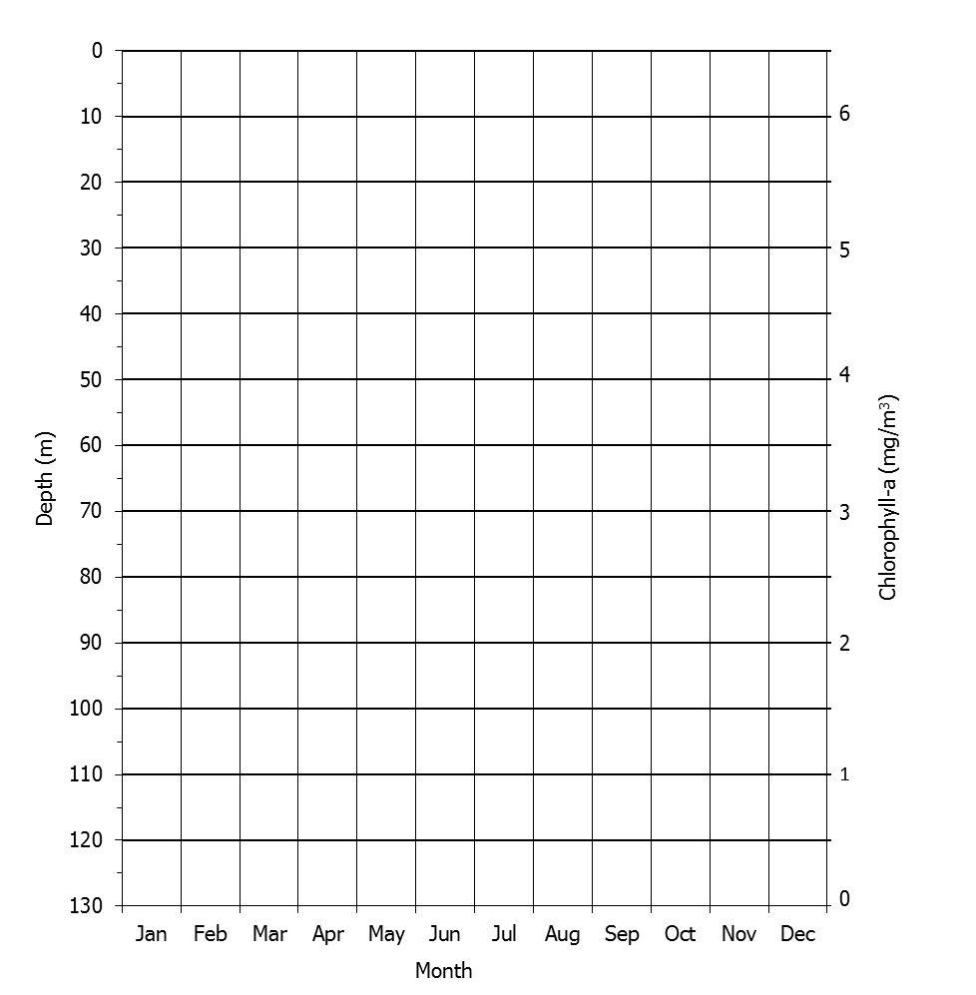

Figure 2. Photic zone depth, mixed layer depth, and phytoplankton biomass in temperate

northern hemisphere waters. Determine the depth of the surface mixed layer from the temperature profiles shown below. Remember that the temperature in the surface mixed layer is uniform (because the layer is well mixed). Plot the mixed layer depth for each month shown on Figure 2, using the first day of the month as the plotting point. Connect the points and label the line MIXED LAYER DEPTH.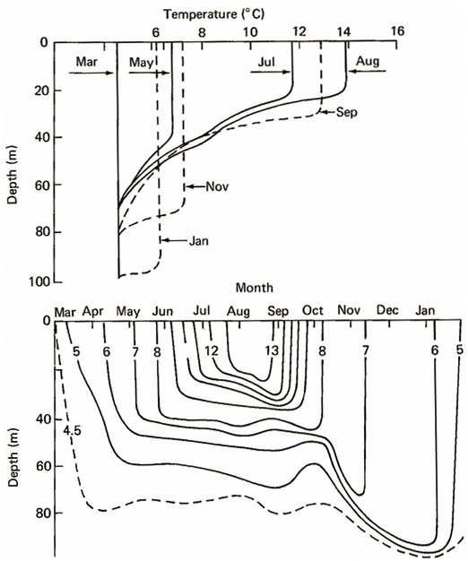

From: Introduction to Physical Oceanography by John A. Knauss, 1978.

The table below contains satellite-derived chlorophyll a concentration data from temperate North Atlantic waters (data were accessed from the NASA Earth Observatory website and represent monthly averaged values for the year 2012, from coordinates 43.2 °N, 51.2°W). Although these data represent pigment concentration, they can be used as a proxy for phytoplankton biomass and productivity with higher pigment concentrations reflective of higher phytoplankton biomass and productivity.

Plot these data on Figure 2 using the axis on the right. Plot each monthly point on the first day of the month to which they apply. Connect the points and label the line PHYTOPLANKTON BIOMASS.

|  |  |  |  |
| --- | --- | --- | --- |
| **Month** | **Chlorophyll-a concentration**  **(mg/m3)** | **Month** | **Chlorophyll-a concentration**  **(mg/m3)** |
| Jan | 0.640 | Jul | 0.640 |
| Feb | 0.737 | Aug | 0.640 |
| Mar | 0.806 | Sep | 0.598 |
| Apr | 6.045 | Oct | 2.091 |
| May | 0.668 | Nov | 0.945 |
| Jun | 0.585 | Dec | 0.834 |

Each of the sketches below represents the upper 140 m of the water column for a different month. Examine Figure 2 and for each of the months of January, April, July and October sketch in and label one horizontal line, indicating the depth of the photic zone, and another horizontal line, indicating the depth of the surface mixed layer.

For each month sketch in a travel path a phytoplankton might take if carried with the water as it mixes through the surface mixed layer.

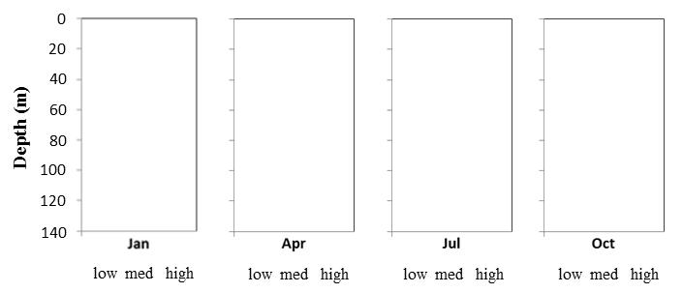

Examine Figure 2 and for each of the sketches above, determine if primary productivity was low, medium or high and circle the appropriate word under each sketch.

Hypothesize why phytoplankton biomass displays the pattern it does. Think about what plants and algae need in order to photosynthesize then consider how the biomass pattern relates to the physical oceanographic parameters of photic zone depth and mixed layer depth.