EES 113 Oceanography
Lab 8: Ocean Circulation
Vocabulary

Density of seawater increases with _______________ temperature, ________________ salinity, and ________________ depth

Layers of the ocean

Surface mixed zone

Transitional mixed zone

Pycnocline

Thermocline

Deep zone

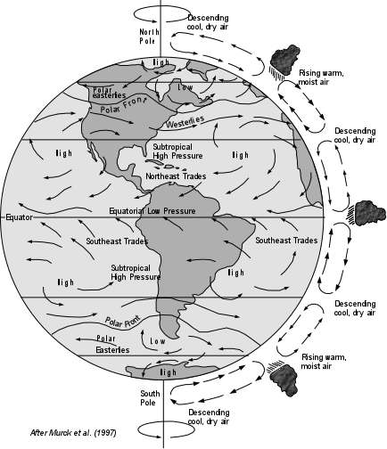

Thermohaline circulation

Surface currents

Gyres

Ekman Transport

Upwelling/Downwelling

Atmospheric Circulation

