ASBESTOS: MINERALOGY, HEALTH HAZARDS AND
PUBLIC POLICY

Helen M. Lang
Department of Geology and Geography
West Virginia University
P.O. Box 6300
Morgantown, West Virginia 26506-6300
e-mail: hlang@wvu.edu

Sid P. Halsor
Department of GeoEnvironmental Science & Engineering
Wilkes University
Wilkes-Barre, Pennsylvania 18766
e-mail: shalsor@wilkes1.wilkes.edu

BACKGROUND

Asbestos refers to certain minerals that have a fibrous habit and are useful for their insulating, heat and chemically resistant properties. Asbestos has been used extensively for over a century in electrical and heat insulation, fireproofing materials, brake and clutch linings, construction materials, filters and many other applications. Recently, the U.S. has severely restricted the use of asbestos, and has a program for removing asbestos from schools and other public buildings (See Gunter, 1994; Ross, 1995 and references therein). In this laboratory exercise you will have an opportunity to examine the crystal structures, optical properties and health hazards of the common asbestos minerals. The laboratory will reinforce optical microscopic skills that you have learned in mineralogy and show you how mineralogy can be critical to understanding a current public policy issue.

Although mineralogists reserve the designation asbestos for fibrous material with a length:width ratio (aspect ratio) of at least 10:1 (Skinner, et al., 1988), asbestos is defined by OSHA (U.S. Occupational Safety and Health Administration, 1972; Web address is given below) as mineral material composed of any of the six silicate minerals in Table 1 with a length:width ratio of 3:1 or greater, diameter less than 5 µm and length greater than 5 µm.
.
Table 1. Asbestos Minerals
.
Mineral Asbestos name Mineral Group Approx. Formula Comments .
Riebeckite Crocidolite (blue) clino-amphibole Na₂Fe³⁺₂(Fe²⁺,Mg)₃Si₈O₂₂(OH)₂ only in pC BIF
Grunerite Amosite (brown) clino-amphibole (Fe²⁺)₂(Fe²⁺,Mg)₅Si₈O₂₂(OH)₂ only in pC BIF,
Transvaal, S.A.
Anthophyllite ortho-amphibole Mg₇Si₈O₂₂(OH)₂ Alpine UM rx
East Finland
Actinolite Byssolite clino-amphibole Ca₂(Mg,Fe²⁺)₅Si₈O₂₂(OH)₂ rarely asbestos
Tremolite Byssolite clino-amphibole Ca₂Mg₅Si₈O₂₂(OH)₂ rarely asbestos
Serpentine Chrysotile(white) trioctahedral Mg₃Si₂O₅(OH)₄ serpentinized
t-o sheet silicate UM rx,Quebec,
Russia, U.S.
ACTIVITY 1 - MINERAL STRUCTURES

The asbestos minerals are either double chain silicates or sheet silicates. We will use the Mineralogy Tutorials CD (Klein, 1995) to review these silicate structures. When you get an opportunity to use the computer, go to Systematic Mineralogy, Silicates, Inosilicates.
Note added 2008: Refer also to Mineralogy and Optical Mineralogy, Dyar, Gunter & Tasa, 2008.

In Inosilicates (chain silicates) look at
Riebeckite - photo is crocidolite, "blue" asbestos
structure - find the tetrahedral double chains, find the strip of M1-M4 octahedral sites between the point-to-point chains, look at the view down the b-axis - note the monoclinic symmetry (all octahedra tilt in the same direction, so a is not perpendicular to c)
Cummingtonite (Grunerite)
photo is grunerite asbestos, which is called amosite or "brown" asbestos
structure - monoclinic, like riebeckite
Anthophyllite - structure - compare anthophyllite's orthorhombic structure to the monoclinic structure of riebeckite and cummingtonite (two layers of octahedra tilt one way, two layers tilt back the other way; a is perpendicular to c, therefore, the mineral is orthorhombic)
Tremolite (Actinolite)
solid solution shows the variations in chemical compositions of most of the amphiboles you have looked at.
Go to Phyllosilicates (sheet silicates) to look at the serpentine asbestos, chrysotile, and related minerals (Click index, silicates, phyllosilicates).
Chrysotile - photo shows cross-fiber chrysotile asbestos
Chrysotile’s structure is shown under lizardite, which has the same basic structure.
Lizardite - photo shows veins of chrysotile (asbestos form) and matrix of lizardite (massive, non-asbestos) serpentine
structure - find the tetrahedral layer (yellow) and the octahedral layer (green) of this tetrahedral-octahedral, t-o, or 1:1 sheet silicate
Kaolinite - structure - the kaolinite structure is very much like that of lizardite, except that kaolinite is dioctahedral (2/3 of the octahedral positions are filled with trivalent cations, Al³⁺) while lizardite and chrysotile are trioctahedral (all the octahedral positions are filled with divalent cations, Mg²⁺ ). Look at the dioctahedral and trioctahedral illustrations and note the differences in structure of lizardite and kaolinite.
Talc - structure - talc is a tetrahedral-octahedral-tetrahedral, t-o-t or 2:1 sheet silicate in contrast to chrysotile and lizardite, which are t-o or 1:1 sheet silicates. Note the differences in the pictures of their structures.

But how can a sheet silicate be fibrous?

The octahedral sheet of serpentine filled with Mg²⁺ (b~9.36Å) is slightly larger than the tetrahedral sheet of serpentine filled with Si⁴⁺ (b~9.05Å). When these two mismatched sheets bond together (share oxygens), they tend to curl with the bigger octahedral sheet outside and the smaller tetrahedral sheet inside. In chrysotile, this results in tightly rolled sheets that form long, thin, flexible fibers. Only under very high magnification in the high resolution transmission electron microscope (HRTEM) can the rolled sheets be seen (Fig. 1).
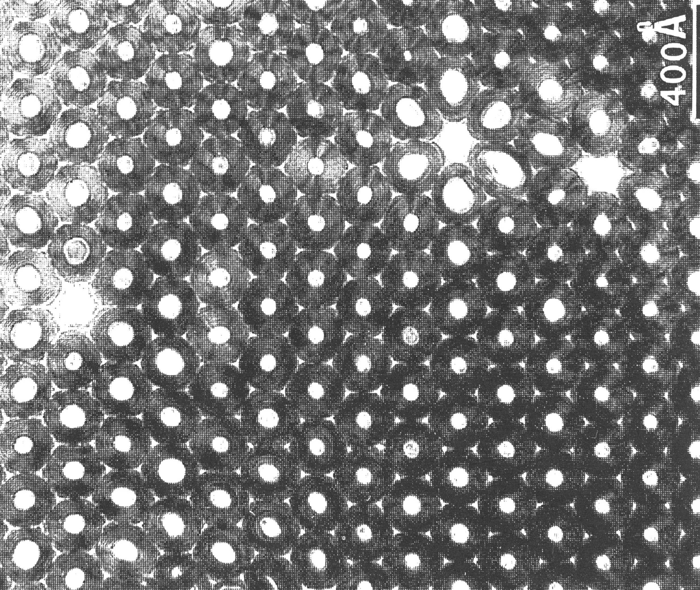

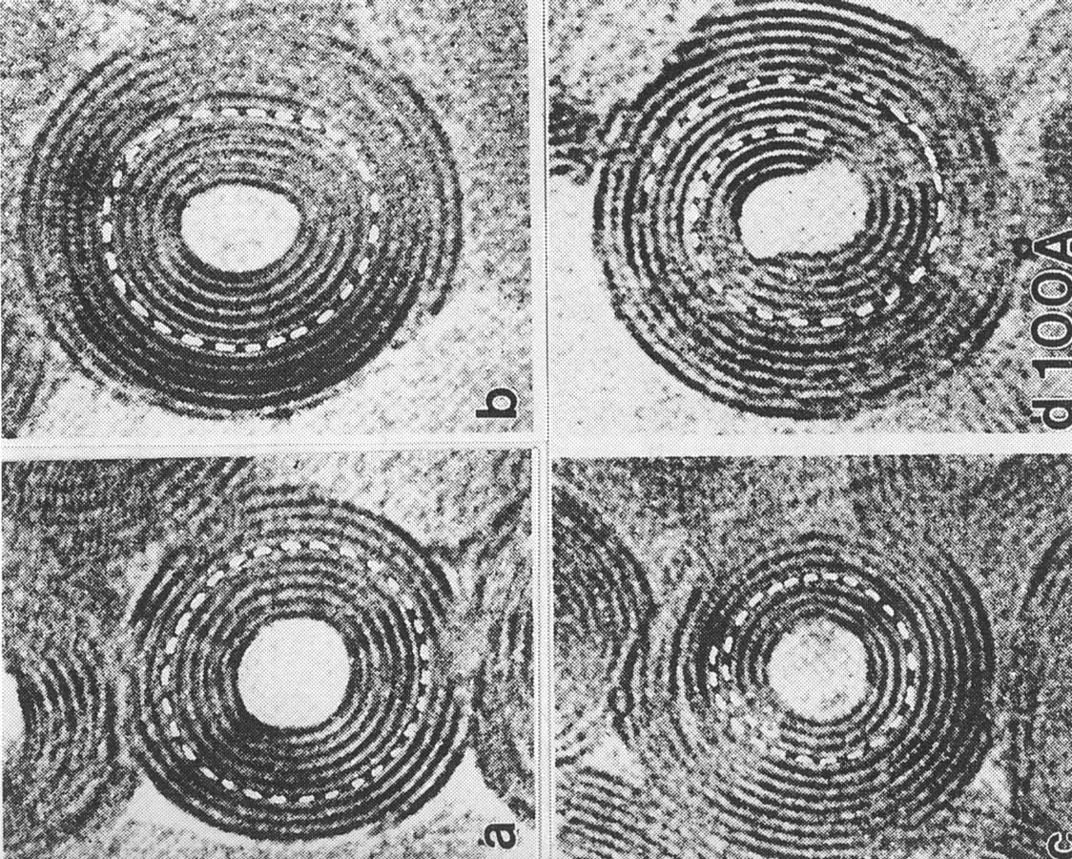

Figure 1. High resolution transmission electron microscope images of chrysotile. a. Packing of chrysotile fibrils in cross-fiber chrysotile asbestos. b. Higher magnification images of chrysotile fibrils with various roll structures viewed parallel to the fibril axis. (after Veblen & Wylie, 1993)
ACTIVITY 2 - MACROSCOPIC AND MICROSCOPIC PROPERTIES

"Hand" samples of each of the types of asbestos are available for you to examine. (Ward's Earth Science, Asbestos Standards Set, 49 E 5840, $126) The samples are sealed in plastic bags so you won't breathe any fibers. Leave the bags closed and handle the samples as little as possible. Crocidolite ("blue" asbestos) is the most hazardous, and chrysotile ("white" asbestos) poses no hazard to the casual observer. At least one of the samples looks more like cleavage fragments than true asbestos, which one? Write down the properties of each of the mineral samples that you can see with the naked eye, hand lens or binocular microscope. Include approximate length and width of fibers, color, and general appearance.

Optical microscopic properties of asbestos and related minerals are given in Table 2. Your instructor will provide you with grain mounts of three Unknown asbestos minerals labeled Asbestos A, Asbestos B, and Asbestos C (the authors chose amosite, chrysotile and crocidolite) to examine under the petrographic microscope. The refractive index of the mounting medium will be in the standard range of 1.53-1.55. Record as many of the optical microscopic properties of each sample as you are able to observe. (Your instructor may provide a form on which to record your observations.) If you are not using dispersion staining, give a name to each unknown based on the information in Table 2. Tell which property or properties you found most useful for identifying each sample.

Table 2. Optical Properties of Asbestos
(diagnostic properties are underlined)

Refractive Index Fiber Morphology
Mineral (relief) Birefringence Extinction and Comments

Amphibole Asbestos
Crocidolite 1.650-1.717 low oblique blue, pleochroic, long,
(high) fibrous w/ broom-like ends

Amosite 1.696-1.730 moderate- oblique & straight, stiff, short white to
(high) high parallel tan fibers

Anthophyllite 1.587-1.670 low parallel straight or slightly curly,
(moderate) long, acicular fibers

Actinolite 1.688-1.705 low- oblique straight or slightly curly,
(high) moderate thick fibers, star-like

Tremolite 1.599-1.620 moderate oblique straight or slightly curly,
(moderate) thin fibers, star-like

Serpentine Asbestos
Chrysotile 1.532-1.556 low parallel long, curly or wavy
(low) fibers

ACTIVITY 3 (OPTIONAL) - DISPERSION STAINING FOR IDENTIFYING
ASBESTOS MINERALS

Dispersion staining is an optical identification technique that can be very helpful in identifying and distinguishing asbestos and non-asbestos fibers. The most diagnostic results are obtained when using a "central stop" objective (from McCrone Research Institute, see Information for Instructors) combined with a high-dispersion immersion oil (from Cargille Laboratories). The technique offers several advantages: 1) it is fast and easy and can be used successfully at the undergraduate level; 2) it yields highly diagnostic results that are unambiguous in their interpretation; and 3) it reinforces the concepts of light refraction and dispersion.

Most microscopists think of staining as applying a chemical dye that imparts a characteristic stain, or color, to plant or animal tissue. Dispersion staining is an optical phenomenon in which color is produced, not by a chemical interaction, but by the dispersion of the refractive index of a particle and the mounting liquid (McCrone, 1987). Light dispersion is what produces the colored Becke lines when the refractive indices of a crystal and liquid match. Because the refractive index of an anisotropic crystal will vary with crystal orientation, different dispersion colors will be obtained depending on the vibration direction of light. The dispersion staining technique enhances and clarifies the observed color lines by utilizing a high-dispersion immersion oil coupled with a special objective that blocks-out axial light and produces dark field illumination. For a less-expensive alternative, it is possible (although less satisfactory) to see dispersion colors by using oblique illumination (Bloss, 1961). The relation between crystallographic axes and highly elongated asbestos fibers allows for easy stage manipulation to test staining colors produced parallel and perpendicular to the vibration direction of light. The dispersion staining colors characteristic of each asbestos mineral are listed in Table 2. A flow chart outlining the procedure for identifying asbestos minerals with dispersion staining is shown in Figure 2.

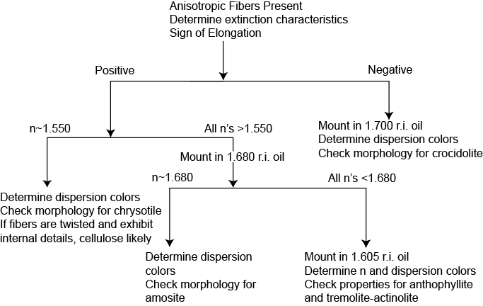
Figure 2. Flow chart outlining the procedure for identifying asbestos and related materials using dispersion staining. Samples should be examined first at low magnification in 1.550 r.i. oil. Non-fibrous materials and multiple fiber types may be present in bulk samples. If fibers are present, it must be determined whether they are isotropic or anisotropic. If fibers are isotropic, fiberglass (1-20 μm uniform diameter, r.i.<1.53) or mineral wool (8-200 μm diameter, bulbous ends and shot, r.i. typically > 1.53) is indicated. For anisotropic fibers, view the fibers at 100X, and follow the flow chart.

Simple steps for dispersion staining:

1) Mount the fiber in a high-dispersion immersion oil that has a refractive index similar to that of the fiber.
2) Rotate the central-stop objective into the light path and close down the substage iris.
3) Rotate the microscope stage so that the elongate fiber lies parallel to the vibration direction of polarized light. Observe and record dispersion color (n//).
4) Rotate stage 90° so that elongate fiber lies perpendicular to the vibration direction of polarized light. Observe and record dispersion color (n⊥).

The dispersion staining technique will be demonstrated to you. Use the technique to examine the asbestos unknowns and identify the minerals. If time and interest allow, you may be able to use this technique to analyze fibers from bulk samples of possible asbestos-containing material (ACM) that you have collected or that have been provided for you.

ACTIVITY 4 - ASBESTOS HAZARDS AND REGULATIONS
(TURN IN AT YOUR NEXT LAB)

Asbestos has been used extensively for insulation of walls and pipes, as a binder in tiles, as the material of brake linings, for specialized textiles, for fire-proofing and to prevent corrosion on the hulls of ships. Occupational exposure to "blue asbestos" (crocidolite) has been shown to cause mesothelioma, a particularly nasty form of lung cancer, and its use has been banned almost worldwide (not specifically banned in U.S.). Occupational exposure (long-term exposure by mining or manipulating asbestos containing materials (ACM)) to other asbestos minerals is linked with asbestosis and lung cancer, especially in asbestos workers who also smoke. Occupational exposure to chrysotile (serpentine asbestos) is less likely to cause health problems than exposure to amphibole asbestos minerals (Ross, 1995; Mossman, et al., 1990; Skinner, et al., 1988).

Approximately 95% of the asbestos used in the United States is chrysotile. "Non-occupational exposure to chrysotile asbestos, despite its wide dissemination in urban environments throughout the world, has not been shown by epidemiological studies to be a significant health hazard." (Ross, 1984) For comparison, it is estimated that far more children die as a result of lightning strikes, drowning, and high school football accidents, to say nothing of automobile accidents and cigarette smoking, than might die as a result of asbestos exposure in schools. Asbestos removal from public and commercial buildings in the U.S. has cost from $2 to 4 billion dollars per year in a few recent years. Removing the asbestos temporarily increases the fibers in the air and exposes a new generation of asbestos workers to occupational levels of exposure, and the asbestos containing material (ACM) has to be disposed of safely at great expense.

For your next lab, write a page stating why you believe that the U.S. government should or should not require the removal or repair of asbestos containing material (ACM) from public schools, under what conditions ACM should be removed and whether different asbestos minerals should be treated differently. You may refer to Table 3 and to the reading materials in the lab (see Reference list) to strengthen your arguments. You may also find useful information at these WWW addresses:
http://www.asbestos-institute.ca/ The Asbestos Institute (a Canadian non-profit institute dedicated to promoting the safe use of asbestos)
http://www.osha.gov/SLTC/asbestos/ U.S. OSHA Asbestos Safety and Health

Table 3. Some Useful Facts about Asbestos and Asbestos Regulations
Asbestos-related Diseases (mainly from Ross, 1995)
Asbestosis- progressive lung fibrosis that causes shortness of breath and eventual death by lung or heart failure. It is caused by all types of asbestos, requires long exposure to high levels of airborne asbestos (occupational), and has a 10-20 year latency period.
Lung Cancer-the same type that is associated with cigarette smoking. It is caused by chrysotile, crocidolite and amosite, especially in those who smoke, requires long exposure to high levels of airborne asbestos (occupational) and has a 10-20 year latency period. There is no evidence of lung cancer from casual exposure to chrysotile.
Mesothelioma-a cancer of the lining of the lung cavity, commonly results in death within 6-18 months of diagnosis. It is caused principally by exposure to crocidolite, to a lesser extent by amosite and has a very long latency period (>20 years). Low, non-occupational exposure to crocidolite can apparently cause mesothelioma.
OSHA definition of asbestos - amosite, crocidolite, anthophyllite, tremolite, actinolite or chrysotile
with length:width ratio > 3:1, length greater than 5 µm and width less than 5 µm
OSHA limit for airborne asbestos in the workplace
(1972) 5 fibers/cm³
(1976) 2 fibers/cm³
(1983) 0.5 fibers/cm³
(1986) 0.2 fibers/cm³
(1992) 0.1 fibers/cm³
Mean concentration of asbestos fibers in air from 219 schools with asbestos containing material (ACM) in the U.S. and Canada
0.00022 fibers/cm³ (Ross, 1995, from Health Effects Institute-Asbestos Report, 1991)
Mean concentration of asbestos fibers in outdoor air
0.00039 fibers/cm³ (Mossman, et al., 1990)
Asbestos abatement contractors are released from liability after cleanup (EPA-AHERA (Asbestos Hazard Emergency Response Act, 1986)) if airborne asbestos in the school is less than 0.005 fibers/cm³
Number of schools in the U.S. estimated to have ACM
31,000 (Wilson, et al., 1994) .
Comparative Risks (expressed two ways) .
(from Mossman, et al., 1990) Annual Rate
Cause (deaths per million) .
Long-term smoking 1200
Home accidents (ages 1 to 14) 60
Motor vehicle accident, pedestrian (ages 5 to 14) 32
Drowning (ages 5 to 14) 27
High school football (1970 to 1980) 10
Aircraft accidents (1979) 6
Whooping cough vaccination (1970 to 1980) 1 to 6
Asbestos exposure in schools 0.005 to 0.093 .
(from Ross, 1995) Risk of Death
Nature of Risk (per one million lifetimes)
Smoking (all causes) 210,000
Motor vehicle accidents 17,000
Home accidents 8,400
Falls 5,600
Drowning 2,100
Frequent airline passenger 1,000
Living in a brick building (radiation) 350
Electrocution 350
Tornadoes 49
Lightning 35
Hurricanes and tropical cyclones 28
Exposure to asbestos in schools 1
(6 hr/d, 5 d/wk, for 14 yrs at 0.00022 fibers/cm³) .

ACKNOWLEDGMENTS

We thank John Brady and other members of the Organizing Committee for organizing the Teaching Mineralogy Workshop and the Workshop participants who took the role of students in this laboratory for their suggestions and lively discussion. LeeAnn Srogi, David Walker and Dexter Perkins are thanked for trying this laboratory in undergraduate classes and providing very helpful reviews.

REFERENCES CITED

Bloss, F.D. (1961) An Introduction to the Methods of Optical Crystallography. Holt, Rinehart & Winston, New York, 294p.

Deer, W.A., Howie, R.A., & Zussman, J. (1992) An Introduction to the Rock Forming Minerals. 2nd Edition, Longman, Essex, England, 696p.

Dyar, M.D., Gunter, M.E. and Tasa, D. (2008) Mineralogy and Optical Mineralogy. Mineralogical Society of America, Chantilly, VA, (704 p.).

Gunter, M.E. (1994) Asbestos as a metaphor for teaching risk perception. Journal of Geological Education, 42, 17-24.

Klein, C. (1995) Mineralogy Tutorials: Interactive Instruction on CD-ROM. John Wiley & Sons, Inc., New York.

McCrone, W.C. (1987) Asbestos Identification. McCrone Research Institute, 2820 S. Michigan Avenue, Chicago, Illinois 60616-3292, 199p.

Mossman, B.T., Bignon, J., Corn, M., Seaton, A., Gee, J.B.L. (1990) Asbestos: Scientific developments and implications for public policy. Science 247, 294-298.

Ross, M. (1984) A survey of asbestos-related disease in trades and mining occupations and in factory and mining communities as a means of predicting health risks of nonoccupational exposure to fibrous minerals. In B. Levadie, Ed., ASTM Special Technical Publication 834, Definitions for Asbestos and other Health-related Silicates, 51-104 (out of print).

Ross, M. (1995) The schoolroom asbestos abatement program: a public policy debacle. Environmental Geology, 26, 182-188.

Skinner, H.C., Ross, M., and Frondel, C. (1988) Asbestos and other fibrous materials: mineralogy, crystal chemistry, and health effects. Oxford University Press, New York, 222 p.

Veblen, D.R. & Wylie, A.G. (1993) Mineralogy of amphiboles and 1:1 layer silicates. In G.D. Guthrie, Jr. & B.T. Mossman, Eds., Health Effects of Mineral Dusts, Reviews in Mineralogy, 28, 61-137.

Wilson, R., Langer, A.M., Nolan, R.P., Gee, J.B.L., and Ross, M. (1994) Asbestos in New York City public school buildings--public policy: is there a scientific basis? Regulatory Toxicology and Pharmacology, 20, 161-169.

INFORMATION FOR INSTRUCTORS

Students in any particular mineralogy class will not necessarily know how to test all of the optical properties referred to in this laboratory exercise. Feel free to adapt the lab and encourage the students to apply any techniques they know how to use.

Source of Materials

Asbestos samples were purchased from Ward's Earth Science (Asbestos Standards Set, 49 E 5840, $126 (includes Clinochrysotile, Thetford, Quebec; Chrysotile, Globe, Arizona; Actinolite, Chester, Vermont (cleavage fragments); Anthophyllite, Udiapur, India; Crocidolite, South Africa; Tremolite, Harquahala Mts., Arizona; Amosite, South Africa)). Grain mounts were made by H.L. from the samples described above (careful handling in a hood with paper face mask). The CD-ROM, Mineralogy Tutorials (ISBN 0-471-10996-7; current price $395) was purchased from John Wiley & Sons. The central-stop objective (part # 289F; cost approximately $500) and information about the dispersion staining technique were obtained by S.H. from McCrone Research Institute, 2820 S. Michigan Avenue, Chicago, Illinois 60616-3292, phone 800-622-8122 (URL http://www.mccrone.com). High-dispersion oils (approximately $60 per bottle) can be obtained from R.J. Cargille Laboratories Inc., phone 201-239-6633.

Handling Asbestos

Hand specimens for this laboratory are sealed in zip-lock plastic bags (double bagging for crocidolite and amosite). Grain mounts are permanently sealed in CR-1 Cover Glass Mounting Medium (Wards 37 E 9550) with a refractive index of 1.535. Direct handling (e.g., preparation of microscope mounts) of amphibole asbestos and bulk samples that may contain crocidolite or amosite asbestos should probably be done in a hood. Limited handling of chrysotile is not believed by most mineralogists to be hazardous to students or instructors.

