VNAME Mars Normal Faults Class
Wednesday, May 3

Features of Normal Faults on Mars
Using the THEMIS image search function at http://viewer.mars.asu.edu/#start, bring up the images that you and your partner found for homework. Check the local time that the images were taken, and work out the approximate sun illumination direction. Why is it important to know the direction of the Sun's rays before you start to interpret an image?

Now that you know the direction of the Sun's rays, you can determine which features are up and which are down. Find a graben and a horst in one of your images. Have me check this before you go on just to make sure you aren't seeing the topography reversed.

Study your images and those of your partner, and find some of the features of normal fault systems that are illustrated in the diagrams on pages 2 and 3. Be prepared to point out to the class what you have learned.

What have you learned about normal fault systems that you didn’t know before, that surprised you, and/or that was different from what you understood previously about normal faults?

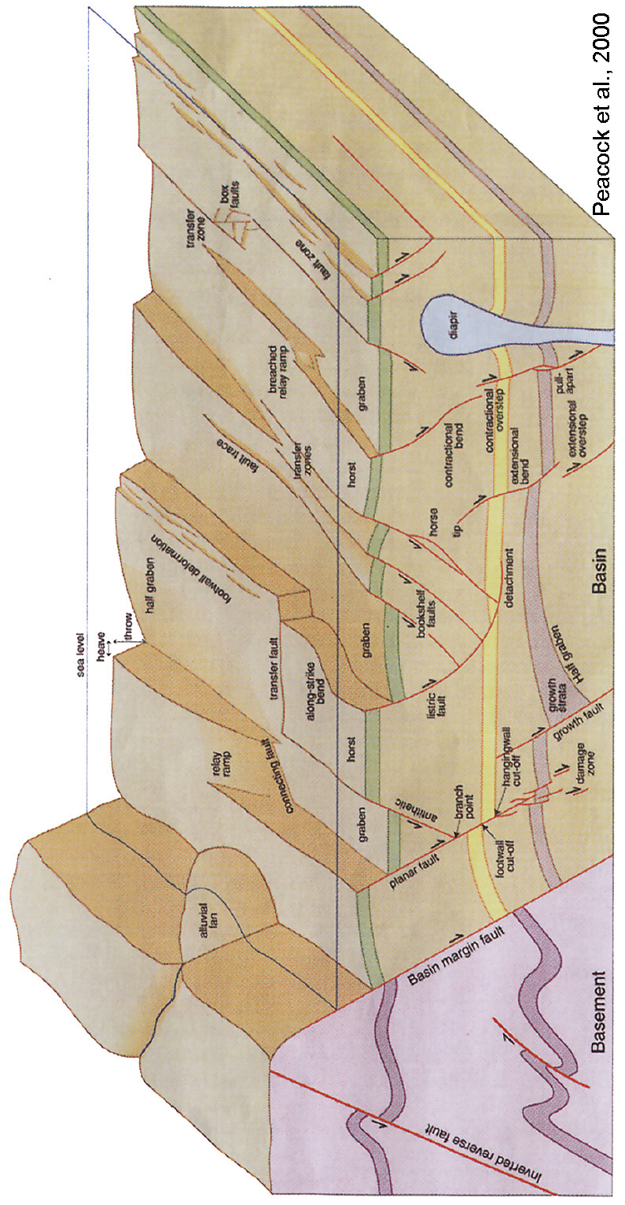
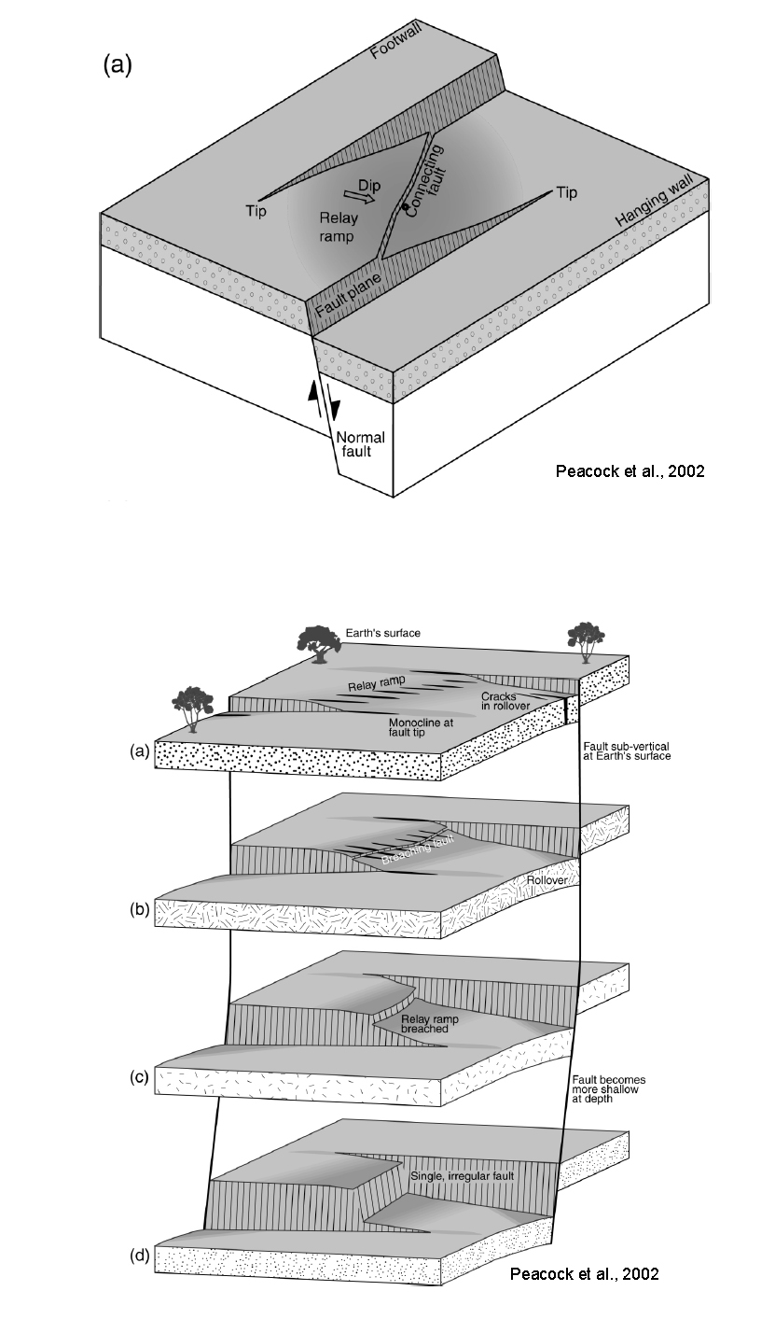
Now, we'll all have a look at THEMIS image V09553011 (on page 3). Work with your partner, and answer the following questions:

- Which way do the faults with the shadowed scarps dip? Explain your reasoning, and draw a cross section sketch.

- Which way do the faults with the sunlit scarps dip? Explain your reasoning, and draw a cross section sketch.

- How is shadow width related to the amount of slip at a given point along the fault? Explain, and draw a sketch.

- Find a fault that you can trace along its entire length. Describe how the amount of slip changes along the strike of the fault from one end to the other.

- Find a place where two normal faults overlap and are separated by a relay ramp. Why are the shadow widths (and therefore slips) on each of the faults less than on either of the faults where they do not overlap?

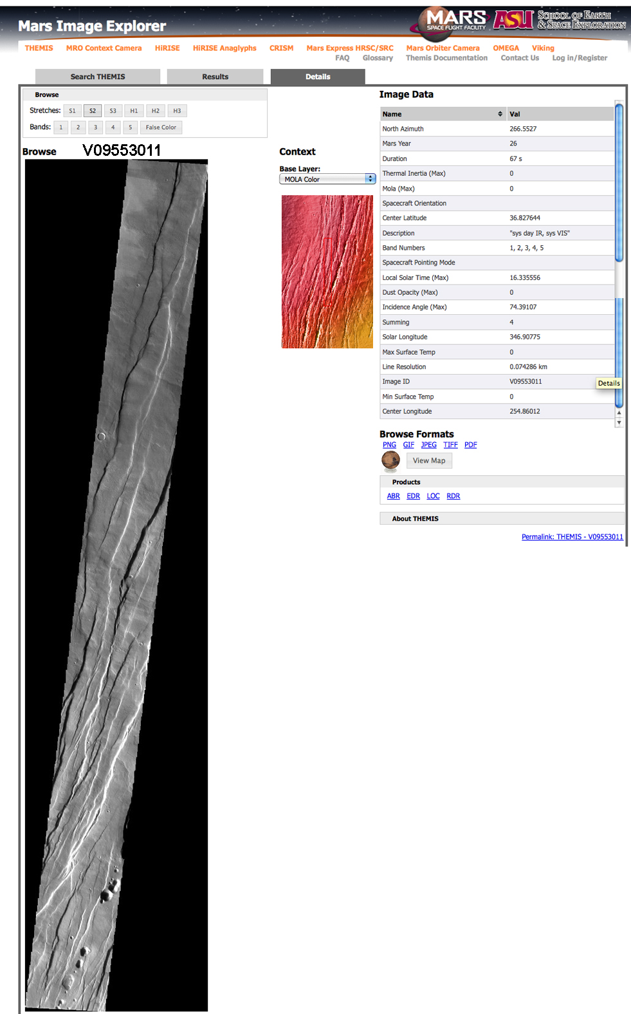
Calculating throw and estimating heave and extension
For this part of the activity, we’re going to work with THEMIS image V1363012 (small version on page 10). The new THEMIS image interface does not provide the solar azimuth (the azimuth of the sun’s rays), which we need. Fortunately, it’s not that difficult to estimate.

- Check the time of day of the image, and work out whether the Sun illumination is broadly from the west or from the east.
- What we need now is the actual illumination direction of the scene (the solar azimuth, which we will measure clockwise from north). For what we are going to do, it will be accurate enough to estimate an approximate azimuth by finding a point in the topography that has a clearly recognizable matching point in the shadow, and measuring the azimuth of the line that connects the two points. Determine the approximate solar azimuth in several places, write them down below, and check with me before you go on.

- Once you have checked with me, use a protractor to measure the solar azimuth from north, and a draw a line in the margin of your printout parallel to the solar azimuth so that you don’t forget this direction.
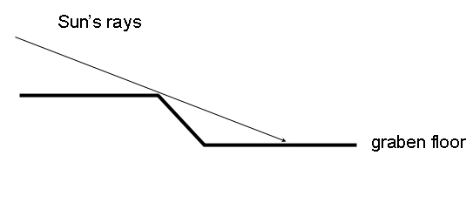
The diagram at right is a cross section showing the general relationship between the Sun's rays and the shadow produced by a normal fault scarp. With your partner, work out how you could use trigonometry to determine graben depth if you know the angle of the Sun's rays and the width of the shadow. Annotate the diagram to show how you would make the calculation.

If we are going to calculate graben depth, why is it important to know the solar azimuth as well as the incidence angle and shadow width?

Use the data in the parameters table for image V13634012 to determine the Sun incidence angle that you need for your calculation. Remember that the incidence angle in the parameters table is measured from the vertical.

Choose a place on image V13634012, and calculate the depth of the graben based on the shadow width and Sun angle. Be sure to measure the shadow width in the direction of the solar azimuth for this image!!! Record your data below:

Shadow width:

Graben depth:

Do you think that graben depth is a reasonable approximation for the throw on the fault? Explain.

In order to calculate heave for the fault, we need to make an assumption about the dip angle of the fault. Unfortunately, we have no independent way of measuring fault dip for the faults in our image. What could we do??

- We might be tempted to measure the scarp width on the bright side of our graben and calculate fault dip from a right triangle with our known throw, but we would have to assume no slope retreat over time. Studies on Mars suggest significant slope retreat, which would give us a dip angle that would be too shallow if we just measured the width of the bright scarp.
- Given that these are simple graben, we could assume a dip. What would a reasonable assumption be for dip on a normal fault, and why?

So! Assuming a reasonable dip, calculate heave for your fault, and draw a diagram illustrating how you made the calculation.

Is that a little or a lot of extension?? Let's do a little back-of-the-envelope (BOE) calculation for extension across the image. This will be a real ballpark value!!

- What do you guess the percent elongation might be across this area??? 10%? 50%? 100%? 200%? Write down what your gut level feeling is before you do a calculation.

- Pick a line that crosses as many faults as possible and that lies approximately perpendicular to the fault traces.
- Using your one shadow calculation as a guide to throw, estimate the total throw of NE-facing (shadowed) normal faults along your line. If, for example, a shadow is half as wide as the one you calculated, estimate the throw as approximately half as big. We could actually do the calculations for each one, but for a BOE calc, an estimate will be fine.

total throw on shadowed faults, in meters:

Because we can't directly calculate the throw on the sunlit normal faults, we're going to make a BOE assumption that each graben is symmetrical (i.e., that each shadowed fault is paired with a sunlit fault of the same throw and heave). So, for our BOE calc, we'll double the throw determined for the shadowed faults.

total throw on sunlit faults plus shadowed faults, in meters:

- Assuming a dip of 60° for all faults, calculate the total heave.

Total heave along your section line, in meters:

- And last, calculate an estimated elongation strain along the line.

Summary and reflection
First, you should know that published values for extension in Ceraunius Fossae range from a few percent to a maximum in the most deformed areas of 10-15% (e.g., Borracini et al., 2005), so your BOE calc is not bad!!

Write an Aunt Tillie statement that summarizes what you did to estimate regional extension in this small part of Ceraunius Fossae.

How much did our assumptions influence our answers? What if the faults actually dip 50°? 70°? Does the picture change dramatically, or is the order of magnitude of heave and extension comparable? What other assumptions did we make, and how much might they have affected our estimations?

What changed in your perception of normal faults and normal fault systems by making these observations of Mars normal faults and by doing these calculations?

What surprised you the most?

If you want to read careful studies done by Mars researchers on normal fault systems and regional extension determined from image measurements, try the following:

Borraccini, F., Lanci, L., Wezel, F.C., and Baioni, D., 2005, Crustal extension in the Ceraunius Fossae, northern Tharsis region, Mars: Journal of Geophysical Research, v. 110, EO6006, doi:10.1029/2004JE002373. Calculated extension using MOLA data along two profiles to be 4-6%, with local max extension up to about 13%. Assumed fault dip of 60°.

Golombek, M.P., Tanaka, K.L., and Franklin, B.J., 1996, Extension across Tempe Terra, Mars, from measurements of fault scarp widths and deformed craters: Journal of Geophysical Research, v. 101, no. E11, p. 26,119-26,130. Used measurements of normal fault scarp width plus average scarp slope data on Viking images. Calculated strains of 2-3%. Fault dip assumed to be 60°±15°. Also determined extension using deformed Noachian craters, which gave mean strain of 2%.

Golombek, M.P., Franklin, B.J., Tanaka, K.L., and Dohm, J.M., 1997, Extension through time across Thaumasia, Mars: 28th Lunar and Planetary Science Conference.

Hauber, E. and Kronberg, P., 2005, The large Thaumasia graben on Mars: is it a rift? Journal of Geophysical Research, v. 110, E07003, doi: 10.1029/2005JE002407. Extension determined using gridded MOLA topography; strain calculated at 1-3%. Assumed fault dip of 60°.

Hauber, E. and Kronberg, P., 1999, Differences in style and age of extensional faulting: examples from the northern Tharsis Province, Mars: 30th Lunar and Planetary Science Conference, abstract #1568.

Kronberg P. and Hauber, E., 1999, Extensional tectonics and new crater statistics of the northern Tharsis Province, Mars: 5th International Conference on Mars.

Plescia, J.B., 1991, Graben and extension in northern Tharsis, Mars: Journal of Geophysical Research, v. 96, no. E3, p. 18,883-18,895. Used photoclinometry and shadow length on Viking images to determine local strains of 1-5%. Assumed a 60° fault dip. South of Alba Patera and north of Ceraunius Fossae.

Schultz, Richard A., 1999, A new look a Martian extensional structures: are the faults more than only skin deep? 5th International Conference on Mars.

Schulta, Richard A., Okubo, Chris H., Goudy, Cheryl L., and Wilkins, Scott J., 2004, Igneous dikes on Mars reveated by Mars Orbiter Laser Altimeter topography: Geology, v. 32, no. 10, p. 889-892.

Wilson, Lionel and Head, James W., III, 2002, Tharsis radial graben systems as the surface manifestation of plume-related dike intrusion complexes: models and implications: Journal of Geophysical Research, v. 107, no. E8, 5057, 10.1029/2001JE0001593.



