**Lecture Tutorial on sediments and sedimentary rocks formed in rivers**

by

**Austin Boyd**

**May 16, 2012**

Lecture Tutorial on sediments and sedimentary rocks formed in rivers

1) If channel shape and water volumes are the same, which river below would have the greater transport velocity?

A B

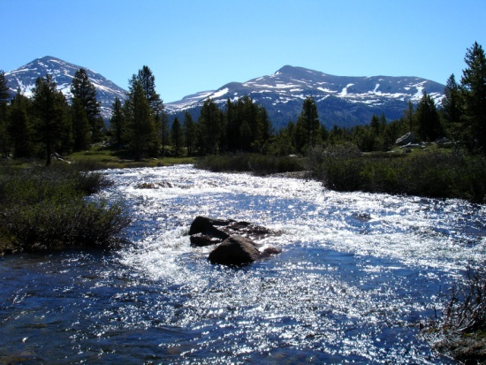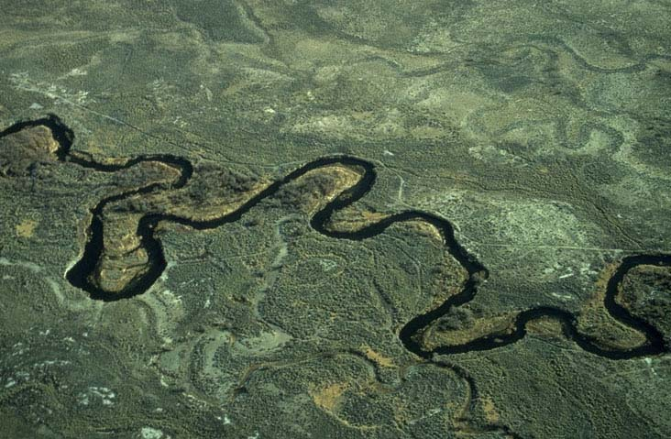

2) If you looked at the bottom of stream A, you would see:

A B

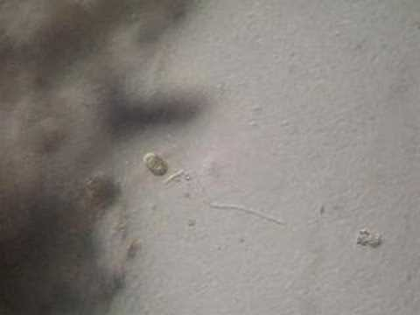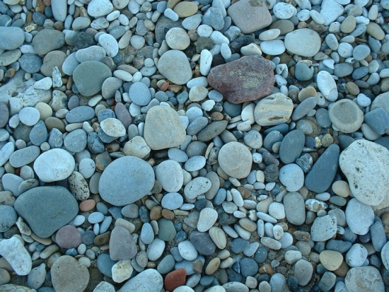

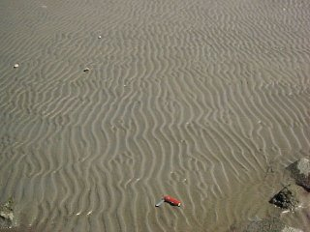C D

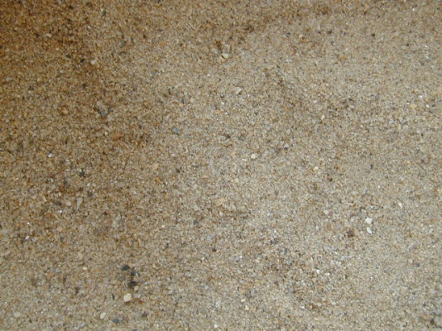

3) Which would you see at the bottom of River B?

a) sediments A b) sediments B c) sediments C d) sediments D

4) The greater the velocity the greater the energy. The greater the energy, the ______ the particle size that can be carried. a) smaller b) larger c) will be the same d) can’t tell this way

5) In which of the following sedimentary environments would you least expect to find gravel? a) active margin beach b) alluvial fans c) glacial d) deep marine

6) Shale is mostly made of clay. In which depositional environment would you expect it to form: a) mountain streams b) braided rivers c) lake bottoms d) fast moving rivers

7) Sandstone is mostly made of sand-sized particles. In which depositional environment would you expect it to be present: a) mountain streams b) braided rivers c) lake bottoms d) ocean bottoms

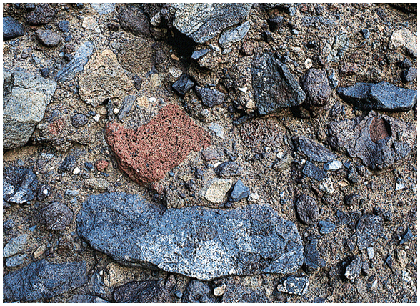8) With time, sediment transport by a fluvial system a) becomes rounded b) becomes smaller c) becomes rounded and smaller d) becomes angular e) none of the above

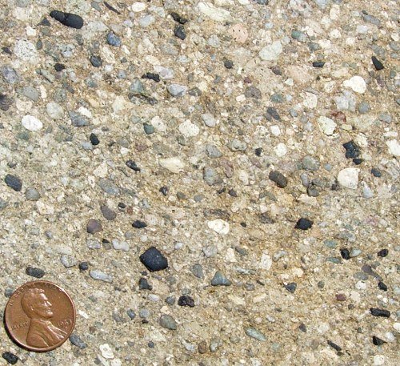9) In which of the above pictures of rock, has the sediment been carried the least distance?

A________ B_________

10) This is a side view of a rock. What do you think happened to cause this pattern of sediment grain change?

