To complete this worksheet, see the instructions in the textbook (Chapter 3 Investigation).
Table 1. Plate Boundaries of an Unknown Ocean and Continents
This perspective view shows two continents, labeled A and B, separated by an ocean.
- Use the topography to identify possible plate boundaries and to propose whether each boundary is divergent, convergent, or transform.
- Use colored pencils or pens to mark the location and type of each plate boundary on the figure below. Use the following colors: divergent = black; convergent = red; transform = green or blue. For transform boundaries, mark only transform faults (where motion is still occurring), not fracture zones (where it is not).
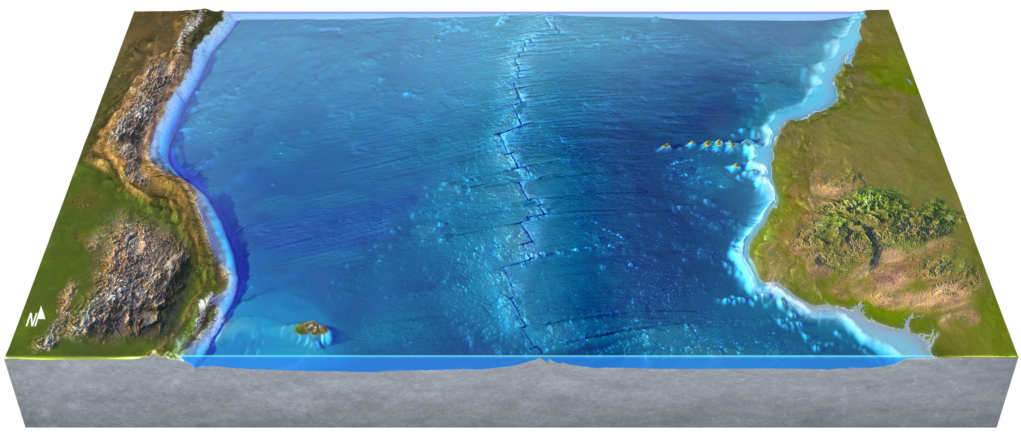
Continent
B
Continent
A

Table 2. Predicting the Location of Earthquakes and Volcanoes
Use your plate boundaries to mark where on the map earthquakes and volcanoes are most likely. On the figure above, do the following:
- Draw circles [○] at any place, on the land or on the ocean floor, where you think earthquakes are likely.
- Draw triangles [▲] in any place, on land or in the ocean, where you think volcanic eruptions are likely. Remember that not all volcanoes form directly on the plate boundary; some form off to one side. Also, a line of islands and seamounts (mountains that are beneath the sea) could mark the track of a hot spot and may not be on a plate boundary.

Table 3. Determining a Safe Place to Live
Determine a relatively safe place to build one city on each continent. Show each location with a plus sign [+] on the map. In the space below, explain your reasons for choosing these as the safest sites.
- Reasons for location of city on Continent A:

- Reasons for location of city on Continent B:

Table 4. Showing the Plate Boundaries in Cross Section
On the figure below, draw a simple cross section of your plates in the subsurface. Use other figures in this chapter as a guide to the thicknesses of the crust and lithosphere and to the geometries typical for each type of plate boundary. Some features are not located along the front edge of the figure and so cannot be shown on the cross section.
- Draw the geometries of the plates at depth for any spreading center or subduction zone.
- Show the variations in thickness of the crust and variations in thickness of the lithosphere.
- Draw arrows to indicate which way the plates are moving relative to each other.
- Show where melting is occurring at depth to form volcanoes on the surface.

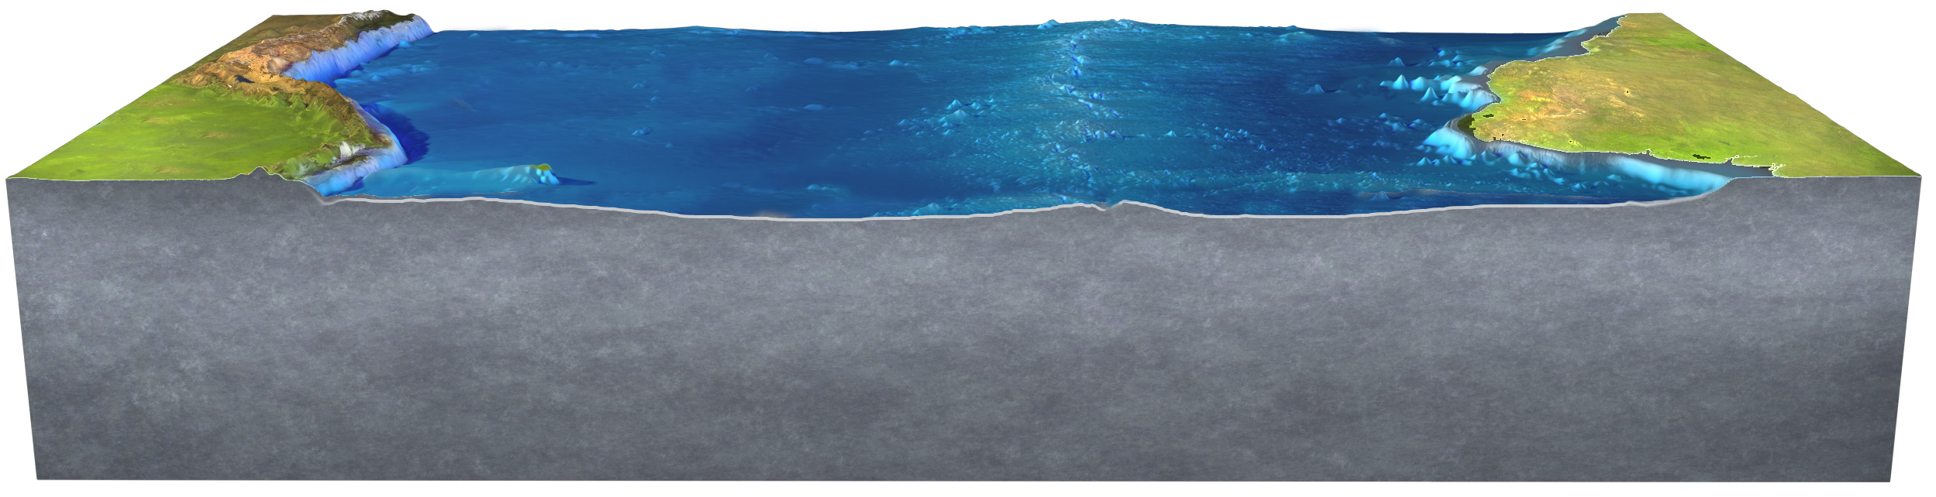
Continent B
Continent A

