“Soil UNDER THE MICROSCOPE” – Steve Driese, Baylor University
- Fundamentals
“Micromorphology is the description, interpretation, and measurement of components, features and fabrics in soils, at the microscopic level.”
from: Bullock et al. (1985), Handbook for Soil Thin Section Description
See http://www.youtube.com/watch?v=-T2luwLcfeg for a bit of humor to start
Eswaran and Drees (2002) provide an excellent introductory Power point presentation on the microscopic study of soils “Soil Under a Microscope” that is available from the USDA-NRCS at: http://soils.usda.gov/use/worldsoils/microscope/

Inexpensive Resource:
Stoops, G., 2003, Guidelines for Analysis and Description of Soil and Regolith Thin Sections: Madison, WI, Soil Science Society of America, 184 p. + CD w/images. (This is very reasonably priced (at $40) but definitely not very exciting book that has a great CD with photomicrographs, and has a very comprehensive reference list.)

Recommended New Resource ($$$$):
Stoops, G., Marcelino, V., and Mees, F. (eds.), 2010, Interpretation of Micromorphological Features of Soils and Regoliths: Amsterdam, Elsevier Pub. Co., 720 p. (spectacularly illustrated newest text with lots of beautiful color images, organized as topical Chapters, each authored by experts; unfortunately, at a price of $210 from Amazon.com, probably out of reach for most faculty and students: get your library to purchase it!)

Other Useful Resources:

Blokhuis, W.A., Kooistra, M.J., and Wilding, L.P., 1990, Micromorphology of cracking clayey soils (Vertisols), in Douglas, L.A., (ed.), Soil Micromorphology: A Basic and Applied Science: New York, Elsevier Pub. Co., Developments in Soil Science 19, p. 23-148.
Brewer, R., 1976, Fabric and Mineral Analysis of Soils, 2nd edition: Huntington, New York, Robert E. Krieger Publishing Co., 482 p. (Considered “the Bible” of micromorphology by many, but employs a rather dense terminology and is out of print!)
Bullock, P, Fédoroff, N., Jungerius, A., Stoops, G., Tursina, T., and Babel, U., 1985, Handbook for Soil Thin Section Description: Wolverhampton, UK, Waine Research Publications, 152 p. (Great book by group of experts, but out of print!)
Cady, J.G., Wilding, L.P., and Drees, L.R., 1986, Petrographic microscope techniques, in Methods of Soil Analysis, Part I. Physical and Mineralogical Methods: Soil Science Society of America, Monograph No. 9, p. 185-218.
Delvigne, J.E., 1998, Atlas of Micromorphology of Mineral Alteration and Weathering: Mineralogical Association of Canada, Canadian Mineralogist Special Publication 3, 494 p.
Douglas, L.A., and Thompson, M.L. (eds.), 1985, Soil Micromorphology and Soil Classification: Madison, WI, Soil Science Society of America Special Publication No. 15, 216 p.
Drees, R., and Ransom, M.D., 1994, Light microscopic techniques in quantitative soil mineralogy, in Quantitative Methods in Soil Mineralogy: Madison, WI, Soil Science Society of America Miscellaneous Publication, p. 137-176.
Eswaran, H., and Drees, R., 2002, Soil Under a Microscope: Evaluating Soils in Another Dimension: College Station, TX, Texas A & M University, Department of Soil & Crop Science (21 Mb Powerpoint Presentation, 79 images, at: http://soils.usda.gov/use/worldsoils/microscope/
Fitzpatrick, E.A., 1993, Soil Microscopy and Micromorphology: New York, John Wiley and Sons, 304 p. (Excellent book, perhaps even “the best”, unfortunately out of print!)
Kubiëna, W.L., 1938, Micropedology: Ames, Iowa, Collegiate Press, Inc., 243 p. (a “classic” by the “Founding Father” of soil micromorphology, and obviously out of print!
Nettleton, W.D. (ed.), 1991, Occurrence, Characteristics, and Genesis of Carbonate, Gypsum, and Silica Accumulations in Soils: Madison, WI, Soil Science Society of America Special Publication No. 26, 149 p.

- Soil and paleosols, at the microscopic scale, consist of fine-grained soil matrix (S-matrix) and pedological features related to soil-forming processes (Brewer, 1976).

Soil matrix (or S-matrix) is composed of (Fig. 1):

1) plasma, mainly fine clay-sized clay mineral particles, but also including organic material of colloid size, which may be soluble,

2) skeleton grains, chiefly silicate sand and silt grains embedded in the plasma, which are generally stable, and

3) soil voids, which are pore spaces occupied by air or water, and include: A) macropores, which are large (> 1-2 μm diameter and up to several cm) pores, such as root pores and animal burrows, and also interpedal pores and soil fractures, and B) matrix pores, which are small (< 1-2 μm diameter) and in the soil matrix.

Pedological features are bodies within the soil that are distinguishable from the enclosing S-matrix, are highly varied, and are extremely useful for understanding soil processes (Figs. 2-8):

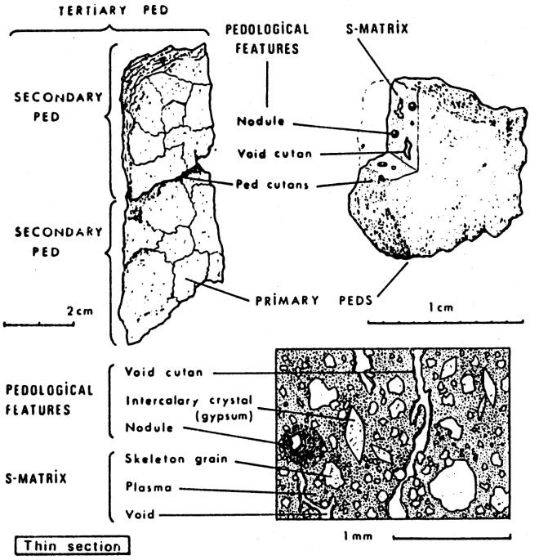
Figure 1 – Micromorphological features associated with different scales of soil peds. From Brewer (1976).

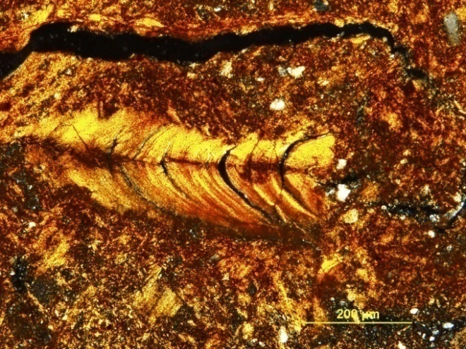

Fig. 2 – Pedogenic clay “meniscate” infilling of biopore in clay-rich Dewey Series Ultisol formed on limestone bedrock in eastern TN (Driese et al., 2010, Southeastern Geology). (XPL)

Some examples include:
1) inherited features, including lithorelicts (pieces of fresh to weathered parent material) and pedorelicts (pieces of reworked soil material),
2) features due to plasma concentrations, such as nodules, subdivided into concretions (banded) and glaebules (not banded) of calcite (Fig. 23) or Fe-Mn, and papules composed of clay aggregations; these features may include septarian shrinkage cracks, circumgranular cracks, and engulfed soil matrix and skeletal grains,
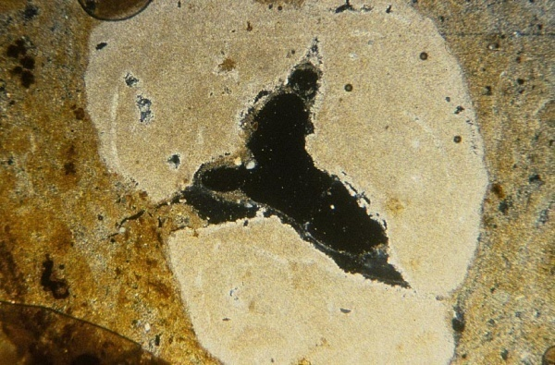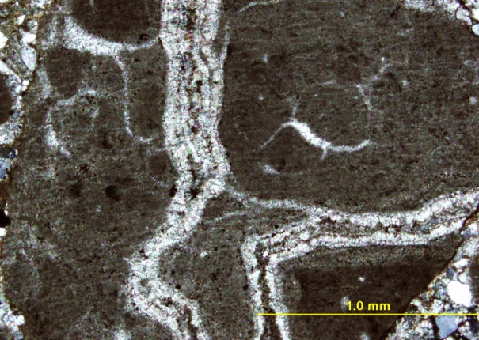
B
A

Fig. 3 – Examples of pedogenic micrite nodules. (A) Pedogenic calcite nodule from Texas Coast Prairie Vertisol (Laewest Series), Victoria, TX showing large interior septarian shrinkage crack. Field of view is 5.5 mm, XPL. (B) Pedogenic calcite nodule from Pennington Fm. (Upper Miss.) paleosol from Pound Gap, KY, showing septarian cracks filled with calcite spar cement (XPL).

3) features due to plasma separations, such as (A) Cutans, or coatings on pore walls (void channel or void plane cutans) and grains (grain cutans): clay = argillans (Figs. 2, 4); Fe = ferrans; Mn = mangans; carbonate = calcitans; silica = silans; neocutans = impregnations of the soil matrix around the pore wall or grain; quasicutans = impregnations some distance from the wall of the void; (B) Sepic-plasmic fabrics, with flecked clays exhibiting various orientations within the S-matrix (Fig. 6): masepic = matrix, one direction, vosepic = void-parallel, skelsepic = grain-parallel, lattice-sepic = lattice- or trellis-like, two directions, etc.; (C) Crystic-plasmic fabric, with crystals of calcite, dolomite, gypsum and other soil evaporite minerals; micrite = microcrystalline calcite; spar = sparry calcite, usually as a void-filling cement, and…………………………

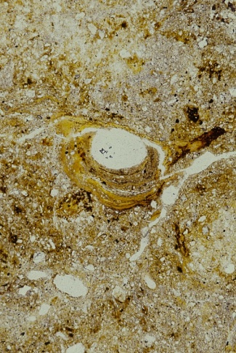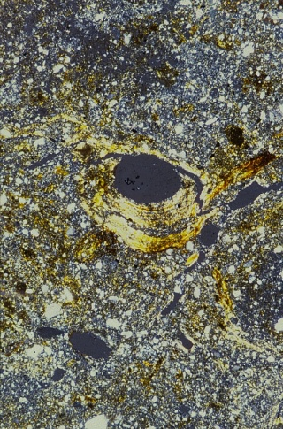
B
A
Fig. 4 – Examples of illuviated pedogenic clay coatings (cutans). (A, B) Root pore-lining in Tupelo Series floodplain Alfisol from eastern Tennessee. PPL (A) and XPL (B). Field of view is 5.5 mm in long dimension in each photo. (C) Root pore-lining in Catskill Fm. (Upper Devonian) paleosol from Selinsgrove, PA. Note evidence for paired walls on oriented clay and vadose silt and sand infillings, and extensive ferruginization by hematite cement (XPL).

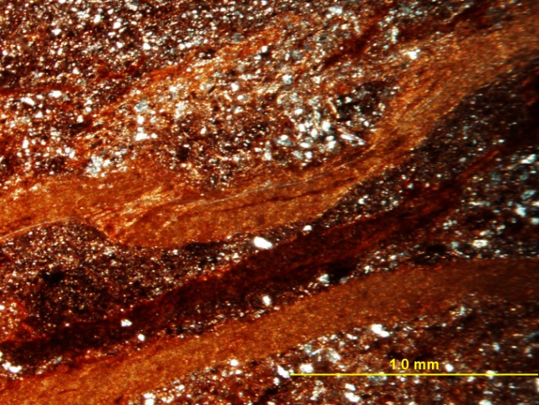
C

Fig. 4 –continued: Examples of illuviated pedogenic clay coatings (cutans). (C) Root pore-lining in Catskill Fm. (Upper Devonian) paleosol from Selinsgrove, PA. Note evidence for paired walls on oriented clay and vadose silt and sand infillings, and extensive ferruginization by hematite cement (XPL).

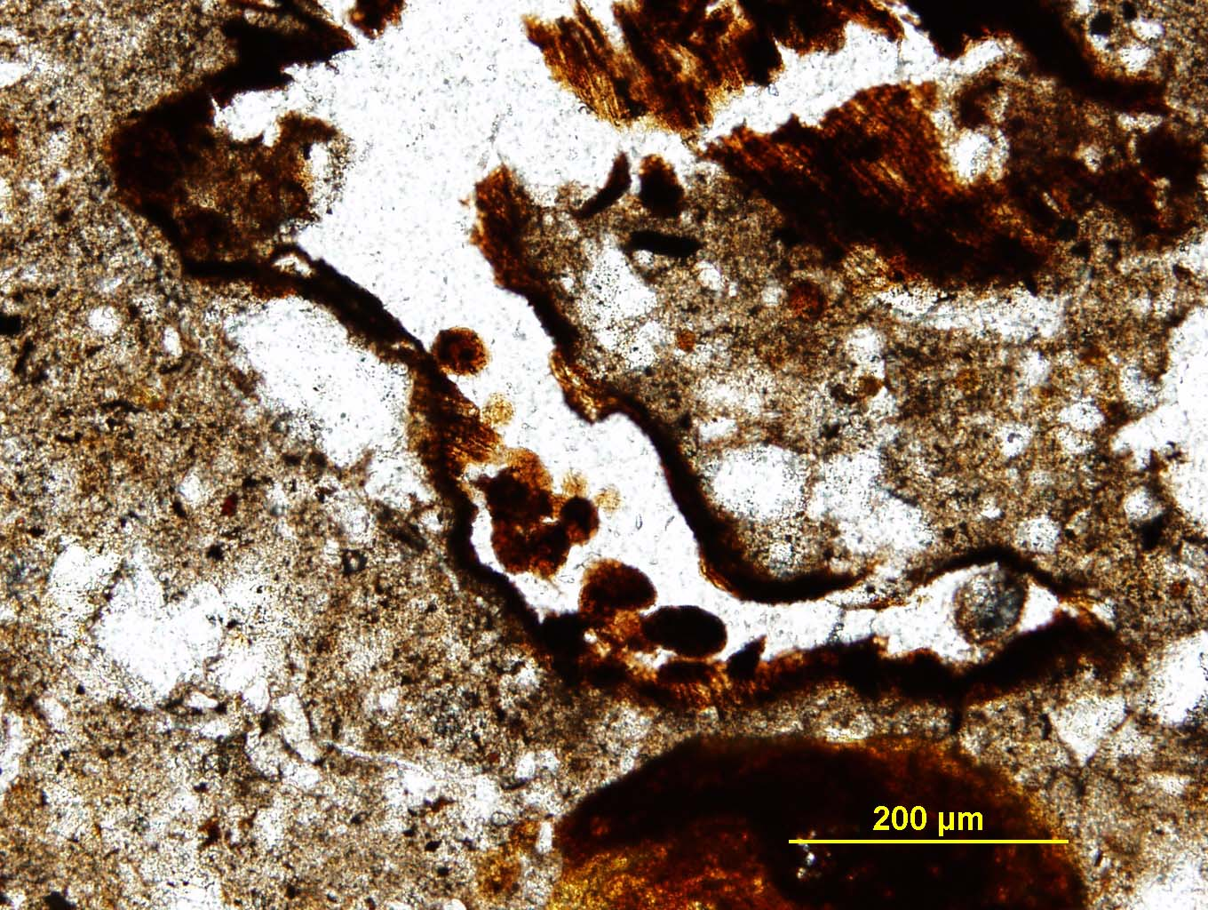
Fig. 5 –Oribatid mite fecal pellets in partially decomposed root from A horizon of Trinity Series Vertisol from east-central Texas.

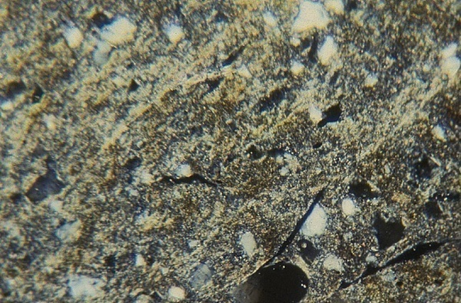
A
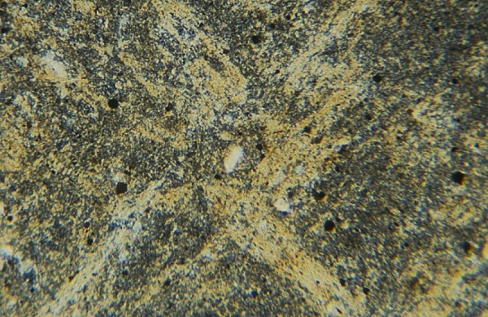
B

Fig. 6 – Examples of sepic-plasmic (bright clay) fabrics showing domains of aligned clays. (A) Laewest Series smectite Vertisol with masepic fabric from Victoria, TX, and (B) Pennington Fm. (Upper Mississippian) illite paleoVertisol with bimasepic fabric from Sparta, TN Tennessee (Driese et al., 2003, Sedimentary Geology). Both are in XPL, field of view is 0.5 mm in long dimension.

4) features due to biological activity, such as pedotubules filled with various types of material: granotubules filled with granular material different from surrounding soil matrix; aggrotubules filled with fecal pellet aggregates, such as worm casts (Fig. 26); isotubules filled with material indistinguishable from surrounding soil matrix; striotubules filled with striated, meniscate material actively back-filled or manipulated by organisms.

- Summary of Stages for Describing Paleosol Thin Sections (FitzPatrick, 1993, refer also to Fig. 27)

1) Examine the slide with the naked eye. (Note: I generally scan the entire thin section on a standard flat bed scanner at 600 dpi resolution, and print the image to help navigate through the thin section and mark where photomicrographs were obtained).

2) Delimit areas of relative uniformity (the whole slide may be uniform)

3) Examine each area with a large hand lens at x 10 magnification.

4) Subdivide into further areas if necessary

5) Examine each uniform area with plane-polarized light at x 20-25 magnification

6) Examine each uniform area with cross-polarized light at x 20-25 magnification

7) Examine each uniform area with plane-polarized light at x 100 magnification

8) Examine each uniform area with cross-polarized light at x 100 magnification

9) Identify and describe the following features (not all present in all thin sections): mineral material, matrix, structure and pores, faunal features, particle size distribution, rock types, organic matter, roots traces, coatings and other surface features, segregations, concretions, nodules and concentrations, weathering features, microorganisms, other features.
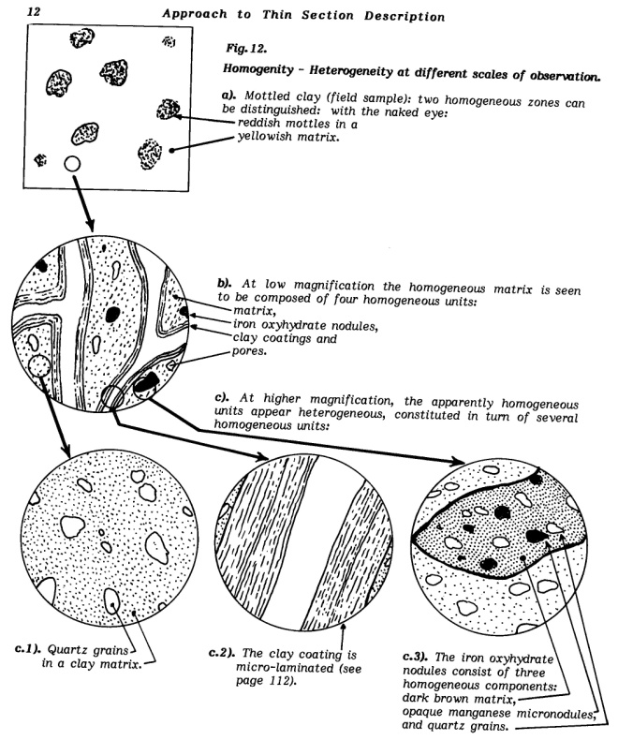
Fig. 7 – Flow-chart hierarchical approach for the study of soils in thin section, starting at the largest scale of observation and moving to progressively higher magnification investigation (from Bullock et al., 1985).

SUGGESTED STANDARD SHEET FOR RECORDING OBSERVATIONS

Specimen Designation:
Formation (or Soil Series):
Investigator:
Locality:
Hand specimen description (if applicable):

Skeletal grains / % estimate: Distinguishing properties:
Pedogenic features/ % estimate:
Soil matrix (plasma)/ % estimate: (Sketches of fields of view at different magnifications)
________________________________
________________________________
________________________________
________________________________
________________________________
________________________________
________________________________
________________________________
________________________________
Cementation and alterations (if lithifiedl):

_________________________________________________
Texture
Instructions for “Soil Under the Microscope” Mini-Workshop (classroom-based):
- Soil Under the Microscope:
  - Participants first review the Power point (2002) prepared by Hari Eswaran (USDA) and Richard Drees (Texas A & M Univ., deceased) entitled “Soil Under the Microscope” – this is a 22 Mb file that is available from the USDA-NRCS at: http://soils.usda.gov/use/worldsoils/microscope/
(note: I had secured Richard’s permission to freely disseminate the file.)

  - Review the preceding abbreviated notes on the basics of soil micromorphology (Resource entitled: “Soil Under the Microscope”)

  - Each participant is to examine one of the soil thin sections provided (either Tupelo Series Alfisol sampled from 6500 yrs BP floodplain in southeastern Tennessee, the >100,000 yr (and possibly even >1-4 Ma) Dewey Series Ultisol formed on Cambro-Ordovician bedrock in eastern Tennessee, or and Pledger Series Vertisol sampled from 6500 yrs BP floodplain in southeastern Texas), and using the thin-section description sheet provided, prepare a brief description of the pedological features.

  - Group discussion: Individual participants are asked to briefly discuss their observations and to compare the characteristic features of the 3 different soils (they are very different), having them discuss their philosophy used in describing the soils and what soil-forming factors influenced soil genesis, and in turn, micromorphology. Optional: Consider the size and distributions of the pore structures (areas filled with epoxy) and discuss how they would affect hydraulic conductivity and contaminant transport in these soils.
References for further reading on the three soils examined:
Driese, S.G., Li, Z.-H., and McKay, L.D., 2008, Evidence for multiple, episodic, mid-Holocene Hypsithermal recorded in two soil profiles along an alluvial floodplain catena, southeastern Tennessee, USA: Quaternary Research, v. 69, p. 276-291. (Tupelo Series Alfisol)
Driese, S.G., Schultz, B.S., and McKay, L.D., 2011, Genesis of clay-rich soils from carbonate bedrock on upland surfaces in the Valley and Ridge Province, eastern Tennessee, USA: Southeastern Geology, v. 48, p. 1-22. (Dewey Series Ultisol)
Mintz, J.S., Driese, S.G., Ludvigson, G.A., and Breecker, D.O., 2011, Seasonal influence of changing hydrology on pedogenic calcite precipitation in Vertisols, Dance Bayou, Brazoria County, TX: Implications for estimating paleoatmospheric pCO₂: Journal of Sedimentary Research, v. 81, p. 394-400. (Pledger series Vertisol)

