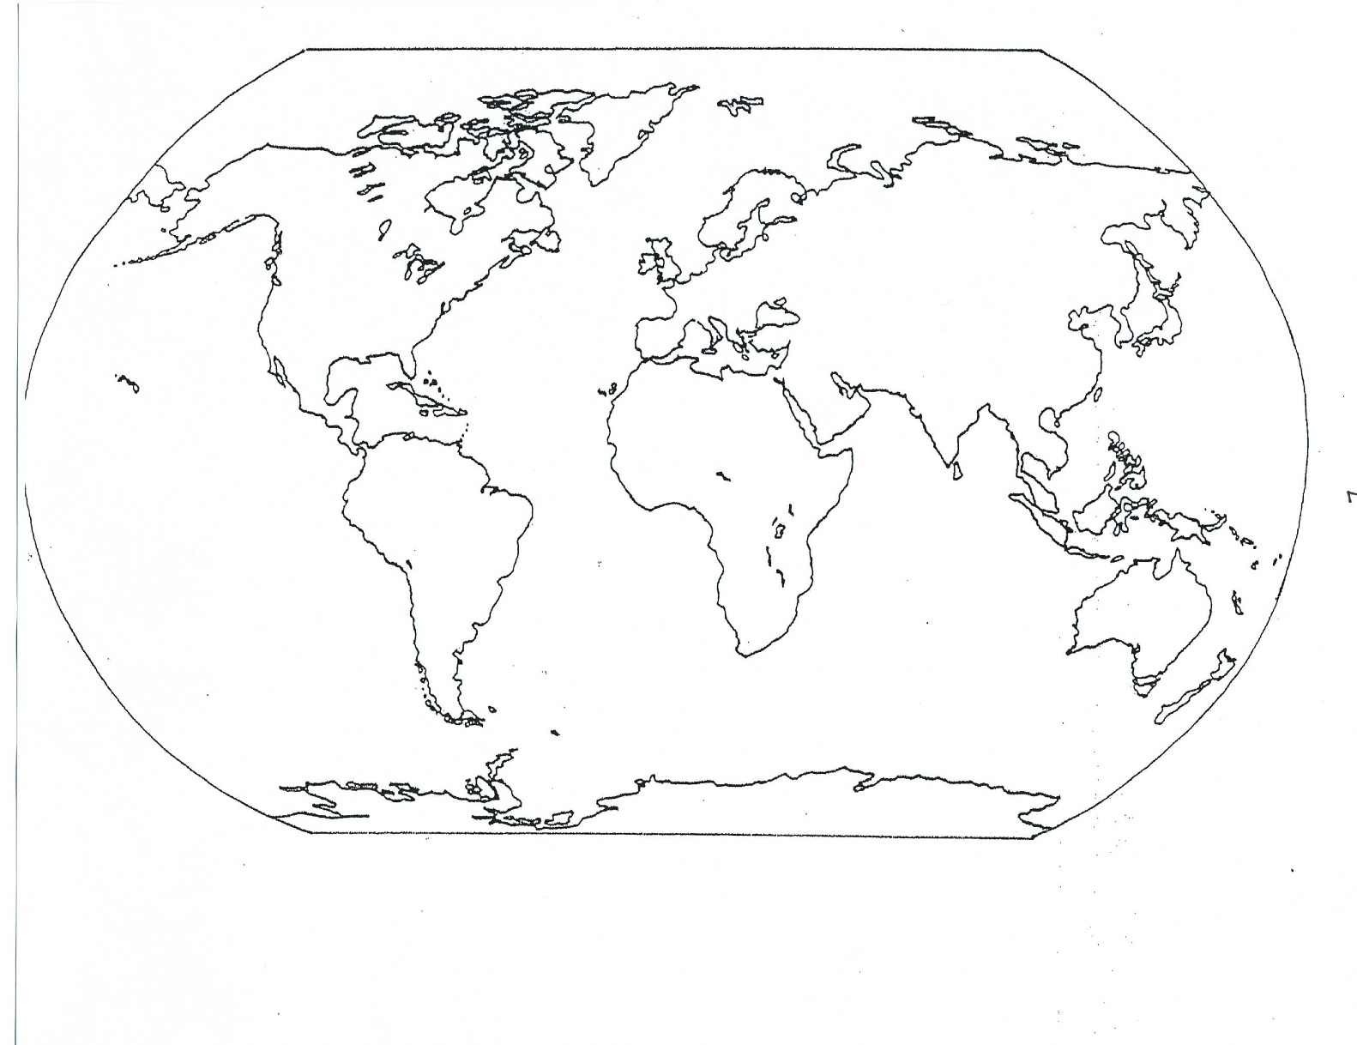
Names:

Instructions: Using your knowledge of the global water cycle and the crayons provided, indicate global precipitation rates over both the land and the oceans. Make sure you draw a legend.

Names:

Instructions: Using your knowledge of the global water cycle and the crayons provided, indicate global evaporation rates over the land. Make sure you draw a legend.

Names:

Instructions: Using your knowledge of the global water cycle and the crayons provided, indicate global evaporation rates over the oceans. Make sure you draw a legend.

Names:

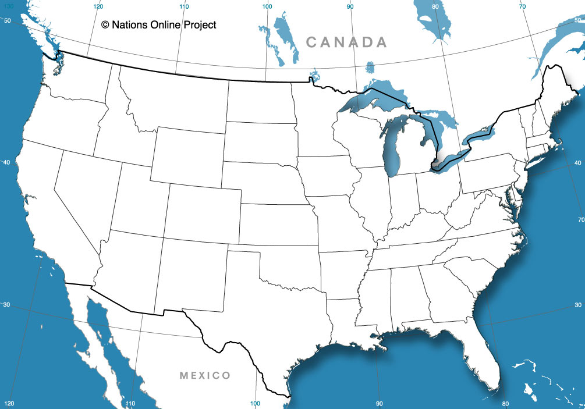
Instructions: Using your knowledge of the global water cycle and the crayons provided, indicate global precipitation rates over the continental US.

