Properties of Porous Media Instructor’s Notes

Objective: Have the students perform experiments to understand porosity and hydraulic conductivity.

Materials:
Examples of Porous Media
-Porous material (sand, gravel, and combo)
-Petri Dish

Darcy Apparatus:
-Six 1-liter soda/water bottles with lids (empty)
-aquarium tubing
-porous material (sand, gravel, and combo)*same as above
-hot glue gun
-screen/netting/material
-metal rod holding apparatus
-drill or screwdriver (for punching holes in bottles/lids)
-rubber bands
-funnel
-20ml graduated cylinders
-binder clips for clamping tubing water flow
-food coloring
-buckets for catching outflow water
-timers (watches, cell phones, timers)

Characterization of porous material:
Put a sample of each material used to fill the Darcy tubes into a dish and place in front of the Darcy apparatus. The students will describe the material in terms of size, sorting, and grain shape.

Preparation of Darcy Tubes:
To make the darcy apparatus for station 2, empty and rinse the soda/water bottles. Cut 3 of the bottles in half (you will be using the top portion with the lid). Carefully poke a hole in the lid of the all of the bottles (try to make the whole about the diameter of the tubing). Measure about 6 x 2 feet of aquarium tubing (6 total 2 foot sections). Take the end of one section of tubing and push it through the hole in the lid of one of the whole bottles and the lid of one of the half bottles). You will want the tube entering both the whole bottle and the cut bottle lids from the outside (rather than feeding the tubing from inside to outside of the bottles-see pictures). Once you’ve fed the tubing through the holes, wrap a rubber band around each end (one inside each lid) and hot glue around the edges (this will prevent leakage).
Once you glue the lids and tubing connections, poke a hole in the bottom of each whole bottle (see pictures below). Feed the remaining 3 sections of tubing into the hole at the bottom of the whole bottle (from outside to inside). Push the tubing up until it comes out of the top. Once it is out of the top, place the netting material around the end of the tubing and secure it with a rubber band. Pull the tubing back out of the hole you just put it through until the rubber band had reached the hole. Secure on the outside of the bottle with hot glue. Fill the whole bottle with the porous material with the funnel. Each apparatus will have one whole bottle filled with the porous material, a half bottle filled with water being held by the metal rod holding apparatus, and tubing connections. See pictures below.

**Note: Make sure to cut the tubing long enough to reach from the base of the reservoir to the datum (table top) to back up to the porous material, so the students can move them up and down without destroying the set-up (this is shown in the drawing but not the pictures). You will also want to secure the tubing to the base of the stand (see the drawn figure below).

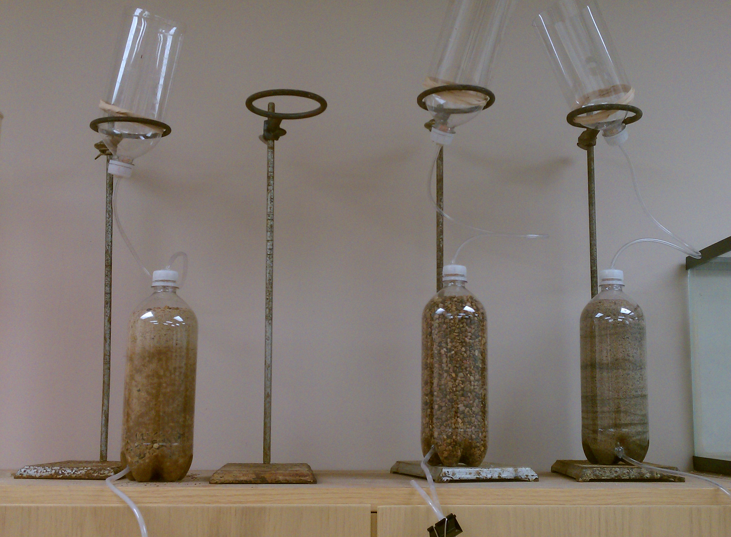

The set up shown in the figure below. Where the students measure head is shown. This can be told to students or drawn on the board. It can also be a topic of conversation to let them figure out where to measure.

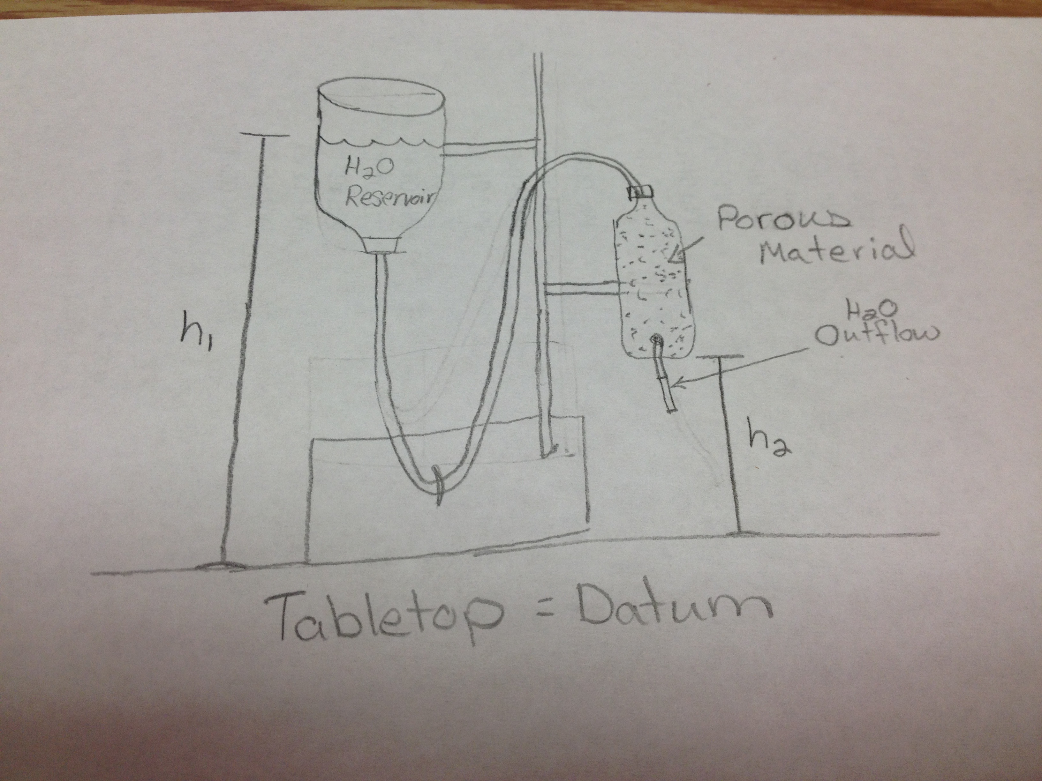

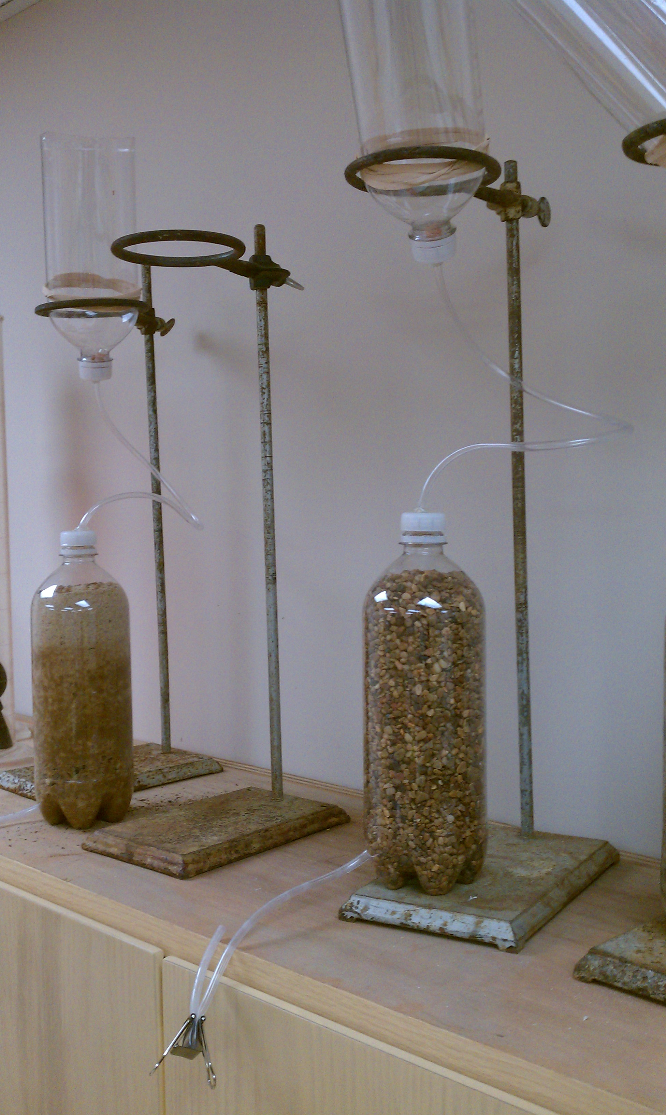

Directions for Exercise:
Fill the petri dishes with the porous medium and label each a, b, or c and place by the corresponding Darcy Apparatus. The students will describe this material for grain size, shape, and sorting. Once the Darcy Apparatus are prepared, saturate the porous media. Make sure to clamp the outflow tube (once filled) so it doesn’t spill out everywhere. Fill the reservoir with water (and the students will need to keep this at a constant level when allowing flow). Place the graduated cylinder, timer (or students can use their own), and food coloring near each station.

Students follow directions and measure/time the flow of water through the material and then calculate the specific discharge and hydraulic conductivity of the material. You may need to discuss or show the students where to measure the head (see above notes and drawn figure).

Note: The students can bring their laptops to class and enter their data directly into excel, which they can use to plot their results.

Assessment: Collect student assignments and grade for assessment.
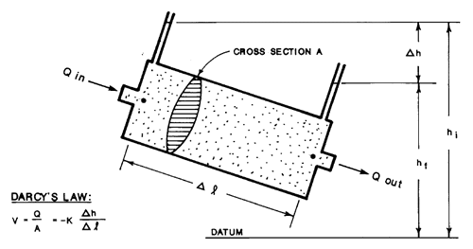
*This figure (above) is from: http://www.env.gov.bc.ca/wsd/plan_protect_sustain/groundwater/gwbc/C02_origin.html .

