EVST/GEOL 2025: Hydrology and Biogeochemistry
February 18, 2013
Carbon in the Oceans

Names: ______________________________________________

Instructions: Write a summary of the information shown in the figure below. Your answer should include both a description of the data and why this pattern is shown.

EVST/GEOL 2025: Hydrology and Biogeochemistry
February 18, 2013
Carbon in the Oceans

Names: ______________________________________________

Instructions: Write a summary of the information shown in the figure below. Your answer should include both a description of the data and why this pattern is shown.
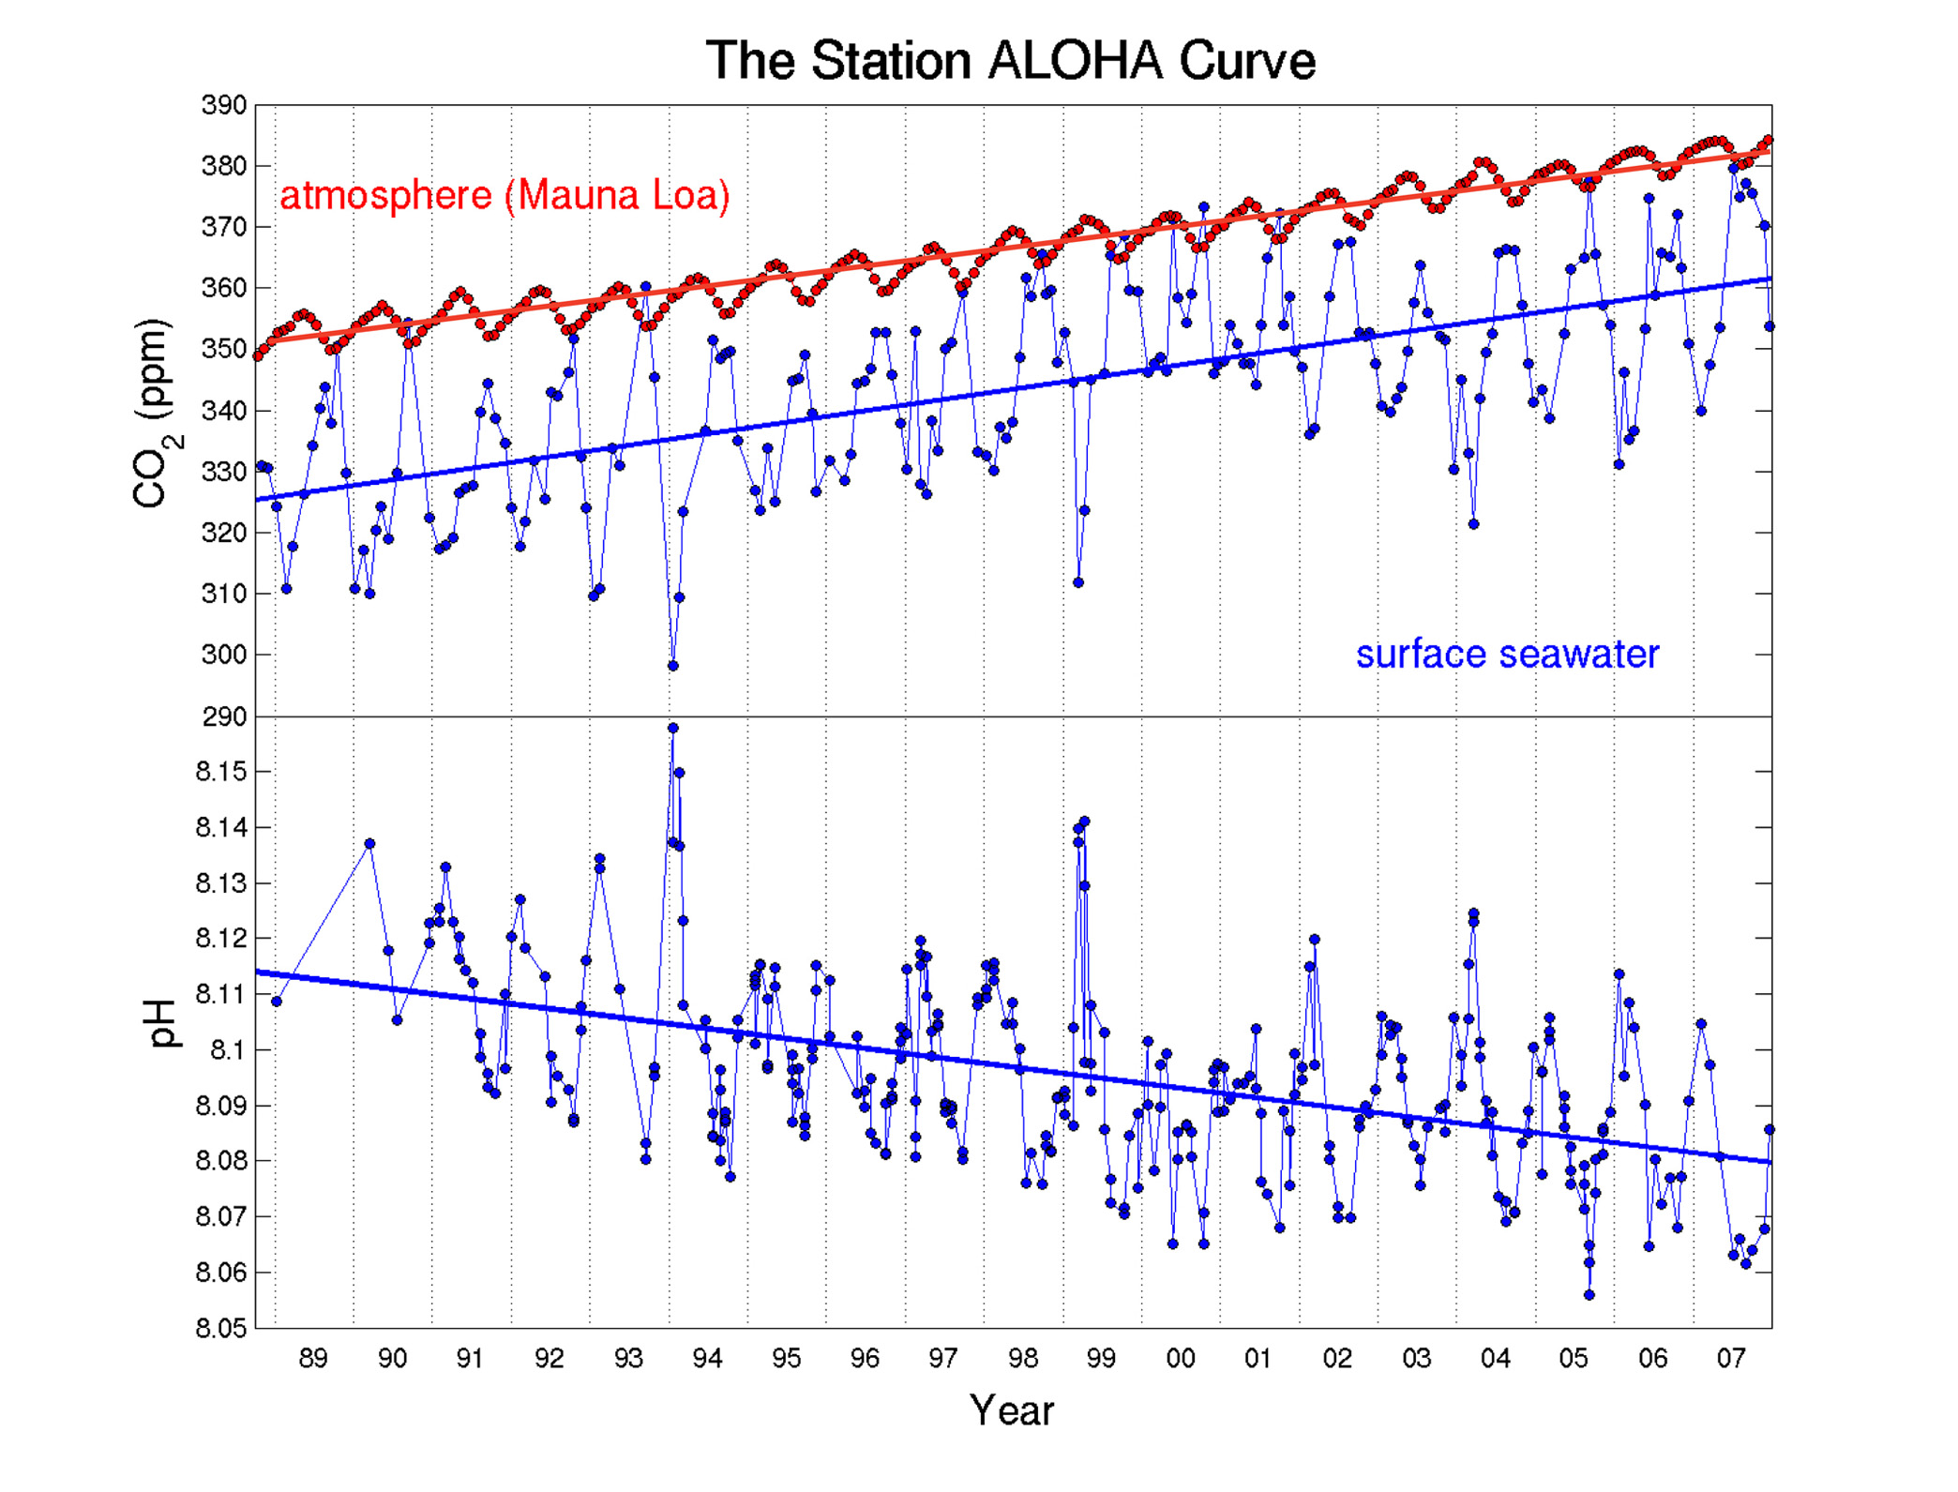

EVST/GEOL 2025: Hydrology and Biogeochemistry
February 18, 2013
Carbon in the Oceans

Names: ______________________________________________

Instructions: Write a summary of the information shown in the figure below. Your answer should include both a description of the data and why this pattern is shown.

EVST/GEOL 2025: Hydrology and Biogeochemistry
February 18, 2013
Carbon in the Oceans

Names: ______________________________________________

Instructions: Write a summary of the information shown in the figure below. Your answer should include both a description of the data and why this pattern is shown.

EVST/GEOL 2025: Hydrology and Biogeochemistry
February 18, 2013
Carbon in the Oceans

Names: ______________________________________________

Instructions: Write a summary of the information shown in the figure below. Your answer should include both a description of the data and why this pattern is shown.

EVST/GEOL 2025: Hydrology and Biogeochemistry
February 18, 2013
Carbon in the Oceans

Names: ______________________________________________

Instructions: Write a summary of the information shown in the figure below. Your answer should include both a description of the data and why this pattern is shown.
Particulate organic C concentrations versus depth in the Black Sea (Wakeham et al., 2003)

EVST/GEOL 2025: Hydrology and Biogeochemistry
February 18, 2013
Carbon in the Oceans

Names: ______________________________________________

Instructions: Write a summary of the information shown in the table below. Your answer should include both a description of why these processes occur.

