Toby Creek Watershed Stream Analysis of Acid Mine Drainage

Ellen Burt
Adv GIS Spring 2010
Final Report

Introduction:
Pennsylvania and many other states have been struggling with pollution in stream ecosystems caused by previous mining activities. Mining for coal in Pennsylvania started in the late 1800s and continued through the 1930s. Even though active mining is not occurring presently within the Toby Creek watershed, there are pollution problems still occurring. Water movement over the strip mines and deep wells contributes to the degradation of the stream’s water quality and ecosystem health (Ayad). Toby Creek is located in Clarion County, PA, north of the town of Clarion. (Figure 1) Toby Creek flows into the Clarion River, which is one of the feeder streams of the Allegheny River (Ayad).
Acid Mine Drainage or Abandoned Mine Drainage (AMD) occurs in areas that have not been restored after coal mining activities. The surface mines and deep ground mines have been left exposed to surface water runoff and ground water flow. When the mixture of water and oxygen come in contact with pyrite or an iron-sulfide that is exposed from mining activities, it triggers a chemical reaction and produces sulfuric acid and iron hydroxide (USGS 2008). The acidic conditions, in Toby Creek and many other streams in Pa, are known to be a hazard to organism’s health and habitat. AMD is a stress to aquatic organisms because it causes the water pH to become too acidic to support life. Some dissolved solids and metals in the water also impact certain organism’s health and creates impossible living conditions (USGS 2008). The project was conducted in order to observe the current condition of Toby Creek and its tributaries. By creating a layout of the water quality data, an analysis can be made for the impacts that Acid Mine Drainage (AMD) has on the stream’s ecosystem, and water quality. The layout of the watershed and water quality data will display areas that are in need of remediation efforts.

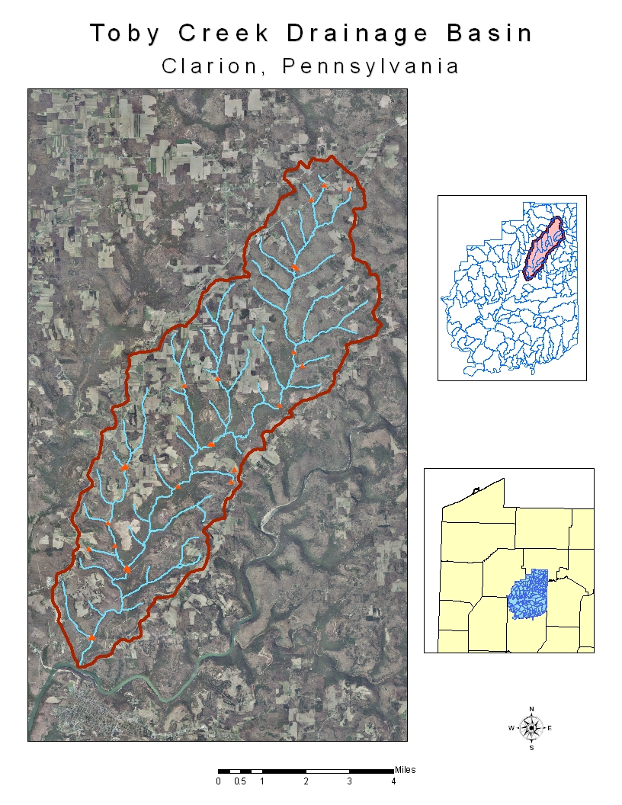
Figure 1: Location of Toby Creek and the boundaries of the watershed.
Methods:
In order to observe the effects of AMD on Toby Creek’s watershed, data was collected at multiple points along Toby Creek and its tributaries. The collection was done by a professor and students from Clarion University during the summer of 2009. The water quality samples that were collected consisted of: pH, Conductivity, Eh, Iron Concentrations, Sulfate and water temperatures. The samples were collected at designated locations but no specific ground coordinates were obtained. Tables were created in Microsoft Excel to organize the data that was then incorporated into a database in ArcCatalog 9.3 (Table 1 and 2).
A database was created in ArcCatalog that holds layers and feature classes of multiple types of data. The coordinate system that was used in this project was the North American Datum of 1983 UTM Zone 17N. The county boundaries of Pennsylvania were obtained from the Pennsylvania Spatial Data Access (PASDA) website and were used for a map projection to locate Toby Creek watershed. A feature class was created to contain the vector data of point layers and stream layers. The outline polygon of the drainage basin was from Clarion University’s M drive data sets and layers. A satellite image of Clarion County with an 8 bit precision was used for displaying the land use and vegetation around the watershed also from the M drive data. Raster datasets of different stream buffers were created using different tools in ArcMap 9.3. The streams that were within the drainage basin boundaries were extracted using the Extract analysis tool. Spatial Analyst Tools such as the IDW interpolation were used as ways to interpolate the stream data into a specific number of classes. Multiple methods were attempted to find an accurate and correct way to display and interpret the data. The IDW (Inverse Distance Weighted) interpolation method estimates the raster cell values based on the water quality data by averaging the values of data within a neighborhood of cell values. (ArcGIS Desktop 9.3 Help) Figure 2 and 3 show the pH values projected from an IDW interpolation method. The IDW interpolation method is useful when trying to interpret a large area such as this drainage basin. Figure 4 displays the the iron concentration data also interpolated into three classes using the IDW method.
An unsupervised land cover classification map was created using ERDAS as a way to show the strip mined areas in relation to the stream and the collection sites (Figure 5). The map shows the type of vegetation or land cover on the strip mines. This assists in the analysis of the watershed to understand where the sources of pollution may be coming from.

Table 1: Water Quality Data from Toby Creek and its tributaries
Loc_ID | Col_Date | Col_Nam | Temp (°C) | Cond (mMho) | pH | Eh (mV) | Tot_Iron (ppm) | Sulfate (ppm)
1 | 5/14/2009 | Dr. Ryberg | 13.4 | 980 | 3 | 282 | 11.5 | 90
2 | 5/14/2009 | Dr. Ryberg | 12.8 | 302 | 3.7 | 316 | 79 | 15
3 | 5/14/2009 | Dr. Ryberg | 13 | 603 | 3.3 | 302 | 61 | 29
4 | 5/13/2009 | Dr. Ryberg | 10.7 | 311 | 3.7 | 293 | 6.7 | 15
5 | 5/13/2009 | Dr. Ryberg | 10.1 | 265 | 4 | 283 | 2.83 | 12
6 | 5/13/2009 | Dr. Ryberg | 11.7 | 570 | 3.5 | 290 | 2.75 | 27
7 | 5/13/2009 | Dr. Ryberg | 14.7 | 800 | 3 | 322 | 40 | 34
8 | 5/13/2009 | Dr. Ryberg | 11.6 | 415 | 3.6 | 328 | 2.8 | 17
9 | 5/13/2009 | Dr. Ryberg | 11.8 | 442 | 3.4 | 345 | 2.57 | 23
10 | 5/13/2009 | Dr. Ryberg | 13.7 | 284 | 4.3 | 302 | 0.82 | 4
11 | 5/13/2009 | Dr. Ryberg | 12.9 | 412 | 5.4 | 244 | 16.5 | 25
12 | 5/13/2009 | Dr. Ryberg | 11.8 | 804 | 5.9 | -10 | 56.1 | 76
13 | 5/13/2009 | Dr. Ryberg | 16.1 | 211 | 4.2 | 248 | 1.2 | 4
14 | 5/13/2009 | Dr. Ryberg | 12.6 | 185 | 5.2 | 198 | 2.45 | 4
15 | 5/13/2009 | Dr. Ryberg | 14.2 | 185 | 5.4 | 143 | 1.26 | 4
16 | 5/13/2009 | Dr. Ryberg | 12.5 | 143 | 5 | 184 | 0.88 | 4
17 | 5/14/2009 | Dr. Ryberg | 11.4 | 128 | 5 | 235 | 0.44 | 4
18 | 5/14/2009 | Dr. Ryberg | 14.4 | 213 | 4.8 | 243 | 0.94 | 4
19 | 5/13/2009 | Dr. Ryberg | 15.4 | 432 | 4.7 | 284 | 4.84 | 16
20 | 5/12/2009 | Dr. Ryberg | 13.7 | 1030 | 4 | 315 | 50.15 | 60
21 | 5/12/2009 | Dr. Ryberg | 18.6 | 196 | 5.8 | 175 | 0.15 | 4
22 | 5/12/2009 | Dr. Ryberg | 14.3 | 48 | 6.4 | 180 | 0.04 | 4
23 | 5/12/2009 | Dr. Ryberg | 14.9 | 21 | 5.2 | 240 | 0 | 4
24 | 5/12/2009 | Dr. Ryberg | 13.2 | 28 | 5.2 | 240 | 0.09 | 4
25 | 5/15/2009 | Dr. Ryberg | 11 | 75 | 7 | 100 | 0.12 | 4
26 | 5/12/2009 | Dr. Ryberg | 11.8 | 207 | 6.5 | 48 | 4.07 | 4
27 | 5/14/2009 | Dr. Ryberg | 14.1 | 244 | 4.1 | 266 | 1.2 | 4

Table 2: Water quality test site locations
Locat_ID | Samp_typ | Samp_Locat
1 | stream | Rapp Run T576
2 | stream | Toby Creek_upstream T578 Brdg and Rapp Run
3 | stream | Toby Creek_downstream Rapp Run
4 | creek | Toby 1 Brdg T577
5 | creek | Toby 1 upstream T577 Brdg
6 | creek | Tributary upstream T577 Brdg
7 | pond | Dead Duck Pond
8 | creek | Step Creek upstream Dead Duck Pond
9 | creek | Step Creek downstream Dead Duck Pond
10 | creek | Step Creek upstream spring Lawn Dr/Madden Dr int
11 | creek | Step Creek downstream spring Lawn Dr/Madden Dr int
12 | source spring | Source spring Lawn Dr/Madden Dr Int
13 | creek | Bridge Eagle Run SR 1006
14 | creek | Toby Creek Bridge SR1013
15 | creek | Toby Creek Bridge T619
16 | creek | Toby Creek Trib T618
17 | spring | Spring downstream off Sarvey Mill Rd T562
18 | stream | Toby Creek Bridge T562
19 | creek | Little Toby Creek Bridge T851
20 | spring | Helen Furnace spring
21 | pond | Helen Furnace
22 | stream | P10 Toby Headwater 1
23 | stream | T634 off rd Headwater 2
24 | stream | T624 Tributary Headwater 3
25 | creek | Rt. 36 Toby Creek Bridge
26 | dug well | Rt. 36 Old Dug Well
27 | stream | Toby Creek Bridge 1004

Table 3: Joined classification of Iron and pH values
Classification | Fe | pH
Low | ≤ 9 | < 3
Moderate | 10 - 25 | 3.1 – 5
High | > 25 | > 5
Figure 2: IDW interpolation Method of the stream’s pH values for monitoring water quality represented in 32 classes.
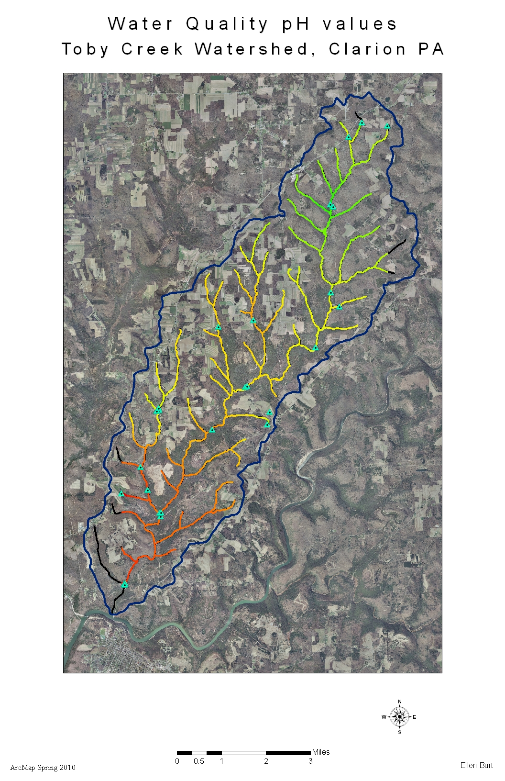
Figure 3: IDW interpolation Method of the stream’s pH values for monitoring water quality, represented in 3 different classes.
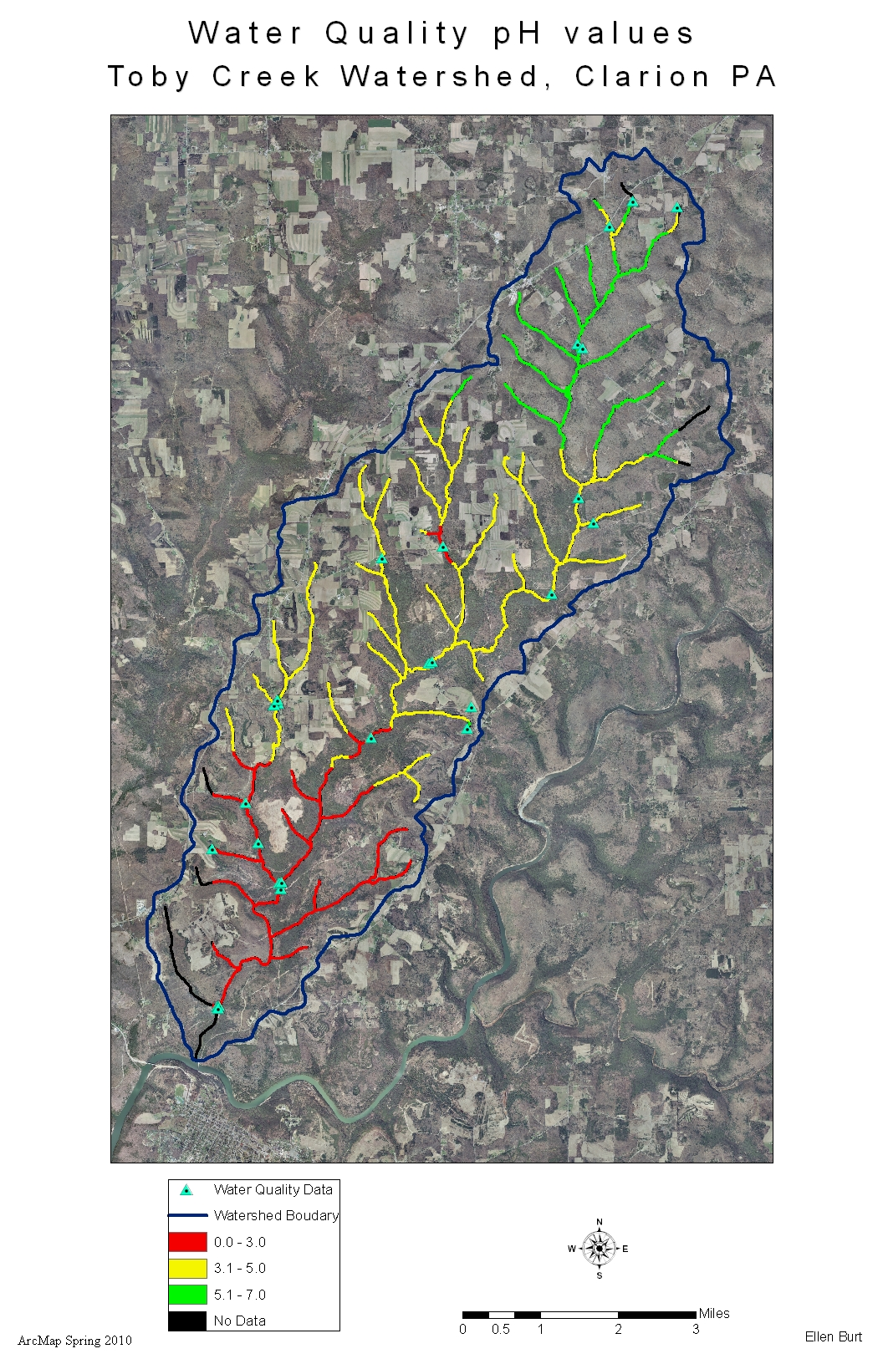
Figure 4: IDW interpolation Method of the stream’s total iron concentration values. The values are categorized into three classes.
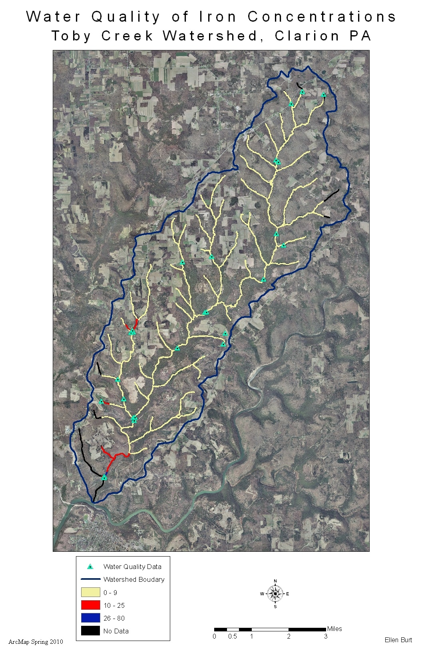

Figure 5: Displays the type of land use in the Toby Creek watershed using an unsupervised classification.
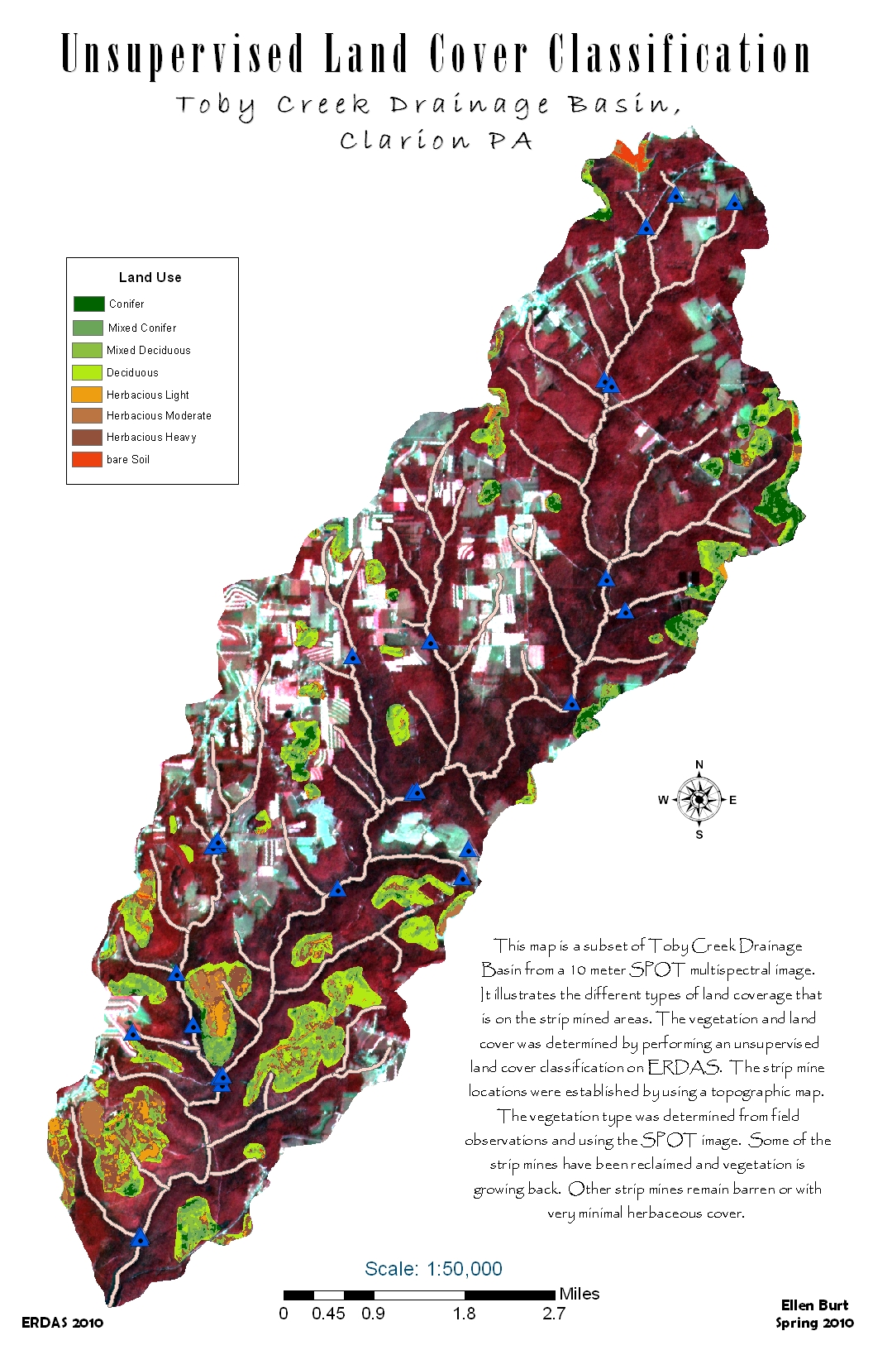
Results and Discussion:
Through observations of the data represented in figures 2 and 3 it is noticeable that the pH values increase in acidity as the flow of water progresses downstream. The head waters show relatively neutral pH values indicating moderate to exceptional water conditions based on acidity. In figure 3, the pH values are interpreted by using three classes to represent low, moderate, and high areas of acidity. Low acidity is classified as values that are less than 3, moderate is between 3.1 – 5, and high acidity is values greater than 5. Along with the pH values, the total Iron concentrations are also interpreted in three classes. The same method of ranking the values is used again for the Iron where values of less than or equal to 9 ppm of Fe is considered low, between 10 and 25 ppm is moderate, and Fe concentrations greater than 25 ppm are considered high. This table of classifying Fe concentrations and pH values is based off of a previous table and interpretation by a Clarion University professor (Ayad). (See table 3)
The unsupervised land cover classification map (figure 5) shows the land cover on the strip mined areas and their relation to the stream system. The bare ground patches left from the unreclaimed strip mines is a contributing factor to the amount of ground water runoff occurring and the transport of sediments and metals into the stream. By observing the drainage patterns of the steams, it is apparent that the location of the strip mines are affecting the water quality down stream. Areas that lack vegetation are more vulnerable to sediment runoff than areas that have thicker herbaceous or forested land cover. The unreclaimed sites have not grown back with vegetation due to the upturned acidic soils and bedrock.
Remediation efforts have been in effect for Pennsylvania’s streams since the Surface Mining Control and Reclamation Act of 1977 and the Clean Water act of 1972. The acts were developed to monitor the amount of sediment discharge from the mines that gets into the streams (Reinhardt). Some of the techniques used in remediation efforts are the use of limestone drainage beds and Caustic soda treatments. The alkaline materials act as to neutralize the acidic water conditions. The Caustic soda treatments are effective but expensive to use over extensive areas of land. The use of limestone beds are ideal to use because they are a cheaper method and they last approximately for 25 years (Turner). Based on the current conditions of Toby Creek which are displayed in the figures, there are several areas that would need more attention and remediation effort directed towards reclaiming those sites.
Conclusion:
The purpose of this project was to display the current water quality conditions of Toby Creek’s watershed and to analyze the areas within the watershed that are struggling with poor water quality. By understanding where the sites with poor water conditions and bare land cover are, a more focused approach for remediation is possible. Funding for the remediation projects would go directly to the source instead of being mislead to sites that are not as much of a priority.
To further this project, the values of iron and pH would be incorporated together and projected together to help illustrate the areas of highest priority for remediation. Also by collecting more data such as the presence heavy metals that are found in the water would give a better understanding of the water quality. Aluminum and Manganese are two of the heavy metals that have been present in AMD affected streams. The heavy metals are contributing factors to the ability for the stream ecosystem to support aquatic life (Turner). It would also be important to monitor fish and other aquatic organism populations because the state of Pennsylvania depends on the economic value of fish (Turner). The presence of certain organisms are indicators of water quality and of healthy living conditions which would be useful in analyzing the stream improvements from remediation.

Predicted Timeline:
Objectives: | Weeks  1-2 | 3 | 4 | 5 | 6 | 7 | 8 | 9 | 10 | 11 | 12 | 13 | 14 | 15 | 16
Setting the Objectives | X | X
Project Proposal |  | X | X | X
Work on Modules |  |  | X | X | X | X | X | X
Data Collection |  |  |  | X | X | X
Create Database |  |  |  |  |  | X | X | X | X
Analyze Watershed |  |  |  |  |  |  |  | X | X
Create Presentation |  |  |  |  |  |  |  |  | X | X | X | X | X
Write Report |  |  |  |  |  |  |  |  |  |  |  | X | X
Presentation |  |  |  |  |  |  |  |  |  |  |  |  |  | X
Turn in Final Project |  |  |  |  |  |  |  |  |  |  |  |  |  |  | X

Actual Timeline:
Objectives: | Weeks  1-2 | 3 | 4 | 5 | 6 | 7 | 8 | 9 | 10 | 11 | 12 | 13 | 14 | 15 | 16
Setting the Objectives | X | X
Project Proposal |  | X | X | X | X
Work on Modules |  |  | X | X | X | X | X | X
Data Collection |  |  |  | X | X | X
Create Database |  |  |  |  |  | X | X | X | X | X | X
Analyze Watershed |  |  |  |  |  |  |  | X | X | X | X | X | X | X
Create Presentation |  |  |  |  |  |  |  |  |  |  |  | X | X
Write Report |  |  |  |  |  |  |  |  |  |  |  | X | X | X | X
Presentation |  |  |  |  |  |  |  |  |  |  |  |  |  | X
Turn in Final Project |  |  |  |  |  |  |  |  |  |  |  |  |  |  | X

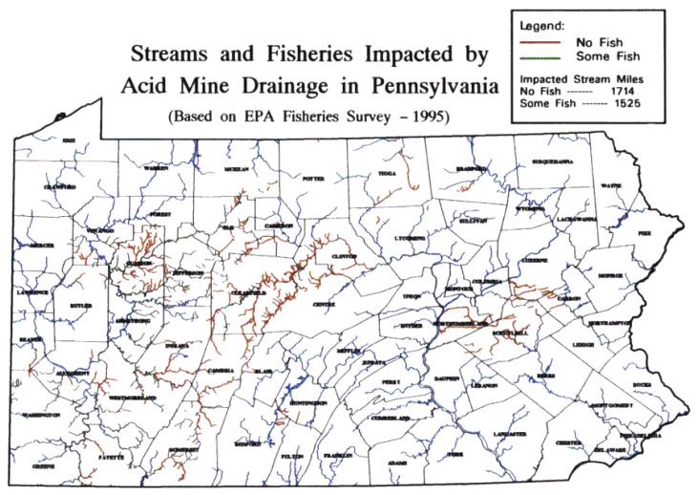
Coal-mine drainage projects in PA, U.S. Environmental
Protection Agency

Works Cited
ArcGIS Desktop 9.3 Help. April 25, 2009. http://webhelp.esri.com/arcgisdesktop/9.3/index.cfm?TopicName=welcome

Ayad, Yasser, Prioritizing Acid Mine Drainage Stream Remediation. ESRI website. Oct.-Dec. 2004. Feb.
2010. <http://www.esri.com/news/arcuser/1104/tobycreek.html>

Ayad, Ryberg, Bernecky, Hnat. Impacts of Acid Mine Drainage: Building Streams Database and Analyzing Toby Creek Sub-Basin. Clarion University of PA, Department of Anthropology, Geography, and Earth Science. Clarion PA 16214. <http://proceedings.esri.com/library/userconf/proc03/p1082.pdf>

Reinhardt Carrie H. Restoration and Reclamation Review. Acid Mine Drainage in Pennsylvania Streams: “Ironing Out” The Problem”. Student On-Line Journal Fall 1999. Department of Horticultural Science University of Minnesota, St. Paul, MN. http://conservancy.umn.edu/bitstream/59448/1/5.1.Reinhardt.pdf

Pennsylvania Streams and Fisheries –Image. Coal-Mine-Drainage Projects in Pennsylvania. USGS. Feb.
2010 <http://pa.water.usgs.gov/projects/amd/tn-amdmap.gif>

USGS. Coal-Mine-Drainage Projects in Pennsylvania. USGS Coal-mine-Drainage Projects in Pennsylvania September 2008. <http://pa.water.usgs.gov/projects/amd/>

Threats-AMD, Trout Unlimited. Feb. 2010 Image.
<http://www.tu.org/conservation/easternconservation/brook-trout/education/threats/amd>

Joseph, Sean D.(Prepared by) Ryberg T. Paul (Submitted to). Toby Creek Watershed: Water Budget and Water Quality Analysis. Clarion University of PA, Clarion Pennsylvania 16214. Water Quality Data and Site Locations.

Turner, Morrow, Harris, Dalby, Dressler, and Seiler. “Acid Mine Drainage: Studies in Remediation. Watershed scale Assessment of an Acid-Mine Drainage Abatement Project in Clarion County.” The Center for Rural Pennsylvania. <http://www.rural.palegis
lature.us/acid_mine_remediation.pdf>.

