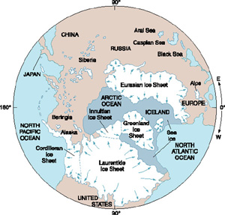
Glacial Isostatic Adjustment

Learning objectives:
-Understand that there have been multiple instances when ice ages have occurred in Earth’s past.
-Explain the relationship between the thickness of ice covering a land surface and the amount of depression of that surface.
-Explain the relationship between the thickness of the ice covering a land surface and the amount of glacial isostatic rebound likely.
- Explain the relationship between the thickness of the ice covering a land surface and the timing of glacial isostatic rebound.
-Be able to identify the timing of the Pleistocene ice age and the extent of ice coverage in our local region.
-Compare the area of the Antarctic ice sheet with the ice sheet that covered North America during the Pleistocene.
-Describe the thickness of the Antarctic ice sheet.
-Describe the pattern of glacial isostatic adjustment in North America following the retreat of the Pleistocene ice sheet.
-Describe the relationship between sea level and ice ages.

A very brief bit of background information:
The ice sheets that covered a large portion of the northern hemisphere during the most recent ice age began to retreat about 20,000 years ago. During the peak of the ice age about 27% of the land surfaces were covered by ice. The glaciers were up to 3,000 meters thick. In North America, ice reached as far south as New Jersey in the east, St. Louis in the mid-west, and to south-central New Mexico in the western mountains. Greenland, Scandinavia, Great Britain, Ireland, and part of northern Russia were also covered with ice.

The ice sheet retreated from our local area by about 14,000 years ago. During this period of melting, the volume of global continental ice decreased by about 70%. This dramatic decrease in ice volume caused sea-levels to rise by over 100 meters on average.

Introduction:
Glacial ice affects much more than just sea level as we will see in part I of this lesson. In this lesson we will be considering the impact of adding a large mass, such as glacial ice, to the Earth’s surface and then removing it over time. Investigating the result of such events provides geoscientists with important data about the visco-elastic properties of the interior of the Earth.

What kinds of questions do you think geoscientists are asking about the way the Earth’s surface and interior behave when ice ages begin and end?

What data do you think would be useful in answering the questions?

What types of tools are needed to collect this data?

Background visuals:
Watch the video - http://www.youtube.com/watch?v=fyXwFK603J4

Part I
In this part of the lesson you will investigate what happens to materials of different densities when large masses are applied and then removed.

Materials:
2 pieces of foam or sponge with different densities
3 different masses (at least 2 kg to start)
Ruler

Experimental design:
Design an experiment to answer the following questions:
- What is the relationship between the amount of mass added to a sponge and the amount of depression of the surface of the sponge?
- What is the relationship between the density of the sponge and the amount of depression of the surface of the sponge?
- What is the relationship between the amount of mass added to a sponge and the amount of time required for the surface of the sponge to return to normal?
- What is the relationship between the density of the sponge and the amount of time required for the surface of the sponge to return to normal?

Write your experimental procedure:

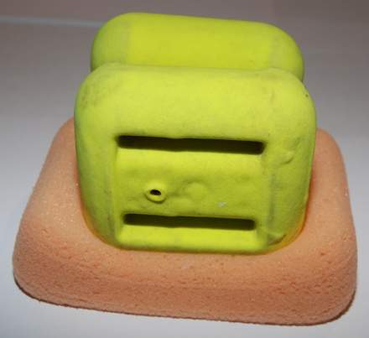

Create a data table to record the data you collect:

Create graphs of the data you collected:
Use Excel to graph your data. Display your graphs below.

Discussion:
Write a discussion section below that addresses the following ideas based on data and observations from your experiment:
-How are the different masses like different ice thicknesses?
-What does the data suggest about the amount of depression of a land surface as a result of loading by different thicknesses of ice?
-How can the different density sponges be related to the density of the Earth’s upper mantle?
-What does the data suggest about the amount of time for the land surface to return to its original level?

Part II:
In this part of the lesson you will investigate the present Antarctic ice sheet using ArcGIS Explorer.
Opening the data set:
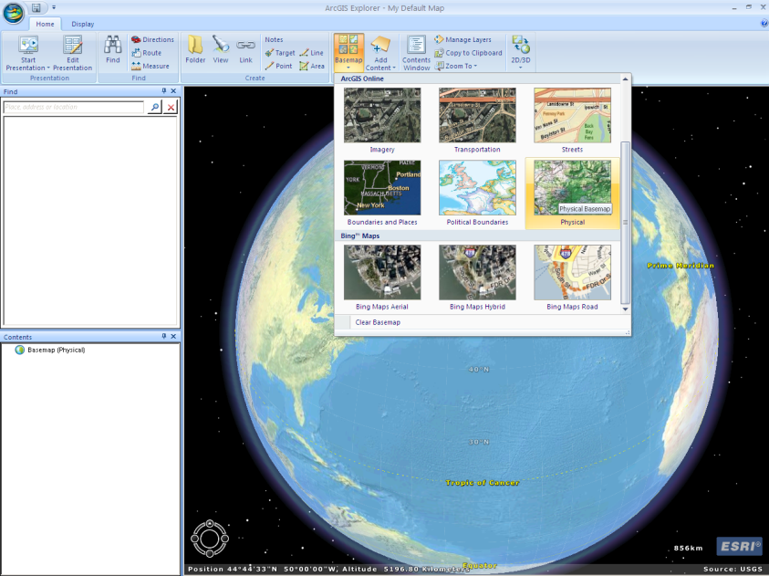
ArcGIS Explorer basics – viewing KML files
- Open ArcGIS Explorer
- Change the base map to the imagery map by clicking on base maps on the ribbon and selecting the imagery map.
- During this activity you will be importing a .kml file as you investigate the Antarctic ice sheet.
- To add a .kml layer to the map click on Add Content on the ribbon. Next choose KML files and then navigate to the file. Double click the file name and it will be added to the map. When it is added a new layer will be created in the content window.
- The data contained in the new layer has been added to your map. To view / hide the data in the layer check and uncheck the box to the left of its name in the contents window.
- If there is a + sign in front of a layer it indicates that the layer can be expanded. Click the + sign to reveal the data in the layer. Double clicking on any layer name “flies” you to that location.
- Navigation tools to zoom in and out, tilt and rotate are docked in the lower left corner of the map area.
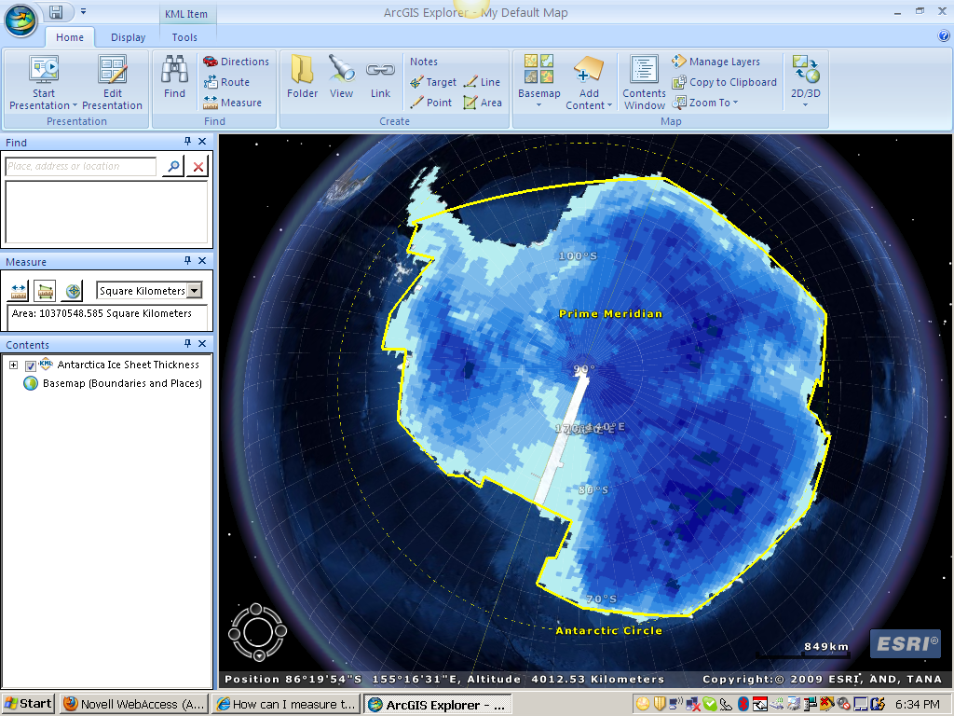
Antarctic Ice Sheet Data & Analysis:
Collect and record the following data:
- Where is the ice sheet thickest? What is the maximum thickness?
- Where is the ice sheet thinnest? How thick are the thinnest regions?
- Measure the area covered by the Antarctic ice sheet using the measurement tool.

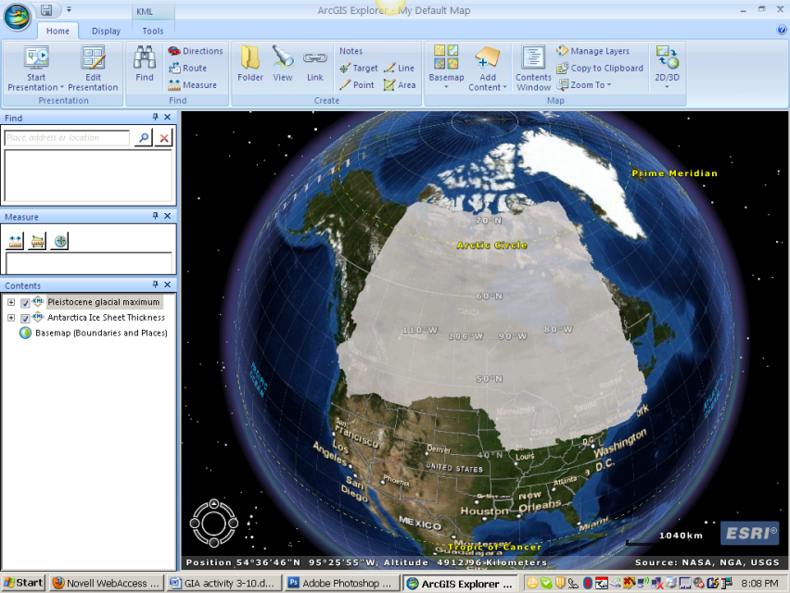
Pleistocene Glacial Maximum in North America:
- Repeat the steps above to add another layer of data to the globe. Add the KML file called Pleistocene Glacial Maximum.
- Measure the area covered by the Pleistocene ice sheet using the measurement tool.
- Measure the area covered by the Greenland ice sheet using the measurement tool.

Discussion:
Write a discussion section that addresses the following ideas based on data and observations from ArcGIS Explorer:
-How thick is the Antarctic ice sheet in different locations?
-Where it the ice sheet thickest?
-Where is the ice sheet thinnest?
-What is the shape of each of the ice sheets compared to the actual continental land masses?
-How large an area do the ice sheets cover?
-How do these areas compare?
-Where do you think the greatest amount of surface depression is occurring on the Antarctic continent?
-Where do you think the least amount of surface depression is occurring on the Antarctic continent?
-Where do you think the greatest amount glacial isostatic adjustment would occur if the ice sheet on Antarctica melted?
-What do you think would happen to sea level if the ice sheet melted?

Part III:
In this part of the lesson you will investigate the retreat of the Pleistocene glaciations and the resulting glacial isostatic adjustment.

Visualizing the retreat of the Pleistocene Ice Sheet:
This investigation will make use of data collected in the Canadian provinces. You will be using several maps and a data table, all found below to write a discussion.

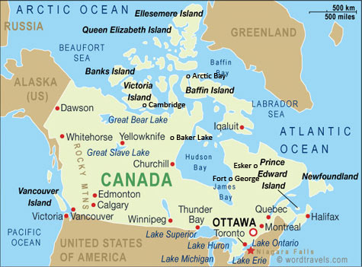
Begin by observing the map showing amounts of isostatic rebound in North American since 6,000 years before present and the map showing the location of major rebound centers. Use the maps to complete the data table below.

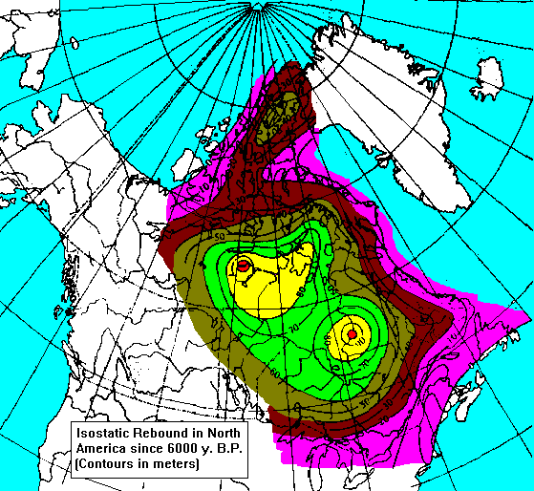

Data Table
Canadian City | Amount of rebound, meters | Duration of rebound, years
Arctic Bay |  | 3700
Cambridge Bay |  | 4300
Coral Harbour |  | 5800
Baker Lake |  | 6000
Churchill |  | 5600
Ivujivik |  | 5300
Fort George |  | 5700
Esker |  | 4600
Montreal |  | 3100
Quebec |  | 2700

Graphing the data:
Create a graph using Excel showing the amount of rebound in meters versus the duration of rebound in years. Add a best fit line to the graph. Display the graph in the space below.

Discussion:
Write a discussion section that addresses the following ideas based on data and observations in parts I-III.
- What is the probable relationship between the thickness of the Pleistocene ice sheet and the rebound centers identified above?
- What is the probable relationship between the rebound centers and the locations where the glacial ice first began to accumulate?
- Describe the relationship show in the graph above of rebound rate versus rebound amount.
- If sea level drops because of an ice age, what happens to areas of land immediately adjacent to the original shoreline?
- If sea level rises as a result of the end of an ice age, what happens to areas of land immediately adjacent to the ice age shoreline?

