This is a model of a water system in an imagined watershed developed by Allyson Beall at Washington State University. This model could be:

- used as a starting point for a discussion of possible future outcomes
- used as a final summary for a discussion of what parameters are important in a system
- built in Stella and used to run possible scenarios for climate or management changes
- used as a ‘game’ with stakeholders or students to illustrate how system components are linked

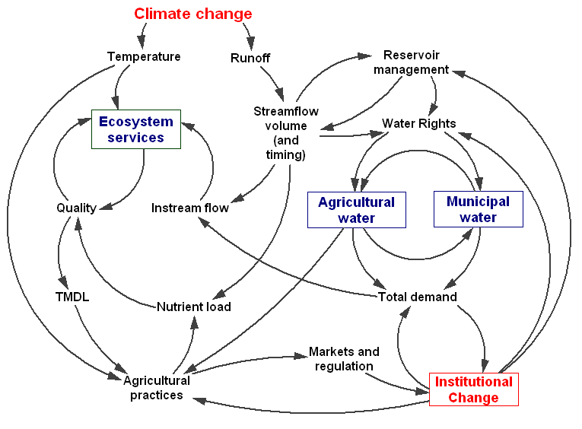

Figure X. This figure illustrates the important linkages and feedbacks present in the basin. Agriculture, municipal and ecosystem services needs will face increasing competition for water due to climate driven hydrologic changes, growth and regulations such as Total Maximum Daily Load (TMDL). Improving understanding of complex feedbacks between the biogeophysical system and human behavior will facilitate development of water management institutions that are able to capture the synergistic mechanisms surrounding the use and demand for water.

